UNITED STATES
SECURITIES AND EXCHANGE COMMISSION
Washington, DC 20549
FORM 10-K
(Mark One)
☒ ANNUAL REPORT PURSUANT TO SECTION 13 OR 15(d) OF THE SECURITIES EXCHANGE ACT OF 1934
For the fiscal year ended December 31, 2020
or
☐ TRANSITION REPORT PURSUANT TO SECTION 13 OR 15(d) OF THE SECURITIES EXCHANGE ACT OF 1934
For the transition period from________to________
Commission File Number: 001-39748
PubMatic, Inc.
(Exact name of registrant as specified in its charter)
Delaware |  |  | 20-5863224
(State or other jurisdiction of incorporation or organization) |  |  | (I.R.S. Employer Identification Number)
3 Lagoon Drive, Suite 180
Redwood City, California 94065
(650) 331-3485
(Address, including zip code, and telephone number, including area code, of registrant’s principal executive offices)
Securities registered pursuant to Section 12(b) of the Act:
Title of Each Class |  |  | Trading Symbol |  |  | Name of Each Exchange on Which Registered
Class A common stock, $0.0001 par value per share |  |  | PUBM |  |  | The Nasdaq Global Market
Securities registered pursuant to Section 12(g) of the Act: None
Indicate by a check mark if the Registrant is a well-known seasoned issuer, as defined in Rule 405 of the Securities Act. Yes ☐ No ☒
Indicate by check mark if the Registrant is not required to file reports pursuant to Section 13 or Section 15(d) of the Act. Yes ☐ No ☒
Indicate by check mark whether the Registrant (1) has filed all reports required to be filed by Section 13 or 15(d) of the Securities Exchange Act of 1934 during the preceding 12 months (or for such shorter period that the Registrant was required to file such reports), and (2) has been subject to such filing requirements for the past 90 days. Yes ☒ No ☐
Indicate by check mark whether the Registrant has submitted electronically every Interactive Data File required to be submitted pursuant to Rule 405 of Regulation S-T (§232.405 of this chapter) during the preceding 12 months (or for such shorter period that the Registrant was required to submit such files). Yes ☐ No ☐
Indicate by check mark whether the registrant is a large accelerated filer, an accelerated filer, a non-accelerated filer, a smaller reporting company, or an emerging growth company. See definitions of “large accelerated filer,” “accelerated filer,” “smaller reporting company,” and “emerging growth company” in Rule 12b-2 of the Exchange Act.
Large accelerated filer ☐ |  |  | Accelerated filer ☐
Non-accelerated filer ☒ |  |  | Smaller reporting company ☐
 |  |  | Emerging growth company ☒
If an emerging growth company, indicate by check mark if the registrant has elected not to use the extended transition period for complying with any new or revised financial accounting standards provided to Section 7(a)(2)(B) of the Securities Act. ☐
Indicate by check mark whether the registrant has filed a report on and attestation to its management’s assessment of the effectiveness of its internal control over financial reporting under Section 404(b) of the Sarbanes-Oxley Act (15 U.S.C. 7262(b)) by the registered public accounting firm that prepared or issued its audit report. ☐
Indicate by check mark whether the registrant is a shell company (as defined in Rule 12b-2 of the Exchange Act). Yes ☐ No ☒
As of June 30, 2020, the last business day of the registrant’s most recently completed second fiscal quarter, there was no established public market for the registrant’s Class A common stock, par value $0.0001 per share. The registrant’s Class A common stock began trading on The Nasdaq Global Market on December 9, 2020. The aggregate market value of common stock held by non-affiliates of the registrant computed by reference to the closing price of the registrant’s Class A common stock on December 9, 2020 was approximately $553 million. Shares of common stock held by each executive officer, director, and their affiliated holders have been excluded in that such persons may be deemed to be affiliates. This determination of affiliate status is not necessarily a conclusive determination for other purposes. As of March 15, 2021, there were 6,837,031 shares of the registrant’s Class A common stock outstanding and 42,186,274 shares of the registrant’s Class B common stock outstanding.
DOCUMENTS INCORPORATED BY REFERENCE
Portions of the registrant’s proxy statement for its 2021 annual meeting of stockholders are incorporated herein by reference in Part III of this Annual Report on Form 10-K to the extent stated herein. Such proxy statement will be filed with the Securities and Exchange Commission within 120 days of the registrant’s fiscal year ended December 31, 2020.

TABLE OF CONTENTS
 |  |  |  |  |  | Page
Note About Forward-Looking Statements |  |  |  |  |  | 1
Market and Industry Data |  |  |  |  |  | 2
Summary of Risk Factors |  |  |  |  |  | 3
Part I
Item 1. |  |  | Business |  |  | 5
Item 1A. |  |  | Risk Factors |  |  | 27
Item 1B. |  |  | Unresolved Staff Comments |  |  | 60
Item 2. |  |  | Properties |  |  | 60
Item 3. |  |  | Legal Proceedings |  |  | 61
Item 4. |  |  | Mine Safety Disclosures |  |  | 61
Part II
Item 5. |  |  | Market for Registrant’s Common Equity, Related Stockholder Matters and Issuer Purchases of Equity Securities |  |  | 62
Item 6. |  |  | Selected Financial Data |  |  | 64
Item 7. |  |  | Management’s Discussion and Analysis of Financial Condition and Results of Operations |  |  | 67
Item 7A. |  |  | Quantitative and Qualitative Disclosures About Market Risk |  |  | 86
Item 8. |  |  | Financial Statements and Supplementary Data |  |  | 87
Item 9. |  |  | Changes in and Disagreement with Accountants on Accounting and Financial Disclosure |  |  | 118
Item 9A. |  |  | Controls and Procedures |  |  | 118
Item 9B. |  |  | Other Information |  |  | 119
Part III
Item 10. |  |  | Directors, Executive Officers and Corporate Governance |  |  | 120
Item 11. |  |  | Executive Compensation |  |  | 120
Item 12. |  |  | Security Ownership of Certain Beneficial Owners and Management and Related Stockholder Matters |  |  | 120
Item 13. |  |  | Certain Relationships and Related Transactions, and Director Independence |  |  | 120
Item 14. |  |  | Principal Accountant Fees and Services |  |  | 120
Part IV
Item 15. |  |  | Exhibits, Financial Statement Schedules |  |  | 121
Item 16. |  |  | Form 10-K Summary |  |  | 124
 |  |  | Signatures |  |  | 125

i
SPECIAL NOTE REGARDING FORWARD-LOOKING STATEMENTS
This Annual Report on Form 10-K, including the section entitled “Management’s Discussion and Analysis of Financial Condition and Results of Operations,” contains forward-looking statements. The words “believe,” “may,” “will,” “potentially,” “estimate,” “continue,” “anticipate,” “intend,” “could,” “would,” “project,” “plan,” “expect,” and similar expressions that convey uncertainty of future events or outcomes are intended to identify forward-looking statements. Forward-looking statements include, but are not limited to, statements about:
•our future financial and operating results;
•our ability to maintain our growth and profitability;
•our ability to attract and retain publishers;
•our ability to expand the utilization of our buyers;
•our ability to maintain a consistent supply of quality advertising inventory;
•our ability to maintain our competitive technological advantages against competitors in our industry;
•our expectations concerning the advertising industry and, in particular, the market for programmatic ad purchasing;
•our ability to successfully navigate our business through the COVID-19 pandemic;
•our ability to timely and effectively adapt our existing technology;
•our ability to introduce new offerings and bring them to market in a timely manner;
•our ability to maintain, protect, and enhance our brand and intellectual property;
•our ability to continue to expand internationally;
•our expectations concerning relationships with third parties;
•our ability to attract and retain qualified employees and key personnel while maintaining our corporate culture;
•future acquisitions of or investments in complementary companies or technologies; and
•our ability to comply with evolving legal and industry standards and regulations, particularly concerning data protection and consumer privacy.
These forward-looking statements are subject to a number of risks, uncertainties and assumptions, including those described in “Risk Factors” and elsewhere in this Annual Report on Form 10-K. Moreover, we operate in a very competitive and rapidly changing environment, and new risks emerge from time to time. It is not possible for our management to predict all risks, nor can we assess the impact of all factors on our business or the extent to which any factor, or combination of factors, may cause actual results to differ materially from those contained in any forward-looking statements we may make. In light of these risks, uncertainties, and assumptions, the forward-looking events and circumstances discussed in this Annual Report on Form 10-K may not occur and actual results could differ materially and adversely from those anticipated or implied in the forward-looking statements.
You should not rely upon forward-looking statements as predictions of future events. Although we believe that the expectations reflected in the forward-looking statements are reasonable, we cannot guarantee that the future results, levels of activity, performance, or events and circumstances reflected in the forward-looking statements will be achieved or occur. We undertake no obligation to update publicly any forward-looking statements for any reason after the date of this Annual Report on Form 10-K to conform these statements to actual results or to changes in our expectations, except as required by law.
You should read this Annual Report on Form 10-K and the documents that we reference in this Annual Report on Form 10-K and have filed with the Securities and Exchange Commission (the “SEC”), with the understanding that our actual future results, levels of activity, performance, and circumstances may be materially different from what we expect.
Unless otherwise indicated, the terms “PubMatic,” “we,” “us,” and “our” refer to PubMatic, Inc. and our consolidated subsidiaries.

1
MARKET AND INDUSTRY DATA
Unless otherwise indicated, information contained in this Annual Report on Form 10-K concerning our industry and the markets in which we operate, including our general expectations and market position, market opportunity and market size, is based on information from various sources, including eMarketer Inc. (“eMarketer”), as well as assumptions that we have made that are based on those data and other similar publicly available sources and on our knowledge of the markets for our products and services. This information involves important assumptions and limitations, and you are cautioned not to give undue weight to such estimates. While we believe the market position, market opportunity and market size information included in this this Annual Report on Form 10-K is generally reliable, information of this sort is inherently imprecise and we have not independently verified market and industry data from third-party sources. In addition, projections, assumptions, and estimates of our future performance and the future performance of the industry in which we operate is necessarily subject to a high degree of uncertainty and risk due to a variety of factors, including those described in “Risk Factors” and elsewhere in this this Annual Report on Form 10-K. These and other factors could cause results to differ materially from those expressed in the estimates made by the independent parties and by us.
The source of, and selected additional information contained in, the independent industry publications related to the information so identified are provided below:
•eMarketer, Total Media Ad Spending Worldwide, 2020-2024 (June 2020);
•eMarketer, Digital Ad Spending Worldwide, 2019-2024 (June 2020);
•eMarketer, Programmatic Ad Spending Worldwide, 2012-2021 (Nov 2019);
•eMarketer, Over-the-Top Video Revenues Worldwide, 2013, 2019 & 2023 (Jan 2020);
•eMarketer, Mobile Ad Spending Worldwide, 2020-2024 (June 2020); and
•eMarketer, Average Time Spent per Day by Internet Users Worldwide Using the Internet via Mobile vs. Desktop, 2012-2019 (March 2020).
This Annual Report on Form 10-K contains our trade names, trademarks, and service marks, including the PubMatic name and logo, and all product names. This Annual Report on Form 10-K may also contain the trade names, trademarks, and service marks of other companies. We do not intend our use or display of other companies’ trade names, trademarks, or service marks to imply a relationship with these other companies, or endorsement or sponsorship of us by these other companies. Other trademarks appearing in this Annual Report on Form 10-K are the property of their respective holders.

2
SUMMARY OF RISK FACTORS
The following is a summary of the principal risks described below in Part I, Item 1A “Risk Factors” in this Annual Report on Form 10-K. We believe that the risks described in the “Risk Factors” section are material to investors, but other factors not presently known to us or that we currently believe are immaterial may also adversely affect us. The following summary should not be considered an exhaustive summary of the material risks facing us, and it should be read in conjunction with the “Risk Factors” section and the other information contained in this Annual Report on Form 10-K.
•Our revenue and results of operations are highly dependent on the overall demand for advertising.
•If our existing customers do not expand their usage of our platform, or if we fail to attract new publishers and buyers, our growth will suffer. Moreover, any decrease in the use of the advertising channels that we primarily depend on, or failure to expand into emerging channels, could adversely affect our business, results of operations, and financial condition.
•Our business depends on our ability to maintain and expand access to valuable ad impressions from publishers, including our largest publishers.
•Our business depends on our ability to maintain and expand access to spend from buyers, including a limited number of DSPs, agencies, and advertisers.
•If the use of digital advertising is rejected by consumers, through opt-in, opt-out or ad-blocking technologies or other means, it could have an adverse effect on our business, results of operations, and financial condition.
•If we fail to make the right investment decisions in our platform, or if we fail to innovate and develop new solutions that are adopted by publishers, we may not attract and retain publishers, which could have an adverse effect on our business, results of operations, and financial condition.
•The extent to which the ongoing COVID-19 pandemic, including the resulting global economic uncertainty, and measures taken in response to the pandemic, could adversely affect our business, results of operations, and financial condition will depend on future developments, which are highly uncertain and difficult to predict.
•Our business depends on our ability to collect, use, and disclose data to deliver advertisements. Any limitation imposed on our collection, use or disclosure of this data could significantly diminish the value of our solution and cause us to lose publishers, buyers, and revenue. Consumer tools, regulatory restrictions and technological limitations all threaten our ability to use and disclose data.
•If the use of third-party “cookies,” mobile device IDs or other tracking technologies is restricted without similar or better alternatives, our platform’s effectiveness could be diminished and our business, results of operations, and financial condition could be adversely affected.
•Our operating history makes it difficult to evaluate our business and prospects and may increase the risk associated with your investment.
•The digital advertising industry is intensely competitive, and if we do not effectively compete against current and future competitors, our business, results of operations, and financial condition could be harmed.
•Our sales and marketing efforts may require significant investments and, in certain cases, involve long sales cycles, and may not yield the results we seek.
•If we do not manage our growth effectively, the quality of our platform and solutions may suffer, and our business, results of operations, and financial condition may be adversely affected
•Market pressure may reduce our revenue per impression.
•If publishers, buyers, and data providers do not obtain necessary and requisite consents from consumers for us to process their personal data, we could be subject to fines and liability.
3
•We are subject to laws and regulations related to data privacy, data protection, information security, and consumer protection across different markets where we conduct our business, including in the United States and Europe, and industry requirements and such laws, regulations, and industry requirements are constantly evolving and changing.
•Seasonal fluctuations or market changes in digital advertising activity could adversely affect our business, results of operations, or financial condition.
•Our efforts to offer private marketplace solutions may not be successful, or we may not be able to scale our platform to meet this demand in a timely manner, and, as a result, we may not realize a return from our investments in that area.
•We are subject to payment-related risks if DSPs dispute or do not pay their invoices, and any decreases in payments or in our overall take rate could have a material adverse effect on our business, results of operations, and financial condition. These risks may be heightened as a result of the COVID-19 pandemic and resulting economic downturn.
• Our use and reliance upon technology and development resources in India may expose us to unanticipated costs and liabilities, which could affect our ability to realize cost savings from our technology operations in India.
•If mobile devices or their operating systems and Internet browsers develop in ways that prevent advertisements from being delivered to consumers, our business, results of operations, and financial condition generally, will be adversely affected.
•If CTV develops in ways that prevent advertisements from being delivered to consumers, our business, results of operations, and financial condition may be adversely affected.
•Our continued business success depends upon our ability to offer high-quality inventory with appropriate viewability capabilities, and if our inventory quality declines or if we are unable to offer functionality that addresses quality concerns of both advertisers and publishers, our business, results of operations, and financial condition could be adversely affected.
•We rely on publishers, buyers, and partners to abide by contractual requirements and relevant laws, rules, and regulations when using our platform, and legal claims or enforcement actions resulting from their actions could expose us to liabilities, damage our reputation, and be costly to defend.
•We may be subject to intellectual property rights claims by third parties, which are costly to defend, could require us to pay significant damages and could limit our ability to use technology or intellectual property.
•Insiders have substantial control over our company, including as a result of the dual class structure of our common stock, which could limit or preclude your ability to influence corporate matters, including the election of directors and the approval of any change of control transaction.
•Sales of substantial amounts of our Class A common stock in the public markets, or the perception that they might occur, could cause the market price of our Class A common stock to decline.
•Our charter documents and Delaware law could discourage takeover attempts and other corporate governance changes.

4
PART I

ITEM 1. BUSINESS

Our Mission
PubMatic fuels the endless potential of Internet content creators.
Overview
Our company provides a specialized cloud infrastructure platform that enables real-time programmatic advertising transactions. We believe that our purpose-built technology and infrastructure provides superior outcomes for both Internet content creators (publishers) and advertisers (buyers). For the fiscal year ended December 31, 2020, our platform efficiently processed approximately 46.9 trillion ad impressions, up 69% from approximately 27.8 trillion ad impressions in the fiscal year ended December 31, 2019, each in a fraction of a second.
PubMatic was founded in 2006 with the vision that data-driven decisions would be the future of advertising and since then we have invested significantly in developing our platform. By harnessing our massive data asset and leveraging our sophisticated machine learning algorithms, we increase publisher revenue, advertiser return on investment (“ROI”), and marketplace liquidity, while improving the cost efficiency of our technology platform and our publishers’ and buyers’ businesses.
Our cloud infrastructure platform provides superior monetization for publishers by increasing the value of an impression and providing incremental demand through our deep and growing relationships with buyers. Our global platform is omnichannel, supporting a wide array of ad formats and digital device types. We are aligned with our publisher and app developer partners by being independent. We do not own media and therefore do not have a vested interest in driving ad revenue to specific media properties. During the fiscal year ended December 31, 2020, we added approximately 360 new publishing partners. As of December 31, 2020, we served approximately 1,200 publishers and app developers, including many of the leading digital companies such as Verizon Media Group and News Corp. We have also demonstrated that we can retain and grow revenues from our publisher customers, as evidenced by our net dollar-based retention rate of 122% for the year ended December 31, 2020, an increase from 109% for the year ended December 31, 2019.
Building on our early success as a sell side platform (“SSP”), we have extended our platform to also meet the needs of buyers. We are integrated with the leading demand side platforms (“DSPs”), such as The Trade Desk and Google DV360, allowing them to execute real-time transactions with our publisher clients. More recently, agencies and advertisers have started consolidating their spend with fewer, larger technology platforms to improve transparency, quality, and control over their advertising dollars. We have entered into agreements with all of the major agency holding companies and some of the largest advertisers in the world and believe this will continue to drive more ad spend to our platform.
We believe we are positioned to benefit from several trends in the advertising industry, including the rapid proliferation of digital media, the emergence of new media and advertising formats, and the increasing sophistication of the digital advertising ecosystem. Innovations in how digital advertising is delivered have driven a meaningful increase in the available number of ad impressions to be processed, which occur when an advertisement is shown to an Internet user’s device. This growth has driven a corresponding need for scaled, real-time processing of massive volumes of data and efficient infrastructure. These trends are occurring as buyers and consumers seek increased transparency and governments are creating new data and privacy regulations.
We own and operate our own software and hardware infrastructure around the world, which saves significant costs as compared to companies that rely on public cloud alternatives, partly due to the data-intensive nature of digital advertising. As we have extended our cloud infrastructure to service an increasing number of ad formats and devices, we have expanded our profit margins and maintained our capital efficiency that is among best-in-class for similar publicly-traded technology companies.
5
Our culture and our team are two of the most important assets in building and expanding our business. We have been recognized as a “Great Place to Work” by Great Place to Work Institute Inc. and have benefited from strong employee retention rates. We foster deep employee engagement through personal development and learning to create a diverse and inclusive culture focused on rapid innovation, customer focus, and strong team execution.
Global advertising (digital and traditional) spending was approximately $614 billion in 2020 and is expected to grow to approximately $846 billion in 2024, according to eMarketer. As advertisers follow audiences online, digital advertising is expected to outpace growth of the overall advertising market. According to eMarketer, global digital ad spend is expected to be approximately $395 billion in 2021 and is expected to grow at a more than 10% rate annually over the next three years. We believe that changes in the digital advertising landscape will continue to enhance our market opportunity.
Our Industry
Digital advertising is the primary business model of the Internet.
Advertising funds the creation of journalism, news, and entertainment, and for billions of consumers around the world, it subsidizes or enables free Internet consumption. Buyers can achieve significantly higher return on investment with online advertisements that are delivered both at scale and on a personalized basis. Publishers can successfully sell their advertising inventory by sharing data and information about their digital audiences on an individualized basis and at scale.
In recent years, the digital advertising ecosystem has become increasingly complex due to a variety of factors. While programmatic header bidding, a core digital advertising technology, has enabled the purchasing and selling of vast amounts of digital advertising inventory, there now exist significant challenges related to the proliferation of media across platforms, transaction speed, increased costs, transparency, and regulatory requirements. To address these issues at scale for both buyers and sellers, specialized software and hardware infrastructure are needed to optimally power these technology-driven transactions.
Rapid Proliferation of Digital Media Across Multiple Platforms
In the past decade, consumers have dramatically increased the amount of time that they spend online and on mobile devices communicating with friends, consuming media, conducting business, and researching and purchasing goods and services. According to eMarketer, consumers accessed the Internet via a mobile device on average 77 minutes per day in 2012. This usage increased to 202 minutes per day in 2019, an increase of 162%. Numerous activities that historically occurred offline continue to shift online, including visiting your doctor (telehealth), staying fit (streaming classes), ordering food (online delivery), and buying cars (online with local delivery), in addition to work and school from home. In order to better reach consumers, every major media format has transitioned or is in the process of transitioning content from traditional or analog means of delivery to digital. The television market transition to over-the-top (“OTT”) and connected TV (“CTV”), which is enabling consumers to stream content via the Internet, is the latest transition and represents a significant opportunity for digital advertising. The COVID-19 pandemic has further accelerated digital adoption habits which should lead to further rapid growth in the number of available ad impressions that can be monetized programmatically, as well as increased advertiser budgets seeking to reach these audiences online.
The Rise of Programmatic Header Bidding
Direct sales via manual, person-to-person processes are inadequate to create a real-time advertising marketplace for buyers and sellers. The challenges of scale and complexity of the digital advertising ecosystem require an automated and efficient approach to purchasing ads online, known as programmatic advertising. Programmatic advertising, on an automated basis, enables buyers, advertisers, and/or their ad agencies, to purchase ad impressions on publisher supplied inventory, including websites, apps, TVs, and various other formats to transact within milliseconds in a sophisticated, technology-driven marketplace.
6
Header bidding, which came to prominence starting in 2016, further increased the complexity of programmatic advertising. Header bidding involves putting software code on a publisher’s website or app allowing it to host a single parallel auction with multiple interested parties simultaneously, rather than the earlier process of sequential auctions for that impression. This innovation has fundamentally transformed programmatic advertising by providing buyers with increased transparency and equal access to ad impressions, which results in greater demand for each ad impression and increased publisher revenue. According to Kevel, header bidding has now been adopted by 67% of digital publishers in the United States.
Massive Volumes of Data and Increased Costs
Header bidding has led to a significant increase in the number of ad impressions that need to be processed and analyzed in real-time by each participant in the digital advertising ecosystem. As consumers increasingly engage with digital media, and as advertisers bid on a growing array of ad formats and impressions, an immense amount of data is generated. The data includes anonymized consumer information about interests and intent, log files of winning and losing advertiser bids, and transaction records for billing and payment reconciliation. Technology infrastructure platforms must rapidly process this data while offering a seamless digital ad experience for consumers.
Growing transaction volumes and increasingly complex data processing requirements can lead to rising overall costs for technology vendors. While header bidding increases the number of SSPs processing each ad impression, the underlying number of opportunities to place a personalized ad in front of a consumer does not grow, which creates processing complexity. Similarly, as SSPs process more ad impressions due to header bidding, so must DSPs. Each of these trends created by header bidding can significantly increase costs for technology providers if not properly addressed with superior technology.
Ad Spending Consolidating on Fewer Sell Side Platforms
As advertisers increase the percentage of their overall advertising budgets spent on digital formats, they are increasingly demanding improved transparency and control of their entire digital advertising supply chain. Transparency includes understanding what fees are being paid for every ad transaction, to whom the fees are being paid, and what value is being delivered by every fee recipient. In addition, transparency allows the advertiser to know the type of ad inventory being purchased and the content appearing adjacent to the advertiser’s ads to avoid purchasing fraudulent or fake inventory or appearing next to content that reflects poorly on the advertiser’s brand. This desire for transparency and control has led to a growing trend for advertisers to establish direct relationships with vendors in the digital advertising ecosystem that have transparent business practices and technical capabilities to meet their objectives. This has resulted in a larger portion of media spend consolidating onto fewer, more transparent technology platforms.
Protecting Consumer Privacy and Regulatory Challenges
There is an increasing awareness of how Internet user data is being leveraged to target ads, resulting in a growing number of privacy laws and regulations being established globally, including the General Data Protection Regulation (the “GDPR”) in the European Union, the California Consumer Privacy Act (the “CCPA”) in California, and the Video Privacy Protection Act in the United States. We believe these trends will continue locally and globally. There have also been a growing number of consumer-focused non-profit organizations and commercial entities advocating for privacy rights. These institutions are enabling Internet consumers to assert their rights over the use of their online data in advertising transactions, a trend which we support.
7
The digital advertising landscape must continue to adapt to these trends and incorporate awareness of consumer privacy and compliance with regulatory authorities. For example, publishers, and their downstream supply and demand partners, are required to obtain unambiguous consent from European Union data subjects to process their personal data. In addition to legal and policy requirements, participants in the digital advertising supply chain were encouraged to agree upon technical specifications to collect and transmit detailed records of consent (or an alternative basis for the processing of personal data) and the purposes of that data processing. This demand resulted in widespread adoption of the Interactive Advertising Bureau (the “IAB”) Transparency & Consent Framework 2.0 (the “TCF”) in August 2020. Prior to the TCF, dueling technical standards resulted in industry-wide confusion following adoption of the GDPR.
Over the years, Apple has greatly limited the use of third-party cookies within its web browser (Safari’s Intelligent Tracking Prevention) and recently announced the decision to make the app-based Identifier for Advertisers (the “IDFA”) opt-in by consumers rather than opt-out. Google is also, along with Apple, leading an active industry dialog to deliver the next wave of privacy compliant advertising solutions. Google announced its intention to limit the use of third-party cookies potentially starting in 2022 in its Chrome web browser, as well as limit the use of alternate user-level tracking technologies and browsing history in its own ad platforms. We believe the “Open Internet” outside the “walled gardens” (a colloquial term that refers to closed advertising platforms including Google and Facebook) will shift from targeting by anonymized and invisible third-party cookies or identifiers to known identities based on consumer choice and opt-in. This shift towards significantly more reliable and accurate consumer identity has the potential to significantly increase advertiser ROI and therefore publisher revenue.
Our Market Opportunity
We believe that changes in the digital advertising landscape greatly enhance our market opportunity, namely: increasing impression volumes and data requirements, the growing desirability of Open Internet advertising, increased demand for transparent and privacy-safe solutions, and complex regulatory and commercial requirements.
Global advertising (digital and traditional) spending was approximately $614 billion in 2020 and is expected to grow to approximately $846 billion in 2024, according to eMarketer. As advertisers follow audiences online, digital advertising is expected to outpace growth of the overall advertising market. According to eMarketer, global digital ad spend is expected to be approximately $395 billion in 2021 and is expected to grow at a more than 10% rate annually over the next three years. We believe that changes in the digital advertising landscape will continue to enhance our market opportunity.
Our solutions enable advertising on the Open Internet. While walled gardens have grown their market share in recent years, advertisers have become increasingly dissatisfied with their limited ability to access and use their data outside the walled gardens, the lack of control over the user-generated content shown next to their ads, and the poor stewardship of user data. As a result of these concerns, more than 1,000 advertisers on Facebook, including five of their top 20 advertisers, announced their intention to pause ad budgets in 2020. In contrast, Open Internet advertising can provide advertisers control over where their ads appear, enable access to high quality, professional content, allow control over their data, and achieve transparency into the cost of media and associated technology fees. As publishers improve their ability to target ads using known consumer identity, the Open Internet offers the potential to further increase advertiser ROI, grow publisher revenue, and expand our market opportunity.
8
Our Role in the Digital Advertising Ecosystem
Our platform is a key component of powering the digital advertising ecosystem because of the role we play in meeting the needs of ad sellers and ad buyers.
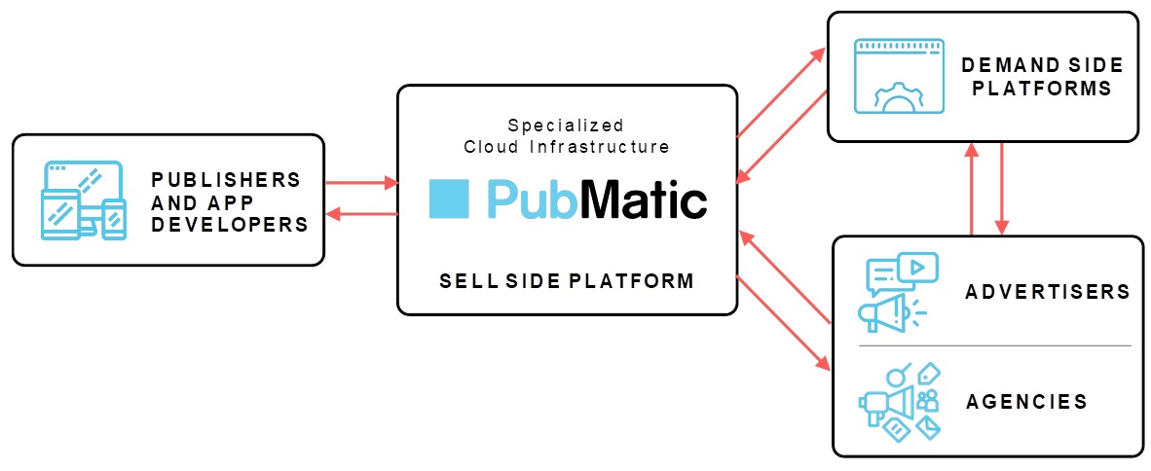
Publishers and App Developers. Publishers and app developers create websites and apps that contain content for consumers along with adjacent viewable space for advertisements. As consumers navigate through these websites and apps, individual ad impressions are shown to them. These impressions are typically sold to buyers programmatically in real-time via a third-party technology infrastructure platform or SSP. Publishers and app developers rely on advertising revenue as the key driver for their businesses and rely on the capabilities of these third parties in order to achieve optimal yield for their advertising inventory.
During the year ended December 31, 2020, we added approximately 360 new publishing partners. As of December 31, 2020, we served approximately 1,200 publishers and app developers worldwide on our platform, consisting of over 60,000 domains and 20,000 apps, including many of the leading digital companies such as Verizon Media Group and News Corp. We have also demonstrated that we can retain and grow revenues from our publisher customers, as evidenced by our net dollar-based retention rate of 122% for the year ended December 31, 2020, an increase from 109% for the year ended December 31, 2019.
Sell Side Platforms. Traditionally referred to as sell side platforms or SSPs, platforms such as ours are designed to monetize inventory for publishers and app developers. Buyers and sellers come together through our marketplace to present, target, and purchase available advertising inventory. Our platform rapidly and efficiently processes significant volumes of ad bid data, providing a seamless digital experience for consumers. Traditionally, SSPs have focused exclusively on the needs of sellers in this process, and have limited their interactions with buyers to the buyer’s agent, the demand side platform or DSP. As buyers have sought greater control of their advertising supply chains, we have extended the capabilities of our specialized cloud infrastructure platform over the last several years to serve the needs of advertisers and agencies as well.
Demand Side Platforms. Advertisers and agencies often engage demand side platforms, which act as advertising demand aggregators, to execute their digital marketing campaigns across various ad formats. We are integrated with the leading DSPs around the world, such as The Trade Desk and Google DV360, enabling them to execute real-time transactions with our publisher clients. We maintain active integrations with DSPs around the world, some of which are global and omnichannel in nature or more narrowly targeted on specific ad formats or geographic markets.
9
Advertisers and Agencies. Spending begins with advertisers, who often engage advertising agencies to help plan and execute their advertising campaigns. To better control and optimize their advertising operations, advertisers and agencies are consolidating their spend with fewer, larger technology platforms who can deliver transparency and ensure the highest levels of inventory quality and control. We have entered into agreements with all of the major agency holding companies and some of the largest advertisers in the world and believe this will continue to drive more ad spend to our platform. These advertisers and agencies access our platform through DSPs. We believe our purpose-built technology platform and direct relationships with advertisers and agencies will lead to significant consolidation of spend onto our platform.
Our Specialized Cloud Infrastructure Platform
We are a specialized cloud infrastructure provider that enables real-time programmatic advertising transactions in a market characterized by significant data and impression volumes, regulatory complexity, and increased focus on transparency and privacy. Over the past 14 years we have built, enhanced and deployed our technology infrastructure to address these market conditions and provide superior outcomes for both publishers and buyers.
We have deployed our purpose-built infrastructure globally in order to serve our customers with the high-speed transaction capabilities required to provide a seamless digital ad experience for consumers. Our offering is omnichannel and targets a diverse set of publishers touching many ad formats, and digital device types, including mobile app, mobile web, desktop, display, video, over-the-top and connected TV, and rich media.
Real-time Ad Transaction Processing
We have designed our specialized cloud infrastructure for the rapid and efficient processing of real-time, programmatic ad transactions and the aggregation and analysis of the significant data accompanying each transaction. We power our cloud platform by proprietary our software deployed on PubMatic-owned and operated hardware close to our customers around the world. Our technology platform processes each potential ad in a fraction of a second to optimize the consumer ad experience. For the fiscal year ended December 31, 2020, our platform efficiently processed approximately 46.9 trillion ad impressions, up 69% from approximately 27.8 trillion ad impressions in the fiscal year ended December 31, 2019.
Sophisticated, Purpose-built Technology that Delivers Superior Outcomes
Since our founding, we have believed that data-driven decisions would be the future of advertising and have accordingly invested in developing our machine learning capabilities. By harnessing our massive data assets and advanced machine learning capabilities, we are able to deliver superior outcomes by increasing advertiser ROI and publisher revenue, while increasing the cost efficiency of our platform and our customers’ and partners’ businesses. Some examples of the outcomes of our machine learning competencies include:
•Reducing buyers’ and our operational costs. Our algorithms determine the optimal traffic to send to each buyer, and then prioritize the DSPs most likely to bid on and win a particular ad impression, which in turn reduces the number of bid requests we send them, leading to reduced costs for buyers and for us.
•Increasing publisher revenue while maximizing the buyer’s probability of winning. Our system dynamically predicts the winning price of an auction and seeks to ensure that a buyer’s bid is high enough to clear this price.
We created our own internal machine learning program to train promising engineers to further our machine learning technology and over the last two years have developed over 60 machine learning based software projects through this program. Today, every engineering team at PubMatic has machine learning expertise embedded within it.
10
Independent and Customer Aligned
We are aligned with our customers, both publishers and buyers, by being an independent infrastructure platform. We do not own media and therefore do not have a vested interest in driving ad revenue to specific media properties. We do not take a position in media or arbitrage media. Our independence and alignment have resulted in a strong level of trust and confidence among publishers and buyers alike that our data-driven software decisions and our recommendations are in their best interests. As evidence of this, each of our top ten buyers by spend have been integrated and buying on our platform for over seven years.
Transparency and Quality for Agencies and Advertisers
We operate on a fundamental principle of transparency, being one of the first digital advertising infrastructure platforms to provide log-level data to buyers and provide transparency on every ad impression. In addition, advertisers utilizing our cloud infrastructure have full control over which publishers, ad formats, and specific ad impressions on which they would like to bid. We are among the first to offer a fraud-free program in 2017 where buyers are credited for any fraudulent inventory they may have purchased on our platform. Our buyers have experienced very low fraud levels with credits of 0.22% of overall ad spending on our platform in the fourth quarter of 2020. This compares very favorably to a recent Trustworthy Accountability Group industry average of fraud at 11% of advertising spending.
Enabling Identity on the Open Internet
As advertising in the Open Internet shifts from targeting by anonymized and invisible third-party cookies that consumers must opt out of, and instead towards known first-party identity based on consumer choice and opt-in or other privacy compliant solutions, publishers and advertisers must transition to a new identity paradigm. While there are various constituents across the digital advertising industry creating new identity solutions, we have built a comprehensive platform that greatly simplifies the implementation and ongoing management of identity solution providers. Our solution allows for the use of many of the leading identifiers in a scaled and privacy-compliant fashion resulting in increased publisher revenue and buyer ROI.
Scalable, Self-service Platform that Eases the Burden of a Complex Digital Advertising Landscape
Our cloud infrastructure solutions are available via self-serve, including an easy-to-use customer user interface and a set of application programming interfaces that allow our publisher customers to configure new inventory, extend into new geographies or ad formats, review reporting insights, and manage and track payments and billing cycles. Our platform also assists with managing the increasingly complex compliance burdens brought on by new industry guidelines and government regulations. We provide the tools and the mechanisms to help enable publisher inventory to be in compliance with these norms and requirements, maintaining strong data minimization practices, and allocating responsibility for data flows and legal compliance in agreements with vendors, publishers, and buyers.
Our Strengths
Publishers are actively seeking to maximize the value of their ad inventory, and buyers are seeking to increase advertising ROI. We believe that our efficient cloud infrastructure, rapid innovation, and transparent business model provide incentives to ad buyers to consolidate an increasing share of their total digital spend on our platform. At the same time, our direct publisher relationships, omnichannel header bidding capabilities, global scale, and access to incremental advertiser demand through direct relationships with buyers drive superior yield for publishers.
11
We believe the following strengths provide us with long-term competitive advantages:
Investment in Innovation Enabled by Profitable Business Model
Our business model driven by our technology platform, owned infrastructure, and offshore research and development has led to positive net income for five consecutive years and positive Adjusted EBITDA for eight consecutive years. We have generated positive net cash provided by operating activities for seven consecutive years and an average gross margin over 70% for the last nine years. We have consistently achieved among best-in-class margins compared to other similar publicly-traded technology companies. Our structural cost advantages enable us to continuously invest in driving innovation, while delivering both top line revenue growth and profitability.
Flexible Platform and Culture of Rapid Innovation
We built our company and our technology platform to be highly dynamic and to support rapid innovation. Our product and development teams are focused on continuous innovation and enhancement of our products and solutions. We believe that the flexibility of our platform and responsiveness to evolving customer needs and technical requirements enables us to achieve superior outcomes for our customers.
Since our founding, we have invested significantly in a software ideation, development, build, test, and deployment process that allows us to routinely convert a requirement into working software within two weeks or less. Our platform is highly modular, which allows us to innovate and improve individual software components without affecting the rest of the platform. We utilize a microservices architecture to interconnect each module via application programming interfaces with defined interfaces for internal and external consumption. We focus on reliability and scalability of each individual module and across our platform to maximize uptime and scale up based on customer demand. In 2020, we released new software across our global infrastructure approximately 326 times, more than once per business day. The result of our flexible platform and culture of rapid innovation is that we are highly responsive to evolving customer needs, which we believe is important in a rapidly evolving digital advertising industry.
Indicative of the flexibility and robustness of our platform, since header bidding’s rise in 2016, we have increased the efficiency of our platform dramatically, introduced solutions to make auctions more transparent for advertisers, and expanded our header bidding technology beyond desktop to mobile web, mobile app, digital video, and most recently OTT/CTV.
Highly Efficient Infrastructure
As a result of our long-term, internal development efforts on our technology stack and strategic approach of owning our own hardware, we believe that we have among the lowest cost infrastructures of any specialized cloud infrastructure platform in the advertising market. We own and operate our proprietary software and hardware infrastructure around the world. This approach saves significant costs compared to companies that rely on public cloud alternatives due to the data-intensive nature of digital advertising and the immense volume of ad impressions created by header bidding. Since our inception, we have built and constantly improved upon our infrastructure, and in turn we have developed a deep expertise in continuously optimizing and growing it. As a result, our cost of revenue per impression processed decreased by 32% in 2020 compared to 2019, and decreased by 18% in 2019 compared to 2018. We believe that the capital efficiency and operating expertise requirements that we possess present a significant barrier to entry. Even as we grow the applicability of our cloud infrastructure to include more ad formats and devices, such as mobile, video, and now OTT/CTV, we have maintained strong capital efficiency as measured by revenue per dollar of capital expenditures. The efficiency of our infrastructure has enabled us to grow our access to first-party data, which generally refers to customer owned audience data, ad impression and bid request data, and advertiser bid response data, further driving superior results across our platform for buyers and sellers.
12
Since our founding, the vast majority of our technology team, which represents 44% of our workforce, has been based in Pune, India, with an average tenure of 3.3 years as of December 31, 2020. Many of our senior engineers have worked together at PubMatic since the founding of our company. Our mindset and culture of driving efficiency across our business, whether in engineering, sales, marketing, or elsewhere, continuously pushes us to find ways to achieve greater results with less human and capital resources.
Machine Learning and Data Processing
We leverage our artificial intelligence and machine learning capabilities to record, aggregate, analyze, and act on vast amounts of data to help our customers optimize their digital advertising businesses in real-time. In December 2020, our technology platform processed approximately 187 billion ad impressions and 2 petabytes of data every day. This data includes first party customer owned audience data, ad impression and bid request data, and advertiser bid response data. We flow all of this data through our machine learning platform in order to run thousands of algorithmic iterations on trillions of data points per month. These capabilities improves long term marketplace liquidity resulting in increased publisher revenue and higher advertiser ROI.
Customer Trust and Alignment
We are aligned with both publishers and buyers, by being an independent and transparent infrastructure provider. We do not own media and therefore do not have a vested interest in driving ad revenue to specific media properties. We do not take a position in media or arbitrage media. We operate with a fundamental principle of transparency and provide detailed insights into fees to our customers. Our customers can therefore be confident that our algorithmic software decisions and our guidance are independent and in their best interests. Our trusted status has enabled us to build direct relationships with publishers, advertisers, agencies, and DSPs. Our ability to meet the demands of both buyers and inventory sellers enables us to produce superior outcomes for all industry participants.
Global, Omnichannel Reach
We are a global business with distributed critical infrastructure and a go-to-market presence in every major advertising market in the world outside of China. Many of our publisher customers have diversified businesses with media properties and audiences across the globe and with a wide variety of ad products including display and video ads across desktop, tablet, mobile, and connected TV devices. Similarly, many of our advertiser and agency customers have brand portfolios that span the globe with a variety of ad campaign requirements – from branding to performance, to combinations thereof. All of these parties actively seek global, omnichannel platform providers that can solve for their needs around the world and across ad formats and devices. By providing global, omnichannel reach of our infrastructure, we are well positioned to help publishers and ad buyers make their advertising businesses more efficient and effective.
Growth Strategy
We believe we are positioned to benefit from tailwinds in the advertising industry, including the rapid proliferation of digital media, the need for purpose-built infrastructure to address the increasing complexity in the digital advertising landscape, and increasing consumer time spent online, all of which have been accelerated by the COVID-19 pandemic. Our growth strategy includes:
Attract New Publishers and Expand our Relationship with Existing Publishers
We constantly seek to acquire new high-quality publishers around the world. New publisher clients may include major media companies, app developers, e-commerce providers, and OTT platforms– any company that monetizes its audience through digital advertising. Once acquired, we seek to expand our relationship with existing publishers by establishing multiple header bidding integrations, leveraging our omnichannel capabilities to maximize our access to publishers’ ad formats and devices, and expanding into the various properties that a publisher may own around the world. We may also up-sell additional products to publisher customers including our header bidding management as well as identity and audience solutions. To capitalize on new and existing publisher
13
opportunities, we continue to grow our specialized customer success teams, which are structured around specific ad formats, products and geographies. We have demonstrated that we can retain and grow revenues from our publisher customers, as evidenced by our net dollar-based retention rates of 122% for the fiscal year ended December 31, 2020 and 109% for 2019.
Attract New Buyers and Expand our Relationship with Existing Buyers
We strive to acquire new buyers (including advertisers, agencies and DSPs) through our strong value proposition that includes omnichannel real-time bidding, transparency, our fraud-free program and efficiency. We work with DSPs to help them reduce their costs and improve advertiser ROI, which in turn makes us the specialized cloud infrastructure platform of choice for many of our buying partners. As advertisers and agencies increasingly consolidate their spending with fewer larger technology platforms, we seek to increase the proportion of their digital ad spending on our platform through direct relationships. We have entered into Supply Path Optimization (“SPO”) agreements directly with both advertisers and agencies through various arrangements ranging from custom data and workflow integrations, product features, and volume-based business terms. The effect of these SPO agreements is to increase the volume of ad spend on our platform without corresponding increases in technology costs. We have expanded and realigned our sales team to focus on advertisers and agencies directly and will continue to hire additional sales headcount to support these efforts.
Efficiently Expand Our Infrastructure Platform to Process More Ad Impressions
The COVID-19 pandemic has further accelerated digital adoption, which should lead to further growth in the number of available ad impressions that can be monetized programmatically as well as increase in advertiser budgets seeking to reach various audiences digitally. We have a track record of cost-effectively expanding the capacity of our infrastructure platform as exemplified by average daily ad impressions having increased approximately 300% in the three months ended December 31, 2020 compared to three months ended March 31, 2018, while the corresponding costs related to processing these impressions have increased approximately 45%. We expect to continue to invest in both software and hardware infrastructure to continue growing the number of valuable ad impressions we process on our platform.
Improve Liquidity in Our Marketplace
We strive to continuously improve publisher revenue and advertiser ROI by investing in our technology and improving our machine learning capabilities. We leverage our artificial intelligence and machine learning capabilities, alongside our growing publisher and buyer relationships, to improve liquidity in our marketplace. Increasing numbers of ad impressions, increasing advertiser bids, and data proliferation provide us with many opportunities to better match sellers and buyers of ad inventory. We believe that improved matching will lead to growth of our platform and greater publisher and buyer retention.
Develop New Products
As we grow our customer base and process increasing volumes of ad impressions and data, we gain insights into new challenges we can solve on behalf of our customers. We have successfully introduced multiple new products into the market over the past 12 months, including our identity solution (Identity Hub), our header bidding management solution for OTT (OpenWrap OTT), and our audience data platform (Audience Encore). We are constantly focused on creating new products that we believe solve our customers’ needs.
14
Expand Into New Ad Formats
We have demonstrated an ability to extend header bidding into a variety of ad formats – initially desktop display, then mobile web, mobile app, digital video, and most recently with OTT/CTV. As technology and media evolve, additional ad formats may become attractive to us – whether existing in the ecosystem today or entirely new. These may include audio/podcast ads, native ads and digital out of home ads. Each ad format represents an opportunity to further extend our cloud infrastructure, increase our platform utilization, and acquire new customers or expand our relationship with existing customers.
Expand into New Geographies
We decide to enter new advertising markets around the world based on size, growth rate, and other characteristics. For example, in 2018, we entered Indonesia, in 2019 we entered South Korea. We are constantly evaluating new markets with a strategy to use our existing global infrastructure and adjacent sales office, or by expanding our infrastructure footprint and placing personnel directly in those markets.
Our Publishers and App Developers
We primarily work with publishers and app developers who allow us direct access to their ad inventory, as well as select channel partners that meet our quality and scale thresholds. We have direct relationships with publishers such as Verizon Media Group and News Corp and app developers such as Zynga and Electronic Arts. Our channel partners aggregate and provide further access to thousands of sites and apps from smaller publishers. We refer to our publishers, app developers, and channel partners collectively as our publishers.
We help monetize valuable impressions for our clients across a wide array of ad formats and digital device types, including mobile app, mobile web, desktop, display, video, OTT/CTV, and rich media. During the fiscal year ended December 31, 2020, we added approximately 360 new publishing partners. As of December 31, 2020, we served approximately 1,200 publishers and app developers, representing over 80,000 individual domains and apps worldwide on our platform across a diverse group of content verticals including news, eCommerce, gaming, media, weather, fashion, technology, and more.
We believe our specialized cloud infrastructure platform provides the following benefits:
•Customer alignment. We are aligned with our publishers by being an independent infrastructure provider. We do not own media and therefore do not have a vested interest in driving ad revenue to specific media properties.
•Monetization. Through our infrastructure-based approach, we provide superior monetization for publishers. We achieve this by increasing the value of each impression by enhancing available data and providing incremental demand via our deep relationships with buyers.
•Innovation. Since our inception, we have consistently delivered new capabilities to our publishers, including Identity Hub, OpenWrap OTT, and Audience Encore.
•Global, Omni-channel. Our offering is global, omni-channel and efficient for our publishers to work with, targeting a wide array of ad formats and digital device types, including mobile app, mobile web, desktop, display, video, connected TV, and rich media.
•Compliance. We assist publishers with their regulatory compliance by managing advertising transactions in a transparent manner with our buyers, adopting industry wide technical specifications and business processes that respect consumer choices, and providing guidance on best practices regarding user consents and opt-outs.
15
We are party to an agreement with Yahoo! Inc., which was assumed by Verizon Media Group upon its acquisition of Yahoo in 2017, pursuant to which Verizon Media Group is a publisher customer of ours. The initial term of this agreement ended in December 2016, and it automatically renews for successive one-year terms unless either party provides at least 30 days’ prior written notice. Either party may terminate for convenience immediately upon prior written notice. For the years ended December 31, 2020 and 2019, Verizon Media Group accounted for 20% and 28%, of our revenue, respectively.
Our Buyers
Buyers on our platform include DSPs, agencies and individual advertisers. We have broad exposure to the ecosystem of buyers, reaching on average approximately 73,000 advertisers per month in 2020. As spending on programmatic advertising increasingly becomes a larger share of overall ad spending, advertisers and agencies are seeking greater control of their digital advertising supply chains. To take advantage of this industry shift, we have entered into SPO agreements directly with buyers. As part of these agreements, we are providing advertisers and agencies with benefits ranging from custom data and workflow integrations, product features, and volume-based business terms. As a result of these direct relationships, our existing advertisers and agencies are incentivized to allocate an increasing percentage of their advertising budgets to our platform. We are increasing buyer spend on our platform for the following reasons:
•Buyer Alignment. We do not own media and therefore do not have a vested interest in driving ad revenue to specific media properties. We do not take a position in media or arbitrage media.
•Omnichannel Real Time Bidding. Advertisers and agencies often have a large portfolio of brands requiring a variety of campaign types and support for a wide array of inventory formats and devices. Our omnichannel platform meets these requirements, which is a further driver of efficiency for our buyers.
•Transparent business model. We were one of the first Sell Side Platforms to provide log-level data to buyers and provide fee transparency on every ad impression.
•Inventory quality. We operate one of the most comprehensive processes in the digital advertising ecosystem to enhance inventory quality. We were among the first to offer a fraud-free program in 2017 where our buyers are credited for any fraudulent inventory they may have purchased on our platform.
•Efficiency. We work closely with DSPs to make them more efficient which has led to certain DSPs consolidating their spend on our platform. Our algorithms determine the optimal traffic to send to each buyer, and then prioritize the DSPs most likely to bid on and win a particular ad impression, which reduces the number of bid requests we send them, leading to reduced costs for buyers and for us.
Two of our largest DSP relationships are with Google and The Trade Desk. We are party to an agreement with Google LLC, under which Google is a buyer on our platform. The initial one-year term of the current agreement ended in May 2019, and it automatically renews for successive one-year terms unless either party provides written notice at least 60 days’ prior to the end of the initial term or such successive terms. Either party may terminate for convenience upon providing at least 30 days’ prior written notice. We signed a prior similar agreement with a Google subsidiary in 2012. We are also party to an agreement with The Trade Desk, Inc., under which The Trade Desk is a buyer on our platform. The initial term of the agreement ended in November 2013, and it automatically renews for successive one-year terms. Either party may terminate for convenience upon providing at least 30 days’ prior written notice.
16
Our Technology
Overview
We have designed our technology to efficiently process real-time advertising transactions while leveraging data to optimize outcomes for publishers and buyers. We own and operate our software and hardware infrastructure globally, which saves significant infrastructure expenditures as compared to public cloud alternatives. We designed our platform using a flexible, service-oriented architecture in order to facilitate rapid development of new solutions, to meet evolving industry demands, and to support new use cases and new ad formats. Our omni-channel platform supports a wide array of publishers, ad formats and devices, including mobile app, mobile web, desktop, display, video, OTT/CTV, and rich media.
Rapid innovation is a core driver of our business success and our corporate culture. Our technical personnel are located across our global offices in Pune, India, Redwood City, California, and New York, New York. Our agile development process and flexible, service-oriented architecture empower our development teams to routinely convert a requirement into working software within a typical time frame of two weeks or less. In 2020, we released new software across our global infrastructure approximately 326 times, more than once per business day.
We offer our solution as a complete, unified offering for publishers who want a simple, efficient and comprehensive solution. We also offer modular access to our platform via rich application programming interfaces and a mobile SDK, for publishers who wish to integrate with or extend the platform, or develop new business models and custom advertising solutions.
Data
Among the central benefits of our software platform is the processing, management and analysis of valuable data assets. The tens of billions of ad impressions and nearly trillion advertiser bids that we process every day generate enormous volumes of data that we harness to drive higher revenue for our publishers and increased ROI for our buyers. This data includes:
•Ad impression and bid request data, which contain parameters such as page URL or app bundle ID, location of the user, operating system of the user’s device, device type, ad size and ad location on the page;
•First party customer owned audience data, such as segment data that specifies whether a consumer is a recent shopper for electronics or automobiles; and
•Advertiser bid response data, which is bidding data received from DSPs, agencies, and advertisers.
We have developed proprietary data and analytics offerings that allow publishers to monitor their ad business in near real-time, as well as advanced tools publishers can use to find new business opportunities, optimize their monetization strategy, and help maximize the value of their digital ad business. This data is also used by our machine learning algorithms to enhance our bidding and auctioning process by analyzing large datasets and applying algorithms to drive optimal results.
17
Artificial Intelligence and Machine Learning
We analyze the data on our platform through extensive application of artificial intelligence technologies, including machine learning and natural language processing. Examples of how we leverage our artificial intelligence and machine learning capabilities to improve outcomes for our customers are:
•Identify valuable ad impressions and predict auction behavior: When our machine learning models predict that an impression will attract high bids, our algorithms adjust pricing guidance to bidders in real time, which can lead to significant inventory yield improvements for publishers and higher win rates for ad buyers.
•Optimize impression selection: Our ability to accurately predict and monetize high value impressions allows us to operate more efficiently, due to the fact that the cost of processing low-value impressions and high-value impressions are approximately the same. Our algorithms, such as impression throttling, deploy a variety of levers to optimize traffic sent to DSPs, agencies, and advertisers.
•Improve our self-service capabilities: Publishers can enter natural language queries, such as “Show me average CPM for yesterday” and the analytics system will generate charts and tables with relevant data for rapid and informative analysis.
We have developed a proprietary machine learning training curriculum called the ML2 Program in order to significantly expand our use of machine learning throughout our technical organization. In the past two years, 219 machine learning training courses have been completed by 99 of our engineers who have then leveraged that learning to solve PubMatic specific problems. In total, we have completed over 60 machine learning projects over the last two years.
Programmatic Header Bidding
We are a leading provider of technology solutions that enable and improve header bidding for our customers. We developed an enterprise wrapper, OpenWrap, that was among the first header bidding solutions launched for general availability. OpenWrap was released in April 2016 and enables publishers to holistically manage and configure all header bidding partners through a powerful, synchronized and intuitive user interface. OpenWrap provides a transparent, real-time view into bid activity and volume, monetization and latency metrics which allow publishers to make smarter decisions and drive sustainable monetization. Our cloud infrastructure is interoperable with the other major header bidding software frameworks including open source Prebid, Google’s Open Bidding, Amazon’s Transparent Ad Marketplace, and others. We believe we are thought leaders in the header bidding space and are represented on the boards of Prebid and the IAB Tech Lab.
We have continuously enhanced the capabilities of our OpenWrap solution and our header bidding technology. For example, in 2017, we expanded OpenWrap’s header bidding technology to mobile app developers and introduced the industry’s first hybrid client and server side wrapper. In 2019, we launched the OpenWrap SDK for in-app developers. In 2020, we launched header bidding support for OTT and CTV inventory and announced that our Identity Hub product would support server-to-server integration with OpenWrap.
Regulatory Compliance
A growing set of privacy regulations have introduced complexity regarding the collection, use, and transmission of consumer data to the digital advertising ecosystem. Most notably, the GDPR that took effect in May 2018 and the CCPA that took effect in January 2020, among other global privacy laws and regulations, have created a compliance burden for advertisers, publishers, and their partners to navigate. The advertising industry has developed a number of the technical and policy solutions to create standards for compliance, such as IAB TCF.
18
We have implemented a number of technology innovations, process enhancements, and industry solutions in response to our publishers’ increased obligations. Through the TCF and other frameworks, we can identify and pass user consent parameters, and opt-in or opt-out as applicable, in a bid request. We are also able to evaluate whether such consents apply to our various demand partners, such as DSPs and agencies. Some of the specific measures we have taken include:
•User Consent. Working with publishers and channel partners to ensure appropriate consent is being obtained, recorded, and transmitted as applicable.
•Data Mapping. Undertaking data mapping exercises for the purpose of understanding data flows in how we collect, use, and transmit personal information from our publishers, buyers, and data providers.
•Data Minimization. Establishing mechanisms to collect only the data that is needed and pseudonymizing data wherever possible (including masking IP address or geolocation data as applicable).
•Data Retention. Implementing a short data retention period across our technology platform so that we promptly delete, aggregate, or anonymize consumer data.
•Publisher and Demand Side Agreements. Monitoring and updating our agreements with publishers, DSPs, agencies, and advertisers, as applicable, to address privacy and regulatory compliance.
Inventory Quality
The quality of the inventory made available to advertisers has a significant impact on their ROI. Bad actors promoting botnets, fake ads, ad stuffing and other malignant methodologies reduce the ROI for advertisers and siphon dollars away from quality publishers. We have developed a multi-pronged strategy to create a high-quality marketplace beginning with high quality publisher selection, supported by proprietary and third-party fraud detection software, manual review, timely fraud investigations, and a fraud-free program in which buyers are credited for any fraudulent inventory they may have purchased on our platform. Our buyers have experienced very low fraud levels with credits of 0.22% of overall ad spending on our platform in the fourth quarter of 2020. This compares very favorably to a recent Trustworthy Accountability Group industry average of fraud at 10.83% of advertising spending.
Ad Quality
Ad quality refers to the quality of the advertisements that run on publishers’ sites. We have developed proprietary solutions targeting the reduction of security issues, including malware, redirects, unsafe code, and other similar practices; quality issues, including unsafe creative categories (such as alcohol or drugs) and creative attributes (Inbanner video, Expandables, Text Ads); and performance issues, including network load, number of trackers and memory size.
On an average day, we scan nearly one million new advertisement creatives in near real-time using our Real-Time Ad Scanning (“RTAS”) system. RTAS connects to proprietary technology and partners’ services to extract the nature of creatives. Publishers can configure their preferences for quality attributes using our blocklist manager, creative attribute selection, and keyword blocking. A comprehensive reporting suite is available for publishers to monitor the top performing creatives and review the lost opportunity due to excessive blocking.
19
Log-level Transparency and Insights
We enable buyers to gain additional transparency and insights to help them inform future ad buying and optimize their supply paths by providing them access to log-level data, which is comprised of various attributes that are relevant to a single ad impression within an auction. Log-level data provides buyers transaction verification data, or how the auction operates and what fees are being charged.
Reporting
Our technology platform provides extensive reporting capabilities to both buyers and publishers via application programming interfaces for direct integration into a customer’s reporting systems. Publishers are able to review performance, monitor key performance indicators (“KPIs”), and make adjustments to their set up and optimization. Buyers have access to campaign insight data to facilitate testing and adaptation toward maximizing ROI. Detailed performance by ad format, channels, and ad sizes allows for optimization to achieve maximum performance.
Self-Service
We design and implement self-service workflow solutions to allow publishers to efficiently manage their ad inventory. For example, publishers can update their own price floors, add or remove advertisers from blocklists, add new web sites and mobile apps, manage optimize their header bidding set ups, and leverage identity graphs from multiple ID providers. Ad buyers can configure the attributes for the inventory they desire, setup new or adjust existing Private Marketplace deals, and access extensive reporting on their media buying activities with us.
Our Team and Culture
Our culture and our team are our most important asset in building and expanding our business. Our team identifies new problems to solve, builds solutions, optimizes and extends our infrastructure, and acquires and serves customers. We believe that strong and diverse customer teams deepen customer relationships, promote innovation, and increase productivity.
Our people strategy revolves around creating employee experiences that foster deep employee engagement built upon personal development and achievement that is supported by continuous feedback, learning, and team building. Our steadfast focus on driving employee engagement has resulted in increasing employee retention rates (90% annualized employee retention through the twelve months of 2020) and average global tenure (3.3 years as of December 31, 2020). Our workplaces in the United States have been certified by Great Place To Work (2017-2021) and recognized on Fortune’s list of Best Workplaces in the Bay Area 2020. Our India subsidiary has also been certified by Great Place To Work (2018-2021) as well as named to the list of Great Mid-size Workplaces and Best Workplaces in IT & IT-BPM in 2019 and 2020.
We have achieved these results by delivering custom learning programs and creating opportunities for advancement that align with the dynamic needs of our business. Our practice of open and transparent communication coupled with a performance-based approach to compensation has created a culture in which employees feel empowered in their ability to influence and impact our business and be rewarded for their efforts. The value proposition we offer to our employees is rounded out with strong benefits programs that include paid family leave, health and wellness benefits and company sponsored opportunities to give back to the communities in which they work and live.
20
We are also committed to being inclusive in our hiring practices, promotion practices, and management practices as a means of ensuring equal opportunity for all employees as we continue to diversify our workforce. The diversity of our workforce has been publicly documented since 2017 with our annual Diversity & Inclusion Report. Our Inclusion Action Plan for 2020-2021 consists of five areas that focus on listening, learning, hiring, socio-economic support, and activism. This plan will be executed in part by our newly established Diversity & Inclusion Committee. The plan has a global focus that takes into consideration regional cultural differences to provide interactive employee experiences that drive continuous support for inclusion throughout our organization.
It has always been our goal to attract and retain the best talent in the industry and our inclusive interview process includes finding those candidates that best add to our company mission, values, and cultural principles. These three guiding elements form a social contract between employees as well as set expectations for the common behaviors we can expect from each other and inform how we treat our customers. They are infused in every aspect of our business, from employee experience and workplace culture to marketing strategies and customers success.
Our mission: fuel the endless potential of Internet content creators.
Values:
•We put the customer first.
•We are biased towards action.
•We are leaders and innovators.
•We are committed to integrity.
•We celebrate teamwork.
Cultural Principles:
•We will empower every individual team member and treat each other as partners.
•We will make having fun a priority.
•We will hire and retain the best talent.
•We will communicate internally with honesty, transparency, and authenticity, including positive and negative information.
As of December 31, 2020, we had 548 employees, of whom 198 were located in the United States, 260 in India, and 90 in our other offices around the world.
Technology and Development
We expect to continue investing in our technology in order to support efficient and effective ad monetization, which includes maximizing the yield from existing ad impressions and productively adding new ad impressions processed on our platform. We also intend to continue developing innovative capabilities for our customers.
As of December 31, 2020, we had 204 employees engaged in technology and development.
Our technology and development personnel, based in Pune, India, Redwood City, California, and New York, New York, are highly credentialed—33% of the 204 personnel have advanced degrees.
21
Our Competition
The digital advertising ecosystem is competitive and complex due to a variety of factors. While programmatic header bidding has enabled the purchasing and selling of vast amounts of digital advertising inventory, there now exist significant challenges related to the proliferation of media across platforms, transaction speed, increased costs, transparency, and regulatory requirements. To address these issues at scale for both publishers and buyers, we provide specialized software and hardware infrastructure to optimally power technology-driven transactions. We compete with SSPs like Magnite, smaller private SSPs in markets around the world, as well as divisions of larger companies like Google.
Factors that enable us to effectively compete for ad impressions from publishers include:
•Publisher Trust and Alignment.
•Monetization.
•Innovation.
•Global, Omnichannel Scale.
•Regulatory Compliance.
Factors that enable us to effectively compete for ad spending from buyers include:
•Buyer Alignment.
•Omnichannel Real Time Bidding.
•Transparent business model.
•Inventory quality.
•Efficiency.
While there is direct competition as noted above, our cloud infrastructure is interoperable with the major header bidding software frameworks including open source Prebid, Google’s Open Bidding, Amazon’s Transparent Ad Marketplace, and others. As a result, we are able to gain access to competitors’ ad impressions.
We have also demonstrated an ability to extend our header bidding infrastructure into a variety of higher-growth ad formats such as mobile web, mobile app, digital video, and most recently OTT/CTV.
We believe that our specialized cloud infrastructure enables us to compete favorably on the factors described above. In addition, we believe that new market entrants would find it difficult to gain direct access to publishers and ad buyers given their limited scale and would face significant costs to integrate with publishers and ad buyers and comply with growing regulatory requirements around the world.
Sales and Marketing
We primarily deploy a self-service model and focus our sales and marketing efforts on supporting, advising, and training our publishers to optimize their usage of our platform. We employ a nimble in-market sales team with expertise in programmatic advertising to attract premium publishers to our platform. New publishers on our platform work closely with our Customer Success team, which handles on-boarding and providing support throughout the publisher relationship life cycle. We have streamlined the on-boarding process through automation and self-service tools.
22
We have dedicated teams focused on new publisher acquisition and existing publisher relationship management. Our Customer Success team, which focuses on existing publishers, is organized and specialized by type of ad format and device and is trained to both maximize the number of integrations with each publisher, and deploy our value added solutions that we provide. Similarly, we have teams focused on new business acquisition and existing partner retention and expansion for advertisers, agencies, and DSPs. These teams focus on onboarding new partners and increasing spend across a variety of ad formats, devices, and geographies.
Our marketing team is focused on achieving thought leadership, educating customers on how to harness programmatic advertising to improve their business, guiding buyers on how to maximize ROI via the PubMatic cloud infrastructure, supporting our sales team, generating new leads and increasing awareness for our brand.
Intellectual Property
The protection of our technology and intellectual property is an important component of our success. We protect our intellectual property rights by relying on federal and state statutory and common law rights, foreign laws where applicable, and contractual restrictions. We seek to control access to our proprietary technology by entering into non-disclosure agreements with third parties and disclosure and invention assignment agreements with our employees and contractors.
We consider our trademarks, patents, copyrights, trade secrets, and other intellectual property rights to be, in the aggregate, material to our business. We currently own two issued U.S. patents, expiring in 2034, relating to online advertising and auction techniques. We also own one issued Japanese patent. We also own trademark registrations and applications for the “PubMatic” name and variants thereof and other product-related marks in the United States and certain foreign countries. We have also registered numerous Internet domain names related to our business. In addition to our intellectual property rights, we also consider the skills and ingenuity of our employees and the functionality and frequent enhancements to our solutions to be contributors to our success in the marketplace. We believe our platform would be difficult, time consuming, and costly to replicate. We protect our competitive technology position through our ability to execute and deliver new functionality quickly, as well as our continuous development of new intellectual property as we innovate.
We intend to pursue additional intellectual property protection to the extent we believe it would be beneficial and cost effective. Despite our efforts to protect our intellectual property rights, they may not be respected in the future or may be invalidated, circumvented, or challenged. In addition, the laws of various foreign countries where our products are distributed may not protect our intellectual property rights to the same extent as laws in the United States.
Privacy and Data
We are subject to laws and regulations governing privacy and the transmission, collection, and use of consumer data. Interest-based advertising, or the use of data to draw inferences about a consumer’s interests and deliver relevant advertising to that consumer, has come under increasing scrutiny by legislative, regulatory, and self-regulatory bodies, privacy advocates, academics, and commercial interests in the United States and abroad that focus on data protection and consumer privacy. In particular, much of this scrutiny has focused on the use of cookies and other tracking technologies that collect or aggregate information about consumers’ online browsing and mobile app usage activity. Because both our company and our publishers rely upon large volumes of such data collected primarily through cookies and other tracking technologies, it is essential that we monitor legal requirements and other developments in this area, domestically and globally, maintain a robust privacy and security compliance program, and engage in responsible privacy practices, including providing consumers with notice of the types of data we collect, how we collect it, with whom we share it, how we use that data to provide our solutions, and the applicable choices we offer consumers.
23
We provide notice through our privacy policies and notices, which can be found on our website at www.pubmatic.com. As stated in our privacy policy, we do not collect information, such as names, addresses or telephone phone numbers, for providing our advertising services that can be used directly to reveal the identity of the underlying individual. We take steps not to collect and store such information (although on occasion, our publishers voluntarily share information of their consumers with us and in such circumstances we require the publishers to have obtained all necessary consents for such sharing). Our advertising and reporting rely on information that does not, on its own, directly reveal the identity of the underlying individuals (and we do not attempt to associate this information with other information that can identify such individuals). We typically do collect and store IP addresses, geo-location information, and device identifiers that are considered personal data or personal information under the privacy laws of some jurisdictions or otherwise may be the subject of current or future data privacy legislation or regulation. The definition of personally identifiable information, personal information, or personal data, varies by jurisdiction and continues to evolve in ways that may require us to adapt our practices to avoid violating laws or regulations related to the collection, storage, and use of consumer data. As a result, our technology platform and business practices must be assessed regularly against a continuously evolving legal and regulatory landscape, and we have adopted strong data minimization practices that mitigate our compliance risks.
There are also a number of specific laws and regulations governing the collection and use of certain types of consumer data relevant to our business. For example, the Children’s Online Privacy Protection Act (“COPPA”) imposes restrictions on the collection and use of data provided by children under the age of 13 by child-directed websites or online services, such as apps, directed to children or any website if the collection of such data is known to the website or app operator. We have taken various steps to implement a system in which our publishers are contractually obligated to either flag or notify us in writing of child-directed websites. When websites are flagged, or we receive notice of such websites, we do not collect personal information, as defined by COPPA, including cookie identifiers that can recognize the same consumer across multiple sites over time, or location information more specific than street and city, on such websites or online services.
Additionally, our compliance with our privacy policy and our general consumer data privacy and security practices are subject to review by the Federal Trade Commission, which may bring enforcement actions to challenge allegedly unfair and deceptive trade practices, including the violation of privacy policies and representations or material omissions therein.
Certain State Attorneys General in the United States may also bring enforcement actions based on comparable state laws or federal laws that permit state-level enforcement. In California, for example, the Attorney General may bring enforcement actions for violations of the CCPA, as modified by the Attorney General’s recently approved enforcement guidelines. We have registered as a data broker in California with the California Attorney General. When we receive bid requests that include an opt-out signal, we do not sell personal information, as defined by the CCPA. We have also adopted the IAB CCPA Compliance Framework, which includes a technical specification to identify consumer signals to opt-out of sale of their data, and have signed the IAB Limited Service Provider Agreement that imposes service provider obligations for certain opted-out bid requests. These IAB frameworks are designed to facilitate compliance with the CCPA although the California Attorney General’s office has not yet approved such frameworks. The CCPA sets forth high potential liabilities for data privacy violations on a per-record basis, and the industry faces an uncertain compliance burden as our partners and publishers work to become compliant with the law. Adding further complexity in California, voters approved a California ballot initiative, the California Privacy Rights Act (“CPRA”), which will take effect in January 2023. The CPRA will impose additional data protection obligations on companies doing business in California, including additional consumer rights processes and opt-outs for certain uses of sensitive data and sharing of personal data. Likewise, Virginia enacted the Consumer Data Protection Act (“CDPA”), which imposes consumer rights processes and requires user consent for certain types of sensitive data, which also takes effect in January 2023. The CDPA also sets forth high potential liabilities for data privacy violations on a per-record basis, and the industry faces an uncertain compliance burden as our partners and publishers work to become compliant with the law in the future.
24
Outside of the United States, our privacy and data practices are subject to regulation by data protection authorities and other regulators in the countries in which we do business. The use and transfer of personal data in member states of the European Union is currently governed under the GDPR, which grants additional rights to consumers about their data, such as deletion and portability, and generally prohibits the transfer of personal data of EU subjects outside of the EU, unless the party exporting the data from the EU implements a compliance mechanism designed to ensure that the receiving party will adequately protect such data. We had relied on the EU-U.S. Privacy Shield framework (Privacy Shield framework), to transfer personal data of EU subjects to the United States, but the Privacy Shield framework was recently declared invalid by Court of Justice of the European Union. (“CJEU”) on July 16, 2020. In the same judgement, while the CJEU upheld the adequacy of the standard contractual clauses (a standard form of contract approved by the European Commission as an adequate personal data transfer mechanism, and potential alternative to the Privacy Shield framework), it made clear that reliance on them alone may not necessarily be sufficient in all circumstances and cast doubt on their future use. Use of the standard contractual clauses must now be assessed on a case-by-case basis taking into account the legal regime applicable in the destination country, in particular applicable surveillance laws and rights of individuals. The use of standard contractual clauses for the transfer of personal data specifically to the United States remains under review by a number of European data protection supervisory authorities.
The GDPR sets out higher potential liabilities for certain data protection violations, which may result in fines up to the greater of €20 million or 4% of an enterprise’s global annual revenue. Additionally, when the transition period following Brexit expires at the beginning of 2021, we will also have to comply with the UK GDPR, which will also have the ability to fine up to the greater of €20 million (£17 million) or 4% of global turnover.
Further, the EU is currently in discussions to replace the ePrivacy Directive (commonly called the “Cookie Directive”) with the ePrivacy Regulation that governs the use of technologies that collect, access, and store consumer information and may create additional compliance burdens for us in Europe.
Other jurisdictions have enacted legislation that closely tracks the concepts, obligations, and consumer rights described in the GDPR, including Brazil’s General Data Protection law and Thailand’s Personal Data Protection Act. Some jurisdictions, including Russia and China, have in recent years enacted data localization laws, which require any personal information of citizens of those jurisdictions to be stored and processed on servers located in those jurisdictions. Such laws are gaining momentum and are being enforced by local authorities.
Beyond laws and regulations, we are also members of self-regulatory bodies that impose additional requirements related to the collection, use, and disclosure of consumer data, including the IAB, the Digital Advertising Alliance, and the NAI. Under the requirements of these self-regulatory bodies, in addition to other compliance obligations, we provide consumers with notice via our privacy policies about our use of cookies and other technologies to collect consumer data, our collection and use of consumer data to deliver interest-based advertisements, and consumers’ opt-out choices. We also allow consumers to opt-out from the use of data we collect for purposes of interest-based advertising through mechanisms described in our privacy policies available on our website. Some of these self-regulatory bodies have the ability to discipline members or participants, which could result in penalties and cause reputational harm. Additionally, some of these bodies might refer violations of their requirements to the Federal Trade Commission or other regulators.

25
Available Information
We were founded in 2006 and incorporated as Komli, Inc., a Delaware corporation, in November 2006. In November 2008, we changed our name to PubMatic, Inc. Our principal executive offices are located at 3 Lagoon Drive, Suite 180, Redwood City, California, 94065, and our telephone number is (650) 331-3485. Our website address is www.pubmatic.com.
We file Annual Reports on Form 10-K, Quarterly Reports on Form 10-Q, Current Reports on Form 8-K, proxy statements, and related amendments, exhibits and other information with the SEC. The SEC maintains an Internet site that contains reports, proxy and information statements, and other information regarding issuers that file electronically with the SEC at www.sec.gov. You may access and read our filings without charge through the SEC’s website or through our investor relations website at https://investors.pubmatic.com/financial-information/sec-filings, as soon as reasonably practicable after such materials are electronically filed with or furnished to the SEC pursuant to Section 13(a) or 15(d) of the Securities Exchange Act of 1934, as amended (the “Exchange Act”).
We webcast via our investor relations website our earnings calls and certain events we participate in or host with members of the investment community. Our investor relations website also provides notifications of news or announcements regarding our financial performance and other items that may be material or of interest to our investors, including SEC filings, investor events, press and earnings releases. Further, corporate governance information, including our corporate governance guidelines, board committee charters, and code of conduct, is also available on our investor relations website at https://investors.pubmatic.com/corporate-governance/governance-highlights.
Website addresses referred to in this Annual Report on Form 10-K are not intended to function as hyperlinks, and the information contained on or available through our website is not incorporated into, and does not form a part of this Annual Report on Form 10-K or any other report or documents we file with or furnish to the SEC.

26
ITEM 1A. RISK FACTORS
Investing in our common stock involves a high degree of risk. You should carefully consider the risks and uncertainties described below, together with all of the other information in this Annual Report on Form 10-K, including our consolidated financial statements and related notes, before making an investment decision. The risks and uncertainties described below are not the only ones we face. Additional risks and uncertainties that we are unaware of, or that we currently believe are not material, may also become important factors that affect us. If any of the following risks materializes, our business, financial condition, results of operations, and prospects could be materially harmed, which could cause the price of our Class A common stock to decline, and cause any investment in our Class A common stock to lose some or all of its value.
Risks Related to Our Business and Our Industry
Our revenue and results of operations are highly dependent on the overall demand for advertising. Factors that affect the amount of advertising spending, such as economic downturns and the COVID-19 pandemic, can make it difficult to predict our revenue and could adversely affect our business, results of operations, and financial condition.
Our business depends on the overall demand for advertising and on the economic health of our current and prospective publishers and buyers. For example, due to the COVID-19 pandemic and the recession in the United States and global economy in the second quarter of 2020, advertising demand on our platform decreased and did not recover to pre-COVID-19 levels for two months. Various macroeconomic factors could cause advertisers to reduce their advertising budgets, including adverse economic conditions and general uncertainty about economic recovery or growth, particularly in North America, Europe, and Asia, where we do most of our business; instability in political or market conditions generally; and any changes in tax treatment of advertising expenses and the deductibility thereof. Reductions in overall advertising spending as a result of these factors could make it difficult to predict our revenue and could adversely affect our business, results of operations, and financial condition.
If our existing customers do not expand their usage of our platform, or if we fail to attract new publishers and buyers, our growth will suffer. Moreover, any decrease in the use of the advertising channels that we primarily depend on, or failure to expand into emerging channels, could adversely affect our business, results of operations, and financial condition.
We depend upon our buyer and publisher relationships to continue to grow the usage of our platform. In doing so, we compete for both supply and demand with larger, well-established companies that may have technological advantages stemming from their experience in the market. We must continue to adapt and improve our technology to compete effectively, and customers have not always embraced our offering due to various factors, including switching costs from moving away pre-existing technology integrations, such as already implemented header bidding wrappers, and lack of awareness of our omni-channel offerings. Although we believe we provide superior transparency and accountability to such competitors, certain customers may place technological or financial demands that we are unable to meet. These and other factors may make it difficult for us to increase our business with our publishers and buyers, cause some buyers to reduce their spending with us, or increase our costs of doing business, adversely affecting our business, results of operations, and financial condition.
27
Historically, our buyers have predominantly used our platform to purchase mobile, display, and video advertising inventory from our publishers. We expect that these will continue to be significant channels used by our customers for digital advertising in the future. We also believe that our revenue growth may depend on our ability to expand within mobile, video, and in particular, CTV, and we have been, and are continuing to, enhance such channels. We may not be able to accurately predict changes in overall advertiser demand for the channels in which we operate and cannot assure you that our investment in formats will correspond to any such changes. Any decrease in the use of mobile, display, and video advertising, whether due to customers losing confidence in the value or effectiveness of such channels, regulatory restrictions or other causes, or any inability to further penetrate CTV or enter new and emerging advertising channels, could adversely affect our business, results of operations, and financial condition.
Our business depends on our ability to maintain and expand access to valuable ad impressions from publishers, including our largest publishers.
Our business depends on our access to valuable ad impressions. We depend upon publishers, including channel partners, which aggregate large numbers of smaller publishers, to provide advertising space which we can offer to prospective buyers. A relatively small number of premium publishers have historically accounted for a significant portion of the ad impressions sold on our platform, as well as a significant portion of our revenue from publishers, including a relatively small number of channel partners. In particular, for the years ended December 31, 2020 and 2019, 20% and 28%, respectively, of our revenue was derived from ad impressions sold on our platform from our largest publisher, Verizon Media Group. Our agreement with Verizon Media Group, signed in 2015, automatically renews each year for successive one-year terms unless either party provides 30 days’ prior written notice. Either party may also terminate for convenience immediately upon written notice. We expect to depend upon a relatively small number of premium publishers and channel partners for the foreseeable future. To support our continued growth, we will seek to add additional publishers to our platform, and to expand current utilization with our existing publishers.
We have no minimum commitments from publishers, so the amount, quality, and cost of ad impressions available to us can change at any time, and we cannot assure you that we will have access to a consistent volume or quality of ad impressions at a reasonable cost, or at all. For example, in January 2020, MoPub disabled all access to traffic from Grindr due to a European consumer advocacy group filing a complaints against it for alleged violations of the GDPR, which resulted in a pause of all monetization on Grindr for nearly two months and reduced the number of ad impressions available on our platform. Any disruptions in our relationships with premium publishers or largest channel partners could adversely affect our business, results of operations, and financial condition. If we cannot retain or add individual publishers with valuable ad impressions, or if such publishers decide not to make their valuable ad impressions available to us, then our buyers may be less inclined to use our platform, which could adversely affect our business, results of operations, and financial condition.
Our business depends on our ability to maintain and expand access to spend from buyers, including a limited number of DSPs, agencies, and advertisers.
Our business depends on our ability to maintain and expand our access to ad campaigns and spending from buyers such as DSPs, as well as agencies and advertisers (which execute their purchases through DSPs), to purchase advertising impressions from our publishers. A limited number of large DSPs – The Trade Desk and Google DV360 in particular – account for a significant portion of the ad impressions purchased on our platform. Our agreements with each of The Trade Desk and Google LLC, originally signed in 2011 and 2012, respectively, automatically renew each year for successive one-year terms unless, in the case of our agreement with Google LLC, either party provides at least 60 days’ prior written notice. In addition, either party may terminate for convenience upon providing at least 30 days’ prior written notice. We expect to depend upon these DSPs for a large percentage of impressions purchased for the foreseeable future. Any disruptions in our relationships with DSPs, agencies or advertisers could harm our business, results of operations, and financial condition. To support our continued growth, we will seek to expand upon current levels of utilization with these DSPs, agencies, and advertisers.
28
We have no minimum commitments from buyers to spend on our platform, so the amount of demand available to us can change at any time, and we cannot assure you that we will have access to a consistent volume or quality of ad campaigns or demand for our ad impressions at a reasonable, or at all. If a buyer or group of buyers representing a significant portion of the demand in our marketplace decides to materially reduce use of our platform, it could cause an immediate and significant decline in our revenue and profitability and adversely affect our business, results of operations, and financial condition. Additionally, if we overestimate future usage, we may incur additional expenses in adding infrastructure without a commensurate increase in revenue, which would adversely affect our business, results of operations, and financial condition.
If the use of digital advertising is rejected by consumers, through opt-in, opt-out or ad-blocking technologies or other means, it could have an adverse effect on our business, results of operations, and financial condition.
Consumers can, with increasing ease, implement technologies that limit our ability to collect and use data to deliver advertisements, or otherwise limit the effectiveness of our platform. Cookies may be deleted or blocked by consumers. The most commonly used Internet browsers allow consumers to modify their browser settings to block first-party cookies (placed directly by the publisher or website owner that the consumer intends to interact with) or third-party cookies (placed by parties, like us, that have no direct relationship with the consumer), and some browsers block third-party cookies by default. For example, Apple recently announced its intention to move to “opt-in” privacy models, requiring users to voluntarily choose to receive targeted ads, which may reduce the value of ad impressions on its iOS mobile application platform. Many applications and other devices allow consumers to avoid receiving advertisements by paying for subscriptions or other downloads. Mobile devices using Android and iOS operating systems limit the ability of cookies to track consumers while they are using applications other than their web browser on the device. As a consequence, fewer of our cookies or publishers' cookies may be set in browsers or be accessible in mobile devices, which adversely affects our business.
Some consumers also download free or paid “ad blocking” software on their computers or mobile devices, not only for privacy reasons, but also to counteract the adverse effect advertisements can have on the consumer experience, including increased load times, data consumption, and screen overcrowding. Ad-blocking technologies and other global privacy controls may prevent some third-party cookies, or other tracking technologies, from being stored on a consumer's computer or mobile device. If more consumers adopt these measures, our business, results of operations, and financial condition could be adversely affected. Ad-blocking technologies could have an adverse effect on our business, results of operations, and financial condition if they reduce the volume or effectiveness and value of advertising. In addition, some ad blocking technologies block only ads that are targeted through use of third-party data, while allowing ads based on first-party data (i.e., data owned by the publisher). These ad blockers could place us at a disadvantage because we rely on third-party data, while some large competitors have troves of first-party data they use to direct advertising. Other technologies allow ads that are deemed “acceptable,” which could be defined in ways that place us or our publishers at a disadvantage, particularly if such technologies are controlled or influenced by our competitors. Even if ad blockers do not ultimately have an adverse effect on our business, investor concerns about ad blockers could cause our stock price to decline.
Our results of operations may fluctuate significantly and may not meet our expectations or those of securities analysts and investors.
Our results of operations have fluctuated in the past, and future results of operations are likely to fluctuate as well. In addition, because our business is evolving, our historical results of operations may be of limited utility in assessing our future prospects. Factors that can cause our results of operations to fluctuate include:
•changes in demand and pricing for ad impressions sold on our platform;
•changes in our access to valuable ad impressions from publishers;
•addition or loss of publishers on our platform, and costs associated with adding or attempting to retain them;
29
•seasonality in our business;
•changes in the structure of the buying and selling of ad impressions;
•changes in the pricing policies of publishers and competitors;
•changes in costs of third-party services;
•changes and uncertainty in our legislative, regulatory, and industry environment, particularly in the areas of data protection and consumer privacy;
•introduction of new technologies or solutions;
•unilateral actions taken by DSPs, agencies, advertisers, or publishers; and
•changes in our capital expenditures as we acquire hardware, technologies, and other assets for our business.
Any one or more of the factors above may result in significant fluctuations in our results of operations. You should not rely on our past results as an indicator of our future performance.
Because many of our expenses are based upon forecasted demand and may be difficult to reduce in the short term, volatility in quarterly revenue could cause significant variations in quarterly results of operations. We may not forecast our revenue or expenses accurately, causing our results of operations to diverge from our estimates or the expectations of securities analysts, and investors. If we fail to meet or exceed such expectations for these or any other reasons, the trading price of our Class A common stock could fall, and we could face costly litigation, including securities class action lawsuits.
If we fail to make the right investment decisions in our platform, or if we fail to innovate and develop new solutions that are adopted by publishers, we may not attract and retain publishers, which could have an adverse effect on our business, results of operations, and financial condition.
We face intense competition in the marketplace and are confronted by rapidly changing technology, evolving industry standards, and consumer preferences, regulatory changes, and the frequent introduction of new solutions by our competitors that we must adapt and respond to. We need to continuously update our platform and the technology we invest in and develop, including our machine learning and other proprietary algorithms, in order to attract publishers and buyers and keep ahead of changes in technology, evolving industry standards and regulatory requirements. Our platform is complex and new solutions can require a significant investment of time and resources to develop, test, introduce, and enhance. These activities can take longer than we expect. Moreover, we may not make the right decisions regarding these investments. New formats and channels, such as mobile header bidding and CTV, present unique challenges that we must address in order to succeed. Our success in new formats and channels depends upon our ability to integrate our platform with these new formats and channels. If our mobile and video solutions or our new CTV solutions are not widely adopted by publishers, we may not retain publishers. In addition, new demands from publishers and buyers, superior offerings by competitors, changes in technology, or new industry standards or regulatory requirements could render our platform or our existing solutions less effective and require us to make unanticipated changes to our platform or business model. Our failure to adapt to a rapidly changing market, anticipate publisher and buyer demand, or attract and retain publishers would cause our revenue or revenue growth rate to decline, and adversely affect our business, results of operations, and financial condition.
30
The extent to which the ongoing COVID-19 pandemic, including the resulting global economic uncertainty, and measures taken in response to the pandemic, could adversely affect our business, results of operations, and financial condition will depend on future developments, which are highly uncertain and difficult to predict.
In March 2020, the World Health Organization characterized COVID-19 as a pandemic. Since then, the COVID-19 pandemic has disrupted the flow of the economy and put unprecedented strains on governments, health care systems, educational institutions, businesses, and individuals around the world and resulted in regional quarantines, labor shortages or stoppages, changes in consumer purchasing patterns, disruptions to service providers to deliver data on a timely basis, or at all, and overall economic instability. The impact on the global population and the duration of the COVID-19 pandemic is difficult to assess or predict. It is even more difficult to predict the impact on the global economic market, which will be highly dependent upon the actions of governments, businesses, and other enterprises in response to the pandemic and the effectiveness of those actions. The pandemic has already caused, and is likely to result in further, significant disruption of global financial markets and economic uncertainty. Although the advertising market and our business have generally recovered from the economic effects of the COVID-19 pandemic, it did initially adversely impact our sales and operations. We continue to monitor our operations, the operations of publishers, DSPs, and agencies, as well as government recommendations as the pandemic continues to impact the U.S. and global economy.
In light of the uncertain and rapidly evolving situation relating to the spread of COVID-19, we have taken temporary precautionary measures intended to help minimize the risk of the virus to our employees, our customers, and the communities in which we participate, which could adversely affect our business, results of operations, or financial condition. As a company with employees, customers, partners, and investors across the globe, we believe in upholding our company value of being good people by doing our part to help slow the spread of the virus. To this end, we are temporarily requiring most employees to work remotely, have suspended all non-essential travel worldwide for our employees, are canceling or postponing company-sponsored events, and are discouraging employee attendance at industry events and in-person work-related meetings. We have also downsized our headquarters in the Bay Area as we expect greater numbers of our employees to work remotely in the short-term future, reducing our operating costs. Although we continue to monitor the situation and may adjust our current policies as more information and guidance become available, temporarily suspending travel and doing business in-person could negatively impact our marketing efforts, lengthen sales cycles and result in an increase in certain prospective and current customers seeking lower prices or other more favorable contract terms, slow down our recruiting efforts, or create operational or other challenges as we adjust to a fully-remote workforce, any of which could adversely affect our business, results of operations, and financial condition.
A recession, depression, or other sustained adverse market events resulting from the spread of COVID-19 could adversely affect our business, results of operations, and financial condition, as well as the value of our common stock. Our customers or potential customers, particularly in industries most impacted by the COVID-19 pandemic including transportation, travel and hospitality, retail, and energy, may reduce their advertising spending or delay their advertising initiatives, which could adversely affect our business, results of operations, and financial condition. We may also experience curtailed customer demand, reduced customer spend or contract duration, delayed collections, lengthened payment terms, and increased competition due to changes in terms and conditions and pricing of our competitors’ products and services.
Our business depends on our ability to collect, use, and disclose data to deliver advertisements. Any limitation imposed on our collection, use or disclosure of this data could significantly diminish the value of our solution and cause us to lose publishers, buyers, and revenue. Consumer tools, regulatory restrictions and technological limitations all threaten our ability to use and disclose data.
As we process transactions through our platform, we collect large amounts of data about advertisements and where they are placed, such as advertiser and publisher preferences for media and advertising content. We also collect data on ad specifications such as placement, size and format, ad pricing, and auction activity such as price floors, bid response behavior, and clearing prices. Further, we collect data on consumers that does not identify the individual, including browser, device location and characteristics, online browsing behavior, exposure to and interaction with advertisements, and inferential data about purchase intentions, and preferences. We collect this data
31
through various means, including from our own systems, pixels that publishers allow us to place on their websites to track consumer visits, software development kits installed in mobile applications, cookies, and other tracking technologies. Our publishers, buyers, and data providers may choose to provide us with their proprietary data about consumers.
We aggregate this data and analyze it in order to enhance our services, including the pricing, placement, and scheduling of advertisements. As part of our real-time analytics service offering we also share the data, or analyses based on it, with our publishers and buyers. Our ability to collect, use and share data about advertising transactions and consumer behavior is critical to the value of our services. There are many technical challenges relating to our ability to collect, aggregate and associate the data, and we cannot assure you that we will be able to do so effectively. Evolving regulatory standards could place restrictions on the collection, management, aggregation and use of information, which could result in a material increase in the cost of collecting or otherwise obtaining certain kinds of data and could limit the ways in which we may use or disclose information. Internet users can, with increasing ease, implement practices or technologies that may limit our ability to collect and use data to deliver advertisements, or otherwise inhibit the effectiveness of our platform. Although our publishers and buyers generally permit us to aggregate and use data from advertising placements, subject to certain restrictions, publishers or buyers might decide to restrict our collection or use of their data.
Any limitations on this ability could impair our ability to deliver effective solutions, which could adversely affect our business, results of operations, and financial condition.
If the use of third-party “cookies,” mobile device IDs or other tracking technologies is restricted without similar or better alternatives, our platform’s effectiveness could be diminished and our business, results of operations, and financial condition could be adversely affected.
We use “cookies,” or small text files placed on consumer devices when an Internet browser is used, as well as mobile device identifiers, to gather data that enables our platform to be more effective. Our cookies and mobile device IDs do not identify consumers directly, but record information such as when a consumer views or clicks on an advertisement, when a consumer uses a mobile app, the consumer’s location, and browser or other device information. Publishers and partners may also choose to share their information about consumers’ interests or give us permission to use their cookies and mobile device IDs. We use data from cookies, mobile device IDs, and other tracking technologies to help advertisers decide whether to bid on, and how to price, an ad impression in a certain location, at a given time, for a particular consumer. Without cookies, mobile device IDs, and other tracking technology data, transactions processed through our platform would be executed with less insight into consumer activity, reducing the precision of advertisers' decisions about which impressions to purchase for an advertising campaign. This could make placement of advertising through our platform less valuable, and harm our revenue. If our ability to use cookies, mobile device IDs or other tracking technologies is limited, we may be required to develop or obtain additional applications and technologies to compensate for the lack of cookies, mobile device IDs and other tracking technology data, which could be time consuming or costly to develop, less effective, and subject to additional regulation.
Our operating history makes it difficult to evaluate our business and prospects and may increase the risk associated with your investment.
We operate in an evolving industry with ever-changing customer needs, and, as a result, our business has evolved over time such that our operating history makes it difficult to evaluate our business and future prospects. Although we have experienced substantial revenue growth, we may not be able to sustain this growth rate, current revenue levels or profitability. We expect to face challenges, risks, and difficulties frequently experienced by growing companies in rapidly developing industries, including those relating to:
•recruiting, integrating, and retaining qualified and motivated employees, particularly engineers;
•developing, maintaining, and expanding relationships with publishers, DSPs, agencies, and advertisers;
32
•innovating and developing new solutions that are adopted by and meet the needs of publishers, DSPs, agencies, and advertisers;
•competing against companies with a larger customer base or greater financial or technical resources;
•global economic disruption and technological changes driven by the COVID-19 pandemic;
•further expanding our business internationally;
•managing expenses as we invest in our infrastructure and platform technology to scale our business and operate as a public company; and
•responding to evolving industry standards and government regulations that impact our business, particularly in the areas of data protection and consumer privacy.
If we are not successful in addressing these and other issues, our business may suffer, our revenue may decline and we may not be able to achieve further growth or sustain profitability.
The digital advertising industry is intensely competitive, and if we do not effectively compete against current and future competitors, our business, results of operations, and financial condition could be harmed.
The digital advertising ecosystem is competitive and complex due to a variety of factors. While programmatic header bidding has enabled the purchasing and selling of vast amounts of digital advertising inventory, there now exist significant challenges related to proliferation of media across platforms, transaction speed, increased costs, transparency, and regulatory requirements. To address these issues at scale for both buyers and sellers, we provide specialized software and hardware infrastructure to optimally power technology-driven transactions. To successfully grow our business, we compete with SSPs like Magnite, Inc., smaller private SSPs in markets around the world, as well as divisions of larger companies like Google.
Some of our competitors have longer operating histories, greater name recognition, and greater financial, technical, sales, and marketing resources than we have. In addition, some competitors, particularly those with greater scale or a more diversified revenue base and a broader offering, have greater flexibility than we do to compete aggressively on the basis of price and other contract terms, or to compete with us by including in their product offerings services that we may not provide. Some competitors are able or willing to agree to contract terms that expose them to risks that might be more appropriately allocated to publishers or buyers of advertising (including inventory risk and the risk of having to pay publishers for unsold advertising impressions), and in order to compete effectively we might need to accommodate risks that could be difficult to manage or insure against. Some existing and potential buyers have their own relationships with publishers or are seeking to establish such relationships, and many publishers are investing in capabilities that enable them to connect more effectively directly with buyers. Our business suffers to the extent that publishers and buyers purchase and sell advertising inventory directly from one another or through other intermediaries other than us, reducing the amount of advertising spend on our platform. If we are unable to compete effectively for publishers’ ad impressions and buyer’s advertising spend, we may experience less demand for the ad impressions processed on our platform, which could adversely affect our business, results of operations, and financial condition.
There has also been rapid evolution and consolidation in the advertising technology industry, and we expect these trends to continue, thereby increasing the capabilities and competitive posture of larger companies, particularly those that are already dominant in various ways, and enabling new or stronger competitors to emerge. Many publishers and buyers are large consolidated organizations that may need to acquire other companies in order to grow. Smaller publishers and buyers may need to consolidate in order to compete effectively. There is a finite number of large publishers and buyers in our target markets, and any consolidation of publishers or buyers may give the resulting enterprises greater bargaining power or result in the loss of publishers and buyers that use our platform, reducing our potential base of publishers and buyers, each of which would lead to erosion of our revenue.
33
Some of our competitors may also choose to sell products or services competitive to ours at lower prices by accepting lower margins and profitability, or may be able to sell products or services competitive to ours at lower prices given proprietary ownership of data, technical superiority, or economies of scale. Such introduction of competent, competitive products, pricing strategies, or other technologies by our competitors that are superior to or that achieve greater market acceptance than our products and services could adversely affect our business. In such event, we could experience a decline in market share and revenues and be forced to reduce our prices, resulting in lower profit margins for us. Loss of existing or future market share to new competitors and increased price competition could substantially harm our business, results of operations, and financial condition.
Our sales and marketing efforts may require significant investments and, in certain cases, involve long sales cycles, and may not yield the results we seek.
Our sales and marketing teams educate prospective publishers and buyers about the use, technical capabilities, and benefits of our platform. Our sales cycle, from initial contact to contract execution and implementation, can take significant time with certain buyers, including agencies. We are often required to explain how our platform can optimize the value of a premium publisher’s ad impressions or how a DSP can discover valuable ad impressions. We may spend substantial time and resources prospecting for new business or responding to requests for proposals from potential publishers and buyers, and it may not result in revenue. Following contract execution and implementation, ongoing sales cycles and account management can take significant time. We are often required to explain how an additional platform integration can enhance incremental demand or engage multiple trading teams within an advertising agency to source ad campaigns and create additional demand. We may not succeed in attracting new publishers despite our significant investment in our business development, sales and marketing organizations, and it is difficult to predict when new publishers will begin generating revenue through our platform, and the extent of that revenue. We may not succeed in expanding relationships with existing publishers and buyers, despite our significant investment in our sales, account management, and marketing organizations, and it is difficult to predict when additional products will generate revenue through our platform, and the extent of that revenue.
If we do not manage our growth effectively, the quality of our platform and solutions may suffer, and our business, results of operations, and financial condition may be adversely affected.
The continued growth in our business may place demands on our infrastructure and our operational, managerial, administrative, and financial resources. Our success will depend on the ability of our management to manage growth effectively. Among other things, this will require us at various times to:
•strategically invest in the development and enhancement of our platform and data center infrastructure;
•improve coordination among our engineering, product, operations, and other support organizations;
•manage multiple relationships with various partners, customers, and other third parties;
•manage international operations;
•develop our operating, administrative, legal, financial, and accounting systems and controls; and
•recruit, hire, train, and retain personnel.
If we do not manage our growth well, the efficacy and performance of our platform may suffer, which could harm our reputation and reduce demand for our platform and solutions. Failure to manage future growth effectively could harm our business and have an adverse effect on our business, results of operations, and financial condition.
34
Market pressure may reduce our revenue per impression.
Our revenue may be affected by market changes, new demands by publishers and buyers, new solutions, and competitive pressure. Our solutions may be priced too high or too low, either of which may carry adverse consequences. We may receive requests from publishers for discounts, fee revisions, rebates, and refunds, or from DSPs, agencies and advertisers for volume discounts, fee revisions, and rebates. Any of these developments could adversely affect our business, results of operations, or financial condition.
In addition, although header bidding is well-established, some of our other, newer products such as OpenWrap and Audience Encore utilize different pricing approaches, and we do not know whether our current or potential customers or the market in general will continue to accept such approaches going forward. Any failure for our pricing approaches to gain acceptance could adversely affect our business, results of operations, and financial condition.
We must scale our platform infrastructure to support anticipated growth and transaction volume. If we fail to do so, we may limit our ability to process ad impressions, and we may lose revenue.
Our business depends on processing ad impressions in milliseconds, and we must handle an increasingly large volume of such transactions. The addition of new solutions, such as header bidding in mobile and the CTV and OTT formats, support of evolving advertising formats, handling, and use of increasing amounts of data, and overall growth in impressions place growing demands upon our platform infrastructure. If we are unable to grow our platform to support substantial increases in the number of transactions and in the amount of data we process, on a high-performance, cost-effective basis, our business, results of operations, and financial condition could be adversely affected. We expect to continue to invest in our platform in order to meet these requirements, and that investment may adversely affect our business, results of operations, and financial condition.
If we fail to detect or prevent fraud on our platform, or malware intrusion into the systems or devices of our publishers and their consumers, publishers could lose confidence in our platform, and we could face legal claims that could adversely affect our business, results of operations, and financial condition.
We may be subject to fraudulent or malicious activities undertaken by persons seeking to use our platform for improper purposes. For example, someone may attempt to divert or artificially inflate advertiser purchases through our platform, or to disrupt or divert the operation of the systems, and devices of our publishers, and their consumers in order to misappropriate information, generate fraudulent billings or stage cyberattacks, or for other illicit purposes. For example, sophisticated bot-nets and other complex forms of click fraud might be used to generate fraudulent impressions and divert advertising revenue from legitimate websites of publishers. Those activities could also introduce malware through our platform in order to commandeer or gain access to information on consumers’ computers. We use third-party tools and proprietary technology to identify non-human traffic and malware, and we may reduce or terminate relationships with publishers that we find to be engaging in such activities. For example, in May 2020, we terminated a publisher for sending traffic that was part of the Icebucket spoofing scheme, where cybercriminals sent traffic mimicking connected TVs to fraudulently take CTV advertising dollars. During the investigative phase, we terminated the publisher which was reportedly a major vector for this particular spoofing attack. Although we continuously assess the quality and performance of advertising on publishers’ digital media properties, it may be difficult to detect fraudulent or malicious activity, and we rely on our own and third-party tools, as well as the controls of publishers. Further, perpetrators of fraudulent impressions and malware frequently change their tactics and may become more sophisticated over time, requiring both us and third parties to improve processes for assessing the quality of publisher inventory and controlling fraudulent activity. If we fail to detect or prevent fraudulent or malicious activity of this sort, our reputation could be damaged, publishers may contest payment, demand refunds, or fail to give us future business, or we could face legal claims from publishers. Even if we are not directly involved in fraud or malicious activity, any sustained failures of others in our industry to adequately detect and prevent fraud could generate the perception that programmatic trading is unsafe and lead our publishers to avoid programmatic advertising.
35
If publishers, buyers, and data providers do not obtain necessary and requisite consents from consumers for us to process their personal data, we could be subject to fines and liability.
Because we do not have direct relationships with consumers, we rely on publishers, buyers, and data providers, as applicable, to obtain the consent of the consumer on our behalf to process their data and deliver interest-based advertisements, and to implement any notice or choice mechanisms required under applicable laws, but if publishers, buyers, or data providers do not follow this process (and in any event as the legal requirements in this area continue to evolve and develop), we could be subject to fines and liability. We may not have adequate insurance or contractual indemnity arrangements to protect us against any such claims and losses.
Prominent technology companies have announced plans to replace cookies with alternative mechanisms, and if cookies are discontinued in favor of proprietary tracking mechanisms, our costs to develop alternatives could increase.
Some prominent technology companies, including Google, have announced intentions to discontinue the use of cookies, and to develop alternative methods and mechanisms for tracking consumers. For example, in January 2020, Google announced its intention to limit the use of third-party cookies potentially starting in 2022 in its Chrome web browser. As companies replace cookies, it is possible that such companies may rely on proprietary algorithms or statistical methods to track consumers without cookies, or may utilize log-in credentials entered by consumers into other web properties owned by these companies, such as their email services, to track web usage, including usage across multiple devices. Alternatively, such companies may build different and potentially proprietary consumer tracking methods into their widely-used web browsers. For example, in March 2021, Google announced its intention to limit the use of alternate user-level identifiers and browsing history in its own ad platforms and products. Although we believe our platform is well-positioned to adapt and continue to provide key data insights to our publishers without cookies, this transition could be more disruptive, slower, or more expensive than we currently anticipate, and could materially affect our ability to serve our customers, and our business, results of operations, and financial condition could be adversely affected.
We are subject to laws and regulations related to data privacy, data protection, and information security, and consumer protection across different markets where we conduct our business, including in the United States and Europe and industry requirements and such laws, regulations, and industry requirements are constantly evolving and changing. Our actual or perceived failure to comply with such obligations could have an adverse effect on our business, results of operations, and financial condition.
We receive, store, and process data about or related to consumers in addition to our customers, employees, and services providers. Our handling of this data is subject to a variety of federal, state, and foreign laws and regulations and is subject to regulation by various government authorities. Our data handling also is subject to contractual obligations and may be deemed to be subject to industry standards.
The U.S. federal and various state and foreign governments have adopted or proposed limitations on the collection, distribution, use, and storage of data relating to individuals, including the use of contact information and other data for marketing, advertising and other communications with individuals and businesses. In the United States, various laws and regulations apply to the collection, processing, disclosure, and security of certain types of data. Additionally, the U.S. Federal Trade Commission and many state attorneys general are interpreting federal and state consumer protection laws as imposing standards for the online collection, use, dissemination, and security of data. If we fail to comply with any such laws or regulations, we may be subject to enforcement actions that may not only expose us to litigation, fines, and civil and/or criminal penalties, but also require us to change our business practices as well as have an adverse effect on our business, results of operations, and financial condition.
The regulatory framework for data privacy issues worldwide is currently evolving and is likely to remain uncertain for the foreseeable future. The occurrence of unanticipated events often rapidly drives the adoption of legislation or regulation affecting the use, collection, or other processing of data and manners in which we conduct our business. Restrictions could be placed upon the collection, management, aggregation, and use of information, which could result in a material increase in the cost of collecting or otherwise obtaining certain kinds of data and
36
could limit the ways in which we may use or disclose information. In particular, interest-based advertising, or the use of data to draw inferences about a user’s interests and deliver relevant advertising to that user, and similar or related practices (sometimes referred to as behavioral advertising or personalized advertising), such as cross-device data collection and aggregation, steps taken to de-identify personal data, and to use and distribute the resulting data, including for purposes of personalization and the targeting of advertisements, have come under increasing scrutiny by legislative, regulatory, and self-regulatory bodies in the United States and abroad that focus on consumer protection or data privacy. Much of this scrutiny has focused on the use of cookies and other technology to collect information about Internet users’ online browsing activity on web browsers, mobile devices, and other devices, to associate such data with user or device identifiers or de-identified identities across devices and channels. In addition, providers of Internet browsers have engaged in, or announced plans to continue or expand, efforts to provide increased visibility into, and certain controls over, cookies and similar technologies and the data collected using such technologies. For example, in January 2020, Google announced that at some point in the following 24 months the Chrome browser will block third-party cookies. Because we, and our customers, rely upon large volumes of such data collected primarily through cookies and similar technologies, it is possible that these efforts may have a substantial impact on our ability to collect and use data from Internet users, and it is essential that we monitor developments in this area domestically and globally, and engage in responsible privacy practices, including providing consumers with notice of the types of data we collect and how we use that data to provide our services.
In the United States, the U.S. Congress and state legislatures, along with federal regulatory authorities have recently increased their attention on matters concerning the collection and use of consumer data. In the United States, non-sensitive consumer data generally may be used under current rules and regulations, subject to certain restrictions, so long as the person does not affirmatively “opt-out” of the collection or use of such data. If an “opt-in” model or other more restrictive regulations were to be adopted in the United States, less data would be available, and the cost of data would be higher.
California recently enacted legislation, the California Consumer Privacy Act (the “CCPA”) that became operative on January 1, 2020 and became enforceable by the California Attorney General on July 1, 2020, along with related regulations which came into force on August 14, 2020. The CCPA creates individual privacy rights for California residents and increases the privacy and security obligations of businesses handling personal data. The CCPA is enforceable by the California Attorney General and there is also a private right of action relating to certain data security incidents. The CCPA generally requires covered businesses to, among other things, provide new disclosures to California consumers and afford California consumers new abilities to opt-out of certain sales of personal information, a concept that is defined broadly, and although formal guidance has not been issued, behavioral advertising is believed to be a sale under CCPA by us, consumer advocacy groups and in some cases our larger competitors. We cannot yet fully predict the impact of the CCPA or subsequent guidance on our business or operations, but it may require us to further modify our data processing practices and policies and to incur substantial costs and expenses in an effort to comply. Decreased availability and increased costs of information could adversely affect our ability to meet our customers’ requirements and could have an adverse effect on our business, results of operations, and financial condition.
Additionally, a recent California ballot initiative, the California Privacy Rights Act (the “CPRA”), imposes additional data protection obligations on companies doing business in California, including additional consumer rights processes and opt-outs for certain uses of sensitive data and sharing of personal data starting in January 2023. As voted into law by California residents in November 2020, the CPRA could have an adverse effect on our business, results of operations, and financial condition. The effects of the CCPA and CPRA are potentially significant and may require us to modify our data collection or processing practices and policies and to incur substantial costs and expenses in an effort to comply and increase our potential exposure to regulatory enforcement and/or litigation.
The CCPA has encouraged “copycat” laws and in other states across the country, such as in Nevada, New Hampshire, Illinois, and Nebraska. In March 2020, Virginia passed the Consumer Data Protection Act (the “CDPA”) which takes effect in January 2023. The CDPA is enforceable by the Virginia Attorney General and creates individual privacy rights for Virginia residents and increases the privacy obligations of businesses handling sensitive personal data. We cannot yet fully predict the impact of the CDPA or subsequent guidance on our business
37
or operations, but it may require us to further modify our data processing practices and policies and to incur substantial costs and expenses in an effort to comply. Other proposed legislation may add additional complexity, variation in requirements, restrictions, and potential legal risk, require additional investment in resources to compliance programs, and could impact strategies and availability of previously useful data and could result in increased compliance costs and/or changes in business practices and policies.
In Europe, the GDPR took effect on May 25, 2018 and applies to products and services that we provide in Europe, as well as the processing of personal data of EU citizens, wherever that processing occurs. The GDPR includes operational requirements for companies that receive or process personal data of residents of the European Union that are different than those that were in place in the European Union. For example, we have been required to offer new controls to data subjects in Europe before processing data for certain aspects of our service. Failure to comply with GDPR may result in significant penalties for non-compliance of up to the greater of €20 million or 4% of an enterprise’s global annual revenue. In addition to the foregoing, a breach of the GDPR could result in regulatory investigations, reputational damage, orders to cease/ change our processing of our data, enforcement notices, and/ or assessment notices (for a compulsory audit). We may also face civil claims including representative actions and other class action type litigation (where individuals have suffered harm), potentially amounting to significant compensation or damages liabilities, as well as associated costs, diversion of internal resources, and reputational harm.
Further, in the European Union, regulators are increasingly focusing on compliance with requirements in the online behavioral advertising ecosystem, and current national laws that implement the ePrivacy Directive will be replaced by an EU Regulation, known as the ePrivacy Regulation, which will significantly increase fines for non-compliance and impose burdensome requirements around obtaining consent. While the text of the ePrivacy Regulation is still under development, a recent European court decision and regulators’ recent guidance are driving increased attention to cookies and tracking technologies. As regulators start to enforce the strict approach (which has already begun to occur in Germany, where data protection authorities have initiated a probe on third-party cookies), this could lead to substantial costs, require significant systems changes, limit the effectiveness of our marketing activities, divert the attention of our technology personnel, adversely affect our margins, increase costs, and subject us to additional liabilities. In addition, some countries are considering or have passed legislation implementing data protection requirements or requiring local storage and processing of data or similar requirements that could increase the cost and complexity of delivering our services, including Brazil’s General Data Protection law and Thailand’s Personal Data Protection Act. Any failure to achieve required data protection standards (which are not currently clear when applied to the online advertising ecosystem) may result in lawsuits, regulatory fines, or other actions or liability, all of which may harm our results of operations. Because the interpretation and application of privacy and data protection laws such as the CCPA and GDPR, and the related regulations and standards, are uncertain, it is possible that these laws, regulations and standards may be interpreted and applied in manners that are, or are asserted to be, inconsistent with our data management practices or the technological features of our solutions.
We are also subject to laws and regulations that dictate whether, how, and under what circumstances we can transfer, process and/or receive certain data that is critical to our operations, including data shared between countries or regions in which we operate and data shared among our products and services.
38
In addition to government regulation, privacy advocacy and industry groups may propose new and different self-regulatory standards that either legally or contractually apply to us or our customers. We are members of self-regulatory bodies that impose additional requirements related to the collection, use, and disclosure of consumer data. Under the requirements of these self-regulatory bodies, in addition to other compliance obligations, we are obligated to provide consumers with notice about our use of cookies and other technologies to collect consumer data and of our collection and use of consumer data for certain purposes, and to provide consumers with certain choices relating to the use of consumer data. Some of these self-regulatory bodies have the ability to discipline members or participants, which could result in fines, penalties, and/or public censure (which could in turn cause reputational harm). Additionally, some of these self-regulatory bodies might refer violations of their requirements to the U.S. Federal Trade Commission or other regulatory bodies. If we were to be found responsible for such a violation, it could adversely affect our reputation, as well as our business, results of operations, and financial condition.
Our success depends on our ability to retain key members of our management team, and on our ability to hire, train, retain, and motivate new employees.
Our success depends upon the continued service of members of our senior management team and other key employees. Our Co-Founder and Chief Executive Officer, Rajeev K. Goel, is critical to our overall management, as well as the continued development of our platform and relationships with publishers, DSPs, and agencies, and our strategic direction. We do not maintain key-person insurance on any of our employees. Some of our key employees may receive significant proceeds from sales of our common stock, which may reduce their motivation to continue to work for us. As a result, we may be unable to retain them, which could make it difficult to operate our business, cause us to lose expertise or know-how, and increase our recruitment and training costs.
Our success also depends on our ability to hire, train, retain, and motivate new employees. Competition for employees in our industry can be intense, and we compete for experienced personnel with many companies that have greater resources than we have. The market for talent in our key areas of operations, especially in engineering, and competition for qualified personnel is particularly intense in the San Francisco Bay Area, where we are headquartered, as well as in Pune, India, and New York, where we maintain offices.
Seasonal fluctuations or market changes in digital advertising activity could adversely affect our business, results of operations, or financial condition.
We generate all of our revenue directly or indirectly from the purchase and sale of digital ad impressions processed on our platform. Our revenue, net cash provided by operating activities, results of operations, and other key operating and performance metrics may vary from quarter to quarter due to the seasonal nature of digital advertising spending. For example, digital advertisers tend to devote a large portion of their budgets to campaigns in the fourth quarter of the year, to coincide with consumer holiday spending, and then have a significantly smaller advertising budget in the first calendar quarter. Pricing of digital ad impressions in the fourth quarter is likely to be higher due to increased demand. In addition, adverse economic conditions or economic uncertainty may cause advertisers to decrease purchases of digital ad impressions, adversely affecting our revenue and results of operations. For example, if the walled gardens of Google and Facebook become the preferred destinations for advertisers, lower demand for ad impressions processed on our platform could cause publishers to reduce their use of our platform or to cease using it altogether. A decline in the market for programmatic advertising or the failure of that market to grow as expected could also adversely affect our business, results of operations, and financial condition. Any decline in the volume or perceived quality of the ad impressions available on our platform could further reduce demand. Any such developments could have a material adverse effect on our business, results of operations, and financial condition.
Our efforts to offer private marketplace solutions may not be successful, or we may not be able to scale our platform to meet this demand in a timely manner, and, as a result, we may not realize a return from our investments in that area.
We believe there is significant and growing demand for private marketplace solutions (“PMPs”), and we are making significant investments to meet that demand and grow our market share of PMPs. PMPs may involve lower
39
fees than we can charge for our real-time bidding services, which may not be fully offset by anticipated higher pricing. In some cases, we have experienced fee pressure as we have built out our PMP offering, and we expect this fee pressure to increase as more competitors, including new entrants as well as publishers themselves, build their own technology and infrastructure to enter this business. Even if the market for these solutions develops as we anticipate, publishers and buyers might not embrace our offerings to the degree we expect due to various factors such as inertia from moving off of existing implementations of competitive products. Additionally, even if publishers and buyers embrace our offerings, the positive effect of our PMP offerings on our results of operations may be offset or negated if PMPs cannibalize our open marketplace transaction volumes, by similar offerings from our competitors, or other adverse developments.
We are subject to payment-related risks if DSPs dispute or do not pay their invoices, and any decreases in payments or in our overall take rate could have a material adverse effect on our business, results of operations, and financial condition. These risks mays be heightened as a result of the COVID-19 pandemic and resulting economic downturn.
We generate revenue primarily through revenue share agreements with our publishers. We invoice DSPs and collect the full purchase price for the digital ad impressions they purchase, retain our fees, and remit the balance to the publisher. However, in some cases, we are required to pay publishers for digital ad impressions delivered even if we are unable to collect from the buyer that purchased the digital ad impressions. In the past, certain buyers have sought to slow their payments to us or been forced into filing for bankruptcy protection, resulting in us not receiving payment. These challenges have been exacerbated by the COVID-19 pandemic and resulting economic impact, as many of our buyers are experiencing financial difficulties and liquidity constraints. In certain cases, buyers have been unable to timely make payments and we have suffered losses. For example, in early 2019, the advertising company Sizmek declared bankruptcy, which led us to lose approximately $6 million in contracted spending on our platform. While our contracts generally do not contain such exposure, there are certain agreements under which we may be responsible for the whole amount of contracted spending, whether or not ultimately paid by the buyer.
In addition, a prolonged economic downturn, as a result of the COVID-19 pandemic or otherwise, may lead additional buyers to slow or default on payments or in some cases seek bankruptcy protection. We cannot assure you that we will not experience bad debt in the future, and write-offs for bad debt could have an adverse effect on our business, results of operations, or financial condition in the periods in which the write-offs occur. If our cash collections are significantly diminished as a result of these dynamics, our revenue and/or cash flow could be adversely affected, and we may need to use working capital to fund our accounts payable pending collection from the buyers. This may result in additional costs and cause us to forgo or defer other more productive uses of that working capital.
Moreover, a majority of our advertising spend comes from buyers purchasing advertising inventory programmatically on our platform through their DSPs. We experience requests from publishers and buyers for discounts, fee concessions or revisions, rebates, or other forms of consideration, refunds, and greater levels of pricing transparency and specificity, in some cases as a condition to maintain the relationship or to increase the amount of advertising spend that the buyer sends to our platform. In addition, we charge fees to publishers for use of our platform, and we may decide to offer discounts or other pricing concessions in order to attract more inventory or demand, or to compete effectively with other providers that have different or lower pricing structures and may be able to undercut our pricing due to greater scale or other factors. Our revenue, take rate, the value of our business, and the price of our Class A common stock could be adversely affected if we cannot maintain and grow our revenue and profitability through volume increases that compensate for any price reductions, or if we are forced to make significant fee concessions, rebates, or refunds, or if buyers reduce spending with us, or publishers reduce inventory available through our exchange due to fee disputes or pricing issues.
40
Our international operations subject us to additional costs and risks, and may not yield returns, and our continued international expansion may not be successful.
We have entered into several international markets and expect to enter into additional markets in the future. For the year ended December 31, 2020, we generated approximately 35% of our revenue from outside the United States. We expect to continue to expand our international operations. Further expansion may require significant management attention and financial resources and may place burdens on our management, administrative, operational, legal, and financial infrastructure. The costs and risks inherent in conducting business internationally include:
•difficulty and cost associated with maintaining effective controls at foreign locations;
•adapting our platform and solutions to non-U.S. publishers’ preferences and customs;
•difficulties in staffing and managing foreign operations;
•difficulties in enforcing our intellectual property rights;
•new and different sources of competition;
•regulatory and other delays and difficulties in setting up foreign operations;
•compliance with anti-bribery laws, such as the U.S. Foreign Corrupt Practices Act and the U.K. Anti-Bribery Act 2010, by us, our employees, and our business partners;
•compliance with export and import control and economic sanctions, laws and regulations, such as those administered by the U.S. Office of Foreign Assets Control;
•compliance with foreign data privacy laws, such as the EU ePrivacy Directive and GDPR;
•restrictions on the transfers of funds;
•currency exchange rate fluctuations and foreign exchange controls;
•economic and political instability in some countries;
•health or similar issues, such as a pandemic or epidemic;
•compliance with the laws of numerous taxing jurisdictions where we conduct business, potential double taxation of our international earnings, and potentially adverse tax consequences due to changes in applicable U.S. and foreign tax laws; and
•the complexity and potential adverse consequences of U.S. tax laws as they relate to our international operations.
As we continue to expand our business globally, our success will depend, in large part, on our ability to anticipate and effectively manage these risks. These factors and others could harm our ability to increase international revenues and, consequently, could adversely affect our business, results of operations, and financial condition. The expansion of our existing international operations and entry into additional international markets will require significant management attention and financial resources. Our failure to manage these risks successfully could adversely affect our business, results of operations, and financial condition.
41
Our use and reliance upon technology and development resources in India may expose us to unanticipated costs and liabilities, which could affect our ability to realize cost savings from our technology operations in India.
Most of our technology and development work is conducted in Pune, India. We cannot assure you that our reliance upon development resources in India will enable us to achieve meaningful cost reductions or greater resource efficiency. Further, our development efforts and other operations in India involve significant risks, including:
•difficulty hiring and retaining engineering and management resources due to intense competition for such resources and resulting wage inflation;
•heightened exposure to changes in economic, security, and political conditions in India;
•the effects of the COVID-19 pandemic on general health and economic conditions in India; and
•fluctuations in currency exchange rates and tax compliance in India.
In addition, enforcement of intellectual property rights and confidentiality protections in India may not be as effective as in the United States or other countries. Policing unauthorized use of proprietary technology is difficult and expensive, and we might need to resort to litigation to protect our trade secrets and confidential information. The experience and capabilities of Indian courts in handling intellectual property litigation vary, and outcomes are unpredictable. Further, such litigation may require significant expenditure of cash and management efforts and could harm our business, financial condition, and results of operations. An adverse determination in any such litigation will impair our intellectual property rights and may harm our business, results of operations, and financial condition.
We expect to continue to rely on significant cost savings obtained by concentrating our technology and development and engineering work in India, rather than in the United States, but difficulties resulting from the factors noted above and other risks related to our operations in India could increase our expenses and harm our competitive position. The historical rate of wage inflation has been higher in India than in the United States. In addition, if the Rupee strengthens against the U.S. Dollar, our costs would increase. If the cost of technology and development work in India significantly increases or the labor environment in India changes unfavorably, our cost savings may be diminished. Any such developments could adversely affect our business, results of operations, and financial condition.
We must provide value to both publishers and buyers of advertising without being perceived as favoring one over the other or being perceived as competing with them through our service offerings.
We provide a platform that intermediates between publishers seeking to sell advertising space and buyers seeking to purchase that space. Although only the publishers are our direct customers and represent nearly all of our revenue, we believe we have strong relationships with the DSPs, agencies, and advertisers that purchase advertisements through our programmatic bidding and other solutions. Our ability to provide quality impressions with price transparency and competitive pricing to both publishers and buyers is critical to our ability to succeed, and if we were to be perceived as favoring one side of the transaction to the detriment of the other, or presenting a competitive challenge to their own businesses, demand for our platform from publishers or buyers would decrease and our business, results of operations, and financial condition would be adversely affected.
We depend on third-party data centers, the disruption of which could adversely affect our business, results of operations, and financial condition.
We host our company-owned infrastructure at third-party data centers. Any damage to or failure of our systems generally would prevent us from operating our business. We rely on the Internet and, accordingly, depend upon the continuous, reliable, and secure operation of Internet servers, related hardware and software, and network infrastructure. While we control and have access to our servers and all of the components of our network that are located in our external data centers, we do not control the operation of these facilities. The owners of our data center
42
facilities have no obligation to renew their agreements with us on commercially reasonable terms, or at all. If we are unable to renew these agreements on commercially reasonable terms, or if one of our data center operators is acquired, we may be required to transfer our servers and other infrastructure to new data center facilities, and we may incur significant costs and possible service interruption in connection with doing so.
Problems faced by our third-party data center operations, with the telecommunications network providers with whom we or they contract, or with the systems by which our telecommunications providers allocate capacity among their customers, including us, could adversely affect the experience of publishers. Additionally, improving our platform’s infrastructure and expanding its capacity in anticipation of growth in new channels and formats, as well as implementing technological enhancements to our platform to improve its efficiency and cost-effectiveness are key components of our business strategy, and if our data centers are unable to keep up with our growing needs for capacity, this could have an adverse effect on our business. Any changes in third-party service levels at our data centers or any errors, defects, disruptions, or other performance problems could adversely affect our reputation, expose us to liability, cause us to lose customers, or otherwise adversely affect our business, results of operations, and financial condition. Service interruptions might reduce our revenue, trigger refunds to publishers, subject us to potential liability, or adversely affect our business, results of operations, and financial condition.
The ongoing effects of the COVID-19 pandemic, or the occurrence of a natural disaster, an act of terrorism, vandalism or sabotage, or other unanticipated problems at these facilities could result in interruptions in the availability of our platform. While we have disaster recovery arrangements in place, they have not been tested under actual disasters or similar events and may not effectively permit us to continue to provide our products and services in the event of any problems with respect to our data centers. Moreover, because we do not currently have full redundancy with respect to the services at each data center, if one of our data centers shuts down there may be a period of time that our products or services, or some of our products or services, will be unavailable to publishers served by that data center. If any of these events were to occur to our business, our business, results of operations, or financial condition could be adversely affected.
Platform outages or disruptions, including any interruptions due to cyberattacks or to our failure to maintain adequate security and supporting infrastructure as we scale, could damage our reputation and our business, results of operations, and financial condition.
As we grow our business, we expect to continue to invest in our platform infrastructure, including hardware and software solutions, network services and database technologies, as well as potentially increase our reliance on open source software. Without these improvements, our operations might suffer from unanticipated system disruptions, slow transaction processing, unreliable service levels, impaired quality or delays in reporting accurate information regarding transactions in our platform, any of which could negatively affect our reputation and ability to attract and retain publishers. The steps we take to enhance the reliability, integrity and security of our platform as it scales are expensive and complex, and poor execution could result in operational failures. In addition, cyberattack techniques are constantly evolving and becoming increasingly diverse growing increasingly more sophisticated and could involve denial-of-service attacks or other maneuvers that have the effect of disrupting the availability of services on our platform, which could seriously harm our reputation and business. Other types of cyberattacks could harm us even if our platform operations are left undisturbed. For example, attacks may be designed to deceive employees into releasing control of their systems to a hacker, while others may aim to introduce computer viruses or malware into our systems with a view to stealing confidential or proprietary data. We are also vulnerable to unintentional errors or malicious actions by persons with authorized access to our systems that exceed the scope of their access rights, distribute data erroneously, or, unintentionally or intentionally, interfere with the intended operations of our platform. Incidents like this can give rise to a variety of losses and costs, including legal exposure, and regulatory fines, damages to deputation, amongst others. Although we maintain insurance coverage, it may be insufficient to protect us against all losses and costs stemming from security breaches, cyberattacks and other types of unlawful activity, or any resulting disruptions from such events. Outages and disruptions of our platform, including any caused by cyberattacks, may harm our reputation and our business, results of operations, and financial condition.
43
Maintaining the security and availability of our platform, network, and internal IT systems and the security of information we hold on behalf of our customers is a critical issue for us and our customers. Attacks on our customers and our own network are frequent and take a variety of forms, including DDoS attacks, infrastructure attacks, botnets, malicious file attacks, cross-site scripting, credential abuse, ransomware, bugs, viruses, worms, and malicious software programs.
Our software platform could be susceptible to errors, defects, or unintended performance problems that could adversely affect our business, results of operations, and financial condition.
We depend upon the sustained and uninterrupted performance of our platform to operate our business. Software bugs, faulty algorithms, technical or infrastructure problems, or system updates could lead to an inability to process data to place advertisements or price inventory effectively, or cause advertisements to display improperly or be placed in proximity to inappropriate content, which could adversely affect our business, results of operations, and financial condition. These risks are compounded by the complexity of our technology and the large amounts of data we utilize. Because our software is complex, undetected material defects, errors and failures may occur. Despite testing, errors, or bugs in our software may not be found until the software is in our live operating environment. For example, changes to our solution have in the past caused errors in the measurements of transactions conducted through our platform, resulting in disputes raised by publishers. Errors or failures in our solution, even if caused by the implementation of changes by publishers or partners to their systems, could also result in negative publicity, damage to our reputation, loss of or delay in market acceptance of our solution, increased costs or loss of revenue, or loss of competitive position. In such an event, we may be required or choose to expend additional resources to help mitigate any problems resulting from defects, errors and failures in our software. As a result, defects or errors in our products or services could harm our reputation, result in significant costs to us, impair the ability of publishers to sell and for buyers to purchase inventory and impair our ability to fulfill obligations with publishers and partners. Any significant interruptions could adversely affect our business, results of operations, and financial condition.
Legal uncertainty and industry unpreparedness for new regulations may mean substantial disruption and inefficiency, demand constraints, and reduced inventory supply and value.
Some of our publishers may be unprepared to comply with evolving regulatory guidance under the CCPA, CPRA, GDPR, CDPA or other new regulations, and may therefore remove personal data from their inventory before passing it into the bid stream, at least temporarily. This may lower their inventory, resulting in loss of ad spend and revenue for us. Further, since do not have direct relationships with end users, we rely on publishers to obtain such consents as required. While we can and do provide training and guidance on compliance, the nature of the ecosystem and technology does not support 100% verification that consent from end users has been obtained, when required, and we may pass on unknowingly pass on consumer personal information when we should not be. This exposes us to potential regulatory scrutiny, investigations, fines, penalties, and other legal and financial exposure. Additionally, privacy and data protection laws are evolving, and it is possible that these laws may be interpreted and applied in a manner that is inconsistent with our safeguards and practices that could result in fines, lawsuits and other penalties, and significant changes to our publishers business practices and inventory. Even well-prepared publishers and buyers may be confronted with difficult choices and administrative and technical hurdles as they implement their compliance programs and integrate with multiple other parties in the ecosystem. Privacy and data protection laws are evolving, and it is possible that these laws may be interpreted and applied in a manner that is inconsistent with our safeguards and practices that could result in fines, lawsuits and other penalties, and significant changes to our publisher’s business practices. Further, compliance program design and implementation will be an ongoing process as understanding of the CCPA, GDPR, or other new regulations increase and industry compliance standards evolve. The resulting process friction could result in substantial inefficiency and loss of inventory and demand, as well as increased burdens upon our organization as we seek to assist customers and adapt our own technology and processes as necessary to comply with the law and adapt to industry practice. The uncertain regulatory environment caused by the CCPA, GDPR, or other new regulations may disadvantage us in comparison to large, integrated competitors such as Google and Facebook, which have greater compliance resources and can take advantage of their direct relationships with end users to secure consents from end users. Changes in the business practices of such large integrated competitors could impose additional requirements with respect to the retention and security of our
44
handling or ability to handle customer and end user data, could limit our marketing and core business activities, and have an adverse effect on our business, results of operations, and financial condition.
Recent rulings from the Court of Justice of the European Union invalidated the EU-US Privacy Shield as a lawful means for transferring personal data from the European Union to the United States; this introduces increased uncertainty and may require us to change our EU data practices and/or rely on an alternative legally sufficient compliance measure.
The GDPR generally prohibits the transfer of personal data of EU subjects outside of the European Union, unless a lawful data transfer solution has been implemented or a data transfer derogation applies. On July 16, 2020, in a case known as Schrems II, the Court of Justice of the European Union (the “CJEU”) ruled on the validity of two of the primary data transfer solutions. The first method, EU-US Privacy Shield operated by the U.S. Department of Commerce, was declared invalid as a legal mechanism to transfer data from Europe to the United States. As a result, despite the fact that we have certified our compliance to the EU-US Privacy Shield, our customers may no longer rely on this mechanism as a lawful means to transfer European data to us in the United States. For the time being, however, the Department of Commerce continues to operate the EU-US Privacy Shield, and if we fail to comply with the Privacy Shield requirements, we risk investigation and sanction by U.S. regulatory authorities, including the Federal Trade Commission. Such investigation could cost us significant time and resources, and could potentially result in fines, criminal prosecution, or other penalties. While the United States and the European Union are in discussions regarding a replacement to Privacy Shield, we cannot predict if we it will happen or if it does, what impact it will have on our business and industry.
The second mechanism, Standard Contractual Clauses (“SCCs”), an alternative transfer measure that we also offer to our EU customers for extra-EU data transfers, was upheld as a valid legal mechanism for transnational data transfer. However, the ruling requires that European organizations seeking to rely on the SCCs to export data out of the European Union ensure the data is protected to a standard that is “essentially equivalent” to that in the European Union including, where necessary, by taking “supplementary measures” to protect the data. It remains unclear what “supplementary measures” must be taken to allow the lawful transfer of personal data to the United States, and it is possible that EU data protection authorities may determine that there are no supplementary measures that can legitimize EU-US data transfers. For the time being, we will rely on SCCs for EU-US transfers of EU personal data and explore what “supplementary measures” can implemented to protect EU personal data that is transferred to us in the United States. SCCs also contemplate data received from a third party, but may not cover data that is collected directly on behalf of a third party. It remains unclear whether SCCs can cover our use of cookies and other tracking technologies placed directly on consumer’s browsers or devices through our publishers or buyers’ websites.
We may also need to restructure our data export practices as a result of Brexit. European Union law may cease to apply to the United Kingdom. This means that data may not be able to flow freely between the European Union and the United Kingdom, and our United Kingdom subsidiaries may need to enter into SCCs and adopt “supplementary measures” both with customers and other group entities, in order to ensure the continuing flow of data to and from the United Kingdom subsidiary. We would likely need to restructure our transfers of European data via another European subsidiary and have such entity enter into the SCCs with other group entities and implement “supplementary measures” to ensure the continuing flow of data from the European Union to the United States. In the event that use of the SCCs is subsequently invalidated as a solution for data transfers to the United States, or there are additional changes to the data protection regime in the European Union resulting in any inability to transfer personal data from the European Union to the United States in compliance with data protection laws, European customers may be more inclined to work with businesses that do not rely on such compliance mechanisms to ensure legal and regulatory compliance, such as EU-based companies or other competitors that do not need to transfer personal data to the United States in order to avoid the above-identified risks and legal issues. Such changes could cause us to incur penalties under GDPR and could increase the cost and complexity of operating our business.
45
If mobile devices or their operating systems and Internet browsers develop in ways that prevent advertisements from being delivered to consumers, our header bidding business, as well as our business, results of operations, and financial condition generally, will be adversely affected.
Our success in the mobile channel depends upon the ability of our platform to provide advertising for mobile connected devices, the major operating systems or Internet browsers that run on them, and the thousands of applications that are downloaded onto them. The design of mobile devices and operating systems or browsers is controlled by third parties that may also introduce new devices and operating systems or modify existing ones, and network carriers may affect our ability to access specified content on mobile devices. For example, Apple recently announced its intent to eliminate the Identifier for Advertisers, which we and other advertising firms have used to deliver targeted advertisements to consumers. While the effects of this development are uncertain and would not prevent us from operating our header bidding technology on Apple products, it could reduce the value of the ad impressions we offer. If our platform cannot operate effectively with popular devices, operating systems, or Internet browsers, including Apple devices and iOS, our business, results of operations, and financial condition would be adversely affected.
Our platform utilizes header bidding, a nascent technology solution for mobile advertising, by which impressions that would have previously been exposed to different potential sources of demand in a sequence dictated by ad server priorities are instead available for concurrent competitive bidding by demand sources. This can help publishers increase revenue by exposing their inventory to more bidders, thereby allocating more inventory to demand sources that value it most highly. Header bidding allows us to compete with demand sources that would previously have been above us in publishers' ad server sequences.
We sell advertisement inventory directly through mobile application publishers, as well as through software development kits such as our OpenWrap SDK, and other proprietary technology of third parties, such as aggregators. From time to time our relationships with these third parties are terminated, the scale of these third parties' business with application providers is reduced, these third parties develop their own solutions that render ours obsolete, and the third parties' customers begin transacting directly between each other rather than through the third party, which causes the amount of mobile inventory available through our platform to decline. Any rapid or significant decline in mobile inventory would adversely affect our business, results of operations, and financial condition.
If CTV develops in ways that prevent advertisements from being delivered to consumers, our business, results of operations, and financial condition may be adversely affected.
As online video advertising has continued to scale and evolve, the amount of online video advertising being bought and sold programmatically has increased dramatically; this market continues to grow with the increased popularity of CTV and OTT media. However, despite the opportunities created by programmatic advertising, programmatic solutions for CTV and OTT publishers are still nascent compared to desktop and mobile video solutions. Many CTV publishers have backgrounds in cable or broadcast television and have limited experience with digital advertising, and in particular programmatic advertising. For these publishers, it is extremely important to protect the quality of the viewer experience to maintain brand goodwill and ensure that online advertising efforts do not create sales channel conflicts or otherwise detract from their direct sales force. In this regard, programmatic advertising presents a number of potential challenges, including the ability to ensure that ads are brand safe, comply with business rules around competitive separation, are not overly repetitive, are played at the appropriate volume, and do not cause delays in load-time of content. We believe that our platform is well-positioned to allow publishers the opportunity to achieve these goals and also reliably achieve “ad potting,” or the placement of the desired number of advertisements in commercial breaks. In fact, our OpenWrap OTT platform was designed to address these challenges and we have invested significant time and resources cultivating relationships with CTV publishers to establish best practices and evangelize the benefits of programmatic CTV. While we believe that programmatic advertising will continue to grow as a percentage of overall CTV advertising, there can be no assurance that CTV publishers will adopt programmatic solutions such as ours, or the rate at which they may adopt such solutions, which could adversely affect our business, results of operations, and financial condition.
46
Failure to comply with industry self-regulation could adversely affect our business, results of operations, and financial condition.
In addition to complying with government regulations, we participate in trade associations and industry self-regulatory groups that promote best practices or codes of conduct addressing privacy. For example, we have undertaken to comply with industry codes of conduct in the United States and Europe. On our website, we offer consumers the ability to opt out of receiving advertisements based on cookies or other technologies. If we encounter difficulties implementing such guidelines, or our opt-out mechanisms fail to work as designed, we may experience negative publicity and be the subject of investigations or litigation. Any representations that we make regarding our adherence to self-regulatory standards could result in regulatory action if we fail to meet them. Any such action against us could be costly and time consuming, require us to change our business practices, cause us to divert management’s attention and our resources, and be damaging to our reputation and our business. New self-regulatory guidelines that are inconsistent with our practices or in conflict with applicable laws and regulations in the United States and other countries where we do business could arise. If we fail to abide by or are perceived as not operating in accordance with applicable laws and regulations and industry best practices or any industry guidelines or codes with regard to privacy or the provision of Internet advertising, our reputation may suffer and we could lose relationships with our publishers or others.
In addition to government regulation, privacy advocates, and industry groups may propose new and different self-regulatory standards that may apply to us, and are constantly evolving in the United States, European Union, and other countries. Because the interpretation and application of privacy and data protection laws, regulations, rules, and other standards are still uncertain, it is possible that these laws, rules, regulations, and other actual or alleged legal obligations, such as contractual or self-regulatory obligations, may be interpreted and applied in a manner that is inconsistent with our existing data management practices or the functionality of our platform. If so, in addition to the possibility of fines, lawsuits, and other claims, we could be required to fundamentally change our business activities and practices or modify our software, which could have an adverse effect on our business, results of operations, and financial condition.
We generally do not have a direct relationship with consumers who view advertisements placed through our platform, so we may not be able to disclaim liabilities from such consumers through terms of use on our platform.
Advertisements on websites, applications and other digital media properties of publishers purchased through our platform are viewed by consumers visiting the publishers’ digital media properties. Those publishers often have terms of use in place with their consumers that disclaim or limit their potential liabilities to consumers, or pursuant to which consumers waive rights to bring class actions against the publishers. We generally do not have terms of use in place with such consumers, so we cannot disclaim or limit potential liabilities to them through terms of use, which may expose us to greater liabilities than certain of our competitors.
Our continued business success depends upon our ability to offer high-quality inventory with appropriate viewability capabilities, and if our inventory quality declines or if we are unable to offer functionality that addresses quality concerns of both advertisers and publishers, our business, results of operations, and financial condition could be adversely affected.
We must address quality concerns of both advertisers and publishers. Publishers require ad quality tools that enable granular control over the characteristics of the ads that run on their ad impressions, including those relating to the advertiser, industry and content for a particular ad. We must also provide automatic or ad hoc blocking of ads that contain malware or other ads the publisher deems undesirable. Our inventory quality tools must continue to help publishers demonstrate the value and quality of their ad impressions to DSPs, advertisers, and agencies with automated fraud detection and viewability reporting. Maintaining and upgrading our capabilities associated with ad quality and inventory quality is complex and costly. If we fail to maintain high quality controls for our publishers and partners, our business, results of operations, and financial condition could be adversely affected.
47
In addition, the viewability of ad impressions is important to certain advertisers, because it enables them to assess the value of particular ad impressions as a means to reach a target audience. However, there is no consensus regarding the definition of viewability or the minimum standard viewability thresholds and metrics that should apply for different ad formats. We cannot predict whether consensus views will emerge, or what they will be. Incorporating accepted viewability approaches fully into our business as they evolve will require us to incur additional costs to integrate relevant technologies and process additional information through our platform. In addition, ad impressions that are well differentiated on the basis of viewability will also typically be differentiated on the basis of value, with those that are less viewable valued lower. In this context, if we are not able to effectively transact ad impressions with higher viewability and to incorporate appropriate viewability capabilities into our platform, we could be competitively disadvantaged and our business, results of operations, and financial condition could be adversely affected.
Future acquisitions or strategic investments could be difficult to identify and integrate, divert the attention of management, and could disrupt our business, dilute stockholder value and adversely affect our business, results of operations, and financial condition.
As part of our growth strategy, we may acquire or invest in other businesses, assets or technologies that are complementary to and fit within our strategic goals. Any acquisition or investment may divert the attention of management and require us to use significant amounts of cash, issue dilutive equity securities or incur debt. We have limited experience in acquiring other businesses. In addition, the anticipated benefits of any acquisition or investment may not be realized, and we may be exposed to unknown risks, any of which could adversely affect our business, results of operations, and financial condition, including risks arising from:
•difficulties in integrating the operations, technologies, product or service offerings, administrative systems, and personnel of acquired businesses, especially if those businesses operate outside of our core competency or geographies in which we currently operate;
•ineffectiveness or incompatibility of acquired technologies or solutions;
•potential loss of key employees of the acquired business;
•inability to maintain key business relationships and reputation of the acquired business;
•diversion of management attention from other business concerns;
•litigation arising from the acquisition or the activities of the acquired business, including claims from terminated employees, customers, former stockholders or other third parties;
•assumption of contractual obligations that contain terms that are not beneficial to us, require us to license or waive intellectual property rights, or increase our risk of liability;
•complications in the integration of acquired businesses or diminished prospects, including as a result of the COVID-19 pandemic and its global economic effects;
•failure to generate the expected financial results related to an acquisition on a timely manner or at all;
•failure to accurately forecast the impact of an acquisition transaction; and
•implementation or remediation of effective controls, procedures, and policies for acquired businesses.
To fund future acquisitions, we may pay cash or issue additional shares of our Class A common stock, which could dilute our stockholders or diminish our cash reserves. Borrowing to fund an acquisition would result in increased fixed obligations and could also subject us to covenants or other restrictions that could limit our ability to effectively run our business.
48
We rely on publishers, buyers, and partners to abide by contractual requirements and relevant laws, rules, and regulations when using our platform, and legal claims or enforcement actions resulting from their actions could expose us to liabilities, damage our reputation, and be costly to defend.
The publishers, buyers, and partners engaging in transactions through our platform impose various requirements upon each other, and they and the underlying advertisers are subject to regulatory requirements by governments and standards bodies applicable to their activities. We may assume responsibility for satisfying or facilitating the satisfaction of some of these requirements through the contracts we enter into with publishers, buyers, and partners. In addition, we may have responsibility for some acts or omissions of publishers, buyers, or partners transacting business through our platform under applicable laws or regulations or as a result of common law duties, even if we have not assumed responsibility contractually. These responsibilities could expose us to significant liabilities, perhaps without the ability to impose effective mitigating controls upon, or to recover from, publishers and buyers. Moreover, for those third parties who are both publishers and buyers on our platform, it is feasible that they could use our platform to buy and sell advertisements in an effort to inflate their own revenue. We could be subject to litigation as a result of such actions, and, if we were sued, we would incur legal costs in our defense and cannot guarantee that a court would not attribute some liability to us.
We contractually require our publishers, buyers, data providers, and partners to abide by relevant laws, rules and regulations, and restrictions by their counterparties, when transacting on our platform, and we generally attempt to obtain representations from buyers that the advertising they place through our platform complies with applicable laws and regulations and does not violate third-party intellectual property rights, and from publishers about the quality and characteristics of the impressions they provide. We also generally receive representations from publishers, buyers, and data providers about their privacy practices and compliance with applicable laws and regulations, including their maintenance of adequate privacy policies that disclose and permit our data collection practices. Nonetheless, there are many circumstances in which it is difficult or impossible for us to monitor or evaluate their compliance. For example, we cannot control the content of publisher’s media properties, and we are often unable to determine exactly what information a partner collects after an ad has been placed, and how the buyer uses any such collected information. Moreover, we are unable to prevent DSPs from aggregating bid requests from publishers and directing it to their own buying platforms or even reselling such bid data to advertisers or third parties.
If publishers, buyers, data providers, or partners fail to abide by relevant laws, rules and regulations, or contract requirements, when transacting over our platform, or after such a transaction is completed, we could potentially face liability to consumers for such misuse. Potential sources of liability to consumers include malicious activities, such as the introduction of malware into consumers’ computers through advertisements served through our platform, and code that redirects consumers to sites other than the ones consumers sought to visit, potentially resulting in malware downloads or use charges from the redirect site. Publishers often have terms of use in place with their consumers that disclaim or limit their potential liabilities to such consumers, or pursuant to which consumers waive rights to bring class-action lawsuits against the publishers related to advertisements. Similarly, if such misconduct results in enforcement action by a regulatory body or other governmental authority, we could become involved in a potentially time-consuming and costly investigation or we could be subject to some form of sanction or penalty. We may not have adequate indemnity to protect us against, and our policies of insurance may not cover, such claims and losses.
We are subject to anti-bribery, anti-corruption, and similar laws and non-compliance with such laws can subject us to criminal penalties or significant fines and harm our business and reputation.
We are subject to anti-bribery and similar laws, such as the U.S. Foreign Corrupt Practices Act of 1977, as amended, or the FCPA, the U.S. domestic bribery statute contained in 18 U.S.C. § 201, the USA PATRIOT Act, U.S. Travel Act, the U.K. Bribery Act 2010 and Proceeds of Crime Act 2002, and possibly other anti-corruption, anti-bribery, and anti-money laundering laws in countries in which we conduct activities. Anti-corruption laws have been enforced with great rigor in recent years and are interpreted broadly and prohibit companies and their employees and their agents from making or offering improper payments or other benefits to government officials and others in the private sector. The FCPA or other applicable anti-corruption laws may also
49
hold us liable for acts of corruption or bribery committed by our third-party business partners, representatives, and agents, even if we do not authorize such activities. As we increase our international sales and business, and increase our use of third parties, our risks under these laws will increase. As a public company, the FCPA separately requires that we keep accurate books and records and maintain internal accounting controls sufficient to assure management’s control, authority, and responsibility over our assets. We have adopted policies and procedures and conduct training designed to prevent improper payments and other corrupt practices prohibited by applicable laws, but cannot guarantee that improprieties will not occur. Noncompliance with these laws could subject us to investigations, sanctions, settlements, prosecution, other enforcement actions, disgorgement of profits, significant fines, damages, other civil and criminal penalties or injunctions, suspension and/or debarment from contracting with specified persons, the loss of export privileges, reputational harm, adverse media coverage, and other collateral consequences. Any investigations, actions, and/or sanctions could have an adverse effect on our business, results of operations, and financial condition.
We are subject to governmental economic sanctions requirements and export and import controls that could impair our ability to compete in international markets or subject us to liability if we are not in compliance with applicable laws.
We are subject to various U.S. export control and trade and economic sanctions laws and regulations, including the U.S. Export Administration Regulations and the various sanctions programs administered by the U.S. Department of the Treasury’s Office of Foreign Assets Control (collectively, “Trade Controls”). U.S. Trade Controls may prohibit the shipment of specified products and services to certain countries, governments, and persons. Although we endeavor to conduct our business in compliance with Trade Controls, our failure to successfully comply may expose us to negative legal and business consequences, including civil or criminal penalties, governmental investigations, and reputational harm.
Furthermore, if we export our technology or software, the exports may require authorizations, including a license, a license exception, or other appropriate government authorization or regulatory requirements. Complying with Trade Controls may be time-consuming and may result in the delay or loss of opportunities.
In addition, various countries regulate the import of encryption technology, including the imposition of import permitting and licensing requirements, and have enacted laws that could limit our ability to offer our platform or could limit our customers’ ability to use our platform in those countries. Changes in our platform or future changes in export and import regulations may create delays in the introduction of our platform in international markets or prevent our customers with international operations from deploying our platform globally. Any change in export or import regulations, economic sanctions or related legislation, or change in the countries, governments, persons, or technologies targeted by such regulations, could result in decreased use of our platform by, or in our decreased ability to export our technology and services to, existing or potential customers with international operations. Any decreased use of our platform or limitation on our ability to export our platform would likely adversely affect our business, results of operations, and financial condition.
Our corporate culture has contributed to our success, and if we cannot maintain it as we grow, we could lose the innovation, creativity, and teamwork fostered by our culture, and our business may be harmed.
We believe our corporate culture has been a critical component of our success as we believe it fosters innovation, creativity, and teamwork across our business, helping to drive our success. We intend to expand our overall headcount and operations both domestically and internationally, with no assurance that we will be able to do so while effectively maintaining our corporate culture. As we expand and change, in particular across multiple geographies or following acquisitions, it may be difficult to preserve our corporate culture, which could reduce our ability to innovate, create, and operate effectively. In turn, the failure to preserve our culture could adversely affect our business, results of operations, and financial condition by negatively affecting our ability to attract, recruit, integrate and retain employees, continue to perform at current levels, and effectively execute our business strategy.
50
Our intellectual property rights may be difficult to enforce and protect, which could enable others to copy or use aspects of our technology without compensating us, thereby eroding our competitive advantages and having an adverse effect on our business, results of operations, and financial condition.
We rely upon a combination of trade secrets, third-party confidentiality and non-disclosure agreements, additional contractual restrictions on disclosure and use, and trademark, copyright, patent, and other intellectual property laws to establish and protect our proprietary technology and intellectual property rights. We currently own trademark registrations and applications for the “PubMatic” name and variants thereof and other product-related marks in the United States and certain foreign countries. We have also registered numerous Internet domain names related to our business. We also rely on copyright laws to protect computer programs related to our platform and our proprietary technologies, although to date we have not registered for statutory copyright protection. In order to bring a copyright infringement lawsuit in the United States, the copyright must be registered. Accordingly, the remedies and damages available to us for unauthorized use of our software may be limited. Historically, we have prioritized keeping our technology architecture, trade secrets, and engineering roadmap private, and as a general matter, have not patented our proprietary technology. As a result, we cannot look to patent enforcement rights to protect much of our proprietary technology. Furthermore, our patent strategy is still in its early stages. We may not be able to obtain any further patents, and our pending application may not result in the issuance of a patent. Any issued patents may be challenged, invalidated, or circumvented, and any rights granted under these patents may not actually provide adequate defensive protection or competitive advantages to us. Additionally, the process of obtaining patent protection is expensive and time-consuming, and we may not be able to prosecute all necessary or desirable patent applications at a reasonable cost or in a timely manner.
While it is our policy to protect and defend our rights to our intellectual property, we cannot predict whether steps taken by us to protect our intellectual property will be adequate to prevent infringement, misappropriation, dilution, or other violations of our intellectual property rights. Third parties may knowingly or unknowingly infringe our intellectual property rights, third parties may challenge intellectual property rights held by us, and pending and future trademark and patent applications may not be approved. These claims may result in restrictions on our use of our intellectual property or the conduct of our business. In any of these cases, we may be required to expend significant time and expense to prevent infringement or to enforce our rights. We also cannot guarantee that others will not independently develop technology with the same or similar functions to any proprietary technology we rely on to conduct our business and differentiate ourselves from our competitors. Unauthorized parties may also attempt to copy or obtain and use our technology to develop applications with the same functionality as our solutions, and policing unauthorized use of our technology and intellectual property rights is difficult and may not be effective. In addition, the laws of some foreign countries may not be as protective of intellectual property rights as those of the United States, and mechanisms for enforcement of our intellectual property rights in such countries may be inadequate. If we are unable to protect our intellectual property rights (including in particular, the proprietary aspects of our platform) we may find ourselves at a competitive disadvantage to others who have not incurred the same level of expense, time and effort to create, and protect their intellectual property.
Our customer agreements generally restrict the use of our confidential information solely to such customer’s use in connection with its use of our services. In spite of such limitations, reverse engineering our software or the theft or misuse of our confidential information could occur by customers or other third parties who have access to our technology.
We also endeavor to enter into agreements with our employees and contractors in order to limit access to and disclosure of our confidential information, as well as to clarify rights to intellectual property and technology associated with our business. These agreements may not effectively grant all necessary rights to any inventions that may have been developed by the employees or consultants party thereto. In addition, these agreements may not effectively prevent unauthorized use or disclosure of our confidential information, intellectual property or technology and may not provide an adequate remedy in the event of unauthorized use or disclosure of our confidential information, intellectual property, or technology. Furthermore, protecting our intellectual property is particularly challenging after our employees or our contractors end their relationship with us, and, in some cases,
51
decide to work for our competitors. Enforceability of the non-compete agreements that we have in place is not guaranteed, and contractual restrictions could be breached without discovery or adequate remedies.
We rely on licenses to use the intellectual property rights of third parties to conduct our business.
We rely on products, technologies, and intellectual property that we license from third parties, for use in operating our business. We cannot assure you that these third-party licenses, or support for such licensed products and technologies, will continue to be available to us on commercially reasonable terms, if at all. We cannot be certain that our licensors are not infringing the intellectual property rights of others or that our suppliers and licensors have sufficient rights to the technology in all jurisdictions in which we may operate. Some of our license agreements may be terminated by our licensors for convenience. If we are unable to obtain or maintain rights to any of this technology because of intellectual property infringement claims brought by third parties against our suppliers and licensors or against us, or if we are unable to continue to obtain the technology or enter into new agreements on commercially reasonable terms, our ability to operate and expand our business could be harmed.
If publishers or buyers do not have sufficient rights to the content, technology, data, or other material that they provide or make available to us, our business and reputation may be harmed.
If publishers or buyers do not have sufficient rights to the content, technology, data, or other material associated with an ad impression that they provide, or if it infringes or is alleged to infringe the intellectual property rights of third parties, we could be subject to claims from those third parties, which could adversely affect our business, results of operations, and financial condition. For example, channel partners may aggregate ad impressions across several publishers, and we may not be able to verify that these aggregators own or have rights to all of their digital ad impressions. As a result, we may face potential liability for copyright, patent, trademark or other intellectual property infringement, or other claims. Litigation to defend these claims could be costly and have an adverse effect on our business, results of operations, and financial condition. We cannot assure you that we are adequately insured to cover claims of these types or adequately indemnified for all liability that may be imposed on us as a result of these claims.
We may be subject to intellectual property rights claims by third parties, which are costly to defend, could require us to pay significant damages and could limit our ability to use technology or intellectual property.
We operate in an industry with extensive intellectual property litigation. There is a risk that our business, platform, and services may infringe or be alleged to infringe the trademarks, copyrights, patents, and other intellectual property rights of third parties, including patents held by our competitors or by non-practicing entities. We may also face allegations that our employees have misappropriated or divulged the intellectual property of their former employers or other third parties. Regardless of whether claims that we are infringing patents or other intellectual property rights have any merit, the claims are time consuming, divert management attention and financial resources and are costly to evaluate and defend. Some of our competitors have substantially greater resources than we do and are able to sustain the cost of complex intellectual property litigation to a greater extent and for longer periods of time than we could. Results of these litigation matters are difficult to predict and may require us to stop offering some features, purchase licenses, which may not be available on favorable terms or at all, or modify our technology or our platform while we develop non-infringing substitutes, or incur significant settlement costs. Any of these events could have an adverse effect on our business, results of operations, and financial condition.
Our platform relies on third-party open source software components. Failure to comply with the terms of the underlying open source software licenses could expose us to liabilities, and the combination of open source software with code that we develop could compromise the proprietary nature of our platform.
Our platform utilizes software licensed to us by third-party authors under “open source” licenses and we expect to continue to utilize open source software in the future. The use of open source software may entail greater risks than the use of third-party commercial software, as open source licensors generally do not provide warranties or other contractual protections regarding infringement claims or the quality of the code. To the extent that our
52
platform depends upon the successful operation of the open source software we use, any undetected errors or defects in this open source software could prevent the deployment or impair the functionality of our platform, delay new solutions introductions, result in a failure of our platform, and injure our reputation. For example, undetected errors or defects in open source software could render it vulnerable to breaches or security attacks, and, in conjunction, make our systems more vulnerable to data breaches. Furthermore, some open source licenses contain requirements that we make available source code for modifications or derivative works we create based upon the type of open source software we use. If we combine our proprietary software with open source software in a specific manner, we could, under some open source licenses, be required to release the source code of our proprietary software to the public. This would allow our competitors to create similar solutions with lower development effort and time and ultimately put us at a competitive disadvantage.
Although we monitor our use of open source software to avoid subjecting our platform to conditions we do not intend, we cannot assure you that our processes for controlling our use of open source software in our platform will be effective. If we are held to have breached the terms of an open source software license, we could be required to seek licenses from third parties to continue operating using our solution on terms that are not economically feasible, to re-engineer our solution or the supporting computational infrastructure to discontinue use of code, or to make generally available, in source code form, portions of our proprietary code.
Our business is subject to the risk of catastrophic events such as pandemics, earthquakes, flooding, fire, and power outages, and to interruption by man-made problems such as terrorism.
Our business is vulnerable to damage or interruption from pandemics, earthquakes, flooding, fire, power outages, telecommunications failures, terrorist attacks, acts of war, human errors, break-ins, and similar events. In particular, the COVID-19 pandemic, including the reactions of governments, markets, and the general public, may result in a number of adverse consequences for our business, results of operations, and financial condition, many of which are beyond our control. A significant natural disaster could have a material adverse effect on our business, results of operations, and financial condition, and our insurance coverage may be insufficient to compensate us for losses that may occur. Our corporate offices and one of our data center facilities are located in California, a state known for seismic activity. Significant portions of our development and advertising operations work is located in Pune, India, which is susceptible to earthquakes and flooding. In addition, acts of terrorism, which may be targeted at metropolitan areas that have higher population density than rural areas, could cause disruptions in our or publishers’ and partners’ businesses or the economy as a whole. Our servers may also be vulnerable to computer viruses, break-ins, denial-of-service attacks, and similar disruptions from unauthorized tampering with our computer systems, which could lead to interruptions, delays, loss of critical data. We may not have sufficient protection or recovery plans in some circumstances, such as natural disasters affecting California, New York, Virginia, or Pune, India. As we rely heavily on our data center facilities, computer and communications systems and the Internet to conduct our business and provide high-quality customer service, these disruptions could negatively impact our ability to run our business and either directly or indirectly disrupt publishers’ and partners’ businesses, which could have an adverse effect on our business, results of operations, and financial condition.
We are an emerging growth company subject to reduced disclosure requirements, and there is a risk that availing ourselves of such reduced disclosure requirements will make our Class A common stock less attractive to investors.
We are an emerging growth company, and for as long as we continue to be an emerging growth company, we intend to take advantage of exemptions from various reporting requirements such as, but not limited to, not being required to obtain auditor attestation of our reporting on internal control over financial reporting, having reduced disclosure obligations about our executive compensation in our periodic reports and proxy statements, and not being required to hold advisory stockholder votes on executive compensation and stockholder approval of any golden parachute payments not previously approved. If some investors find our Class A common stock less attractive as a result, there may be a less active trading market for our Class A common stock, and our stock price may be more volatile.
53
We will remain an emerging growth company until the earliest of: the end of the fiscal year in which the market value of the shares of our outstanding capital stock held by non-affiliates is $700 million or more as of the end of the second quarter of that year, the end of the fiscal year in which we have total annual gross revenue of $1.07 billion, the date on which we issue more than $1.0 billion in nonconvertible debt in a three-year period, or December 31, 2025.
If we fail to establish and maintain effective internal controls, our ability to produce accurate financial statements and other disclosures on a timely basis could be impaired.
The Sarbanes-Oxley Act requires, among other things, that we maintain effective disclosure controls and procedures and internal control over financial reporting. We are continuing to develop and refine our disclosure controls and other procedures that are designed to ensure that information required to be disclosed by us in the reports that we will file with the SEC is recorded, processed, summarized, and reported within the time periods specified in SEC rules and forms and that information required to be disclosed in reports under the Securities Exchange Act of 1934, as amended (the “Exchange Act”), is accumulated and communicated to our principal executive and financial officers. We are also continuing to expand our internal controls over financial reporting. In order to maintain and improve the effectiveness of our disclosure controls and procedures and internal control over financial reporting, we have expended, and anticipate that we will continue to expend, significant resources, including accounting-related costs, and significant management oversight. If any of these new or improved controls and systems do not perform as expected, we may experience material weaknesses in our controls. In addition to our results determined in accordance with GAAP, we believe certain non-GAAP measures and key metrics may be useful in evaluating our operating performance. We present certain non-GAAP financial measures and key metrics in this report and intend to continue to present certain non-GAAP financial measures and key metrics in future filings with the SEC and other public statements. Any failure to accurately report and present our non-GAAP financial measures and key metrics could cause investors to lose confidence in our reported financial and other information, which would likely have a negative effect on the trading price of our Class A common stock.
Our current controls and any new controls that we develop may become inadequate because of changes in conditions in our business. Further, weaknesses in our disclosure controls and internal control over financial reporting may be discovered in the future. Any failure to develop or maintain effective controls or any difficulties encountered in their implementation or improvement could harm our results of operations or cause us to fail to meet our reporting obligations and may result in a restatement of our consolidated financial statements for prior periods. Any failure to implement and maintain effective internal control over financial reporting also could adversely affect the results of periodic management evaluations and annual independent registered public accounting firm attestation reports regarding the effectiveness of our internal control over financial reporting that we will eventually be required to include in our periodic reports that will be filed with the SEC. Ineffective disclosure controls and procedures and internal control over financial reporting could also cause investors to lose confidence in our reported financial and other information, which would likely have a negative effect on the trading price of our Class A common stock. In addition, if we are unable to continue to meet these requirements, we may not be able to remain listed on the Nasdaq Global Market. We are not currently required to comply with the SEC rules that implement Section 404 of the Sarbanes-Oxley Act and are therefore not required to make a formal assessment of the effectiveness of our internal control over financial reporting for that purpose. As a public company, we will be required to provide an annual management report on the effectiveness of our internal control over financial reporting commencing with our second annual report on Form 10-K.
Our independent registered public accounting firm is not required to formally attest to the effectiveness of our internal control over financial reporting until after we are no longer an “emerging growth company” as defined in the JOBS Act. At such time, our independent registered public accounting firm may issue a report that is adverse in the event it is not satisfied with the level at which our internal control over financial reporting is documented, designed or operating. Any failure to maintain effective disclosure controls and internal control over financial reporting could harm our business, results of operations, and financial condition and could cause a decline in the price of our Class A common stock.
54
Our management team has limited experience managing a public company and we will incur significantly increased costs and devote substantial management time as a result of operating as a public company.
Most members of our management team have limited experience managing a publicly traded company, interacting with public company investors, and complying with the increasingly complex laws, rules, and regulations that govern public companies. As a public company, we are subject to significant obligations relating to reporting, procedures and internal controls, and our management team may not successfully or efficiently manage such obligations. These obligations and scrutiny will require significant attention from our management and could divert their attention away from the day-to-day management of our business, which could adversely affect our business, results of operations, and financial condition. We expect that compliance with these requirements will increase our compliance costs. We will need to hire additional accounting, financial, and legal staff with appropriate public company experience and technical accounting knowledge and will need to establish an internal audit function. We cannot predict or estimate the amount of additional costs we may incur as a result of becoming a public company or the timing of these costs.
We also expect that being a public company will make it more expensive for us to obtain director and officer liability insurance, and we may be required to accept reduced coverage or incur substantially higher costs to obtain coverage. These factors could also make it more difficult for us to attract and retain qualified members of our board of directors, particularly to serve on our Audit Committee and Compensation Committee, and qualified executive officers.
Our loan agreement contains operating and financial covenants that may restrict our business and financing activities.
As of December 31, 2020, we had no outstanding borrowings under our loan and security agreement with Silicon Valley Bank (“SVB”). Borrowings under this agreement are secured by substantially all of our assets, excluding our intellectual property. This loan and security agreement also restricts our ability, without SVB’s written consent, to, among other things:
•dispose of or sell our assets;
•make material changes in our business or management;
•consolidate or merge with other entities;
•incur additional indebtedness;
•create liens on our assets;
•pay dividends;
•make investments;
•enter into transactions with affiliates; and
•pay off or redeem subordinated indebtedness.
In addition, our loan and security agreement with SVB contains covenants requiring us to comply with minimum monthly liquidity requirements.
The operating and financial restrictions and covenants in the loan and security agreement, as well as any future financing arrangements that we may enter into, may restrict our ability to finance our operations, engage in, expand, or otherwise pursue our business activities and strategies. On occasion in the past, we failed to comply with covenants related to providing audited financial statements, for which we obtained waivers from SVB. Our ability to
55
comply with these or other covenants may be affected by events beyond our control, and future breaches of these or other covenants could result in a default under the loan and security agreements. If not waived, future defaults could cause all of the outstanding indebtedness under our loan and security agreement to become immediately due and payable and terminate all commitments to extend further credit.
If we do not have or are unable to generate sufficient cash to repay our debt obligations when they become due and payable, either upon maturity or in the event of a default, we may not be able to obtain additional debt or equity financing on favorable terms, if at all, which may negatively impact our ability to operate and continue our business as a going concern.
We are subject to regulation with respect to political advertising, which lacks clarity and uniformity.
We are subject to regulation with respect to political advertising activities, which are governed by various federal and state laws in the United States, and national and provincial laws worldwide. Online political advertising laws are rapidly evolving and our publishers may impose restrictions on receiving political advertising. The lack of uniformity and increasing compliance requirements around political advertising may adversely impact the amount of political advertising spent through our platform, increase our operating and compliance costs, and subject us to potential liability from regulatory agencies.
We may need additional capital in the future to meet our financial obligations and to pursue our business objectives. Additional capital may not be available on favorable terms, or at all, which could compromise our ability to meet our financial obligations and grow our business.
We may need to raise additional capital to fund operations in the future or to finance acquisitions or other business objectives. Additional capital may not be available on favorable terms or at all. Lack of sufficient capital resources could significantly limit our ability to meet our financial obligations or to take advantage of business and strategic opportunities. Any additional capital raised through the sale of equity or convertible debt securities would dilute your stock ownership, and any new equity securities we issue could have rights, preferences, and privileges superior to those of holders of our Class A common stock. Any debt financing we secure in the future could involve restrictive covenants relating to our capital raising activities and other financial and operational matters, which may make it more difficult for us to obtain additional capital and to pursue business opportunities, including potential acquisitions. If we are unable to obtain adequate financing or financing on terms satisfactory to us when we require it, we may be required to delay, reduce the scope of, or eliminate material parts of our business strategy, including potential additional acquisitions or development of new technologies and geographic expansion.
Our tax liabilities may be greater than anticipated.
The U.S. and non-U.S. tax laws applicable to our business activities are subject to interpretation and are changing. We are subject to audit by the Internal Revenue Service and by taxing authorities of the state, local and foreign jurisdictions in which we operate. Our tax obligations are based in part on our corporate operating structure, including the manner in which we develop, value, use and hold our intellectual property, the jurisdictions in which we operate, how tax authorities assess revenue-based taxes such as sales and use taxes, the scope of our international operations, and the value we ascribe to our intercompany transactions. Taxing authorities may challenge, and have challenged, our tax positions and methodologies for valuing developed technology or intercompany arrangements, positions regarding the collection of sales and use taxes, and the jurisdictions in which we are subject to taxes, which could expose us to additional taxes. Any adverse outcomes of such challenges to our tax positions could result in additional taxes for prior periods, interest and penalties, as well as higher future taxes. In addition, our future tax expense could increase as a result of changes in tax laws, regulations or accounting principles, or as a result of earning income in jurisdictions that have higher tax rates. For example, the European Commission has proposed, and various jurisdictions have enacted or are considering enacting laws that impose separate taxes on specified digital services, which may increase our tax obligations in such jurisdictions. Any increase in our tax expense could have a negative effect on our financial condition and results of operations. Moreover, the determination of our provision for income taxes and other tax liabilities requires significant estimates and judgment by management, and the tax treatment of certain transactions is uncertain. Given uncertainty with respect to the impact of the COVID-19
56
pandemic on our operations, the income tax benefit/expense we record may vary significantly in future periods. Any changes, ambiguity, or uncertainty in taxing jurisdictions’ administrative interpretations, decisions, policies and positions, including the position of taxing authorities with respect to revenue generated by reference to certain digital services, could also materially impact our income tax liabilities. Although we believe we will make reasonable estimates and judgments, the ultimate outcome of any particular issue may differ from the amounts previously recorded in our financial statements and any such occurrence could adversely affect our business, results of operations, and financial condition.
Risks Related to Ownership of Our Class A Common Stock
The trading price of the shares of our Class A common stock has been and may continue to be volatile and could subject us to litigation.
Technology stocks historically have experienced high levels of volatility. The trading price of our Class A common stock has fluctuated substantially and may continue to do so. These fluctuations could cause you to incur substantial losses, including all of your investment in our Class A common stock. Factors that could cause fluctuations in the trading price of our Class A common stock include the following:
•significant volatility in the market price and trading volume of technology companies in general and of companies in the digital advertising industry in particular;
•announcements of new solutions or technologies, commercial relationships, acquisitions, or other events by us or our competitors;
•price and volume fluctuations in the overall stock market from time to time;
•changes in how customers perceive the benefits of our platform and future offerings;
•the public’s reaction to our press releases, other public announcements, and filings with the SEC;
•fluctuations in the trading volume of our shares or the size of our public float;
•sales of large blocks of our common stock; actual or anticipated changes or fluctuations in our results of operations or financial projections;
•changes in actual or future expectations of investors or securities analysts;
•litigation involving us, our industry, or both;
•governmental or regulatory actions or audits;
•regulatory developments applicable to our business, including those related to privacy in the United States or globally;
•general economic conditions and trends;
•major catastrophic events in our domestic and foreign markets; and
•departures of key employees.
In addition, if the market for technology stocks, the stock of digital advertising companies or the stock market, in general, experiences a loss of investor confidence, the trading price of our Class A common stock could decline for reasons unrelated to our business, results of operations, or financial condition. The trading price of our Class A common stock might also decline in reaction to events that affect other companies in the digital advertising
57
industry even if these events do not directly affect us. In the past, following periods of volatility in the market price of a company’s securities, securities class action litigation has often been brought against that company. If litigation is instituted against us, we could incur substantial costs and divert management’s attention and resources.
Insiders have substantial control over our company, including as a result of the dual class structure of our common stock, which could limit or preclude your ability to influence corporate matters, including the election of directors and the approval of any change of control transaction.
Our Class B common stock has ten votes per share, and our Class A common stock has one vote per share. Our directors, officers, and holders of more than 5% of our common stock, and their respective affiliates, hold in the aggregate approximately 95.6% of the voting power of our capital stock. Because of the ten-to-one voting ratio between our Class B and Class A common stock, the holders of our Class B common stock collectively will continue to control a majority of the combined voting power of our common stock and therefore be able to control all matters submitted to our stockholders for approval until the date that is ten years from the closing of our initial public offering. This concentrated control will limit or preclude your ability to influence corporate matters for the foreseeable future, including the election of directors, amendments of our organizational documents, and any merger, consolidation, sale of all or substantially all of our assets, or other major corporate transaction requiring stockholder approval. The interests of this group of stockholders may not coincide with our interests or the interests of other stockholders. This concentration of ownership may also have the effect of deterring, delaying or preventing a change of control of our company, could deprive our stockholders of an opportunity to receive a premium for their common stock as part of a sale of our company and might ultimately affect the market price of our common stock. Having a dual-class common stock structure may make our Class A common stock less attractive to some investors, such as funds and investment companies that attempt to track the performance of any indexes that prohibit or limit the inclusion of companies with such structures.
Future transfers by holders of Class B common stock will generally result in those shares converting to Class A common stock, subject to limited exceptions, such as transfers effected for estate planning purposes. The conversion of Class B common stock to Class A common stock will have the effect, over time, of increasing the relative voting power of those holders of Class B common stock who retain their shares in the long term. As a result, it is possible that one or more of the persons or entities holding our Class B common stock could gain significant voting control as other holders of Class B common stock sell or otherwise convert their shares into Class A common stock.
Sales of substantial amounts of our Class A common stock in the public markets, or the perception that they might occur, could cause the market price of our Class A common stock to decline.
Sales of a substantial number of shares of our Class A common stock into the public market, particularly sales by our directors, executive officers, and principal stockholders, or the perception that these sales might occur, could cause the market price of our Class A common stock to decline and may make it more difficult for you to sell your common stock at a time and price that you deem appropriate.
In addition, as of December 31, 2020, we had options outstanding that, if fully exercised, would result in the issuance of approximately 8.5 million shares of Class B common stock. All of the shares of Class B common stock issuable upon the exercise or settlement of stock options, and the shares reserved for future issuance under our equity incentive plans, will be registered for public resale under the Securities Act. Accordingly, these shares will be able to be freely sold in the public market upon issuance subject to applicable vesting requirements.
Additionally, the holders of approximately 31.4 million shares of our Class B common stock, or their transferees, have rights, subject to some conditions, to require us to file registration statements for the public resale of the Class A common stock issuable upon conversion of such shares or to include such shares in registration statements that we may file for us or other stockholders. If we were to register these shares for resale, they could be freely sold in the public market. If these additional shares are sold, or if it is perceived that they will be sold, in the public market, the trading price of our common stock could decline.
58
Our charter documents and Delaware law could discourage takeover attempts and other corporate governance changes.
Our restated certificate of incorporation and restated bylaws contain provisions that could delay or prevent a change in control of our company. These provisions could also make it difficult for stockholders to elect directors who are not nominated by the current members of our board of directors or take other corporate actions, including effecting changes in our management. These provisions include:
•a provision that our board of directors will be classified into three classes of directors with staggered three-year terms at such time as the outstanding shares of our Class B common stock represent less than a majority of the combined voting power of our common stock, which could delay the ability of stockholders to change the membership of our board;
•the ability of our board to issue shares of preferred stock without stockholder approval, which could be used to significantly dilute the ownership of a hostile acquirer;
•a prohibition on stockholder action by written consent effective upon such time as the outstanding shares of our Class B common stock represent less than a majority of the combined voting power of our common stock;
•the requirement that a special meeting of stockholders may be called only by the chairman of the board, our chief executive officer, our lead director, or a majority of our board;
•the requirement for the affirmative vote of holders of at least 66-2/3% of the voting power of all of the then outstanding shares of the voting stock, voting together as a single class, to amend provisions of our restated certificate of incorporation or our restated bylaws;
•the ability of our board to amend the bylaws, which may allow it to take additional actions to prevent an unsolicited takeover and inhibit the ability of an acquirer;
•the requirement that stockholders submitting notice of a nomination or proposal to be considered at an annual meeting of our stockholders must have continuously beneficially owned at least 1% of our outstanding common stock for a period of one year before giving such notice;
•advance notice procedures with which stockholders must comply to nominate candidates to our board or to propose matters to be acted upon at a stockholders’ meeting; and
•the dual class common stock structure in which holders of our Class B common stock have the ability to control the outcome of matters requiring stockholder approval, even if they own significantly less than a majority of the outstanding shares of our common stock, including the election of directors and significant corporate transactions, such as a merger or other sale of our company or its assets.
In addition, our restated certificate of incorporation provides that the Court of Chancery of the State of Delaware will be the exclusive forum for derivative actions, actions asserting a breach of fiduciary duty, actions asserting a claim against us arising pursuant to the Delaware General Corporation Law, our restated certificate of incorporation or restated bylaws, or any action asserting a claim against us that is governed by the internal affairs doctrine. This choice of forum provision may limit a stockholder’s ability to bring a claim in a judicial forum that it finds favorable for disputes with us or any of our directors, officers, or other employees, which may discourage lawsuits with respect to such claims. Alternatively, if a court were to find the choice of forum provision contained in our restated certificate of incorporation to be inapplicable or unenforceable in an action, we may incur additional costs associated with resolving such action in other jurisdictions, which could harm our business, results of operations, and financial condition.
59
In addition, because we are incorporated in Delaware, we are governed by the provisions of the anti-takeover provisions of the Delaware General Corporation Law, which may discourage, delay or prevent a change in control by prohibiting us from engaging in a business combination with an interested stockholder for a period of three years after the person becomes an interested stockholder, even if a change of control would be beneficial to our existing stockholders. Although we believe these provisions collectively provide for an opportunity to obtain greater value for stockholders by requiring potential acquirers to negotiate with our board, they would apply even if an offer rejected by our board was considered beneficial by some stockholders. In addition, these provisions may frustrate or prevent any attempts by our stockholders to replace or remove our current management by making it more difficult for stockholders to replace members of our board, which is responsible for appointing the members of our management.
Because we do not anticipate paying any cash dividends on our common stock in the foreseeable future, capital appreciation, if any, will be your sole source of gains.
We have never declared or paid any dividends on our common stock. We currently intend to retain any earnings to finance the operation and expansion of our business, and we do not anticipate paying any cash dividends in the foreseeable future. Any determination to pay dividends in the future will be at the discretion of our board of directors. In addition, the terms of our existing debt arrangements preclude us from paying dividends and our future debt agreements, if any, may contain similar restrictions. As a result, you may only receive a return on your investment in our Class A common stock if the market price of our Class A common stock increases.
General Risk Factors
If securities or industry analysts do not publish research or publish unfavorable research about our business, our stock price and trading volume could decline.
The trading market for our Class A common stock will, to some extent, depend on the research and reports that securities or industry analysts publish about us or our business. We do not have any control over these analysts. If one or more of the analysts who cover us should downgrade our shares, change their opinion of our business prospects or publish inaccurate or unfavorable research about our business, our share price may decline. If one or more of these analysts who cover us ceases coverage of our company or fails to regularly publish reports on us, we could lose visibility in the financial markets, which could cause our share price or trading volume to decline.

ITEM 1B. UNRESOLVED STAFF COMMENTS
None.

ITEM 2. PROPERTIES
Prior to the COVID-19 pandemic, our corporate headquarters were located in Redwood City, California. Since April 2020, all headquarter personnel have been working remotely. We decided to not renew our headquarters lease which expired in August 2020. We currently lease approximately 3,500 square feet to support our general and administrative functions, while our sales and marketing, technology and development, engineering and customer support employees continue to work remotely.
Since our founding, we have maintained a presence in Pune, India overseen by one of our founders. Prior to the COVID-19 pandemic, we occupied space consisting of approximately 35,300 square feet under a lease which expired in 2021. We used this facility primarily for technology and development, and to a lesser extent general administration and customer support. Since our personnel in the Pune office have also been working remotely due to the COVID-19 pandemic, we decided not to renew our existing lease. We currently lease approximately 2,200 square feet to support our network operations center and for general administration purposes.
60
We also maintain regional offices in New York, London, Tokyo, and Singapore for regional sales and marketing, technology and development, and customer support personnel. We also have sales offices in several locations, including Munich, Hamburg, Stockholm, Amsterdam, and Sydney. We maintain data center co-location facilities in San Jose, California; San Francisco, California; Clifton, New Jersey; Manassas, Virginia; London, United Kingdom; Amsterdam, The Netherlands; Tokyo, Japan; and Singapore.
We believe that our current facilities are adequate to meet our needs for the immediate future, and that, should it be needed, suitable additional space will be available to accommodate any such expansion of our operations.

ITEM 3. LEGAL PROCEEDINGS
From time to time, we may become involved in legal or regulatory proceedings, lawsuits and other claims arising in the ordinary course of our business. In view of the inherent difficulty of predicting the outcome of such matters, we cannot state what the eventual outcome of such matters will be. However, based on our knowledge, we are not presently a party to any legal proceedings that, in the opinion of our management, would individually or taken together have a material adverse effect on our business, operating results, financial condition, or cash flows. Regardless of outcome, litigation can have an adverse impact on us due to defense and settlement costs, diversion of management resources, negative publicity and reputational harm, and other factors. For additional information, see Note 6 to our consolidated financial statements included elsewhere in this Annual Report on Form 10-K.

ITEM 4. MINE SAFETY DISCLOSURES
Not applicable.

61
PART II

ITEM 5. MARKET FOR REGISTRANT’S COMMON EQUITY, RELATED STOCKHOLDER MATTERS AND ISSUER PURCHASES OF EQUITY SECURITIES
Our Class A common stock began trading on the NASDAQ Global Market on December 9, 2020 under the symbol “PUBM.” Prior to that date, there was no public trading market for our Class A common stock. There is no public trading market for our Class B common stock.
Holders of Record
As of December 31, 2020, there was one holder of record of our Class A common stock and 246 holders of record of our Class B common stock. Because our shares of Class A common stock are held in street name by brokers and other nominees on behalf of stockholders, we are unable to estimate the total number of beneficial owners of our Class A common stock represented by the holder of record.
Dividend Policy
We have never declared or paid cash dividends on our common stock. We currently intend to retain all available funds and any future earnings for use in the operation of our business and do not anticipate paying any dividends on our common stock in the foreseeable future. Any future determination to declare dividends will be made at the discretion of our board of directors and will depend on our financial condition, operating results, capital requirements, general business conditions, and other factors that our board may deem relevant.
Securities Authorized for Issuance Under Equity Compensation Plans
The information required by this item will be included in our proxy statement relating to our 2021 annual meeting of stockholders to be filed by us with the SEC no later than 120 days after the close of our fiscal year ended December 31, 2020 (the “Proxy Statement”) and is incorporated herein by reference.
Unregistered Sales of Equity Securities
From January 1, 2020 through December 9, 2020 (the date of the filing of our registration statement on Form S-8), we granted to our directors, officers and employees options to purchase an aggregate of 2,249,070 shares of our Class B common stock under our equity incentive plans at exercise prices ranging from $2.16 to $17.00 per share.
The foregoing transaction(s) did not involve any underwriters, any underwriting discounts or commissions, or any public offering. We believe the offers, sales, and issuances of the above securities were exempt from registration under the Securities Act in reliance on Rule 701 because the transactions were pursuant to compensatory benefit plans or contracts relating to compensation as provided under such rule. The recipients of the securities in each of these transactions represented their intentions to acquire the securities for investment only and not with a view to or for sale in connection with any distribution thereof. All recipients had adequate access, through their relationships with us or otherwise, to information about us. The issuances of these securities were made without any general solicitation or advertising.
Purchases of Equity Securities by the Issuer and Affiliated Purchasers
None.
Stock Performance Graph
A stock performance graph has not been included as our Class A common stock was publicly traded for less than 30 days during the year ended December 31, 2020.
62
Use of Proceeds
On December 11, 2020, we sold 2,655,000 shares of our Class A common stock in connection with our initial public offering, at a public offering price of $20.00 per share for an aggregate offering price of $53.1 million. The selling stockholders sold 4,130,000 shares of our Class A common stock, including 885,000 shares sold pursuant to the underwriters’ full exercise of their right to purchase additional shares, at a public offering price of $20.00 per share for an aggregate offering price of $82.6 million. The offer and sale of all of the shares in our initial public offering were registered under the Securities Act pursuant to a registration statement on Form S-1 (File No. 333-250077), which was declared effective by the SEC on December 8, 2020. The representatives of the underwriters of our initial public offering were Jefferies LLC and RBC Capital Markets, LLC. No payments were made by us to directors, officers or persons owning ten percent or more of our common stock or to their associates, or to our affiliates, other than payments in the ordinary course of business to officers for salaries and to non-employee directors pursuant to our director compensation policy.
There has been no material change in the planned use of proceeds from the initial public offering as described in our final prospectus dated December 8, 2020 (the “Prospectus”) filed with the SEC pursuant to Rule 424(b) under the Securities Act.

63

ITEM 6. SELECTED CONSOLIDATED FINANCIAL DATA
The following tables set forth our selected consolidated financial data for the periods indicated. You should read this information in conjunction with “Management’s Discussion and Analysis of Financial Condition and Results of Operations” and our consolidated financial statements and related notes thereto included elsewhere in this Annual Report on Form 10-K. Our historical results are not necessarily indicative of the results to be expected for any future period.
We derived the selected consolidated statements of operations data for the years ended December 31, 2020, 2019 and 2018, the consolidated statement of cash flow data for the years ended December 31, 2020, 2019 and 2018, and the selected consolidated balance sheet data as of December 31, 2020 and 2019 from our audited consolidated financial statements included elsewhere in this Annual Report on Form 10-K. The consolidated balance sheet data as of December 31, 2018 is derived from our audited consolidated financial statements included in our Prospectus.
 |  |  | Year Ended December 31,
 |  |  | 2020 |  |  |  |  |  | 2019 |  |  |  |  |  | 2018
 |  |  | (in thousands, except share and per share data)
Consolidated Statements of Operations Data:
Revenue |  |  | $ | 148,748 |  |  |  |  | $ | 113,871 |  |  |  |  | $ | 99,264
Cost of revenue(1) |  |  | 41,186 |  |  |  |  |  | 36,104 |  |  |  |  |  | 31,235
Gross profit |  |  | 107,562 |  |  |  |  |  | 77,767 |  |  |  |  |  | 68,029
Operating expenses(1):
Technology and development |  |  | 12,250 |  |  |  |  |  | 12,453 |  |  |  |  |  | 12,619
Sales and marketing |  |  | 43,297 |  |  |  |  |  | 36,498 |  |  |  |  |  | 33,444
General and administrative |  |  | 20,260 |  |  |  |  |  | 20,307 |  |  |  |  |  | 16,998
Total operating expenses |  |  | 75,807 |  |  |  |  |  | 69,258 |  |  |  |  |  | 63,061
Operating income |  |  | 31,755 |  |  |  |  |  | 8,509 |  |  |  |  |  | 4,968
Total other income (expense), net |  |  | (175) |  |  |  |  |  | 713 |  |  |  |  |  | 662
Income before provision for income taxes |  |  | 31,580 |  |  |  |  |  | 9,222 |  |  |  |  |  | 5,630
Provision for income taxes |  |  | 4,967 |  |  |  |  |  | 2,579 |  |  |  |  |  | 1,205
Net income |  |  | $ | 26,613 |  |  |  |  | $ | 6,643 |  |  |  |  | $ | 4,425
Net income per share attributable to common stockholders(2)
Basic |  |  | $ | 0.51 |  |  |  |  | $ | 0.04 |  |  |  |  | $ | —
Diluted |  |  | $ | 0.46 |  |  |  |  | $ | 0.04 |  |  |  |  | $ | —
Weighted-average shares used to compute net income per share attributable to common stockholders(2):
Basic |  |  | 12,642,293 |  |  |  |  |  | 10,036,983 |  |  |  |  |  | 11,249,579
Diluted |  |  | 17,125,882 |  |  |  |  |  | 12,169,884 |  |  |  |  |  | 14,157,492
Consolidated Statement of Cash Flow Data:
Net cash provided by operating activities |  |  | $ | 24,330 |  |  |  |  | $ | 35,125 |  |  |  |  | $ | 15,595
Net cash used in investing activities |  |  | (29,877) |  |  |  |  |  | (22,089) |  |  |  |  |  | (12,749)
Net cash provided by (used in) financing activities |  |  | 52,485 |  |  |  |  |  | (1) |  |  |  |  |  | (7,993)
64
_______________
(1)Amounts include stock-based compensation before tax benefit as follows:
 |  |  | Year Ended December 31,
 |  |  | 2020 |  |  |  |  |  | 2019 |  |  |  |  |  | 2018
 |  |  | (in thousands)
Cost of revenue |  |  | $ | 86 |  |  |  |  | $ | 26 |  |  |  |  | $ | 38
Technology and development |  |  | 599 |  |  |  |  |  | 402 |  |  |  |  |  | 554
Sales and marketing |  |  | 1,101 |  |  |  |  |  | 684 |  |  |  |  |  | 759
General and administrative |  |  | 1,777 |  |  |  |  |  | 890 |  |  |  |  |  | 2,041
Total stock-based compensation expense |  |  | $ | 3,563 |  |  |  |  | $ | 2,002 |  |  |  |  | $ | 3,392
(2)See Notes 2 and 12 to our consolidated financial statements included elsewhere in this Annual Report on Form 10-K for an explanation of the calculations of our basic and diluted net income per share attributable to common stockholders as well as the weighted average number of shares used in computation of the per share amounts.
 |  |  | As of December 31,
 |  |  | 2020 |  |  |  |  |  | 2019 |  |  |  |  |  | 2018
 |  |  | (in thousands)
Consolidated Balance Sheet Data:
Cash and cash equivalents |  |  | $ | 81,188 |  |  |  |  | $ | 34,250 |  |  |  |  | $ | 21,215
Marketable securities |  |  | 19,793 |  |  |  |  |  | 21,202 |  |  |  |  |  | 14,294
Accounts receivable, net |  |  | 219,511 |  |  |  |  |  | 117,655 |  |  |  |  |  | 109,293
Total assets |  |  | 371,246 |  |  |  |  |  | 207,445 |  |  |  |  |  | 178,223
Accounts payable |  |  | 176,731 |  |  |  |  |  | 99,384 |  |  |  |  |  | 81,861
Total liabilities |  |  | 195,819 |  |  |  |  |  | 113,909 |  |  |  |  |  | 93,753
Convertible preferred stock |  |  | — |  |  |  |  |  | 61,216 |  |  |  |  |  | 60,820
Redeemable common stock |  |  | — |  |  |  |  |  | 19,025 |  |  |  |  |  | 19,025
Total stockholders’ equity |  |  | 175,427 |  |  |  |  |  | 13,295 |  |  |  |  |  | 4,625
Non-GAAP Financial Measures
In addition to our results determined in accordance with U.S. generally accepted accounting principles (GAAP), including, in particular operating income, net cash provided by operating activities, and net income, we believe that Adjusted EBITDA, a non-GAAP measure, is useful in evaluating our operating performance. We define Adjusted EBITDA as net income adjusted for stock-based compensation expense, depreciation and amortization, impairments of long-lived assets, interest income, and provision for income taxes.
65
The following table presents a reconciliation of Adjusted EBITDA to net income for each of the periods indicated:
 |  |  | Year Ended December 31,
 |  |  | 2020 |  |  |  |  |  | 2019 |  |  |  |  |  | 2018
 |  |  | (in thousands)
Net income |  |  | $ | 26,613 |  |  |  |  | $ | 6,643 |  |  |  |  | $ | 4,425
Add back (deduct):
Stock-based compensation |  |  | 3,563 |  |  |  |  |  | 2,002 |  |  |  |  |  | 3,392
Depreciation and amortization |  |  | 15,743 |  |  |  |  |  | 12,671 |  |  |  |  |  | 12,285
Impairment of internal use software |  |  | — |  |  |  |  |  | 702 |  |  |  |  |  | —
Interest income |  |  | (537) |  |  |  |  |  | (1,290) |  |  |  |  |  | (877)
Provision for income taxes |  |  | 4,967 |  |  |  |  |  | 2,579 |  |  |  |  |  | 1,205
Adjusted EBITDA |  |  | $ | 50,349 |  |  |  |  | $ | 23,307 |  |  |  |  | $ | 20,430
In addition to operating income and net income, we use Adjusted EBITDA as a measure of operational efficiency. We believe that this non-GAAP financial measure is useful to investors for period to period comparisons of our business and in understanding and evaluating our operating results for the following reasons:
•Adjusted EBITDA is widely used by investors and securities analysts to measure a company’s operating performance without regard to items such as stock-based compensation expense, depreciation and amortization, interest expense, provision for income taxes, and certain one-time items such as impairments of long-lived assets, that can vary substantially from company to company depending upon their financing, capital structures and the method by which assets were acquired;
•Our management uses Adjusted EBITDA in conjunction with GAAP financial measures for planning purposes, including the preparation of our annual operating budget, as a measure of operating performance and the effectiveness of our business strategies and in communications with our board of directors concerning our financial performance; and
•Adjusted EBITDA provides consistency and comparability with our past financial performance, facilitates period-to-period comparisons of operations, and also facilitates comparisons with other peer companies, many of which use similar non-GAAP financial measures to supplement their GAAP results.
Our use of this non-GAAP financial measure has limitations as an analytical tool, and you should not consider it in isolation or as a substitute for analysis of our financial results as reported under GAAP. Some of these limitations are as follows:
•Adjusted EBITDA does not reflect: (a) changes in, or cash requirements for, our working capital needs; (b) the potentially dilutive impact of stock-based compensation; or (c) tax payments that may represent a reduction in cash available to us;
•Although depreciation and amortization expense are non-cash charges, the assets being depreciated and amortized may have to be replaced in the future, and Adjusted EBITDA does not reflect cash capital expenditure requirements for such replacements or for new capital expenditure requirements;
Because of these and other limitations, you should consider Adjusted EBITDA along with other GAAP-based financial performance measures, including net income and our GAAP financial results.

66
ITEM 7. MANAGEMENT’S DISCUSSION AND ANALYSIS OF FINANCIAL CONDITION AND RESULTS OF OPERATIONS
The following discussion and analysis of our financial condition and results of operations should be read in conjunction with the section titled “Selected Consolidated Financial Data” and the consolidated financial statements and related notes included elsewhere in this Annual Report on Form 10-K. This discussion contains forward-looking statements based upon current expectations that involve risks and uncertainties. Our actual results may differ materially from those discussed below. Factors that could cause or contribute to such differences include, but are not limited to, those identified below and those discussed in the section titled “Risk Factors” included elsewhere in this Annual Report on Form 10-K.

Overview
PubMatic fuels the endless potential of Internet content creators.
Our company provides a specialized cloud infrastructure platform that enables real-time programmatic advertising transactions. We believe that our purpose-built technology and infrastructure provides superior outcomes for both Internet content creators (publishers) and advertisers (buyers). In December 2020, our platform efficiently processed approximately 187 billion ad impressions daily, each in a fraction of a second.
Our cloud infrastructure platform provides superior monetization for publishers by increasing the value of an impression and providing incremental demand through our deep and growing relationships with buyers. We are aligned with our publisher and app developer partners by being independent. We do not own media and therefore do not have a vested interest in driving ad revenue to specific media properties. Our global platform is omnichannel, supporting a wide array of ad formats and digital device types. As of December 31, 2020, we served approximately 1,200 publishers and app developers, including many of the leading digital companies such as Verizon Media Group and News Corp. We have demonstrated that we can retain and grow revenues from our publisher customers, as evidenced by our net dollar-based retention rate of 122% for the year ended December 31, 2020 and 109% for the year ended December 31, 2019.
Building on our early success as a Sell Side Platform (“SSP”), we have extended our platform to also meet the needs of buyers. We are integrated with the leading Demand Side Platforms (“DSPs”), such as The Trade Desk and Google DV360, allowing them to execute real-time transactions with our publisher clients. More recently, agencies and advertisers have started consolidating their spend with fewer, larger technology platforms to improve transparency, quality, and control over their advertising dollars. In 2020 and 2019, we entered into agreements directly with some of the largest agencies and advertisers in the world and believe this will continue to drive more ad spend to our platform.
We own and operate our own software and hardware infrastructure around the world, which saves significant costs as compared to companies that rely on public cloud alternatives, partly due to the data-intensive nature of digital advertising. As we have extended our cloud infrastructure to service an increasing number of ad formats and devices, we have expanded our profit margins and maintained our capital efficiency that is among best-in-class for similar publicly-traded technology companies. We measure capital expenditures (capex) efficiency over a period time to assess the full impact of our capex investments. The numerator is the sum of our revenues over a two year period (i.e. 2019 to 2020) divided by the sum of capital expenditures for the same period. On this measure, we believe we are among the highest among similar publicly-traded technology companies.
We generate revenue from publishers primarily through revenue share agreements, generally one-year contracts that renew automatically for successive one-year periods, unless terminated prior to renewal.
We primarily work with publishers and app developers who allow us direct access to their ad inventory, as well as select channel partners that meet our quality and scale thresholds. We have direct relationships with publishers such as Verizon Media Group and News Corp and app developers such as Zynga and Electronic Arts.
67
Our channel partners aggregate and provide further access to thousands of sites and apps from smaller publishers. We refer to our publishers, app developers, and channel partners collectively as our publishers.
We help monetize valuable impressions for our clients across a wide array of ad formats and digital device types, including mobile app, mobile web, desktop, display, video, over-the-top (“OTT”), connected television (“CTV”), and rich media. As of December 31, 2020, we served approximately 1,200 publishers and app developers representing over 80,000 individual domains and apps worldwide on our platform across a diverse group of content verticals including news, eCommerce, gaming, media, weather, fashion, technology, and more.
We enter into written service agreements with our DSP buyers that allow them to use our platform to buy ad inventory, but we earn revenue from our publishers. Our platform service agreements with DSPs generally have one-year terms that renew automatically for successive one-year periods, unless terminated prior to renewal. The tenure of each of the top ten DSP buyers on our platform at the end of 2020 was over seven years. We also negotiate Supply Path Optimization (“SPO”) agreements with agencies and advertisers that encourage these buyers to spend a higher share of their advertising budgets on our platform by providing custom data and workflow integrations, product features, and volume-based business terms. SPO agreements typically have a one-year term and renewal terms are generally discussed one quarter prior to a new term. The effect of these SPO agreements is to increase the volume of ad spend on our platform without corresponding increases in technology costs.
Since our founding, we have developed a large portfolio of buyers, reaching on average approximately 73,000 advertisers per month in 2020 through our application programmatic interfaces.
Our buyer partners include:
•DSPs, which are technology-based firms that programmatically purchase ad impressions on behalf of advertisers, and include firms such as Google’s Display & Video 360 platform (“DV360”) and The Trade Desk;
•Agencies and agency trading desks, which consist of firms that provide advertising-related services to advertisers, such as managing the programmatic purchase of advertising inventory, including Dentsu, Havas, Interpublic Group, Omnicom, Publicis, and WPP; and
•Advertisers, who are increasingly taking portions of the media buying process in-house to better control and optimize their digital ad investment and derive superior outcomes.
Our ability to efficiently add and monetize valuable impressions on our platform has led to revenue growth, profitability, and operating cash flow (GAAP net cash provided by operating activities). By focusing on valuable ad impressions, investing in our own specialized cloud software and hardware infrastructure, optimizing platform utilization, and implementing workflow automation, we have achieved strong gross margins. For the year ended December 31, 2020 and the year ended December 31, 2019, our gross margin was 72% and 68%, our net income margin (net income as a percentage of revenue) was 18% and 6%, our Adjusted EBITDA margin (Adjusted EBITDA as a percentage of revenue) was 34% and 20%, and operating cash flow margin (operating cash flows as a percentage of revenue) was 16% and 31%, respectively.
For the year ended December 31, 2020 and the year ended December 31, 2019, we derived approximately 67% and 69% of our revenue from Americas-based publishers, respectively, 23% and 21% from Europe-based publishers, Middle East and Africa-based (“EMEA”) publishers, respectively, and 10% and 10% from Asia-Pacific (“APAC”)-based publishers, respectively. We are focused on expanding outside the United States and expect to increase our proportion of revenue from non-U.S. geographies in the future. We classify publishers by geography based on the billing address of the publisher transacting with us.
In the fourth quarter of 2020, mobile (including mobile video) and video (including OTT/CTV) combined comprised approximately 65% of our revenue. We anticipate mobile to continue increasing as a percentage of our
68
total impressions and revenue in the future. We further expect video to constitute an increasingly important component of our business.
COVID-19
The COVID-19 pandemic has resulted in a global slowdown of economic activity which is likely to decrease demand for a broad variety of goods and services, including those provided by certain of the advertisers on our platform. This situation could also potentially limit our ad buyers’ budgets or disrupt sales channels and advertising and marketing activities generally. The duration of these disruptive effects will continue for an unknown period of time until the virus is contained or economic activity normalizes. With the decline in economic activity, our revenue growth slowed and turned negative in the second quarter of 2020. Although our revenue has subsequently returned to growth, the impact of the pandemic on our future growth and our results of operations is unknown and we are unable to accurately predict the future impact. The extent of the impact of the COVID-19 pandemic on our operational and financial performance will depend on a variety of factors, including the duration and spread of the virus and its impact on our publishers, ad buyers, industry, and employees, all of which are uncertain at this time and cannot be accurately predicted. See “Risk Factors” for further discussion of the adverse impacts of the COVID-19 pandemic on our business.
The table below summarizes the financial highlights of our business:
 |  |  | Year Ended December 31,
 |  |  | 2020 |  |  |  |  |  | 2019 |  |  |  |  |  | 2018
 |  |  | (in thousands)
Revenue |  |  | $ | 148,748 |  |  |  |  | $ | 113,871 |  |  |  |  | $ | 99,264
Operating income |  |  | 31,755 |  |  |  |  |  | 8,509 |  |  |  |  |  | 4,968
Net income |  |  | 26,613 |  |  |  |  |  | 6,643 |  |  |  |  |  | 4,425
Adjusted EBITDA(1) |  |  | 50,349 |  |  |  |  |  | 23,307 |  |  |  |  |  | 20,430
Net cash provided by operating activities |  |  | $ | 24,330 |  |  |  |  | $ | 35,125 |  |  |  |  | $ | 15,595
_______________
(1)For a definition of Adjusted EBITDA, an explanation of our management’s use of this measure, and a reconciliation of Adjusted EBITDA to net income, see “Selected Consolidated Financial Data—Non-GAAP Financial Measures.”

Key Factors Affecting Our Performance
We believe our growth and financial performance are dependent on many factors, including those described below.
Growing access to valuable ad impressions
Our recent growth has been driven by a variety of factors including increased access to mobile web (display and video) and mobile app (display and video) impressions and desktop video impressions. Our performance is affected by our ability to maintain and grow our access to valuable ad impressions from current publishers as well as through new relationships with publishers. The number of ad impressions processed on our platform was approximately 5.9 trillion, 6.3 trillion, 7.0 trillion, 8.6 trillion, 9.0 trillion, 10.3 trillion, 11.8 trillion and 15.8 trillion, for each of the three months ended March 31, 2019, June 30, 2019, September 30, 2019 and December 31, 2019, March 31, 2020, June 30, 2020, September 30, 2020, December 31, 2020, respectively.
Monetizing ad impressions for publishers and buyers
We focus on monetizing digital impressions by coordinating daily over a hundred billion real-time auctions and nearly a trillion bids globally, using our specialized cloud software, machine learning algorithms, and scaled
69
transaction infrastructure. Valuable ad impressions are transparent and data rich, viewable by humans, and verifiable. Each ad impression we auction consists of over 300 independent data parameters, which can yield valuable insights if recorded and analyzed properly. This processing of voluminous data for each ad impression must occur in less than half a second as consumers expect a seamless digital ad experience. By deploying our specialized software and hardware and continuously optimizing our machine learning algorithms, we are able to derive superior outcomes by increasing advertiser return on investment (“ROI”) and publisher revenue, while increasing the cost efficiency of our platform and our customers’ businesses. We continually assess impressions from new and existing publishers through a rigorous validation process. We add or remove impressions from our platform based on an assessment of the projected value of the impressions, which is influenced by the type of publisher and its related consumers, as well as the potential volume of monetizable impressions and ad format types, such as digital video. We continuously create and iterate algorithms that leverage vast datasets flowing through our infrastructure to improve the liquidity in our marketplace. Our ability to drive successful outcomes in the real-time auction process on behalf of our publishers and buyers will affect our operating results.
Identifying valuable ad impressions that we can profitably monetize at scale
We continuously review our available inventory from existing publishers across every format (mobile, desktop, digital video, OTT, CTV, and rich media). The factors we consider to determine which impressions we process include transparency, viewability, and whether or not the impression is human sourced. By consistently applying these criteria, we believe that the ad impressions we process will be valuable and marketable to advertisers. In addition, using a combination of proprietary analysis driven by machine learning algorithms that are continuously updated along with specialized third-party tools, we aim to exclude low value impressions from our platform and, in some cases, may suspend certain publishers, or particular publisher sites and apps, from using our platform if they do not meet our standards. Our confidence in our ability to achieve our quality goals is backed by a fraud-free guarantee to all of our buyers which we introduced in 2017. We believe that this rigorous commitment to quality helps us maintain our reputation as a leader in the programmatic advertising ecosystem. Our financial performance depends in part on how efficiently and effectively we can conduct these activities at scale.
Increasing revenue from publishers and advertising spend from buyers
We leverage our extensive platform capabilities and the subject matter expertise of our team members to grow revenue from our publishers and increase advertising spending from our buyers. Our sales and marketing team includes customer success pods to enhance customer knowledge and implementation of best practices. Once we onboard a new customer, we seek to expand our relationship with existing publishers by establishing multiple header bidding integrations by leveraging our omnichannel capabilities to maximize our access to publishers’ ad formats and devices, and expanding into the various properties that a publisher may own around the world. We may also up-sell additional products to publisher customers including our header bidding management, identity, and audience solutions. We automate workflow processes whenever feasible to drive predictable and value-added outcomes for our customers and increase productivity of our organization.
Net dollar-based retention rate is an important indicator of publisher satisfaction and usage of our platform, as well as potential revenue for future periods. We calculate our net dollar-based retention rate at the end of each year. We calculate our net dollar-based retention rate by starting with the revenue from publishers in the last prior year (“Prior Period Revenue”). We then calculate the revenue from these same publishers in the current year (“Current Period Revenue”). Current Period Revenue includes any upsells and is net of contraction or attrition, but excludes revenue from new publishers. Our net dollar-based retention rate equals the Current Period Revenue divided by Prior Period Revenue. Our net dollar-based retention rate was 122% for 2020, and 109% for 2019. Our growth in the period ended December 31, 2020 and 2019 was primarily attributable to an increase in the number of ad impressions processed from our publishers, upselling additional products, penetration of header bidding for mobile app and digital video, and increased demand from the growth of our buyer relationships primarily through SPO agreements.
We work with DSPs to help them reduce their costs and improve advertiser ROI, which in turn makes us the specialized cloud infrastructure platform of choice for many of our buying partners. As buyers increasingly
70
consolidate their spending with fewer larger technology platforms, we seek to bring an increased proportion of their digital ad spending to our platform through direct deals. We have entered into SPO agreements directly with buyers, advertisers and agencies through various arrangements ranging from custom data and workflow integrations, product features, and volume-based business terms. The effect of these SPO agreements is to increase the volume of ad spend on our platform without corresponding increases in technology costs.
Managing industry dynamics
We operate in the rapidly evolving digital advertising industry. Due to the scale and complexity of the digital advertising ecosystem, direct sales via manual, person-to-person processes are insufficient for delivering a real-time, personalized ad experience, creating the need for programmatic advertising. In turn, advances in programmatic technologies have enabled publishers to auction their ad inventory to more buyers, simultaneously, and in real time through a process referred to as header bidding. Header bidding has also provided advertisers with transparent access to ad impressions. As advertisers keep pace with ongoing changes in the way that consumers view and interact with digital media there will be further innovation and we anticipate that header bidding will be extended into new areas such as OTT/CTV. We believe our focus on publishers and buyers has allowed us to understand their needs and our ongoing innovation has enabled us to quickly adapt to changes in the industry, develop new solutions and do so cost effectively. Our performance depends on our ability to keep pace with industry changes such as header bidding and the evolving needs of our publishers and buyers while continuing our cost efficiency.
Expanding and managing investments
We make software and hardware infrastructure investment decisions to meet expected increases in ad impressions on both a global and regional data center level throughout the calendar year based on the projected quantity, ad format type, and associated data requirements. In parallel, we seek to continuously improve our infrastructure utilization. Our ability to identify and monetize high value impressions allows us to operate more efficiently because the cost of processing low-value impressions and high-value impressions are approximately the same. We believe that increasing utilization of our platform leads to improved outcomes for our customers and more efficient and effective operations for us. To achieve improved utilization, we leverage the data on our platform through extensive application of artificial intelligence technologies, including machine learning and natural language processing. The magnitude and timing of our investments in our software and hardware may lead to fluctuations in our operating results.
Expanding internationally
We plan to continue expanding our international presence and making additional investments in sales and marketing and infrastructure to support our long-term growth and to position ourselves for expected increases in the penetration of programmatic advertising globally. We expect programmatic advertising to grow at different rates in different geographic markets. Our publishers outside of the United States typically have smaller amounts of programmatic inventory, and as a result, our sales and marketing expenses associated with non-U.S. publishers are generally proportionally higher. We are constantly evaluating new markets with a strategy to use our existing infrastructure and adjacent sales offices, or by expanding our infrastructure footprint and placing personnel directly in those markets. Our ability to efficiently expand into new markets will affect our operating results.
Managing Seasonality
The global advertising industry experiences seasonal trends that affect the vast majority of participants in the digital advertising ecosystem. Most notably, advertisers have historically spent relatively more in the fourth quarter of the calendar year to coincide with the holiday shopping season, and relatively less in the first quarter. We expect seasonality trends to continue, and our ability to manage our resources in anticipation of these trends will affect our operating results.

71
Key Components of Our Results of Operations
Revenue
We generate revenue from publishers who use our platform. Our platform allows publishers to sell, in real time, customized ad inventory to buyers and provides automated inventory management and monetization tools to publishers across various device types and digital ad formats. We generate revenue primarily through fees charged to our publishers, which are generally a percentage of the value of the advertising impressions that publishers monetize on the platform. We report revenue on a net basis. This represents gross billings to buyers, net of amounts we pay publishers. We record our accounts receivable at the amount of gross billings to buyers, net of allowances, for the amounts we are responsible to collect, and we record our accounts payable at the net amount payable to publishers. Accordingly, both accounts receivable and accounts payable appear large in relation to revenue, which is reported on a net basis.
Our revenue recognition policies are discussed in more detail under “—Critical Accounting Policies and Estimates.”
Cost of Revenue
Cost of revenue consists of data center co-location costs, depreciation expense related to hardware supporting our platform, amortization expense related to capitalized internal use software development costs, personnel costs, and allocated facilities costs. Personnel costs include salaries, bonuses, stock-based compensation, and employee benefit costs, and are primarily attributable to our cloud operations group, which maintains our servers, and our client operations group, which is responsible for the integration of new publishers and buyers and providing customer support for existing customers. We expect cost of revenue to generally increase in absolute dollars in future periods.
Operating Expenses
Technology and Development. Technology and development expenses consist of personnel costs, including salaries, bonuses, stock-based compensation, and employee benefits costs, allocated facilities costs, and professional services. These expenses include costs incurred in the development, implementation and maintenance of internal use software, including platform and related infrastructure. We expend technology and development costs as incurred, except to the extent that such costs are associated with internal use software development that qualifies for capitalization. We expect technology and development expenses to generally increase in absolute dollars in future periods.
Sales and Marketing. Sales and marketing expenses consist of personnel costs, including salaries, bonuses, stock-based compensation, and employee benefits costs, for our employees engaged in sales, sales support, marketing, business development, and customer relationship functions. Sales and marketing expenses also include expenses related to promotional, advertising and marketing activities, allocated facilities costs, travel, and entertainment primarily related to sales activity and professional services. We expect sales and marketing expenses to increase in absolute dollars in future periods.
General and Administrative. General and administrative expenses consist of personnel costs, including salaries, bonuses, stock-based compensation, and employee benefits costs for our executive, finance, legal, human resources, information technology, and other administrative employees. General and administrative expenses also include outside consulting, legal and accounting services, allocated facilities costs, and travel and entertainment primarily related to intra-office travel and conferences.
We expect to invest in corporate infrastructure and incur additional expenses associated with the transition to and operation as a public company, including increased legal and accounting costs, increased investor relations costs, higher insurance premiums, and compliance costs associated with developing the requisite infrastructure
72
required for internal controls. As a result, we expect general and administrative expenses to increase in absolute dollars in future periods.
Total Other Income (expense), Net
Total other income (expense), net consists of interest income and other income (expense), net. Interest income is generated by investing excess cash into money market accounts and marketable securities. Other income (expense), net consists primarily of gains and losses from foreign currency exchange transactions and the change in fair value of our convertible preferred stock warrant liability, which we previously marked-to-market until the warrant’s exercise in the third quarter of 2019.
Provision for Income Taxes
The provision for income taxes consists primarily of federal, state, and foreign income taxes. Our income tax provision may be significantly affected by changes to our estimates for tax in jurisdictions in which we operate and other estimates utilized in determining the global effective tax rate. Actual results may also differ from our estimates based on changes in economic conditions. Such changes could have a substantial impact on the income tax provision. We reevaluate the judgments surrounding our estimates and make adjustments, as appropriate, each reporting period.
Our effective tax rate differs from the U.S. federal statutory income tax rate due to state taxes, foreign tax rate differences, technology and development tax credits, and stock-based compensation.
Realization of our deferred tax assets is dependent primarily on the generation of future taxable income. In considering the need for a valuation allowance, we consider our historical, as well as future projected, taxable income along with other objectively verifiable evidence. Objectively verifiable evidence includes our realization of tax attributes, assessment of tax credits, and utilization of net operating loss carryforwards during the year.

Results of Operations
The following tables set forth our consolidated results of operations data (in thousands) and such data as a percentage of revenue for the periods presented. The period-to-period comparison of results is not necessarily indicative of results for future periods.
 |  |  | Year Ended December 31,
 |  |  | 2020 |  |  |  |  |  | 2019 |  |  |  |  |  | 2018
Consolidated Statements of Operations:
Revenue |  |  | $ | 148,748 |  |  |  |  | $ | 113,871 |  |  |  |  | $ | 99,264
Cost of revenue(1) |  |  | 41,186 |  |  |  |  |  | 36,104 |  |  |  |  |  | 31,235
Gross profit |  |  | 107,562 |  |  |  |  |  | 77,767 |  |  |  |  |  | 68,029
Operating expenses(1):
Technology and development |  |  | 12,250 |  |  |  |  |  | 12,453 |  |  |  |  |  | 12,619
Sales and marketing |  |  | 43,297 |  |  |  |  |  | 36,498 |  |  |  |  |  | 33,444
General and administrative |  |  | 20,260 |  |  |  |  |  | 20,307 |  |  |  |  |  | 16,998
Total operating expenses |  |  | 75,807 |  |  |  |  |  | 69,258 |  |  |  |  |  | 63,061
Operating income |  |  | 31,755 |  |  |  |  |  | 8,509 |  |  |  |  |  | 4,968
Total other income (expense), net |  |  | (175) |  |  |  |  |  | 713 |  |  |  |  |  | 662
Income before provision for income taxes |  |  | 31,580 |  |  |  |  |  | 9,222 |  |  |  |  |  | 5,630
Provision for income taxes |  |  | 4,967 |  |  |  |  |  | 2,579 |  |  |  |  |  | 1,205
Net income |  |  | $ | 26,613 |  |  |  |  | $ | 6,643 |  |  |  |  | $ | 4,425
73
_______________
(1)Amounts include stock-based compensation before tax benefit as follows:
 |  |  | Year Ended December 31,
 |  |  | 2020 |  |  |  |  |  | 2019 |  |  |  |  |  | 2018
 |  |  | (in thousands)
Cost of revenue |  |  | $ | 86 |  |  |  |  | $ | 26 |  |  |  |  | $ | 38
Technology and development |  |  | 599 |  |  |  |  |  | 402 |  |  |  |  |  | 554
Sales and marketing |  |  | 1,101 |  |  |  |  |  | 684 |  |  |  |  |  | 759
General and administrative |  |  | 1,777 |  |  |  |  |  | 890 |  |  |  |  |  | 2,041
Total stock-based compensation expense |  |  | $ | 3,563 |  |  |  |  | $ | 2,002 |  |  |  |  | $ | 3,392
 |  |  | Year Ended December 31,
 |  |  | 2020 |  |  |  |  |  | 2019 |  |  |  |  |  | 2018
 |  |  | (as percentage of revenue)
Revenue |  |  | 100 |  | % |  |  |  | 100 |  | % |  |  |  | 100 |  | %
Cost of revenue |  |  | 28 |  |  |  |  |  | 32 |  |  |  |  |  | 31
Gross profit |  |  | 72 |  |  |  |  |  | 68 |  |  |  |  |  | 69
Operating expenses:
Technology and development |  |  | 8 |  |  |  |  |  | 11 |  |  |  |  |  | 13
Sales and marketing |  |  | 29 |  |  |  |  |  | 32 |  |  |  |  |  | 34
General and administrative |  |  | 14 |  |  |  |  |  | 18 |  |  |  |  |  | 17
Total operating expenses |  |  | 51 |  |  |  |  |  | 61 |  |  |  |  |  | 64
Operating income |  |  | 21 |  |  |  |  |  | 7 |  |  |  |  |  | 5
Total other income (expense), net |  |  | — |  |  |  |  |  | 1 |  |  |  |  |  | 1
Income before provision for income taxes |  |  | 21 |  |  |  |  |  | 8 |  |  |  |  |  | 6
Provision for income taxes |  |  | 3 |  |  |  |  |  | 2 |  |  |  |  |  | 1
Net income |  |  | 18 |  | % |  |  |  | 6 |  | % |  |  |  | 5 |  | %
Comparison of the Years Ended December 31, 2020 and 2019
Revenue, Cost of Revenue and Gross Profit
 |  |  | Year Ended December 31,
 |  |  | 2020 |  |  |  |  |  | 2019 |  |  |  |  |  | $ Change |  |  |  |  |  | % Change
 |  |  | (dollars in thousands)
Revenue |  |  | $ | 148,748 |  |  |  |  | $ | 113,871 |  |  |  |  | $ | 34,877 |  |  |  |  | 31 |  | %
Cost of revenue |  |  | 41,186 |  |  |  |  |  | 36,104 |  |  |  |  |  | 5,082 |  |  |  |  |  | 14 |  | %
Gross profit |  |  | 107,562 |  |  |  |  |  | 77,767 |  |  |  |  |  | 29,795 |  |  |  |  |  | 38 |  | %
Gross profit margin |  |  | 72 |  | % |  |  |  | 68 |  | %
Revenue increased $34.9 million, or 31%, in 2020 driven by growth in impressions processed on our platform from both existing and new publishers. For the year ended 2020, we served approximately 1,200 publishers worldwide on our platform, compared to approximately 840 publishers worldwide for the year ended 2019, including approximately 360 net new publishers in 2020, which represented over 60,000 domains and 20,000 apps in total, compared to approximately 269 new publishers in 2019, which represented approximately 40,000 domains and 8,000 apps in total. For purposes of our publisher count, we aggregate multiple business accounts from separate divisions, segments or subsidiaries into a single “master” publisher based on our assessment of the related nature of
74
the group. In addition, in 2020 we completed a number of SPO initiatives which increased buyer spend on our platform.
We expect revenue to continue to grow in 2021, with Mobile and Omnichannel Video, which is the combination of short form video and OTT/CTV, as our primary growth drivers.
Cost of revenue increased $5.1 million, primarily due to a $3.3 million increase in depreciation of data center equipment and amortization of internal use software, a $2 million increase in personnel costs as headcount increased by 22% in order to support our growing business, and a $1.5 million increase in equipment upgrades. These increases were partially offset by a $0.9 million decrease in guaranteed inventory purchases related to a test program that was cancelled in the first quarter of 2019, a $0.7 million impairment expense related to internal use software of a discontinued product offering, and a $0.1 million decrease in travel expenses due to the COVID-19 virus outbreak. Overall, our cost of revenue per impression processed in 2020 declined by 32% compared to 2019.
Our gross margin of 72% in 2020 increased compared to 2019 of 68% due to greater utilization of our platform offset by investments for capacity expansion.
We expect the cost of revenue to be higher in 2021 compared to 2020 in absolute dollars primarily due to costs associated with the continued expansion of our capacity to process impressions to support revenue growth.
Technology and Development
 |  |  | Year Ended December 31,
 |  |  | 2020 |  |  |  |  |  | 2019 |  |  |  |  |  | $ Change |  |  |  |  |  | % Change
 |  |  | (dollars in thousands)
Technology and development |  |  | $ | 12,250 |  |  |  |  | $ | 12,453 |  |  |  |  | $ | (203) |  |  |  |  | (2) |  | %
Percent of revenue |  |  | 8 |  | % |  |  |  | 11 |  | %
The decrease in technology and development costs was primarily due to an increase of $1.3 million in the capitalization of internal use software principally as a result of new product development offset by a $1.1 million increase in personnel costs. While our technology and development headcount increased 15%, our personnel costs only increased 7% as a result of lower personnel costs in India where the majority of the incremental hires were based.
We expect technology and development expenses to increase in 2021 compared to 2020 in absolute dollars, primarily due to the additional headcount investment in our key growth opportunities.
Sales and Marketing
 |  |  | Year Ended December 31,
 |  |  | 2020 |  |  |  |  |  | 2019 |  |  |  |  |  | $ Change |  |  |  |  |  | % Change
 |  |  | (dollars in thousands)
Sales and marketing |  |  | $ | 43,297 |  |  |  |  | $ | 36,498 |  |  |  |  | $ | 6,799 |  |  |  |  | 19 |  | %
Percent of revenue |  |  | 29 |  | % |  |  |  | 32 |  | %
Sales and marketing costs increased primarily due to a $7.9 million increase in personnel costs as headcount increased by 21%. These increased costs were partially offset by reduced spending of $0.9 million for travel and entertainment due to the impact of the COVID-19 pandemic and $0.3 million on marketing.
We expect sales and marketing expenses to increase in 2021 compared to 2020 in absolute dollars primarily due to additional headcount investment and marketing programs.
75
General and Administrative
 |  |  | Year Ended December 31,
 |  |  | 2020 |  |  |  |  |  | 2019 |  |  |  |  |  | $ Change |  |  |  |  |  | % Change
 |  |  | (dollars in thousands)
General and administrative |  |  | $ | 20,260 |  |  |  |  | $ | 20,307 |  |  |  |  | $ | (47) |  |  |  |  | — |  | %
Percent of revenue |  |  | 14 |  | % |  |  |  | 18 |  | %
General and administrative expense decreased primarily due to a $3.2 million decrease in bad debt expense and a decrease of $0.5 million in travel expense, partially offset by a $2 million increase in personnel costs associated with a 9% increase in headcount and higher stock-based compensation costs. In addition, professional services, legal and other service costs increased by $1.4 million.
We expect general and administrative expenses to increase in 2021 compared to 2020 in absolute dollars primarily due to the additional headcount and increased costs associated with being a public company.
Total Other Income (Expense), net
 |  |  | Year Ended December 31,
 |  |  | 2020 |  |  |  |  |  | 2019 |  |  |  |  |  | $ Change |  |  |  |  |  | % Change
 |  |  | (dollars in thousands)
Total other income (expense), net |  |  | $ | (175) |  |  |  |  | $ | 713 |  |  |  |  | $ | (888) |  |  |  |  | (125) |  | %
Total other income (expense), net decreased for the year ended December 31, 2020, compared to the prior year period, as a result of lower interest rates and as a result of holding a larger portion of our excess cash in lower yielding money market investments.
Provision for Income Taxes
 |  |  | Year Ended December 31,
 |  |  | 2020 |  |  |  |  |  | 2019 |  |  |  |  |  | $ Change |  |  |  |  |  | % Change
 |  |  | (dollars in thousands)
Provision for income taxes |  |  | $ | 4,967 |  |  |  |  | $ | 2,579 |  |  |  |  | $ | 2,388 |  |  |  |  | 93 |  | %
The difference between the effective tax rate in 2020 of 16% and the federal statutory income tax rate of 21% was primarily due to deductible stock-based compensation, the foreign tax rate differential and federal research and development credits, partially offset by a valuation allowance on state research and development credits.
The difference between the effective tax rate in 2019 of 28% and the federal statutory income tax rate of 21% was primarily due to due to non-deductible stock option expenses, forfeitures of vested non qualifying stock options that had previously been expensed and the foreign tax rate differential.
For discussion on comparison of the fiscal years ended December 31, 2019 and December 31, 2018, see the Results of Operations section disclosed in “Management’s Discussion and Analysis of Financial Condition and Results of Operations” of our Prospectus, which was filed with the SEC on December 9, 2020 and hereby incorporated by reference herein and considered part of this Annual Report on Form 10-K only to the extent referenced.
76
Quarterly Results of Operations
The following table sets forth our unaudited quarterly consolidated statements of operations data for each of the eight quarters in the period ended December 31, 2020. The information for each of these quarters has been prepared on a basis consistent with our audited annual consolidated financial statements appearing elsewhere in this Annual Report on Form 10-K and, in our opinion includes all adjustments, consisting only of normal recurring adjustments necessary for the fair statement of the financial information contained in those statements. The following unaudited consolidated quarterly financial data should be read in conjunction with our consolidated financial statements and the related notes included elsewhere in this Annual Report on Form 10-K. These quarterly results are not necessarily indicative of our operating results for a full year or any future period.
 |  |  | Three Months Ended
 |  |  | March |  |  |  |  |  | June |  |  |  |  |  | Sep |  |  |  |  |  | Dec |  |  |  |  |  | March |  |  |  |  |  | June |  |  |  |  |  | Sep |  |  |  |  |  | Dec
 |  |  | 2019 |  |  |  |  |  | 2019 |  |  |  |  |  | 2019 |  |  |  |  |  | 2019 |  |  |  |  |  | 2020 |  |  |  |  |  | 2020 |  |  |  |  |  | 2020 |  |  |  |  |  | 2020
 |  |  | (unaudited)
 |  |  | (in thousands, except share and per share data)
Revenue |  |  | $ | 23,604 |  |  |  |  | $ | 27,417 |  |  |  |  | $ | 28,457 |  |  |  |  | $ | 34,393 |  |  |  |  | $ | 28,348 |  |  |  |  | $ | 26,361 |  |  |  |  | $ | 37,797 |  |  |  |  | $ | 56,242
Cost of revenue |  |  | 8,797 |  |  |  |  |  | 8,378 |  |  |  |  |  | 9,606 |  |  |  |  |  | 9,323 |  |  |  |  |  | 10,056 |  |  |  |  |  | 9,189 |  |  |  |  |  | 10,491 |  |  |  |  |  | 11,450
Gross profit |  |  | 14,807 |  |  |  |  |  | 19,039 |  |  |  |  |  | 18,851 |  |  |  |  |  | 25,070 |  |  |  |  |  | 18,292 |  |  |  |  |  | 17,172 |  |  |  |  |  | 27,306 |  |  |  |  |  | 44,792
Operating expenses:
Technology and development |  |  | 3,093 |  |  |  |  |  | 3,260 |  |  |  |  |  | 2,981 |  |  |  |  |  | 3,119 |  |  |  |  |  | 2,919 |  |  |  |  |  | 2,971 |  |  |  |  |  | 3,390 |  |  |  |  |  | 2,970
Sales and marketing |  |  | 8,878 |  |  |  |  |  | 8,930 |  |  |  |  |  | 8,443 |  |  |  |  |  | 10,247 |  |  |  |  |  | 9,995 |  |  |  |  |  | 9,236 |  |  |  |  |  | 10,911 |  |  |  |  |  | 13,155
General and administrative |  |  | 5,880 |  |  |  |  |  | 4,939 |  |  |  |  |  | 3,653 |  |  |  |  |  | 5,835 |  |  |  |  |  | 4,349 |  |  |  |  |  | 4,236 |  |  |  |  |  | 5,214 |  |  |  |  |  | 6,461
Total operating expenses |  |  | 17,851 |  |  |  |  |  | 17,129 |  |  |  |  |  | 15,077 |  |  |  |  |  | 19,201 |  |  |  |  |  | 17,263 |  |  |  |  |  | 16,443 |  |  |  |  |  | 19,515 |  |  |  |  |  | 22,586
Operating income (loss) |  |  | (3,044) |  |  |  |  |  | 1,910 |  |  |  |  |  | 3,774 |  |  |  |  |  | 5,869 |  |  |  |  |  | 1,029 |  |  |  |  |  | 729 |  |  |  |  |  | 7,791 |  |  |  |  |  | 22,206
Total other income (expense), net |  |  | 270 |  |  |  |  |  | 333 |  |  |  |  |  | 196 |  |  |  |  |  | (86) |  |  |  |  |  | 274 |  |  |  |  |  | 8 |  |  |  |  |  | 61 |  |  |  |  |  | (518)
Income (loss) before provision for income taxes |  |  | (2,774) |  |  |  |  |  | 2,243 |  |  |  |  |  | 3,970 |  |  |  |  |  | 5,783 |  |  |  |  |  | 1,303 |  |  |  |  |  | 737 |  |  |  |  |  | 7,852 |  |  |  |  |  | 21,688
Provision for (benefit from) income taxes |  |  | (457) |  |  |  |  |  | 338 |  |  |  |  |  | 1,039 |  |  |  |  |  | 1,659 |  |  |  |  |  | 399 |  |  |  |  |  | 84 |  |  |  |  |  | 1,621 |  |  |  |  |  | 2,863
Net income (loss) |  |  | $ | (2,317) |  |  |  |  | $ | 1,905 |  |  |  |  | $ | 2,931 |  |  |  |  | $ | 4,124 |  |  |  |  | $ | 904 |  |  |  |  | $ | 653 |  |  |  |  | $ | 6,231 |  |  |  |  | $ | 18,825
Net income (loss) attributable to common stockholders
Basic |  |  | $ | (2,317) |  |  |  |  | $ | 165 |  |  |  |  | $ | 393 |  |  |  |  | $ | 659 |  |  |  |  | $ | — |  |  |  |  | $ | — |  |  |  |  | $ | 1,195 |  |  |  |  | $ | 7,724
Diluted |  |  | $ | (2,317) |  |  |  |  | $ | 192 |  |  |  |  | $ | 458 |  |  |  |  | $ | 758 |  |  |  |  | $ | — |  |  |  |  | $ | — |  |  |  |  | $ | 1,574 |  |  |  |  | $ | 9,348
Net income (loss) per share attributable to common stockholders:
Basic |  |  | $ | (0.23) |  |  |  |  | $ | 0.02 |  |  |  |  | $ | 0.04 |  |  |  |  | $ | 0.07 |  |  |  |  | $ | — |  |  |  |  | $ | — |  |  |  |  | $ | 0.12 |  |  |  |  | $ | 0.39
Diluted |  |  | $ | (0.23) |  |  |  |  | $ | 0.02 |  |  |  |  | $ | 0.04 |  |  |  |  | $ | 0.06 |  |  |  |  | $ | — |  |  |  |  | $ | — |  |  |  |  | $ | 0.10 |  |  |  |  | $ | 0.34
77
 |  |  | Three Months Ended
 |  |  | March |  |  |  |  |  | June |  |  |  |  |  | Sep |  |  |  |  |  | Dec |  |  |  |  |  | March |  |  |  |  |  | June |  |  |  |  |  | Sep |  |  |  |  |  | Dec
 |  |  | 2019 |  |  |  |  |  | 2019 |  |  |  |  |  | 2019 |  |  |  |  |  | 2019 |  |  |  |  |  | 2020 |  |  |  |  |  | 2020 |  |  |  |  |  | 2020 |  |  |  |  |  | 2020
 |  |  | (unaudited)
 |  |  | (as percentage of revenue)
Revenue |  |  | 100 |  | % |  |  |  | 100 |  | % |  |  |  | 100 |  | % |  |  |  | 100 |  | % |  |  |  | 100 |  | % |  |  |  | 100 |  | % |  |  |  | 100 |  | % |  |  |  | 100 |  | %
Cost of revenue |  |  | 37 |  | % |  |  |  | 31 |  | % |  |  |  | 34 |  | % |  |  |  | 27 |  | % |  |  |  | 35 |  | % |  |  |  | 35 |  | % |  |  |  | 28 |  | % |  |  |  | 20 |  | %
Gross profit |  |  | 63 |  | % |  |  |  | 69 |  | % |  |  |  | 66 |  | % |  |  |  | 73 |  | % |  |  |  | 65 |  | % |  |  |  | 65 |  | % |  |  |  | 72 |  | % |  |  |  | 80 |  | %
Operating expenses:
Technology and development |  |  | 13 |  | % |  |  |  | 12 |  | % |  |  |  | 10 |  | % |  |  |  | 9 |  | % |  |  |  | 10 |  | % |  |  |  | 11 |  | % |  |  |  | 9 |  | % |  |  |  | 5 |  | %
Sales and marketing |  |  | 38 |  | % |  |  |  | 33 |  | % |  |  |  | 30 |  | % |  |  |  | 30 |  | % |  |  |  | 35 |  | % |  |  |  | 35 |  | % |  |  |  | 29 |  | % |  |  |  | 23 |  | %
General and administrative |  |  | 25 |  | % |  |  |  | 18 |  | % |  |  |  | 13 |  | % |  |  |  | 17 |  | % |  |  |  | 15 |  | % |  |  |  | 16 |  | % |  |  |  | 14 |  | % |  |  |  | 11 |  | %
Total operating expenses |  |  | 76 |  | % |  |  |  | 63 |  | % |  |  |  | 53 |  | % |  |  |  | 56 |  | % |  |  |  | 60 |  | % |  |  |  | 62 |  | % |  |  |  | 52 |  | % |  |  |  | 39 |  | %
Operating income (loss) |  |  | (13) |  | % |  |  |  | 6 |  | % |  |  |  | 13 |  | % |  |  |  | 17 |  | % |  |  |  | 5 |  | % |  |  |  | 3 |  | % |  |  |  | 20 |  | % |  |  |  | 41 |  | %
Total other income (expense), net |  |  | 1 |  | % |  |  |  | 1 |  | % |  |  |  | 1 |  | % |  |  |  | — |  | % |  |  |  | 1 |  | % |  |  |  | — |  | % |  |  |  | — |  | % |  |  |  | (1) |  | %
Income (loss) before provision for income taxes |  |  | (12) |  | % |  |  |  | 7 |  | % |  |  |  | 14 |  | % |  |  |  | 17 |  | % |  |  |  | 6 |  | % |  |  |  | 3 |  | % |  |  |  | 20 |  | % |  |  |  | 40 |  | %
Provision for (benefit from) income taxes |  |  | (2) |  | % |  |  |  | 1 |  | % |  |  |  | 4 |  | % |  |  |  | 5 |  | % |  |  |  | 1 |  | % |  |  |  | — |  | % |  |  |  | 4 |  | % |  |  |  | 5 |  | %
Net income (loss) |  |  | (10) |  | % |  |  |  | 6 |  | % |  |  |  | 10 |  | % |  |  |  | 12 |  | % |  |  |  | 5 |  | % |  |  |  | 3 |  | % |  |  |  | 16 |  | % |  |  |  | 35 |  | %

Adjusted EBITDA
Set forth below is a reconciliation of Adjusted EBITDA to net income (loss) for the periods presented:
 |  |  | Three Months Ended
 |  |  | March |  |  |  |  |  | June |  |  |  |  |  | Sep |  |  |  |  |  | Dec |  |  |  |  |  | March |  |  |  |  |  | June |  |  |  |  |  | Sep |  |  |  |  |  | Dec
 |  |  | 2019 |  |  |  |  |  | 2019 |  |  |  |  |  | 2019 |  |  |  |  |  | 2019 |  |  |  |  |  | 2020 |  |  |  |  |  | 2020 |  |  |  |  |  | 2020 |  |  |  |  |  | 2020
 |  |  | (unaudited)
 |  |  | (dollars in thousands)
Net income (loss) |  |  | $ | (2,317) |  |  |  |  | $ | 1,905 |  |  |  |  | $ | 2,931 |  |  |  |  | $ | 4,124 |  |  |  |  | $ | 904 |  |  |  |  | $ | 653 |  |  |  |  | $ | 6,231 |  |  |  |  | $ | 18,825
Add back (deduct):
Stock-based compensation |  |  | 466 |  |  |  |  |  | 570 |  |  |  |  |  | 496 |  |  |  |  |  | 471 |  |  |  |  |  | 495 |  |  |  |  |  | 500 |  |  |  |  |  | 1,444 |  |  |  |  |  | 1,124
Depreciation and amortization |  |  | 3,075 |  |  |  |  |  | 3,069 |  |  |  |  |  | 3,196 |  |  |  |  |  | 3,331 |  |  |  |  |  | 3,586 |  |  |  |  |  | 3,810 |  |  |  |  |  | 4,178 |  |  |  |  |  | 4,169
Impairment of internal use software |  |  | — |  |  |  |  |  | — |  |  |  |  |  | 702 |  |  |  |  |  | — |  |  |  |  |  | — |  |  |  |  |  | — |  |  |  |  |  | — |  |  |  |  |  | —
Interest income |  |  | (320) |  |  |  |  |  | (344) |  |  |  |  |  | (335) |  |  |  |  |  | (291) |  |  |  |  |  | (260) |  |  |  |  |  | (132) |  |  |  |  |  | (83) |  |  |  |  |  | (62)
Provision for income taxes |  |  | (457) |  |  |  |  |  | 338 |  |  |  |  |  | 1,039 |  |  |  |  |  | 1,659 |  |  |  |  |  | 399 |  |  |  |  |  | 84 |  |  |  |  |  | 1,621 |  |  |  |  |  | 2,863
Adjusted EBITDA |  |  | $ | 447 |  |  |  |  | $ | 5,538 |  |  |  |  | $ | 8,029 |  |  |  |  | $ | 9,294 |  |  |  |  | $ | 5,124 |  |  |  |  | $ | 4,915 |  |  |  |  | $ | 13,391 |  |  |  |  | $ | 26,919
78
_________________
(1)Amounts include stock-based compensation before tax benefit as follows:
 |  |  | Three Months Ended
 |  |  | March |  |  |  |  |  | June |  |  |  |  |  | Sep |  |  |  |  |  | Dec |  |  |  |  |  | March |  |  |  |  |  | June |  |  |  |  |  | Sep |  |  |  |  |  | Dec
 |  |  | 2019 |  |  |  |  |  | 2019 |  |  |  |  |  | 2019 |  |  |  |  |  | 2019 |  |  |  |  |  | 2020 |  |  |  |  |  | 2020 |  |  |  |  |  | 2020 |  |  |  |  |  | 2020
 |  |  | (unaudited)
 |  |  | (dollars in thousands)
Cost of revenue |  |  | $ | 7 |  |  |  |  | $ | 5 |  |  |  |  | $ | 6 |  |  |  |  | $ | 9 |  |  |  |  | $ | 10 |  |  |  |  | $ | 11 |  |  |  |  | $ | 10 |  |  |  |  | $ | 56
Technology and development |  |  | 106 |  |  |  |  |  | 118 |  |  |  |  |  | 105 |  |  |  |  |  | 74 |  |  |  |  |  | 74 |  |  |  |  |  | 80 |  |  |  |  |  | 222 |  |  |  |  |  | 222
Sales and marketing |  |  | 170 |  |  |  |  |  | 186 |  |  |  |  |  | 159 |  |  |  |  |  | 169 |  |  |  |  |  | 180 |  |  |  |  |  | 183 |  |  |  |  |  | 358 |  |  |  |  |  | 380
General and administrative |  |  | 183 |  |  |  |  |  | 261 |  |  |  |  |  | 226 |  |  |  |  |  | 219 |  |  |  |  |  | 231 |  |  |  |  |  | 226 |  |  |  |  |  | 854 |  |  |  |  |  | 466
Total stock-based compensation expense |  |  | $ | 466 |  |  |  |  | $ | 570 |  |  |  |  | $ | 496 |  |  |  |  | $ | 471 |  |  |  |  | $ | 495 |  |  |  |  | $ | 500 |  |  |  |  | $ | 1,444 |  |  |  |  | $ | 1,124

Liquidity and Capital Resources
We have financed our operations and capital expenditures primarily through utilization of cash generated from operations, as well as borrowings under our credit facilities. As of December 31, 2020, we had cash, cash equivalents, and marketable securities of $101.0 million and net working capital, consisting of current assets less current liabilities, of $135.5 million. As of December 31, 2020, we had retained earnings of $42.7 million.
We believe our existing cash, cash equivalents, marketable securities and anticipated net cash provided by operating activities, together with available borrowings under our credit facility, will be sufficient to meet our working capital requirements for at least the next 12 months. However, if our operating performance during the next 12 months is below our expectations, our liquidity and ability to operate our business could be adversely affected. In light of the recent worldwide COVID-19 pandemic, we are closely monitoring the effect that current economic conditions may have on our working capital requirements. To date, the pandemic has not had a material negative impact on our cash flow or liquidity. Our future capital requirements and the adequacy of available funds will depend on many factors, including those set forth under “Risk Factors.”
In the future, we may attempt to raise additional capital through the sale of equity securities or through equity-linked or debt financing arrangements. If we raise additional funds by issuing equity or equity-linked securities, the ownership of our existing stockholders will be diluted. If we raise additional financing by the incurrence of additional indebtedness, we may be subject to increased fixed payment obligations and could also be subject to additional restrictive covenants, such as limitations on our ability to incur additional debt, and other operating restrictions that could adversely impact our ability to conduct our business. Any future indebtedness we incur may result in terms that could be unfavorable to equity investors. We cannot guarantee that we will be able to raise additional capital in the future on favorable terms, or at all. Any inability to raise capital could adversely affect our ability to achieve our business objectives.
Revolving Line of Credit
In February 2011, we entered into a Loan and Security Agreement (the “Loan Agreement”), with Silicon Valley Bank (“SVB”), which was subsequently amended at various times to provide us with additional borrowing capacity and/or flexibility.
As of December 31, 2020, the amount we can borrow under the Loan Agreement was the lesser of $45.0 million or 80% of eligible accounts receivable less certain reserves, minus the aggregate principal amount of all outstanding advances. Interest accrues on advances under the Loan Agreement at a variable rate equal to the prime rate. For any quarter where the average closing outstanding balance under the Loan Agreement is less than $5
79
million, a fee for such unused capacity in the amount of 0.30% per annum of the average unused portion is charged and is payable in arrears. As of December 31, 2020, the applicable interest rate under the Loan Agreement was 3.25%. On March 4, 2021, we amended the Loan Agreement to extend its maturity date to April 7, 2021. As of December 31, 2020, there were no outstanding borrowings under the Loan Agreement.
Our obligations under the Loan Agreement are secured by substantially all of our assets excluding its intellectual property. The Loan Agreement contains affirmative covenants including financial covenants that, among other things, require us to maintain an adjusted quick ratio of no less than 1.0 to 1.0. The adjusted quick ratio is defined as the ratio of unrestricted cash and cash equivalents at SVB, plus billed accounts receivable to total accounts payable plus all SVB loans outstanding and outstanding letters of credit. The Loan Agreement also restricts us from paying dividends to stockholders without prior consent from SVB. We were in compliance with the covenants as of December 31, 2020.

Cash Flows
The following table summarizes our cash flows for the periods presented:
 |  |  | Year Ended December 31,
 |  |  | 2020 |  |  |  |  |  | 2019 |  |  |  |  |  | 2018
 |  |  | (in thousands)
Net cash provided by operating activities |  |  | $ | 24,330 |  |  |  |  | $ | 35,125 |  |  |  |  | $ | 15,595
Net cash used in investing activities |  |  | (29,877) |  |  |  |  |  | (22,089) |  |  |  |  |  | (12,749)
Net cash provided by (used in) financing activities |  |  | 52,485 |  |  |  |  |  | (1) |  |  |  |  |  | (7,993)
Net increase (decrease) in cash and cash equivalents |  |  | $ | 46,938 |  |  |  |  | $ | 13,035 |  |  |  |  | $ | (5,147)
Operating Activities
Our cash flows from operating activities are primarily influenced by growth in our operations, increases or decreases in collections from our buyers and related payments to our publishers, as well as our investment in personnel to support the anticipated growth of our business. Cash flows from operating activities have been affected by changes in our working capital, particularly changes in accounts receivable and accounts payable. The timing of cash receipts from buyers and payments to publishers can significantly impact our cash flows from operating activities. In addition, we expect seasonality to impact quarterly cash flows from operating activities.
For the year ended December 31, 2020, net cash provided by operating activities of $24.3 million resulted primarily from net income of $26.6 million, adjustments for non-cash expenses of $22.6 million, including $15.7 million for depreciation and amortization, $2.9 million for deferred income taxes and $3.6 million for stock-based compensation, and an increase in accounts receivable of $102.2 million, partially offset by an increase in accounts payable of $77.4 million.
For the year ended December 31, 2019, net cash provided by operating activities of $35.1 million resulted from our net income of $6.6 million, adjustments for non-cash expenses of $18.9 million, including $12.7 million for depreciation and amortization, a $3.6 million provision for doubtful accounts, and $2.0 million for stock-based compensation and a net increase in accounts payable of $18.5 million, partially offset by an increase in accounts receivable of $11.9 million. The change in accounts payable was primarily due to the increase in advertising spend through our platform payable to publishers and a shift of business to publishers with longer payment terms. The increase in accounts receivable was primarily due to the increase of advertising spend flowing through our platform in the fourth quarter of 2019 compared to the same quarter in 2018.
80
Investing Activities
Our investing activities primarily included investments in marketable securities, purchases of equipment as we expanded the infrastructure in our third-party data centers, and capitalized internal-use software costs in support of enhancing our platform. Purchases of property and equipment may vary from period-to-period due to the timing of the expansion of our data centers, the addition of headcount, and the development cycles of our software development. As our business grows, we expect our capital expenditures and our investment activity to continue to increase.
For the year ended December 31, 2020, we used $29.9 million of cash in investing activities, consisting of $24.2 million in purchases of property and equipment (primarily data center infrastructure), $7.2 million of investments in capitalized internal use software offset by a net decrease in investments of marketable securities of $1.5 million.
For the year ended December 31, 2019, we used $22.1 million of cash in investing activities, consisting of $9.6 million in purchases of property and equipment (primarily data center infrastructure), a net increase in investments of marketable securities of $6.6 million, $5.4 million of investments in capitalized internal use software and a $0.5 million investment in equity securities of a private company.
Financing Activities
For the year ended December 31, 2020, net cash provided by financing activities of $52.5 million was primarily due to proceeds from the issuance of Class A common stock in connection with the IPO, net of underwriting discounts and commissions and other offering costs of $45.8 million, proceeds from repayment of stockholders’ notes receivables of $4.3 million and proceeds from exercise of stock options of $2.4 million.
For the year ended December 31, 2019, financing activities were immaterial.
For discussion on operating, investing, and financing activities of the fiscal year ended December 31, 2018, see the Liquidity and Capital Resources section disclosed in “Management’s Discussion and Analysis of Financial Condition and Results of Operations” of our Prospectus, which was filed with the SEC on December 9, 2020 and hereby incorporated by reference herein and considered part of this Annual Report on Form 10-K only to the extent referenced.

Contractual Obligations and Future Cash Requirements
Our principal contractual obligations consist of non-cancelable leases for our various facilities. In certain cases, the terms of the lease agreements provide for rental payments that increase over time.
The following table summarizes our contractual obligations, at December 31, 2020 (in thousands):
 |  |  | Payments due by period
 |  |  | Total |  |  |  |  |  | Less than 1 year |  |  |  |  |  | 1 - 3 years |  |  |  |  |  | 3 - 5 years |  |  |  |  |  | More than 5 years
Leases |  |  | $ | 3,318 |  |  |  |  | $ | 2,179 |  |  |  |  | $ | 1,139 |  |  |  |  | $ | — |  |  |  |  | $ | —
Other contractual obligations(1) |  |  | 6,661 |  |  |  |  |  | 4,388 |  |  |  |  |  | 2,273 |  |  |  |  |  | — |  |  |  |  |  | —
Total |  |  | $ | 9,979 |  |  |  |  | $ | 6,567 |  |  |  |  | $ | 3,412 |  |  |  |  | $ | — |  |  |  |  | $ | —
______________
(1)Other contractual obligations consist primarily of contractual obligations to third-party data center providers.
81
As of December 31, 2020, we had $3.2 million of long-term income tax liabilities, including interest, related to uncertain tax positions. Because of the high degree of uncertainty regarding the settlement of these liabilities, we are unable to estimate the years in which future cash outflows may occur.
Off-Balance Sheet Arrangements
Through December 31, 2020, we did not have any relationships with unconsolidated organizations or financial partnerships, such as structured finance or special purpose entities that would have been established for the purpose of facilitating off-balance sheet arrangements or other contractually narrow or limited purposes.
Critical Accounting Policies and Estimates
We prepare our consolidated financial statements in accordance with GAAP. The preparation of the consolidated financial statements requires us to make estimates and assumptions that affect the amounts of assets and liabilities reported, disclosures about contingent assets and liabilities, and reported amounts of revenue and expenses. We evaluate our estimates and assumptions on an ongoing basis using historical experience and other factors, and adjust those estimates and assumptions when facts and circumstances dictate. Actual results could materially differ from these estimates and assumptions.
We believe estimates and assumptions associated with the evaluation of revenue recognition criteria, including the determination of revenue reporting as net versus gross in our revenue arrangements, as well as internal use software development costs, fair values of stock-based awards, and income taxes have the greatest potential impact on our consolidated financial statements. Therefore, we consider these to be our critical accounting policies and estimates.
Revenue Recognition
On January 1, 2019, we adopted Accounting Standards Update 2014-09, Revenue from Contracts with Customers (Topic 606) (ASU 2014-09) using a modified retrospective approach applied to all contracts. The adoption of ASU 2014-09 did not result in a change in timing or amount of revenue recognized.
We recognize revenue through the following steps:
•Identification of a contract with a customer;
•Identification of the performance obligations in the contract;
•Determination of the transaction price;
•Allocation of the transaction price to the performance obligations in the contract; and
•Recognition of revenue when or as the performance obligations are satisfied.
We refer to our publishers, app developers, and channel partners collectively as our publishers. We generate revenue through the monetization of publisher ad impressions processed on our platform. Our platform allows publishers to sell, in real time, ad impressions to buyers and provides automated inventory management and monetization tools to publishers across various device types and digital ad formats. We charge publishers a fee, which is typically a percentage of the value of the impressions monetized through our platform.
We maintain agreements with each publisher and buyer in the form of written service agreements, which set out the terms of the relationship, including payment terms (typically ninety days or less) and access to our platform.
82
We invoice buyers for publisher digital advertising inventory purchased through its platform. We recognize revenue when a bid is won and a buyer purchases inventory on our platform. We estimate and records reductions to revenue for volume discounts based on expected volumes during the incentive term.
The determination as to whether revenue should be reported gross of amounts billed to buyers (gross basis) or net of payments to publishers (net basis) requires significant judgment, and is based on our assessment of whether we are acting as the principal or an agent in the transaction. We have determined that we do not act as the principal in the purchase and sale of digital advertising inventory because we do not control the advertising inventory and do not set the price which is the result of an auction within the marketplace. Based on these and other factors, we report revenue on a net basis.
We generally invoice buyers at the end of each month for the full purchase price of ad impressions monetized in that month. Accounts receivable are recorded at the amount of gross billings for the amounts it is responsible to collect, and accounts payable are recorded at the net amount payable to publishers. Accordingly, both accounts receivable and accounts payable appear large in relation to revenue reported on a net basis.
Internal Use Software Development Costs
We capitalize certain internal use software development costs associated with creating and enhancing internal use software related to our platform and technology infrastructure. These costs include personnel and related employee benefits expenses for employees who are directly associated with and who devote time to software projects, and external direct costs of materials and services consumed in developing or obtaining the software. We expense software development costs that do not meet the criteria for capitalization as incurred and record them in technology and development expenses in the consolidated statements of operations.
Software development activities generally consist of three stages: (i) the planning stage; (ii) the application and infrastructure development stage; and (iii) the post implementation stage. Costs incurred in the planning and post implementation stages of software development, including costs associated with the post configuration training and repairs and maintenance of the developed technologies, are expensed as incurred. We capitalize costs associated with software developed for internal use when both the preliminary project stage is completed and management has authorized further funding for the completion of the project. We capitalize costs incurred in the application and infrastructure development stages, including significant enhancements and upgrades. Capitalization ends once a project is substantially complete and the software and technologies are ready for their intended purpose. We amortize internal use software development costs using a straight-line method over the estimated useful life of two to five years, commencing when the software is ready for its intended use.
Stock-Based Compensation
Stock-based compensation includes stock options and restricted stock awards. We calculate the fair value of stock options on the date of grant using the Black-Scholes option-pricing model for stock options, which is impacted by the fair value of our common stock, as well as changes in assumptions regarding a number of highly complex and subjective variables. These variables include, but are not limited to, the fair value of the underlying common stock, the expected common stock price volatility over the term of the option awards, the expected term of the awards, risk-free interest rates, and the expected dividend yield.
We recognize stock-based compensation for stock-based awards on a straight-line basis over the period during which an employee is required to provide services in exchange for the award (generally the vesting period). We account for forfeitures as they occur.
We calculated the estimated grant-date fair value of our equity-based awards issued to employees calculated using the Black-Scholes option-pricing model, based on the following assumptions:
Fair Value of Common Stock. Prior to our IPO, the fair value was determined by our board of directors, with input from management and valuation reports prepared by third-party valuation specialists. After our IPO, the
83
fair value of common stock for each grant date was determined based on the closing price of our Class A common stock as reported on the date of the respective grant.
Expected Term - The expected term represents the period that we expect our stock-based awards to be outstanding. For option grants that are considered to be “plain vanilla,” we determine the expected term using the simplified method. The simplified method deems the term to be the average of the time-to-vesting and the contractual life of the options. For other option grants, we estimate expected term using historical data on employee exercises and post-vesting employment termination behavior taking into account the contractual life of the award.
Risk-Free Interest Rate - The risk-free interest rate is based on the U.S. Treasury yield curve in effect at the time of grant for zero-coupon U.S. Treasury notes with maturities approximately equal to the option’s expected term.
Expected Volatility - As we have a limited trading history for our common stock, we derived the expected volatility from the average historical stock volatilities of several unrelated public companies within our industry that we consider to be comparable to our business over a period equivalent to the expected term of the stock option grants.
Dividend Rate - We assumed the expected dividend to be zero as we have never paid dividends and have no current plans to do so.
Common Stock Valuations
In valuing our common stock prior to our IPO, the fair value of our common stock was determined by our board of directors, with input from management, taking into account our most recent valuations provided by management from an independent third-party valuation specialist. Our board intended all options granted to have an exercise price per share not less than the per share fair value of our common stock underlying those options on the date of grant. We determined the valuations of our common stock in accordance with the guidelines outlined in the American Institute of Certified Public Accountants Practice Aid, Valuation of Privately-Held-Company Equity Securities Issued as Compensation. The assumptions we use in the valuation models were based on future expectations combined with management judgment, and considered numerous objective and subjective factors to determine the fair value of our common stock as of the date of each option grant, including the following factors:
•the prices, rights, preferences, and privileges of our preferred stock relative to our common stock;
•our operating and financial performance;
•current business conditions and projections;
•the hiring of key personnel;
•our stage of development;
•the likelihood of achieving a liquidity event for the shares of common stock underlying these stock options, such as an initial public offering or sale of our company, given prevailing market conditions;
•any adjustment necessary to recognize a lack of marketability of the common stock underlying the granted options;
•the market performance of comparable publicly-traded companies; and
•the United States and global capital market conditions.
84
In valuing our common stock prior to our IPO, our board determined the equity value of our business using various valuation methods including combinations of income and market approaches. The income approach estimates value based on the expectation of future cash flows that a company will generate. These future cash flows are discounted to their present values using a discount rate derived from an analysis of the cost of capital of comparable publicly traded companies in our industry or similar lines of business as of each valuation date and are adjusted to reflect the risks inherent in our cash flows.
The market approach estimates value considering an analysis of guideline public companies. The guideline public companies method estimates value by applying a representative revenue multiple from a peer group of companies in similar lines of business to us to our forecasted revenue. To determine our peer group of companies, we considered public software and digital advertising companies and selected those that represent similar, but alternative investment opportunities to an investment in our company. From time to time, we updated the set of comparable companies as new or more relevant information became available.
The equity values implied by the income and market approaches reasonably approximated each other as of each valuation date.
Once we determined an equity value, we used a combination of approaches to allocate the equity value to each of our classes of stock. We used a combination of option pricing method (“OPM”), and Probability Weighted Expected Return Method (“PWERM”). The OPM allocates values to each equity class by creating a series of call options on our equity value, with exercise prices based on the liquidation preferences, participation rights, and strike prices of the equity instruments. Using the PWERM, the value of our common stock is estimated based upon a probability-weighted analysis of varying values for our common stock assuming possible future events for our company, such as a strategic sale, an initial public offering or a downside scenario in which we sell at a lower than expected shareholder liquidation value.
Application of this approach involves the use of estimates, judgment and assumptions, such as revenue, expenses, future cash flows, and selection of comparable companies and relevant multiples.
In addition, the discount for marketability was determined using a protective put option model, in which a put option is used as a proxy for measuring discounts for lack of marketability of securities.
For valuation after our IPO, the fair value of common stock for each grant date was determined based on the closing price of our Class A common stock as reported on the date of the respective grant.
Income Taxes
Our income tax provision may be significantly affected by changes to our estimates for tax in jurisdictions in which we operate and other estimates utilized in determining the global effective tax rate. Actual results may also differ from our estimate based on changes in economic conditions. Such changes could have a substantial impact on the income tax provision. We evaluate the judgments surrounding our estimates and make adjustments, as appropriate, each reporting period.
Deferred income tax assets and liabilities are determined based upon the net effects of the differences between the consolidated financial statements carrying amounts and the tax basis of assets and liabilities and are measured using the enacted tax rate expected to apply to taxable income in the years in which the differences are expected to be reversed. A valuation allowance is used to reduce some or all of the deferred tax assets if, based upon the weight of available evidence, it is more likely than not that those deferred tax assets will not be realized.
We recognize the tax benefit from an uncertain tax position only if it is more likely than not that the tax position will be sustained on examination by the taxing authorities, based on the technical merits of the position. The tax benefits recognized in the consolidated financial statements from such positions are then measured based on the largest benefit that has a greater than 50% likelihood of being realized. We recognize interest and penalties accrued
85
related to our uncertain tax positions in our income tax provision in the accompanying consolidated statement of operations.
Recent Accounting Pronouncements
See Note 2 to our consolidated financial statements included in Part II, Item 8 of this Form 10-K, for recently adopted accounting pronouncements and recently issued accounting pronouncements not yet adopted.

ITEM 7A. QUANTITATIVE AND QUALITATIVE DISCLOSURES ABOUT MARKET RISK
We are exposed to certain market risks in the ordinary course of our business. These risks primarily include:
Interest Rate Risk
We had cash and cash equivalents of $81.2 million and marketable securities of $19.8 million as of December 31, 2020, which consisted of bank deposits, money market accounts, commercial paper, U.S. Treasury and government debt securities. The primary objective of our investment activities is to preserve principal while maximizing income without significantly increasing risk. Because our cash, cash equivalents, and marketable securities have a relatively short maturity, our portfolio’s fair value is relatively insensitive to interest rate changes. Our line of credit is at variable interest rates. We had no amounts outstanding under our credit facility as of December 31, 2020. We do not believe that an increase or decrease in interest rates of 100 basis points would have a material effect on our operating results or financial condition. In future periods, we will continue to evaluate our investment policy relative to our overall objectives.
Currency Exchange Risk
Our consolidated results of operations and cash flows are subject to fluctuations due to changes in foreign currency exchange rates. Historically, the majority of our revenue contracts have been denominated in U.S. Dollars. Our expenses are generally denominated in the currencies in which our operations are located, primarily the U.S. Dollar, Indian Rupee and British Pound. To date, we have not entered into any hedging arrangements with respect to foreign currency risk or other derivative instruments. In the event our foreign sales and expenses increase, our operating results may be more greatly affected by foreign currency exchange rate fluctuations, which can affect our operating income. A hypothetical 10% change in the U.S. Dollar to India Rupee exchange rate could result in a change of $0.9 million and $0.8 million in our operating income for the year ended December 31, 2020 and December 31, 2019, respectively. A hypothetical 10% change in the U.S. Dollar to British Pound exchange rate could result in a change of $1.1 million and $0.9 million in our operating income for the year ended December 31, 2020 and December 31, 2019, respectively.
Inflation Risk
We do not believe that inflation has had a material effect on our business, results of operations, or financial condition. If our costs were to become subject to significant inflationary pressures, for example in India, we might not be able to fully offset such higher costs through price increases. Our inability or failure to do so could adversely affect our business, results of operations, and financial condition.

86
ITEM 8. CONSOLIDATED FINANCIAL STATEMENTS AND SUPPLEMENTARY DATA
PUBMATIC, INC. AND SUBSIDIARIES
INDEX TO CONSOLIDATED FINANCIAL STATEMENTS
 |  |  | Page
Report of Independent Registered Public Accounting Firm |  |  | 88
Consolidated Balance Sheets |  |  | 89
Consolidated Statements of Operations |  |  | 90
Consolidated Statements of Comprehensive Income |  |  | 91
Consolidated Statements of Convertible Preferred Stock, Redeemable Common Stock and Stockholders’ Equity |  |  | 92
Consolidated Statements of Cash Flows |  |  | 93
Notes to Consolidated Financial Statements |  |  | 94

REPORT OF INDEPENDENT REGISTERED PUBLIC ACCOUNTING FIRM
To the stockholders and the Board of Directors of PubMatic, Inc.
Opinion on the Financial Statements
We have audited the accompanying consolidated balance sheets of PubMatic, Inc. and subsidiaries (the “Company”) as of December 31, 2020 and 2019, the related consolidated statements of operations, comprehensive income, convertible preferred stock, redeemable common stock and stockholders’ equity and cash flows, for each of the three years in the period ended December 31, 2020, and the related notes (collectively referred to as the “financial statements”). In our opinion, the financial statements present fairly, in all material respects, the financial position of the Company as of December 31, 2020 and 2019, and the results of its operations and its cash flows for each of the three years in the period ended December 31, 2020, in conformity with accounting principles generally accepted in the United States of America.
Basis for Opinion
These financial statements are the responsibility of the Company’s management. Our responsibility is to express an opinion on the Company’s financial statements based on our audits. We are a public accounting firm registered with the Public Company Accounting Oversight Board (United States) (PCAOB) and are required to be independent with respect to the Company in accordance with the U.S. federal securities laws and the applicable rules and regulations of the Securities and Exchange Commission and the PCAOB.
We conducted our audits in accordance with the standards of the PCAOB. Those standards require that we plan and perform the audit to obtain reasonable assurance about whether the financial statements are free of material misstatement, whether due to error or fraud. The Company is not required to have, nor were we engaged to perform, an audit of its internal control over financial reporting. As part of our audits, we are required to obtain an understanding of internal control over financial reporting but not for the purpose of expressing an opinion on the effectiveness of the Company’s internal control over financial reporting. Accordingly, we express no such opinion.
Our audits included performing procedures to assess the risks of material misstatement of the financial statements, whether due to error or fraud, and performing procedures that respond to those risks. Such procedures included examining, on a test basis, evidence regarding the amounts and disclosures in the financial statements. Our audits also included evaluating the accounting principles used and significant estimates made by management, as well as evaluating the overall presentation of the financial statements. We believe that our audits provide a reasonable basis for our opinion.
/s/ DELOITTE & TOUCHE LLP
San Jose, California
March 25, 2021

We have served as the Company's auditor since 2012.

PUBMATIC, INC. AND SUBSIDIARIES

CONSOLIDATED BALANCE SHEETS
(In thousands, except par values and share data)

 |  |  | December 31, 2020 |  |  |  |  |  | December 31, 2019
ASSETS
Current Assets
Cash and cash equivalents |  |  | $ | 81,188 |  |  |  |  | $ | 34,250
Marketable securities |  |  | 19,793 |  |  |  |  |  | 21,202
Accounts receivable - net |  |  | 219,511 |  |  |  |  |  | 117,655
Prepaid expenses and other current assets |  |  | 6,622 |  |  |  |  |  | 4,534
Total Current Assets |  |  | 327,114 |  |  |  |  |  | 177,641
Property, equipment and software - net |  |  | 30,044 |  |  |  |  |  | 20,331
Goodwill |  |  | 6,250 |  |  |  |  |  | 6,250
Deferred income tax asset |  |  | 762 |  |  |  |  |  | 2,139
Other assets, non-current |  |  | 7,076 |  |  |  |  |  | 1,084
TOTAL ASSETS |  |  | $ | 371,246 |  |  |  |  | $ | 207,445
LIABILITIES, CONVERTIBLE PREFERRED STOCK, REDEEMABLE COMMON STOCK, AND STOCKHOLDERS' EQUITY
Current Liabilities
Accounts payable |  |  | $ | 176,731 |  |  |  |  | $ | 99,384
Accrued liabilities |  |  | 14,844 |  |  |  |  |  | 11,120
Total Current Liabilities |  |  | 191,575 |  |  |  |  |  | 110,504
Deferred tax liability |  |  | 1,561 |  |  |  |  |  | —
Other liabilities, non-current |  |  | 2,683 |  |  |  |  |  | 3,405
TOTAL LIABILITIES |  |  | 195,819 |  |  |  |  |  | 113,909
Commitments and contingencies (Note 6)
Convertible preferred stock, par value of $0.0001 per share; no shares authorized, issued and outstanding as of December 31, 2020; 34,000,000 shares authorized as of December 31, 2019; 33,443,969 shares issued and outstanding as of December 31, 2019; aggregate liquidation preference of $62,939 as of December 31, 2019. |  |  | — |  |  |  |  |  | 61,216
Redeemable common stock, zero and 5,901,863 shares as of December 31, 2020 and 2019, respectively. |  |  | — |  |  |  |  |  | 19,025
Stockholders' Equity
Preferred stock, $0.0001 par value per share, 10,000,000 and no shares authorized as of December 31, 2020 and 2019, respectively; No shares issued and outstanding as of December 31, 2020 and 2019 |  |  | — |  |  |  |  |  | —
Common stock, par value $0.0001 per share; 1,000,000,000 and no Class A shares authorized as of December 31, 2020 and 2019, respectively; 6,801,368 and no shares issued and outstanding as of December 31, 2020 and 2019, respectively; 1,000,000,000 and 55,000,000 Class B shares authorized as of December 31, 2020 and 2019; 42,186,774 and 5,746,216 shares issued and outstanding as of December 31, 2020 and 2019, respectively. |  |  | 6 |  |  |  |  |  | 1
Treasury stock, at cost - 3,139,295 and 3,138,419 shares as of December 31, 2020 and 2019, respectively. |  |  | (11,434) |  |  |  |  |  | (11,431)
Additional paid-in capital |  |  | 144,163 |  |  |  |  |  | 8,641
Accumulated other comprehensive income |  |  | 1 |  |  |  |  |  | 6
Retained earnings |  |  | 42,691 |  |  |  |  |  | 16,078
Total Stockholders' Equity |  |  | 175,427 |  |  |  |  |  | 13,295
TOTAL LIABILITIES, CONVERTIBLE PREFERRED STOCK, REDEEMABLE COMMON STOCK, AND STOCKHOLDERS' EQUITY |  |  | $ | 371,246 |  |  |  |  | $ | 207,445

PUBMATIC, INC. AND SUBSIDIARIES
The accompanying notes are an integral part of these consolidated financial statements
89
CONSOLIDATED STATEMENTS OF OPERATIONS
(In thousands, except share and per share data)
 |  |  | Year Ended December 31,
 |  |  | 2020 |  |  |  |  |  | 2019 |  |  |  |  |  | 2018
Revenue |  |  | $ | 148,748 |  |  |  |  | $ | 113,871 |  |  |  |  | $ | 99,264
Cost of revenue |  |  | 41,186 |  |  |  |  |  | 36,104 |  |  |  |  |  | 31,235
Gross profit |  |  | 107,562 |  |  |  |  |  | 77,767 |  |  |  |  |  | 68,029
Operating expenses:
Technology and development |  |  | 12,250 |  |  |  |  |  | 12,453 |  |  |  |  |  | 12,619
Sales and marketing |  |  | 43,297 |  |  |  |  |  | 36,498 |  |  |  |  |  | 33,444
General and administration |  |  | 20,260 |  |  |  |  |  | 20,307 |  |  |  |  |  | 16,998
Total operating expenses |  |  | 75,807 |  |  |  |  |  | 69,258 |  |  |  |  |  | 63,061
Operating income |  |  | 31,755 |  |  |  |  |  | 8,509 |  |  |  |  |  | 4,968
Interest income |  |  | 537 |  |  |  |  |  | 1,290 |  |  |  |  |  | 877
Other income (expense), net |  |  | (712) |  |  |  |  |  | (577) |  |  |  |  |  | (215)
Total other income (expense), net |  |  | (175) |  |  |  |  |  | 713 |  |  |  |  |  | 662
Income before provision for income taxes |  |  | 31,580 |  |  |  |  |  | 9,222 |  |  |  |  |  | 5,630
Provision for income taxes |  |  | 4,967 |  |  |  |  |  | 2,579 |  |  |  |  |  | 1,205
Net income |  |  | $ | 26,613 |  |  |  |  | $ | 6,643 |  |  |  |  | $ | 4,425
Net income per share attributable to common stockholders:
Basic |  |  | $ | 0.51 |  |  |  |  | $ | 0.04 |  |  |  |  | $ | —
Diluted |  |  | $ | 0.46 |  |  |  |  | $ | 0.04 |  |  |  |  | $ | —
Weighted-average shares used to compute net income per share attributable to common stockholders:
Basic |  |  | 12,642,293 |  |  |  |  |  | 10,036,983 |  |  |  |  |  | 11,249,579
Diluted |  |  | 17,125,882 |  |  |  |  |  | 12,169,884 |  |  |  |  |  | 14,157,492

PUBMATIC, INC. AND SUBSIDIARIES
The accompanying notes are an integral part of these consolidated financial statements.
90
CONSOLIDATED STATEMENTS OF COMPREHENSIVE INCOME
(In thousands)
 |  |  | Year Ended December 31,
 |  |  | 2020 |  |  |  |  |  | 2019 |  |  |  |  |  | 2018
Net income |  |  | $ | 26,613 |  |  |  |  | $ | 6,643 |  |  |  |  | $ | 4,425
Other comprehensive income (loss):
Unrealized gain (loss) on marketable securities, net of tax |  |  | (5) |  |  |  |  |  | 6 |  |  |  |  |  | 4
Comprehensive income |  |  | $ | 26,608 |  |  |  |  | $ | 6,649 |  |  |  |  | $ | 4,429

PUBMATIC, INC. AND SUBSIDIARIES
The accompanying notes are an integral part of these consolidated financial statements.
91
CONSOLIDATED STATEMENTS OF CONVERTIBLE PREFERRED STOCK, REDEEMABLE COMMON STOCK AND STOCKHOLDERS’ EQUITY
(In thousands, except share data)
 |  |  | Convertible Preferred Stock |  |  |  |  |  |  |  |  |  |  |  | Redeemable Common Stock |  |  |  |  |  |  |  |  |  |  |  |  |  |  | Common Stock |  |  |  |  |  |  |  |  |  |  |  | Treasury Stock |  |  |  |  |  | Additional Paid-In Capital |  |  |  |  |  | Accumulated Other Comprehensive Income (Loss) |  |  |  |  |  | Retained Earnings |  |  |  |  |  | Total Stockholders’ Equity
 |  |  | Shares |  |  |  |  |  | Amount |  |  |  |  |  | Shares |  |  |  |  |  | Amount |  |  |  |  |  |  |  |  | Shares |  |  |  |  |  | Amount
Balance — December 31, 2017 |  |  | 33,398,753 |  |  |  |  |  | $ | 60,820 |  |  |  |  | — |  |  |  |  |  | $ | — |  |  |  |  |  |  |  | 11,783,850 |  |  |  |  |  | $ | 2 |  |  |  |  | $ | (11,125) |  |  |  |  | $ | 27,119 |  |  |  |  | $ | (4) |  |  |  |  | $ | 5,010 |  |  |  |  | $ | 21,002
Stock-based compensation |  |  |  |  |  |  |  |  |  |  |  |  |  |  |  |  |  |  |  |  |  |  |  |  |  |  |  |  |  |  |  |  |  |  |  |  |  |  |  |  |  |  |  |  |  |  |  | 3,429 |  |  |  |  |  |  |  |  |  |  |  |  |  |  |  |  |  | 3,429
Cashless exercise of common stock warrant |  |  |  |  |  |  |  |  |  |  |  |  |  |  |  |  |  |  |  |  |  |  |  |  |  |  |  |  |  | 9,151 |  |  |  |  |  |  |  |  |  |  |  |  |  |  |  |  |  |  |  |  |  |  |  |  |  |  |  |  |  |  |  |  |  |  |  | —
Exercise of stock options |  |  |  |  |  |  |  |  |  |  |  |  |  |  |  |  |  |  |  |  |  |  |  |  |  |  |  |  |  | 34,849 |  |  |  |  |  |  |  |  |  |  |  |  |  |  |  |  |  | 13 |  |  |  |  |  |  |  |  |  |  |  |  |  |  |  |  |  | 13
Cash settlement for canceled stock options |  |  |  |  |  |  |  |  |  |  |  |  |  |  |  |  |  |  |  |  |  |  |  |  |  |  |  |  |  |  |  |  |  |  |  |  |  |  |  |  |  |  |  |  |  |  |  | (922) |  |  |  |  |  |  |  |  |  |  |  |  |  |  |  |  |  | (922)
Repurchase of treasury stock, at cost |  |  |  |  |  |  |  |  |  |  |  |  |  |  |  |  |  |  |  |  |  |  |  |  |  |  |  |  |  | (199,033) |  |  |  |  |  |  |  |  |  |  |  | (301) |  |  |  |  |  |  |  |  |  |  |  |  |  |  |  |  |  |  |  |  |  |  |  | (301)
Issuance of stockholders notes receivable |  |  |  |  |  |  |  |  |  |  |  |  |  |  |  |  |  |  |  |  |  |  |  |  |  |  |  |  |  |  |  |  |  |  |  |  |  |  |  |  |  |  |  |  |  |  |  | (4,000) |  |  |  |  |  |  |  |  |  |  |  |  |  |  |  |  |  | (4,000)
Reclassification of redeemable common stock |  |  |  |  |  |  |  |  |  |  |  |  |  |  | 5,901,863 |  |  |  |  |  | 19,025 |  |  |  |  |  |  |  |  | (5,901,863) |  |  |  |  |  | (1) |  |  |  |  |  |  |  |  |  |  |  | (19,024) |  |  |  |  |  |  |  |  |  |  |  |  |  |  |  |  |  | (19,025)
Other comprehensive income |  |  |  |  |  |  |  |  |  |  |  |  |  |  |  |  |  |  |  |  |  |  |  |  |  |  |  |  |  |  |  |  |  |  |  |  |  |  |  |  |  |  |  |  |  |  |  |  |  |  |  |  |  | 4 |  |  |  |  |  |  |  |  |  |  |  | 4
Net income |  |  |  |  |  |  |  |  |  |  |  |  |  |  |  |  |  |  |  |  |  |  |  |  |  |  |  |  |  |  |  |  |  |  |  |  |  |  |  |  |  |  |  |  |  |  |  |  |  |  |  |  |  |  |  |  |  |  |  | 4,425 |  |  |  |  |  | 4,425
Balance — December 31, 2018 |  |  | 33,398,753 |  |  |  |  |  | $ | 60,820 |  |  |  |  | 5,901,863 |  |  |  |  |  | $ | 19,025 |  |  |  |  |  |  |  | 5,726,954 |  |  |  |  |  | $ | 1 |  |  |  |  | $ | (11,426) |  |  |  |  | $ | 6,615 |  |  |  |  | $ | — |  |  |  |  | $ | 9,435 |  |  |  |  | $ | 4,625
Stock-based compensation |  |  |  |  |  |  |  |  |  |  |  |  |  |  |  |  |  |  |  |  |  |  |  |  |  |  |  |  |  |  |  |  |  |  |  |  |  |  |  |  |  |  |  |  |  |  |  | 2,022 |  |  |  |  |  |  |  |  |  |  |  |  |  |  |  |  |  | 2,022
Cashless exercise of Series D convertible preferred stock warrants |  |  | 45,216 |  |  |  |  |  | 396 |  |  |  |  |  |  |  |  |  |  |  |  |  |  |  |  |  |  |  |  |  |  |  |  |  |  |  |  |  |  |  |  |  |  |  |  |  |  |  |  |  |  |  |  |  |  |  |  |  |  |  |  |  |  |  |  | —
Exercise of stock options |  |  |  |  |  |  |  |  |  |  |  |  |  |  |  |  |  |  |  |  |  |  |  |  |  |  |  |  |  | 20,983 |  |  |  |  |  | — |  |  |  |  |  |  |  |  |  |  |  | 4 |  |  |  |  |  |  |  |  |  |  |  |  |  |  |  |  |  | 4
Repurchase of treasury stock, at cost |  |  |  |  |  |  |  |  |  |  |  |  |  |  |  |  |  |  |  |  |  |  |  |  |  |  |  |  |  | (1,721) |  |  |  |  |  | — |  |  |  |  |  | (5) |  |  |  |  |  |  |  |  |  |  |  |  |  |  |  |  |  |  |  |  |  |  |  | (5)
Other comprehensive income |  |  |  |  |  |  |  |  |  |  |  |  |  |  |  |  |  |  |  |  |  |  |  |  |  |  |  |  |  |  |  |  |  |  |  |  |  |  |  |  |  |  |  |  |  |  |  |  |  |  |  |  |  | 6 |  |  |  |  |  |  |  |  |  |  |  | 6
Net income |  |  |  |  |  |  |  |  |  |  |  |  |  |  |  |  |  |  |  |  |  |  |  |  |  |  |  |  |  |  |  |  |  |  |  |  |  |  |  |  |  |  |  |  |  |  |  |  |  |  |  |  |  |  |  |  |  |  |  | 6,643 |  |  |  |  |  | 6,643
Balance — December 31, 2019 |  |  | 33,443,969 |  |  |  |  |  | $ | 61,216 |  |  |  |  | 5,901,863 |  |  |  |  |  | $ | 19,025 |  |  |  |  |  |  |  | 5,746,216 |  |  |  |  |  | $ | 1 |  |  |  |  | $ | (11,431) |  |  |  |  | $ | 8,641 |  |  |  |  | $ | 6 |  |  |  |  | $ | 16,078 |  |  |  |  | $ | 13,295
Stock-based compensation |  |  |  |  |  |  |  |  |  |  |  |  |  |  |  |  |  |  |  |  |  |  |  |  |  |  |  |  |  |  |  |  |  |  |  |  |  |  |  |  |  |  |  |  |  |  |  | 3,603 |  |  |  |  |  |  |  |  |  |  |  |  |  |  |  |  |  | 3,603
Exercise of stock options |  |  |  |  |  |  |  |  |  |  |  |  |  |  |  |  |  |  |  |  |  |  |  |  |  |  |  |  |  | 1,241,970 |  |  |  |  |  | — |  |  |  |  |  |  |  |  |  |  |  | 2,409 |  |  |  |  |  |  |  |  |  |  |  |  |  |  |  |  |  | 2,409
Repurchase of treasury stock, at cost |  |  |  |  |  |  |  |  |  |  |  |  |  |  |  |  |  |  |  |  |  |  |  |  |  |  |  |  |  | (876) |  |  |  |  |  |  |  |  |  |  |  | (3) |  |  |  |  |  |  |  |  |  |  |  |  |  |  |  |  |  |  |  |  |  |  |  | (3)
Repayment of shareholders notes receivable |  |  |  |  |  |  |  |  |  |  |  |  |  |  |  |  |  |  |  |  |  |  |  |  |  |  |  |  |  |  |  |  |  |  |  |  |  |  |  |  |  |  |  |  |  |  |  | 4,268 |  |  |  |  |  |  |  |  |  |  |  |  |  |  |  |  |  | 4,268
Reclassification of common stock |  |  |  |  |  |  |  |  |  |  |  |  |  |  | (5,901,863) |  |  |  |  |  | (19,025) |  |  |  |  |  |  |  |  | 5,901,863 |  |  |  |  |  | 1 |  |  |  |  |  |  |  |  |  |  |  | 19,024 |  |  |  |  |  |  |  |  |  |  |  |  |  |  |  |  |  | 19,025
Conversion of convertible preferred stock to common stock upon initial offering |  |  | (33,443,969) |  |  |  |  |  | (61,216) |  |  |  |  |  |  |  |  |  |  |  |  |  |  |  |  |  |  |  |  | 33,443,969 |  |  |  |  |  | 3 |  |  |  |  |  |  |  |  |  |  |  | 61,213 |  |  |  |  |  |  |  |  |  |  |  |  |  |  |  |  |  | 61,216
Issuance of common stock upon initial public offering, net of underwriting discounts and commissions and other offering costs |  |  |  |  |  |  |  |  |  |  |  |  |  |  |  |  |  |  |  |  |  |  |  |  |  |  |  |  |  | 2,655,000 |  |  |  |  |  | 1 |  |  |  |  |  |  |  |  |  |  |  | 45,005 |  |  |  |  |  |  |  |  |  |  |  |  |  |  |  |  |  | 45,006
Other comprehensive loss |  |  |  |  |  |  |  |  |  |  |  |  |  |  |  |  |  |  |  |  |  |  |  |  |  |  |  |  |  |  |  |  |  |  |  |  |  |  |  |  |  |  |  |  |  |  |  |  |  |  |  |  |  | (5) |  |  |  |  |  |  |  |  |  |  |  | (5)
Net income |  |  |  |  |  |  |  |  |  |  |  |  |  |  |  |  |  |  |  |  |  |  |  |  |  |  |  |  |  |  |  |  |  |  |  |  |  |  |  |  |  |  |  |  |  |  |  |  |  |  |  |  |  |  |  |  |  |  |  | 26,613 |  |  |  |  |  | 26,613
Balance — December 31, 2020 |  |  | — |  |  |  |  |  | $ | — |  |  |  |  | — |  |  |  |  |  | $ | — |  |  |  |  |  |  |  | 48,988,142 |  |  |  |  |  | $ | 6 |  |  |  |  | $ | (11,434) |  |  |  |  | $ | 144,163 |  |  |  |  | $ | 1 |  |  |  |  | $ | 42,691 |  |  |  |  | $ | 175,427

PUBMATIC, INC. AND SUBSIDIARIES
The accompanying notes are an integral part of these consolidated financial statements.
92
CONSOLIDATED STATEMENTS OF CASH FLOWS
(In thousands)
 |  |  | Year Ended December 31,
 |  |  | 2020 |  |  |  |  |  | 2019 |  |  |  |  |  | 2018
CASH FLOW FROM OPERATING ACTIVITIES:
Net Income |  |  | $ | 26,613 |  |  |  |  | $ | 6,643 |  |  |  |  | $ | 4,425
Adjustments to reconcile net income to net cash provided by operating activities:
Depreciation and amortization |  |  | 15,743 |  |  |  |  |  | 12,671 |  |  |  |  |  | 12,285
Impairment of internally developed software |  |  | — |  |  |  |  |  | 702 |  |  |  |  |  | —
Stock-based compensation |  |  | 3,563 |  |  |  |  |  | 2,002 |  |  |  |  |  | 3,175
Provision for doubtful accounts |  |  | 319 |  |  |  |  |  | 3,557 |  |  |  |  |  | 753
Change in fair value of preferred stock warrant liability |  |  | — |  |  |  |  |  | 120 |  |  |  |  |  | (80)
Deferred income taxes |  |  | 2,933 |  |  |  |  |  | 193 |  |  |  |  |  | (4)
Amortization of premiums on marketable securities |  |  | (145) |  |  |  |  |  | (341) |  |  |  |  |  | (230)
Other |  |  | 189 |  |  |  |  |  | 19 |  |  |  |  |  | (7)
Changes in operating assets and liabilities:
Accounts receivable |  |  | (102,175) |  |  |  |  |  | (11,919) |  |  |  |  |  | (24,183)
Prepaid expenses and other current assets |  |  | (2,801) |  |  |  |  |  | 618 |  |  |  |  |  | 836
Accounts payable |  |  | 77,357 |  |  |  |  |  | 18,465 |  |  |  |  |  | 17,560
Accrued expenses |  |  | 3,452 |  |  |  |  |  | 2,011 |  |  |  |  |  | 1,706
Other liabilities, non-current |  |  | (718) |  |  |  |  |  | 384 |  |  |  |  |  | (641)
Net cash provided by operating activities |  |  | 24,330 |  |  |  |  |  | 35,125 |  |  |  |  |  | 15,595
CASH FLOWS FROM INVESTING ACTIVITIES:
Purchases of and deposits on property and equipment |  |  | (24,177) |  |  |  |  |  | (9,553) |  |  |  |  |  | (5,187)
Capitalized software development costs |  |  | (7,226) |  |  |  |  |  | (5,442) |  |  |  |  |  | (4,470)
Purchases of marketable securities |  |  | (36,704) |  |  |  |  |  | (37,545) |  |  |  |  |  | (26,992)
Proceeds from sales of marketable securities |  |  | 2,295 |  |  |  |  |  | 696 |  |  |  |  |  | —
Proceeds from maturities of marketable securities |  |  | 35,950 |  |  |  |  |  | 30,255 |  |  |  |  |  | 23,900
Purchase of equity securities |  |  | (15) |  |  |  |  |  | (500) |  |  |  |  |  | —
Net cash used in investing activities |  |  | (29,877) |  |  |  |  |  | (22,089) |  |  |  |  |  | (12,749)
CASH FLOWS FROM FINANCING ACTIVITIES:
Proceeds from initial public offering, net of underwriting discounts and commissions and other offering costs |  |  | 45,811 |  |  |  |  |  | — |  |  |  |  |  | —
Payments on revolving line of credit |  |  | — |  |  |  |  |  | — |  |  |  |  |  | (3,000)
Issuance of stockholders’ notes receivable |  |  | — |  |  |  |  |  | — |  |  |  |  |  | (4,000)
Proceeds from repayments of stockholders’ notes receivable |  |  | 4,268 |  |  |  |  |  | — |  |  |  |  |  | —
Proceeds from exercise of stock options |  |  | 2,409 |  |  |  |  |  | 4 |  |  |  |  |  | 13
Payments on cancellation of stock options |  |  | — |  |  |  |  |  | — |  |  |  |  |  | (705)
Payments to acquire treasury stock |  |  | (3) |  |  |  |  |  | (5) |  |  |  |  |  | (301)
Net cash provided by (used in) financing activities |  |  | 52,485 |  |  |  |  |  | (1) |  |  |  |  |  | (7,993)
NET INCREASE (DECREASE) IN CASH AND CASH EQUIVALENTS |  |  | 46,938 |  |  |  |  |  | 13,035 |  |  |  |  |  | (5,147)
CASH AND CASH EQUIVALENTS - Beginning of Year |  |  | 34,250 |  |  |  |  |  | 21,215 |  |  |  |  |  | 26,362
CASH AND CASH EQUIVALENTS - End of Year |  |  | $ | 81,188 |  |  |  |  | $ | 34,250 |  |  |  |  | $ | 21,215
SUPPLEMENTAL DISCLOSURES OF CASH FLOW INFORMATION:
Income taxes paid |  |  | $ | 2,691 |  |  |  |  | $ | 3,016 |  |  |  |  | $ | 769
SUPPLEMENTAL DISCLOSURES OF NON-CASH INVESTING AND FINANCING INFORMATION:
Stock-based compensation capitalized as internal use software costs |  |  | $ | 40 |  |  |  |  | $ | 20 |  |  |  |  | $ | 37
Property and equipment included in accounts payable and accrued expenses |  |  | $ | 111 |  |  |  |  | $ | 770 |  |  |  |  | $ | 1,717
Capitalized software costs included in accounts payable and accrued expenses |  |  | $ | 1,336 |  |  |  |  | $ | 1,214 |  |  |  |  | $ | 695
Non-cash exercise of convertible preferred stock warrant |  |  | $ | — |  |  |  |  | $ | 396 |  |  |  |  | $ | —
Deferred offering costs incurred during the period included in accounts payable and accrued expenses |  |  | $ | 806 |  |  |  |  | $ | — |  |  |  |  | $ | —

The accompanying notes are an integral part of these consolidated financial statements.
93
PUBMATIC, INC. AND SUBSIDIARIES
Notes to consolidated financial statements

Note 1 - Organization and Description of Business
PubMatic, Inc. and subsidiaries (“Company” or “PubMatic”) was founded in 2006. The Company is headquartered in Redwood City, California and has offices in New York, Europe, Asia, and Australia. The Company provides a specialized cloud infrastructure platform that enables real-time programmatic advertising transactions. The purpose-built technology and infrastructure provides superior outcomes for both publishers and advertising leveraging an efficient design, machine learning, and data processing capabilities, with customer alignment and global omnichannel reach.

Note 2 – Basis of Presentation and Summary of Significant Accounting Policies
Fiscal Year
The Company’s fiscal year ends on December 31. References to fiscal year 2020, for example, refer to the fiscal year ended December 31, 2020.
Basis of Presentation
The accompanying consolidated financial statements have been prepared in accordance with generally accepted accounting principles in the United States of America (“GAAP”). The accompanying consolidated financial statements include the accounts of PubMatic, Inc. and its wholly-owned subsidiaries. All intercompany accounts and transactions have been eliminated in consolidation.
Initial Public Offering
The Company’s registration statement on Form S-1 (the “IPO Registration Statement”) related to its initial public offering (“IPO”) was declared effective on December 8, 2020, and the Company’s Class A common stock began trading on the Nasdaq Global Select Market on December 9, 2020. On December 11, 2020, the Company completed its IPO, in which the Company sold 2,655,000 shares of Class A common stock at a price to the public of $20.00 per share. The Company received aggregate net proceeds of $45.0 million after deducting underwriting discounts, commissions and offering costs. In connection with the IPO all of the shares of convertible preferred stock outstanding automatically converted into an aggregate of 33,443,969 shares of Class B common stock.
Deferred offering costs consist primarily of accounting, legal, and other fees related to our IPO. Prior to the IPO, all deferred offering costs were capitalized in Prepaid expenses and other current assets in the consolidated balance sheets. Upon consummation of the IPO, the $4.4 million of deferred offering costs were reclassified to stockholders’ equity and recorded against the proceeds from the offering. No offering costs were capitalized as of December 31, 2019.
Use of Estimates
The preparation of the consolidated financial statements in conformity with GAAP requires management to make estimates and assumptions that affect the amounts of assets and liabilities reported, disclosures about contingent assets and liabilities, and reported amounts of revenue and expenses.
Significant items subject to such estimates include: revenue recognition criteria, including the determination of revenue reporting as net versus gross in the Company’s revenue arrangements, internal use software development costs, stock-based compensation, and income taxes, including the valuation reserve on deferred tax assets. The Company evaluates its estimates and assumptions on an ongoing basis using historical experience and other factors and adjusts those estimates and assumptions when facts and circumstances dictate.
94
Actual results could materially differ from those estimates and assumptions. Due to the inherent uncertainty involved in making assumptions and estimates, events and changes in circumstances arising after December 31, 2020, including those resulting from the impacts of the COVID-19 pandemic, may result in actual outcomes that differ from those contemplated by the Company’s assumptions and estimates.
Concentration of Credit Risk
Financial instruments that potentially subject the Company to concentration of credit risk consist principally of cash and cash equivalents, marketable securities, and accounts receivable. The Company maintains its cash and cash equivalents with financial institutions in amounts which exceed Federal Deposit Insurance Corporation limits.
The Company’s investment policy limits investments to certain types of securities issued by the U.S. government and its agencies and institutions with investment-grade credit ratings and places restrictions on maturities and concentration by type and issuer. The primary objective of its investment activities is to preserve principal while maximizing income without significantly increasing risk.
Cash and Cash Equivalents
The Company considers all highly liquid investments with an original maturity at the date of purchase of three months or less to be cash equivalents.
Marketable Securities
The Company classifies marketable securities as available-for-sale at the time of purchase and reevaluates such classification at each balance sheet date. The Company may sell these securities at any time for use in current operations even if they have not yet reached maturity. As a result, the Company classifies its marketable securities, including those with maturities beyond twelve months, as current assets in the consolidated balance sheets. These marketable securities are carried at fair value and unrealized gains and losses are recorded in other comprehensive income, which is reflected as a component of stockholders’ equity. These marketable securities are assessed as to whether those with unrealized loss positions are other than temporarily impaired. The Company considers impairments to be other than temporary if they are related to deterioration in credit risk or if it is likely the securities will be sold before the recovery of their cost basis. Realized gains and losses from the sale of marketable securities and declines in value deemed to be other than temporary are determined based on the specific identification method. Realized gains and losses are reported in other income (expense), net in the consolidated statements of operations and comprehensive income.
Fair Value of Financial Instruments
Financial instruments consist of cash equivalents, marketable securities, accounts receivable, accounts payable, accrued liabilities, and a convertible preferred stock warrant. Cash equivalents, marketable securities, and convertible preferred stock warrant liability are remeasured at fair value at the end of every period. Accounts receivable, accounts payable and accrued liabilities are stated at their carrying value, which approximates fair value due to the short time to the expected receipt or payment.
Accounts Receivable and Allowance for Doubtful Accounts
Accounts receivable are recorded at the invoiced amount, are unsecured, and do not bear interest. The allowance for doubtful accounts is based on the best estimate of the amount of probable credit losses in existing accounts receivable. The allowance for doubtful accounts is determined based on historical collection experience and the review in each period of the status of the then outstanding accounts receivable, while taking into consideration current customer information, collection history, and other relevant data. The Company reviews the allowance for doubtful accounts on a quarterly basis. Account balances are written off against the allowance when
95
the Company believes it is probable the receivable will not be recovered. The following table presents the changes in the allowance for doubtful accounts (in thousands):
 |  |  | December 31,
 |  |  | 2020 |  |  |  |  |  | 2019
Allowance for doubtful accounts, beginning balance |  |  | $ | 2,051 |  |  |  |  | $ | 1,784
Provision |  |  | 319 |  |  |  |  |  | 3,557
Write-offs |  |  | (381) |  |  |  |  |  | (3,290)
Allowance for doubtful accounts, ending balance |  |  | $ | 1,989 |  |  |  |  | $ | 2,051
Property and Equipment
Property and equipment, including leasehold improvements, are stated at cost, less accumulated depreciation and amortization. Depreciation is computed using the straight-line method over the estimated useful lives of the related assets, generally three years. Leasehold improvements are amortized on a straight-line basis over the shorter of the estimated useful lives of the assets or the remaining lease term.
Internal Use Software Development Costs
The Company capitalizes certain internal use software development costs associated with creating and enhancing internal use software related to its platform and technology infrastructure. These costs include personnel and related employee benefits expenses for employees who are directly associated with and who devote time to software projects, and external direct costs of materials and services consumed in developing or obtaining the software. Software development costs that do not meet the criteria for capitalization are expensed as incurred and recorded in technology and development expenses in the consolidated statements of operations and comprehensive income.
Software development activities generally consist of three stages, (i) the planning stage, (ii) the application and infrastructure development stage, and (iii) the post implementation stage. Costs incurred in the planning and post implementation stages of software development, including costs associated with the post configuration training and repairs and maintenance of the developed technologies, are expensed as incurred. The Company capitalizes costs associated with software developed for internal use when both the preliminary project stage is completed and management has authorized further funding for the completion of the project. Costs incurred in the application and infrastructure development stages, including significant enhancements and upgrades, are capitalized. Capitalization ends once a project is substantially complete and the software and technologies are ready for their intended purpose. Internal use software development costs are amortized using a straight-line method over the estimated useful life of two to five years, commencing when the software is ready for its intended use.
Impairment of Long-Lived Assets
The Company continually monitors events and changes in circumstances that could indicate that carrying amounts of its long-lived assets, including property and equipment and intangible assets may not be recoverable. When such events or changes in circumstances occur, the Company assesses the recoverability of long-lived assets by determining whether the carrying value of such assets will be recovered through their undiscounted expected future cash flows. If the future undiscounted cash flows are less than the carrying value of these assets, the Company recognizes an impairment loss based on the excess of the carrying value over the fair value of the assets.
Goodwill
Goodwill represents the excess of the aggregate fair value of the consideration transferred in a business combination over the fair value of the assets acquired, net of liabilities assumed. The Company tests for impairment of goodwill annually during the fourth quarter or more frequently if events or changes in circumstances indicate that the goodwill may be impaired.
96
Events or changes in circumstances which could trigger an impairment review include a significant adverse change in legal factors or in the business climate, an adverse action or assessment by a regulator, unanticipated competition, a loss of key personnel, significant changes in the manner of the Company’s use of the acquired assets, or the strategy for the Company’s overall business, significant negative industry or economic trends, or significant underperformance relative to expected historical or projected future results of operations. The Company has not recorded any goodwill impairment to date.
Non-marketable Investments
The Company accounts for investments in non-marketable equity securities that it does not exercise significant influence using the measurement alternative in accordance with Accounting Standards Update 2016-01. Under the measurement alternative, the carrying value is measured at cost, less any impairment, plus or minus changes resulting from observable price changes in orderly transactions for identical or similar investments of the same issuer. Adjustments are determined primarily based on a market approach as of the transaction date. The Company classifies its non-marketable investments as non-current assets on the Consolidated Balance Sheets as those investments do not have stated contractual maturity dates.
Revenue Recognition
On January 1, 2019, the Company adopted Accounting Standards Update 2014-09, Revenue from Contracts with Customers (Topic 606) (ASU 2014-09) using a modified retrospective approach applied to all contracts. The adoption of ASU 2014-09 did not result in a change in timing or amount of revenue recognized.
The Company recognizes revenue through the following steps:
• Identification of a contract with a customer;
•Identification of the performance obligations in the contract;
•Determination of the transaction price;
•Allocation of the transaction price to the performance obligations in the contract; and
•Recognition of revenue when or as the performance obligations are satisfied.
The Company refers to its publishers, app developers, and channel partners collectively as its publishers. The Company generates revenue through the monetization of publisher ad impressions on its platform. The Company’s platform allows publishers to sell, in real time, ad impressions to buyers and provides automated inventory management and monetization tools to publishers across various device types and digital ad formats. The Company charges publishers a fee, which is typically a percentage of the value of the ad impressions monetized through the Company’s platform.
The Company maintains agreements with each publisher and buyer in the form of written service agreements, which set out the terms of the relationship, including payment terms (typically ninety days or less) and access to its platform.
The Company invoices buyers for publisher digital advertising inventory purchased through its platform. The Company recognizes revenue when a bid is won and a buyer purchases inventory on its platform. The Company estimates and records reductions to revenue for volume discounts based on expected volumes during the incentive term.
The determination as to whether revenue should be reported gross of amounts billed to buyers (gross basis) or net of payments to publishers (net basis) requires significant judgment, and is based on the Company’s assessment of whether it is acting as the principal or an agent in the transaction. The Company has determined that it
97
does not act as the principal in the purchase and sale of digital advertising inventory because it does not control the advertising inventory and it does not set the price which is the result of an auction within the marketplace. Based on these and other factors, the Company reports revenue on a net basis.
The Company generally invoices buyers at the end of each month for the full purchase price of ad impressions monetized in that month. Accounts receivable are recorded at the amount of gross billings for the amounts it is responsible to collect, and accounts payable are recorded at the net amount payable to publishers. Accordingly, both accounts receivable and accounts payable appear large in relation to revenue reported on a net basis.
Cost of Revenue
Cost of revenue consists primarily of data center co-location costs, depreciation expense related to hardware supporting the Company’s platform, amortization expense related to capitalized internal use software development costs, personnel costs, and allocated facilities costs. Personnel costs include salaries, bonuses, stock-based compensation, and employee benefit costs, and are primarily attributable to the Company’s network operations group which maintains the Company’s servers and the Company’s client operations group, which is responsible for integration of new publishers and buyers and providing customer support for existing customers.
Technology and Development Costs
Technology and development expenses consist primarily of personnel costs, including salaries, bonuses, stock-based compensation, and employee benefits costs, allocated facilities costs, and professional services. These expenses include costs incurred in the development, implementation and maintenance of internal use software, including platform and related infrastructure. Technology and development costs are expensed as incurred, except to the extent that such costs are associated with internal use software development that meets the criteria for capitalization. The Company amortizes internal use software development costs that relate to its revenue producing activities on its platform to cost of revenue.
Advertising Costs
Advertising costs are expensed as incurred and are included in sales and marketing expenses. The Company’s advertising costs recorded during the years ended December 31, 2020, 2019 and 2018 were $0.5 million, $0.3 million and $0.1 million respectively.
Convertible Preferred Stock Warrant Liability
The Company accounted for a freestanding warrant to purchase shares of convertible preferred stock that was contingently redeemable as a liability in the consolidated balance sheets at its estimated fair value. The convertible preferred stock warrant was subject to remeasurement at each balance sheet date, and any change in fair value was recognized as a component of other income (expense), net in the consolidated statements of operations and comprehensive income. The Company continued to adjust the liability for changes in fair value until the warrant was exercised.
Stock-Based Compensation
The Company calculates the fair value of all stock-based awards, including stock options on the date of grant using the Black-Scholes option-pricing model for stock options, which is impacted by the fair value of the Company’s common stock, as well as changes in assumptions regarding a number of highly complex and subjective variables. These variables include, but are not limited to, the expected common stock price volatility over the term of the stock options, the expected term of the stock options, risk-free interest rates, and the expected dividend yield.
98
Foreign Currency Translation
The functional currency of the Company’s foreign subsidiaries is the U.S. dollar. Accordingly, all monetary assets and liabilities of these subsidiaries are remeasured at the current exchange rate at each balance sheet date, nonmonetary assets and liabilities are measured at historical rates, and revenue and expenses are remeasured at average exchange rates during the period. Transaction gains and losses are included in other income (expense), net in the accompanying consolidated statements of operations and comprehensive income. The Company’s net foreign currency losses recorded during the years ended December 31, 2020, 2019 and 2018 were $0.6 million, $0.4 million, and $0.4 million respectively.
Comprehensive Income
Comprehensive income is composed of two components: net income and other comprehensive gain (loss). The Company’s changes in unrealized gains and losses on available-for-sale marketable securities represent the components of other comprehensive gain (loss) that are excluded from the reported net income.
Income Taxes
The Company utilizes the asset and liability method under which deferred tax assets and liabilities arise from the temporary differences between the tax basis of an asset or liability and its reported amount in the consolidated financial statements, as well as from net operating loss and tax credit carryforwards. Deferred tax amounts are determined by using the tax rates expected to be in effect when the taxes will actually be paid or refunds received, as provided for under currently enacted tax law. A valuation allowance is established when necessary to reduce deferred tax assets to the amount expected to be realized.
The Company recognizes the tax benefit from an uncertain tax position only if it is more likely than not that the tax position will be sustained on examination by the taxing authorities, based on the technical merits of the position. The tax benefits recognized in the consolidated financial statements from such positions are then measured based on the largest benefit that has a greater than 50% likelihood of being realized. The Company recognizes interest and penalties related to income tax matters as income tax expense.
Segment Information
Operating segments are components of an enterprise for which separate financial information is available and is evaluated regularly by the Company’s chief operating decision maker in deciding how to allocate resources and assessing performance. The Company’s chief operating decision maker is its Chief Executive Officer.
The Chief Executive Officer reviews financial information presented on a consolidated basis, for purposes of allocating resources and evaluating financial performance. The Company has one business activity and there are no segment managers accountable for operations, operating results beyond revenue or gross profit, or plans for levels or components below the consolidated unit level. Accordingly, the Company has a single reporting segment.
Concentration of Revenue and Accounts Receivable
The Company defines its revenue concentration based on revenue recognized from individual publishers. For the years ended December 31, 2020, 2019 and 2018, one publisher represented 20%, 28% and 30%, respectively, of the Company’s revenue. As of December 31, 2020, four buyers accounted for 33%, 14%, 13% and 11%, respectively, of accounts receivable. As of December 31, 2019, two buyers accounted for 34% and 17%, respectively, of accounts receivable.
Net Income Per Share Attributable to Common Stockholders
Basic and diluted net income per share attributable to Class A and Class B common stock is computed in conformity with the two-class method required for participating securities. The Company considers the preferred
99
stock as participating securities. Holders of participating securities do not have a contractual obligation to share in the Company’s losses. In accordance with the two-class method, earnings allocated to these participating securities and the related number of outstanding shares of the participating securities have been excluded from the computation of basic and diluted net income per share attributable to common stockholders.
Distributed and undistributed earnings allocated to participating securities are subtracted from net income in determining net income attributable to common stockholders. Basic net income per share is computed by dividing net income attributable to common stockholders by the weighted-average number of shares of our Class A and Class B common stock outstanding.
The diluted net income per share attributable to common stockholders is computed by giving effect to all dilutive securities. Diluted net income per share attributable to common stockholders is computed by dividing the resulting net income attributable to common stockholders by the weighted-average number of fully diluted common shares outstanding. During the periods when there is a net loss attributable to common stockholders, potentially dilutive common stock equivalents have been excluded from the calculation of diluted net loss per share attributable to common stockholders as their effect is anti-dilutive.
Recently Adopted Accounting Pronouncements
In August 2016, FASB issued ASU No. 2016-15, Statement of Cash Flows (Topic 230), Classification of Certain Cash Receipts and Cash Payments (ASU 2016-15), which addresses eight specific cash flow issues with the objective of reducing the existing diversity in practice. The Company adopted ASU 2016-15 effective January 1, 2019 using a retrospective transaction method and such adoption had no impact on the periods presented.
In June 2018, the FASB issued ASU No. 2018-07, Compensation - Stock Compensation (Topic 718) (ASU 2018-07). ASU 2018-07 aligns the accounting for share-based awards to employees and non-employees to follow the same model. The guidance is effective for the Company beginning on January 1, 2020 using a modified retrospective transition approach and early adoption is permitted but no earlier than a Company’s adoption date of Topic 606. The Company adopted this pronouncement on January 1, 2020 and the adoption had no impact on its consolidated financial statements.
In August 2018, the FASB issued ASU No. 2018-13, Fair Value Measurement (Topic 820), Disclosure Framework - Changes to the Disclosure Requirements for Fair Value Measurement (ASU 2018-13) which amended its conceptual framework to improve the effectiveness of disclosures in notes to financial statements. ASU 2018-13 eliminates such disclosures around the amount of and reasons for transfers between Level 1 and Level 2 of the fair value hierarchy. The guidance also adds new disclosure requirements for Level 3 measurements. ASU 2018-13 is effective for the Company beginning January 1, 2020. Early adoption is permitted. The Company adopted this pronouncement on January 1, 2020 and the adoption had no impact on its consolidated financial statements.
In August 2018, the FASB issued ASU No. 2018-15, Intangibles - Goodwill and Other - Internal-Use Software (Subtopic 350-40) - Customer's Accounting for Implementation Costs Incurred in a Cloud Computing Arrangement That Is a Service Contract (ASU 2018-15). ASC 2018-15 aligns the requirements for capitalizing implementation costs in a cloud computing arrangement that is a service contract with the requirements for capitalizing implementation costs incurred to develop or obtain internal-use software. This standard is effective for the Company beginning January 1, 2020. Early adoption is permitted. The Company adopted this pronouncement on January 1, 2020 and the adoption did not have a material impact on its consolidated financial statements.
Recent Accounting Pronouncements Not Yet Adopted
In February 2016, FASB issued ASU No. 2016-02, Leases, which requires an entity to recognize right-of-use assets and lease liabilities on its balance sheet and disclose key information about leasing arrangements. The guidance offers specific accounting guidance for a lessee, lessor, and sale and leaseback transactions. Lessees and lessors are required to disclose qualitative and quantitative information about leasing arrangements to enable a user of the financial statements to assess the amount, timing, and uncertainty of cash flows arising from leases. Leases
100
will be classified as either finance or operating, with the classification affecting the pattern of expense recognition in the income statement. The guidance is effective for the Company for fiscal year 2022 and requires a modified retrospective adoption, with early adoption permitted. Although the Company is currently evaluating the impact of this guidance on its consolidated financial statements, the Company expects that most of its operating lease commitments will be recognized as operating lease liabilities and right-of-use assets upon adoption of the new guidance.
In June 2016, FASB issued ASU No. 2016-13, Financial Instruments – Credit Losses (Topic 326): Measurement of Credit Losses on Financial Instruments (ASU 2016-13). This update changes the accounting for recognizing impairments of financial assets, such that credit losses for certain types of financial instruments will be estimated based on expected losses. The update also modifies the impairment models for available-for-sale debt securities and for purchased financial assets with credit deterioration since their origination. ASU 2016-13 is effective for the Company in fiscal year 2023. Early adoption is permitted after for periods beginning after December 15, 2018. The Company has not yet determined the potential effects of this new accounting guidance on its consolidated financial statements.
In January 2017, the FASB issued ASU No. 2017-04, Intangibles—Goodwill and Other: Simplifying the Test for Goodwill Impairment (ASU 2017-04). ASU 2017-04 eliminates Step 2 from the goodwill impairment test which measures a goodwill impairment loss by comparing the implied fair value of a reporting unit’s goodwill with the carrying amount of that goodwill. Under ASU 2017-04, an entity should perform its annual or interim goodwill impairment test by comparing the fair value of the reporting unit with its carrying amount, and should recognize an impairment loss for the amount by which the carrying amount exceeds the reporting unit’s fair value, with the loss not exceeding the total amount of goodwill allocated to that reporting unit. ASU 2017-04 will be effective for the Company beginning on January 1, 2023. Early adoption is permitted for interim or annual goodwill impairment tests performed after January 1, 2017. At adoption, this update will require a prospective approach. The Company is currently evaluating the impact of adopting this new accounting guidance on its consolidated financial statements and related disclosures.
In December 2019, the FASB issued ASU 2019-12—Simplifying the Accounting for Income Taxes (ASU 2019-12). ASU 2019-12 simplifies the accounting for income taxes by removing certain exceptions to general principles in Topic 740 and clarifies and amends existing guidance for clarity and consistent application. This guidance is effective for the Company beginning January 1, 2022. Early adoption is permitted. The Company is currently evaluating the impact of adopting this new accounting guidance on its consolidated financial statements and related disclosures.

Note 3 – Fair Value Measurements
Assets and liabilities recorded at fair value on a recurring basis in the consolidated balance sheets are categorized based upon the level of judgment associated with the inputs used to measure their fair values. Fair value represents the price that would be received to sell an asset or paid to transfer a liability in an orderly transaction between market participants at the measurement date. Valuation techniques used to measure fair value must maximize the use of observable inputs and minimize the use of unobservable inputs. The authoritative guidance on fair value measurements establishes a three-tier fair value hierarchy for disclosure of fair value measurements as follows:
•Level I – Inputs are unadjusted, quoted prices in active markets for identical assets or liabilities at the measurement date;
•Level II – Inputs are observable, unadjusted quoted prices in active markets for similar assets or liabilities, unadjusted quoted prices for identical or similar assets or liabilities in markets that are not active, or other inputs that are observable or can be corroborated by observable market data for substantially the full term of the related assets or liabilities; and
101
•Level III – Unobservable inputs that are significant to the measurement of the fair value of the assets or liabilities that are supported by little or no market data.
A financial instrument’s categorization within the valuation hierarchy is based upon the lowest level of input that is significant to the fair value measurement. The Company’s assessment of the significance of a particular input to the fair value measurement in its entirety requires management to make judgments and consider factors specific to the asset or liability.
The Company’s financial assets consist of Level I and II assets. The Company classifies its cash equivalents and marketable securities within Level I or Level II because they are valued using either quoted market prices or inputs other than quoted prices which are directly or indirectly observable in the market, including readily-available pricing sources for the identical underlying security which may not be actively traded. The Company’s fixed income available-for-sale securities consist of high quality, investment grade securities from diverse issuers. The valuation techniques used to measure the fair value of the Company’s marketable securities were derived from non-binding market consensus prices that are corroborated by observable market data and quoted market prices for similar instruments.
The Company’s financial liabilities consisted of Level III liabilities. The convertible preferred stock warrant liability was measured at fair value on a recurring basis. Changes in fair value of Level III liabilities were recorded in other income (expense), net. See Note 10 “Warrants.”
The following table sets forth the fair value of the Company’s financial assets and liabilities measured on a recurring basis by level within the fair value hierarchy (in thousands):
 |  |  | December 31, 2020
 |  |  | Level I |  |  |  |  |  | Level II |  |  |  |  |  | Level III |  |  |  |  |  | Total
Financial Assets
Cash equivalents |  |  | $ | 12,462 |  |  |  |  | $ | 7,199 |  |  |  |  | $ | — |  |  |  |  | $ | 19,661
Commercial paper |  |  | $ | — |  |  |  |  | $ | 10,794 |  |  |  |  | $ | — |  |  |  |  | $ | 10,794
U.S. Treasury and government debt securities |  |  | $ | — |  |  |  |  | $ | 8,999 |  |  |  |  | $ | — |  |  |  |  | $ | 8,999
 |  |  | December 31, 2019
 |  |  | Level I |  |  |  |  |  | Level II |  |  |  |  |  | Level III |  |  |  |  |  | Total
Financial Assets
Cash equivalents |  |  | $ | 15,280 |  |  |  |  | $ | 3,692 |  |  |  |  | $ | — |  |  |  |  | $ | 18,972
Commercial paper |  |  | $ | — |  |  |  |  | $ | 15,186 |  |  |  |  | $ | — |  |  |  |  | $ | 15,186
U.S. Treasury and government debt securities |  |  | $ | — |  |  |  |  | $ | 6,016 |  |  |  |  | $ | — |  |  |  |  | $ | 6,016
102
The following table sets forth a summary of the changes in the fair value, which is recognized as a component of other income (expense), net within the consolidated statement of operations and comprehensive income, of the Company’s Level III financial liabilities (in thousands):
 |  |  | Convertible Preferred Stock Warrant
Balance — December 31, 2018 |  |  | $ | 276
Change in fair value |  |  | 120
Exercise of warrants |  |  | (396)
Balance — December 31, 2019 |  |  | —
Change in fair value |  |  | —
Balance — December 31, 2020 |  |  | $ | —

Note 4 – Balance Sheet Components
Marketable Securities
The following table summarizes the Company’s marketable securities by significant investment categories (in thousands):
 |  |  | December 31, 2020
 |  |  | Amortized Cost |  |  |  |  |  | Gross Unrealized Gains |  |  |  |  |  | Gross Unrealized Loss |  |  |  |  |  | Fair Value
Commercial paper |  |  | $ | 10,794 |  |  |  |  | $ | — |  |  |  |  | $ | — |  |  |  |  | $ | 10,794
U.S. Treasury and government debt securities |  |  | $ | 8,998 |  |  |  |  | $ | 1 |  |  |  |  | $ | — |  |  |  |  | $ | 8,999
Total |  |  | $ | 19,792 |  |  |  |  | $ | 1 |  |  |  |  | $ | — |  |  |  |  | $ | 19,793
 |  |  | December 31, 2019
 |  |  | Amortized Cost |  |  |  |  |  | Gross Unrealized Gains |  |  |  |  |  | Gross Unrealized Loss |  |  |  |  |  | Fair Value
Commercial paper |  |  | $ | 15,186 |  |  |  |  | $ | — |  |  |  |  | $ | — |  |  |  |  | $ | 15,186
U.S. Treasury and government debt securities |  |  | $ | 6,010 |  |  |  |  | $ | 6 |  |  |  |  | $ | — |  |  |  |  | $ | 6,016
Total |  |  | $ | 21,196 |  |  |  |  | $ | 6 |  |  |  |  | $ | — |  |  |  |  | $ | 21,202
The remaining contractual maturity of all marketable securities was within one year as of December 31, 2019 and December 31, 2020. Realized gains and losses were not material for the years ended December 31, 2020, 2019 and 2018. As of December 31, 2020 and 2019, there were no securities that were in an unrealized loss position for more than twelve months.
103

Property, Equipment and Software, Net
Property, equipment and software, net consists of the following (in thousands):
 |  |  | December 31,
 |  |  | 2020 |  |  |  |  |  | 2019
Internal-use software |  |  | $ | 24,513 |  |  |  |  | $ | 19,692
Network hardware, computer equipment and software |  |  | 62,764 |  |  |  |  |  | 45,173
Leasehold improvements |  |  | 1,249 |  |  |  |  |  | 1,622
Furniture and fixtures |  |  | 621 |  |  |  |  |  | 906
Property, equipment and software, gross |  |  | 89,147 |  |  |  |  |  | 67,393
Less: accumulated depreciation and amortization |  |  | (59,103) |  |  |  |  |  | (47,062)
Total property, equipment and software, net |  |  | $ | 30,044 |  |  |  |  | $ | 20,331
Depreciation and amortization expense related to property, equipment, and software (excluding amortization of internal use software) was $9.8 million, $6.9 million and $6.3 million for the years ended December 31, 2020, 2019 and 2018, respectively.
The Company capitalized $7.3 million, $6.0 million and $4.6 million in software development costs during the years ended December 31, 2020, 2019 and 2018, respectively. Amortization expense of internal use software was $5.9 million, $5.4 million and $5.0 million for the years ended December 31, 2020, 2019 and 2018, respectively. These costs are included within cost of revenue in the consolidated statements of operations and comprehensive income.
The Company did not recognize any impairment charges on its long-lived assets during the year ended December 31, 2020. During the year ended December 31, 2019 the Company discontinued offering its Unified Ad Server product which is part of capitalized software development and recorded a $0.7 million impairment charge in cost of revenue in the Company’s consolidated statement of operations and comprehensive income.
Accounts Payable
Accounts payable consists of the following (in thousands):
 |  |  | December 31,
 |  |  | 2020 |  |  |  |  |  | 2019
Payable to publishers |  |  | $ | 168,673 |  |  |  |  | $ | 96,834
Other |  |  | 8,058 |  |  |  |  |  | 2,550
Total accounts payable |  |  | $ | 176,731 |  |  |  |  | $ | 99,384
Accrued Expenses
Accrued expenses consist of the following (in thousands):
 |  |  | December 31,
 |  |  | 2020 |  |  |  |  |  | 2019
Accrued compensation |  |  | $ | 13,352 |  |  |  |  | $ | 9,986
Accrued and other current liabilities |  |  | 1,492 |  |  |  |  |  | 1,134
Total accrued expenses |  |  | $ | 14,844 |  |  |  |  | $ | 11,120

104

Note 5 – Loan and Security Agreement
In February 2011, the Company entered into a Loan and Security Agreement (the “Loan Agreement”), with Silicon Valley Bank, or SVB, which was subsequently amended at various times to provide the Company with additional borrowing capacity and/or flexibility.
As of December 31, 2020, under the revolving line of credit with SVB, the amount the Company can borrow was the lesser of $45.0 million or 80% of eligible accounts receivable less certain reserves, minus the aggregate principal amount of all outstanding advances. Interest accrues on advances under the revolving line of credit at a variable rate equal to the prime rate. An unused revolver fee in the amount of 0.30% per annum of the average unused portion of the revolver line is charged and is payable quarterly in arrears in any quarter where the average closing outstanding balance is less than $5.0 million. As of December 31, 2020, the applicable interest rate under the revolving line of credit was 3.25%. The maturity date of the revolving line of credit is April 7, 2021. As of December 31, 2020 there were no outstanding advances under the revolving line of credit.
The Company’s obligations under the line of credit and the letters of credit (described in Note 6) with SVB are secured by substantially all of its assets excluding its intellectual property. The Loan Agreement contains affirmative covenants including financial covenants that, among other things, require the Company to maintain an adjusted quick ratio of no less than 1.0 to 1.0. The adjusted quick ratio is defined as the ratio of unrestricted cash and cash equivalents at SVB, plus billed accounts receivable to total accounts payable plus all SVB loans outstanding and outstanding letters of credit. The Loan Agreement also restricts the Company from paying dividends to stockholders without prior consent from SVB. The Company was in compliance with the financial covenants as of December 31, 2020.

Note 6 – Commitments and Contingencies
Operating Leases and Other Contractual Obligations
The Company has commitments for future payments related to office facilities leases and other contractual obligations. The Company leases its office facilities under operating lease agreements that expire over varying time periods through the year ending December 31, 2023. Certain of these lease agreements have free or escalating rent payment provisions or fund certain leasehold improvements, which the Company accounts as lease incentives. The Company recognizes rent expense under such agreements on a straight-line basis over the lease term, with any lease incentive amortized as a reduction of rent expense over the lease term. The Company also has other contractual obligations expiring over varying time periods through the year ending December 31, 2022. Other contractual obligations primarily relate to minimum contractual payments due to data center providers.
Future minimum commitments as of December 31, 2020, are as follows (in thousands):
Years ending December 31, |  |  | Leases |  |  |  |  |  | Other  Contractual Obligations
2021 |  |  | 2,179 |  |  |  |  |  | 4,388
2022 |  |  | 1,031 |  |  |  |  |  | 2,173
2023 |  |  | 108 |  |  |  |  |  | 100
Total future minimum commitments, net |  |  | $ | 3,318 |  |  |  |  | $ | 6,661
105

Rent expense, net of sublease income, incurred under operating leases was $2.5 million, $2.6 million and $2.5 million for years ended December 31, 2020, 2019 and 2018, respectively. Rent expense was offset by sublease income of $0.4 million, $0.6 million and $0.7 million for the years ended December 31, 2020, 2019 and 2018, respectively.
Letters of Credit
As of December 31, 2020, the Company had an irrevocable letter of credit outstanding related to noncancelable facilities leases in the amounts of $0.7 million, with annual automatic renewal and final expiration date in June 2022. As of December 31, 2019, the Company had two irrevocable letters of credit outstanding related to noncancelable facilities leases in the amounts of $0.7 million and $0.3 million, with annual automatic renewal and final expiration dates in June 2022 and October 2020, respectively.
Legal Matters
From time to time, the Company has become involved in claims and other legal matters arising in the normal course of business. The Company investigates these claims as they arise and accrues for contingencies when the Company believes that a loss is probable and that the Company can reasonably estimate the amount of any such loss. The Company has made an assessment of the probability of incurring any such losses and whether or not those losses are estimable and although claims are inherently unpredictable the Company concluded that these losses are not material to the Company’s business, financial position, results of operations, or cash flows. To the extent there is a reasonable possibility that a loss exceeding amounts already recognized may be incurred, and the amount of such additional loss would be material, the Company will either disclose the estimated additional loss or state that such an estimate cannot be made.
In June 2020, one of the Company’s buyers which had filed for bankruptcy in March 2019, brought a cause of action to recover amounts paid to the Company 90 days prior to its bankruptcy filing on the basis that such payments constituted preferential payments by the buyer. This matter is being managed by the bankruptcy court in consolidation with the buyer’s overall bankruptcy process. The Company has settled the matter for $0.285 million, subject to approval of the settlement by the bankruptcy court.
Indemnification
In the normal course of business, the Company enters into contracts and agreements that contain a variety of representations and warranties and provide for general indemnification. The Company’s exposure under these agreements is unknown because it involves future claims that may be made against the Company, but have not yet been made. To date, the Company has not paid any material claims or been required to defend any actions related to its indemnification obligations. However, the Company may record charges in the future as a result of these indemnification obligations. In addition, the Company has indemnification agreements with certain of its directors and executive officers that require it, among other things, to indemnify them against certain liabilities that may arise due to their status or service as directors or officers of the Company. The terms of such obligations may vary.

106

Note 7 – Common Stock Reserved for Issuance
Prior to the completion of the IPO, all of the 42.6 million shares of common stock reserved for issuance were converted into an equivalent number of shares of Class B common stock.
The Company had reserved shares of common stock, on an as-converted basis, for future issuance as follows:
 |  |  | December 31,
 |  |  | 2020 |  |  |  |  |  | 2019
Conversion of outstanding convertible preferred stock |  |  | — |  |  |  |  |  | 33,443,969
Exercise of common stock warrants |  |  | — |  |  |  |  |  | 18,216
Outstanding stock options |  |  | 8,459,969 |  |  |  |  |  | 7,626,452
RSUs outstanding |  |  | 8,750 |  |  |  |  |  | —
Shares reserved for future option grants under the 2020 Plan |  |  | 5,094,318 |  |  |  |  |  | 1,527,728
Shares available for ESPP |  |  | 500,000 |  |  |  |  |  | —
Total |  |  | 14,063,037 |  |  |  |  |  | 42,616,365

Note 8 – Convertible Preferred Stock
The Company previously issued Series A, Series B, Series C, Series D and Series D Prime convertible preferred stock prior to the IPO. Immediately prior to the completion of the IPO, all of the outstanding shares of convertible preferred stock were converted into an equivalent number of shares of Class B common stock.
Convertible preferred stock as of December 31, 2019 consisted of the following (in thousands, except share amounts):
Convertible Preferred Stock: |  |  |  |  |  | Shares  Authorized |  |  |  |  |  | Shares Issued  and  Outstanding |  |  |  |  |  | Net Carrying  Value |  |  |  |  |  | Aggregate  Liquidation  Preference
Series A |  |  |  |  |  | 6,973,055 |  |  |  |  |  | 6,973,055 |  |  |  |  |  | $ | 7,061 |  |  |  |  | $ | 7,075
Series B |  |  |  |  |  | 6,614,432 |  |  |  |  |  | 6,614,432 |  |  |  |  |  | 3,605 |  |  |  |  |  | 3,630
Series C |  |  |  |  |  | 9,376,233 |  |  |  |  |  | 9,376,233 |  |  |  |  |  | 7,464 |  |  |  |  |  | 7,500
Series D |  |  |  |  |  | 8,000,000 |  |  |  |  |  | 7,753,006 |  |  |  |  |  | 29,971 |  |  |  |  |  | 31,584
Series D Prime |  |  |  |  |  | 3,000,000 |  |  |  |  |  | 2,727,243 |  |  |  |  |  | 13,115 |  |  |  |  |  | 13,150
Undesignated |  |  |  |  |  | 36,280 |  |  |  |  |  | — |  |  |  |  |  | — |  |  |  |  |  | —
Total convertible preferred stock |  |  |  |  |  | 34,000,000 |  |  |  |  |  | 33,443,969 |  |  |  |  |  | $ | 61,216 |  |  |  |  | $ | 62,939
Upon completion of the IPO on December 11, 2020, all shares of convertible preferred stock outstanding, totaling 33,443,969 shares, were automatically converted into an equivalent number of shares of Class B common stock on a one-to-one basis and their carrying value of $61.2 million was reclassified into stockholders’ equity. As of December 31, 2020, there were no shares of convertible preferred stock issued and outstanding.
In connection with the IPO, our amended and restated certificate of incorporation became effective, which authorized the issuance of 10,000,000 shares of undesignated preferred stock with a par value of $0.0001 with rights and preferences, including voting rights, designated from time to time by our board of directors.

107
Note 9 – Stockholders’ Notes Receivable and Redeemable Common Stock
In August 2018, the Company loaned its Chief Executive Officer and Chief Growth Officer a total of $4.0 million under secured nonrecourse promissory notes (the “Notes”). The Notes bear interest at a rate of 2.42% per annum compounded annually and mature on August 30, 2021, with interest and principal due at maturity. The Notes are secured by pledges of 1.6 million shares of outstanding common stock of the Company owned by the two officers (the “Pledged Shares”). The Notes may be prepaid in cash at any time without penalty. At maturity and in certain events of default, the Notes may, at the option of the two officers, be repaid in cash or surrender and cancellation of the Pledged Shares at fair market value. If the Pledged Shares are insufficient to repay the entire amount due under the Notes, then the value of the Pledged Shares will be deemed to be the full amount due under the Notes.
As the Company’s only recourse on the Notes and associated interest is the Pledged Shares then the Notes are accounted for as nonrecourse and recorded to stockholders’ equity. This is accounted for as though the Company repurchased the Pledged Shares and in exchange issued the Notes and granted 1.6 million fully vested stock options with an exercise price equal to the face value of Notes plus interest. Incremental compensation expense of $1.0 million was recorded as stock-based compensation expense within the consolidated statements of operations and comprehensive income and was calculated as the difference between the Repurchase Price (defined as the face value of the Notes and the fair value of the stock options) and the fair value of the Pledged Shares. Periodic principal and interest payments, if any, will be recorded as deposit liabilities until the Notes are paid off, at which time the deposit balance will be transferred to additional paid in capital. No principal or interest payments were paid during the year ended December 31, 2019. In year ended December 31, 2020, all principal and interest due under the notes were prepaid.
In connection with the Notes, the Company provided the officers with a right to sell to the Company outstanding shares of common stock upon settlement of the Notes (the “Put Option”). The officers may only exercise the Put Option upon repayment of the Notes using the Pledged Shares or upon the prepayment of the Notes using proceeds from the officers’ sale or disposal of the Pledged Shares at a price less than the face value of the Notes. The Put Option allows the officers to require the Company to repurchase any or all common stock held or beneficially owned to offset their tax liabilities resulting from the settlement of the Notes via one of the above methods. As the exercisability of the Put Option and therefore redemption of the common stock is outside the control of the Company then all common stock held or beneficially owned by the officers requires temporary equity classification. The Company therefore classified $19.0 million of common stock outside of stockholders’ equity, which represented the fair value of the shares held or beneficially owned on the transaction date. The Company did not adjust the carrying value of the redeemable common stock during the year ended December 31, 2019 since a redemption event was not probable. The Put Option expired unexercised upon the repayment of the Notes and during the Company’s quarter ended September 30, 2020, the $19.0 million of redeemable common stock has been reclassified back to common stock.

Note 10 – Warrants
Convertible Preferred Stock Warrant
In conjunction with the Series D convertible preferred stock financing, the Company issued in September 2012 a warrant to purchase 122,736 shares of Series D convertible preferred stock at an exercise price of $4.0738 per share to a financial advisor. The fair value of the convertible preferred stock warrant at the time of issuance was $0.2 million, which was recorded as non-cash issuance costs against the proceeds of the Series D convertible preferred stock. The convertible preferred stock warrant was immediately exercisable in whole or in part over the term of the warrant. The convertible preferred stock warrant expires at the earlier of (i) seven years from issuance; (ii) immediately prior to the closing of a qualifying initial public offering; or (iii) completion of a liquidation event.
The Company remeasured the convertible preferred stock warrant liability to fair value using a Probability Weighted Expected Return Method, or PWERM. The PWERM involves a forward-looking analysis of the possible future outcomes of the enterprise. This method is particularly useful when discrete future outcomes can be predicted
108
at a high confidence level with a probability distribution. Discrete future outcomes considered under the PWERM may include a sale, initial public offering, or IPO, and dissolution scenarios. To derive the fair value of the convertible preferred stock warrant, the Company considered scenarios of completing the IPO and remaining private in the PWERM analysis.
In September 2019, the Company issued 45,216 Series D convertible preferred shares upon a cashless exercise of all outstanding convertible preferred stock warrants. The Company recorded a $0.4 million increase in convertible preferred stock and a $0.4 million decrease in convertible preferred warrant liability on the exercise. Upon completion of the IPO, there are no outstanding Series D convertible preferred Shares as of December 31, 2020.

Note 11 – Stockholders’ Equity and Stock Option Plans
Common Stock
On December 2020, the Company’s amended and restated its certificate of incorporation to authorize 1,000,000,000 shares of Class A common stock and 1,000,000,000 shares of Class B common stock. The rights of the holders of Class A common stock and Class B common stock are identical, except with respect to voting and conversion rights. Holders of Class A common stock are entitled to one vote and holders of Class B common stock are entitled to ten votes and is convertible into one share of Class A common stock. Each share of Class B is convertible anytime at the option of the holder into one share of Class A common stock. Once converted or transferred and converted into Class A common stock, the Class B common stock will not be reissued.
Equity Incentive Plans
The Company maintains three equity incentive plans: the 2006 Stock Option Plan (the “2006 Plan”), the 2017 Equity Incentive Plan and the 2020 Equity Incentive Plan. In February 2017, the Company adopted the 2017 Equity Incentive Plan (the “2017 Plan”) and all shares remaining unissued under the 2006 Stock Option Plan were assumed by the 2017 Plan. Upon completion of the IPO, the Company adopted the 2020 Equity Incentive Plan (the “2020 Plan”) which serves as the successor to the 2017 Plan. Under the 2020 Plan, the Company may grant the award of stock options, restricted stock awards, stock appreciation rights, restricted stock units (“RSUs”), deferred share units (“DSUs”) performance awards, and stock bonus awards. As of December 31, 2020, the Company has reserved 5,094,318 shares of Class A common stock for the issuance of awards under the 2020 Plan. These available shares will increase automatically on January 1 for each of the first ten calendar years during the term of the 2020 Plan by the number of shares equal to the lesser of five percent (5%) of the aggregate number of outstanding shares of all classes of our common stock outstanding as of the immediately preceding December 31, or a number as may be determined by our board of directors or compensation committee. To the extent outstanding awards under the 2017 Plan and the 2006 Plan are forfeited, lapse unexercised, or would otherwise have been returned to the share reserve under the Prior Plans, the shares of Class B common stock subject to such awards instead will be available
109
for future issuance as Class A common stock under the 2020 Plan. No new awards were issued under the 2006 Plan or 2017 Plan after the effective date of the 2020 Plan.
 |  |  | Options Outstanding
 |  |  | Number of Shares Underlying Outstanding Options |  |  |  |  |  | Weighted-Average Exercise Price |  |  |  |  |  | Weighted Average Remaining Contractual Term (Years) |  |  |  |  |  | Aggregate Intrinsic Value (in thousands)
Outstanding — December 31, 2019 |  |  | 7,626,452 |  |  |  |  |  | $ | 2.20 |  |  |  |  | 6.58 |  |  |  |  |  | $ | 8,739
Options granted |  |  | 2,249,070 |  |  |  |  |  | $ | 3.30
Options exercised |  |  | (1,241,970) |  |  |  |  |  | $ | 1.94
Options canceled |  |  | (160,499) |  |  |  |  |  | $ | 2.60
Options expired |  |  | (13,084) |  |  |  |  |  | $ | 0.25
Outstanding — December 31, 2020 |  |  | 8,459,969 |  |  |  |  |  | $ | 2.53 |  |  |  |  | 6.83 |  |  |  |  |  | $ | 215,144
Vested — December 31, 2020 |  |  | 5,444,291 |  |  |  |  |  | $ | 2.06 |  |  |  |  | 5.63 |  |  |  |  |  | $ | 140,987
Prior to the IPO, aggregate intrinsic value represented the difference between the exercise price of the options and the estimated fair value of the Company’s common stock as determined by the board of directors. After the Company’s IPO, aggregate intrinsic value represents the difference between the exercise price of the options and the fair market value of our common stock on the date of exercise. The intrinsic value of options exercised was $15.7 million, $0.1 million and $0.1 million for the years ended December 31, 2020, 2019 and 2018, respectively.
The weighted-average grant date fair value of options granted was $4.96, $1.65 and $1.81 for the years ended December 31, 2020, 2019 and 2018, respectively. As of December 31, 2020, unrecognized stock-based compensation of $11.3 million related to unvested stock options will be recognized on a straight-line basis over a weighted average period of 3.08 years.
Stock-Based Compensation
The total stock-based compensation recognized for both incentive and non-statutory stock options granted under the 2020, 2017 and 2006 Plan in the consolidated statements of operations and comprehensive income is as follows (in thousands):
 |  |  | December 31,
 |  |  | 2020 |  |  |  |  |  | 2019 |  |  |  |  |  | 2018
Cost of revenue |  |  | $ | 86 |  |  |  |  | $ | 26 |  |  |  |  | $ | 38
Technology and development |  |  | 599 |  |  |  |  |  | 402 |  |  |  |  |  | 554
Sales and marketing |  |  | 1,101 |  |  |  |  |  | 684 |  |  |  |  |  | 759
General and administrative |  |  | 1,777 |  |  |  |  |  | 890 |  |  |  |  |  | 2,041
Total stock-based compensation |  |  | 3,563 |  |  |  |  |  | 2,002 |  |  |  |  |  | 3,392
Tax benefit from stock-based compensation |  |  | (493) |  |  |  |  |  | (181) |  |  |  |  |  | (148)
Total stock-based compensation, net of tax effect |  |  | $ | 3,070 |  |  |  |  | $ | 1,821 |  |  |  |  | $ | 3,244
110
Determination of Fair Value
 |  |  | Year Ended December 31,
 |  |  | 2020 |  |  |  |  |  | 2019 |  |  |  |  |  | 2018
Fair market value of common stock |  |  | $3.20-$17.00 |  |  |  |  |  | $3.01-$3.18 |  |  |  |  |  | $3.04-$3.69
Expected term (in years) |  |  | 5.7–6.4 |  |  |  |  |  | 5.2-6.6 |  |  |  |  |  | 5.0–6.6
Risk-free interest rate |  |  | 0.3%–1.5% |  |  |  |  |  | 1.4%–2.6% |  |  |  |  |  | 2.6%–3.1%
Expected volatility |  |  | 50%–55% |  |  |  |  |  | 52%–54% |  |  |  |  |  | 52%–54%
Dividend rate |  |  | —% |  |  |  |  |  | —% |  |  |  |  |  | —%
The fair value of each grant of stock options was determined using the Black-Scholes option-pricing model and assumptions discussed below. Each of these inputs is subjective and generally requires significant judgment to determine.
Fair Value of Common Stock - Prior to the Company’s IPO, the fair value was determined by the board of directors, with input from management and valuation reports prepared by third-party valuation specialists. After the Company’s IPO, the fair value of each share of underlying common stock was based on the closing price of our Class A common stock as reported on the date of the grant.
Expected Term - The expected term represents the period that the Company’s stock-based awards are expected to be outstanding. For option grants that are considered to be “plain vanilla,” the Company determines the expected term using the simplified method. The simplified method deems the term to be the average of the time-to-vesting and the contractual life of the options. For other option grants, the Company estimates expected term using historical data on employee exercises and post-vesting employment termination behavior taking into account the contractual life of the award.
Risk-Free Interest Rate - The risk-free interest rate is based on the U.S. Treasury yield curve in effect at the time of grant for zero-coupon U.S. Treasury notes with maturities approximately equal to the option’s expected term.
Expected Volatility - Since the Company has a short trading history of its common stock, the expected volatility is derived from the average historical stock volatilities of several unrelated public companies within the Company’s industry that the Company considers to be comparable to its business over a period equivalent to the expected term of the stock option grants.
Dividend Rate - The expected dividend is assumed to be zero as the Company has never paid dividends and has no current plans to do so.
2020 Employee Stock Purchase Plan
In November 2020, the board of directors adopted, and our stockholders approved, the 2020 Employee Stock Purchase Plan (ESPP), which became effective in connection with the IPO. A total of 500,000 shares of our Class A common stock were initially reserved for issuance under the ESPP.
The aggregate number of shares reserved for sale under our ESPP will increase automatically on January 1st of each of the first ten calendar years during the term of the ESPP after the first offering date by the number of shares equal to the lesser of 1% of the total outstanding shares of all classes of our common stock as of the immediately preceding December 31 (rounded down to the nearest whole share) provided that our board of directors or the compensation committee may, in its sole discretion, reduce the amount of the increase in any particular year. The aggregate number of shares issued over the term of our ESPP, subject to stock dividends, recapitalizations,
111
stock splits, reverse stock splits, subdivisions, combinations, reclassifications or similar changes to our capital structure, may not exceed 7,500,000 shares of our Class A common stock.
Generally, all regular employees, including executive officers, employed by us or by any of our designated affiliates, except for those holding 5% or more of the total combined voting power or value of all classes of our stock, employees who are “highly compensated employees”, citizens or residents of foreign jurisdiction and independent contractors, may participate in the ESPP and may contribute, normally through payroll deductions, up to 15% of their earnings (as defined in the ESPP) for the purchase of our Class A common stock under the ESPP. Unless otherwise determined by our board of directors, Class A common stock will be purchased for the accounts of employees participating in the ESPP on each Purchase Date at a price per share equal to eighty-five percent (85%) of the lesser of: (a) the Fair Market Value on the Offering Date or (b) the Fair Market Value on the Purchase Date. No employee may purchase shares under the ESPP at a rate in excess of $25,000 in Fair Market Value for each calendar year in which such Offering Period is in effect or 3,500 shares. The 2020 ESPP provides for, at maximum, 27 months offering periods with each offering period may itself consist of one or more six (6)-month purchase periods, generally in May and November each year, beginning December 9, 2020 through May 31, 2022 with Purchase Date on the last day of each Purchase Period. As of December 31, 2020, no shares have been purchased under the 2020 ESPP.

112
Note 12 – Net Income Per Share Attributable to Common Stockholders
The following table sets forth the computation of the Company’s basic and diluted net income per share (in thousands, except share and per share data):
 |  |  | Year Ended December 31,
 |  |  | 2020 |  |  |  |  |  |  |  |  | 2019 |  |  |  |  |  |  |  |  | 2018
 |  |  | Class A |  |  | Class B |  |  |  |  |  | Class A |  |  | Class B |  |  |  |  |  | Class A |  |  | Class B
 |  |  | (in thousands, except share and per share data)
Numerator:
Net income |  |  | $ | 202 |  | $ | 26,411 |  |  |  |  | $ | — |  | $ | 6,643 |  |  |  |  | $ | — |  | $ | 4,425
Less: Undistributed earnings allocated to participating securities |  |  | — |  |  | (20,187) |  |  |  |  |  | — |  |  | (6,204) |  |  |  |  |  | — |  |  | (4,425)
Reallocation of net income attributable to common stockholders |  |  | (13) |  |  | 13 |  |  |  |  |  | — |  |  | — |  |  |  |  |  | — |  |  | —
Net income attributable to common stockholders – basic |  |  | $ | 189 |  | $ | 6,237 |  |  |  |  | $ | — |  | $ | 439 |  |  |  |  | $ | — |  | $ | —
Denominator:
Weighted average common shares outstanding – basic |  |  | 371,199 |  |  | 12,271,094 |  |  |  |  |  | — |  |  | 10,036,983 |  |  |  |  |  | — |  |  | 11,249,579
Net income per share attributable to common stockholders – basic: |  |  | $ | 0.51 |  | $ | 0.51 |  |  |  |  | $ | — |  | $ | 0.04 |  |  |  |  | $ | — |  | $ | —
Numerator:
Net income attributable to common stockholders - diluted |  |  | $ | 172 |  | $ | 7,757 |  |  |  |  | $ | — |  | $ | 508 |  |  |  |  | $ | — |  | $ | —
Denominator:
Weighted average shares outstanding – basic |  |  | 371,199 |  |  | 12,271,094 |  |  |  |  |  | — |  |  | 10,036,983 |  |  |  |  |  | — |  |  | 11,249,579
Options to purchase common stock |  |  | 805 |  |  | 4,482,784 |  |  |  |  |  | — |  |  | 2,119,796 |  |  |  |  |  | — |  |  | 2,890,121
Warrants to purchase common stock |  |  | — |  |  | — |  |  |  |  |  | — |  |  | 13,105 |  |  |  |  |  | — |  |  | 17,792
Weighted average shares outstanding – diluted |  |  | 372,004 |  |  | 16,753,878 |  |  |  |  |  | — |  |  | 12,169,884 |  |  |  |  |  | — |  |  | 14,157,492
Net income per share attributable to common stockholders – diluted |  |  | $ | 0.46 |  | $ | 0.46 |  |  |  |  | $ | — |  | $ | 0.04 |  |  |  |  | $ | — |  | $ | —
113
The following weighted-average outstanding shares of common stock equivalents were excluded from the computation of diluted net income per share attributable to common stockholders for the periods presented because including them would have been anti-dilutive:
 |  |  | Year Ended December 31,
 |  |  | 2020 |  |  |  |  |  |  |  |  | 2019 |  |  |  |  |  |  |  |  | 2018
 |  |  | Class A |  |  | Class B |  |  |  |  |  | Class A |  |  | Class B |  |  |  |  |  | Class A |  |  | Class B
Options to purchase common stock |  |  | — |  |  | 846,481 |  |  |  |  |  | — |  |  | 3,359,458 |  |  |  |  |  | — |  |  | 2,731,945
Common stock issuable upon conversion of convertible preferred stock |  |  | — |  |  | — |  |  |  |  |  | — |  |  | 33,410,274 |  |  |  |  |  | — |  |  | 33,398,753
Common stock issuable upon exercise and conversion of preferred stock warrant |  |  | — |  |  | — |  |  |  |  |  | — |  |  | — |  |  |  |  |  | — |  |  | 122,736
Total excludable from net income per share attributable to common stockholders – diluted |  |  | — |  |  | 846,481 |  |  |  |  |  | — |  |  | 36,769,732 |  |  |  |  |  | — |  |  | 36,253,434

114
Note 13 – Income Taxes
The geographical breakdown of the Company’s income before provision for income taxes is as follows (in thousands):
 |  |  | December 31,
 |  |  | 2020 |  |  |  |  |  | 2019 |  |  |  |  |  | 2018
Domestic |  |  | $ | 28,169 |  |  |  |  | $ | 6,995 |  |  |  |  | $ | 3,631
International |  |  | 3,411 |  |  |  |  |  | 2,227 |  |  |  |  |  | 1,999
Income before provision for income taxes |  |  | $ | 31,580 |  |  |  |  | $ | 9,222 |  |  |  |  | $ | 5,630
The components of the provision for income taxes are as follows (in thousands):
 |  |  | December 31,
 |  |  | 2020 |  |  |  |  |  | 2019 |  |  |  |  |  | 2018
Current provisions for income taxes:
Federal |  |  | $ | 360 |  |  |  |  | $ | 1,639 |  |  |  |  | $ | 535
State |  |  | 240 |  |  |  |  |  | 58 |  |  |  |  |  | 145
Foreign |  |  | 1,434 |  |  |  |  |  | 689 |  |  |  |  |  | 529
Total current tax expense |  |  | 2,034 |  |  |  |  |  | 2,386 |  |  |  |  |  | 1,209
Deferred tax expense:
Federal |  |  | $ | 1,845 |  |  |  |  | $ | 254 |  |  |  |  | $ | 458
State |  |  | 1,170 |  |  |  |  |  | 4 |  |  |  |  |  | (440)
Foreign |  |  | (82) |  |  |  |  |  | (65) |  |  |  |  |  | (22)
Total deferred tax expense |  |  | 2,933 |  |  |  |  |  | 193 |  |  |  |  |  | (4)
Total provision for income taxes |  |  | $ | 4,967 |  |  |  |  | $ | 2,579 |  |  |  |  | $ | 1,205
The Company has not historically provided for U.S. deferred taxes on the cumulative earnings of non-U.S. affiliates that have been reinvested indefinitely. However, under the Tax Act the Company was deemed to have repatriated the cumulative earnings of its non-U.S. affiliates and the U.S. liability associated with those cumulative earnings has been reflected in the current federal tax provision. In addition, the Tax Act has enacted tax provisions that will subject all foreign earnings to U.S. taxation. The Company will continue to maintain its policy of indefinite reinvestment to the extent that the repatriation of foreign earnings are restricted by local laws, accounting rules, substantial incremental costs associated with repatriating the foreign earnings, or other business requirements.
The income tax provision differs from the amount of income tax determined by applying the applicable U.S. federal statutory income tax rate of 21% to pre-tax income.
115
The reconciliation of the statutory federal income after-tax rate and the Company’s effective income after-tax rate is as follows:
 |  |  | December 31,
 |  |  | 2020 |  |  |  |  |  | 2019 |  |  |  |  |  | 2018
Statutory federal income tax rate |  |  | 21.00 |  | % |  |  |  | 21.00 |  | % |  |  |  | 21.00 |  | %
State after-tax rate |  |  | 4.47 |  |  |  |  |  | 0.67 |  |  |  |  |  | (5.24)
Stock options |  |  | (6.79) |  |  |  |  |  | 5.48 |  |  |  |  |  | 10.57
Research credit |  |  | (2.04) |  |  |  |  |  | (2.85) |  |  |  |  |  | (7.22)
Transfer pricing reserve |  |  | 1.32 |  |  |  |  |  | (0.68) |  |  |  |  |  | (3.99)
Foreign rate differential |  |  | 0.61 |  |  |  |  |  | 2.37 |  |  |  |  |  | 5.52
Foreign derived intangible income |  |  | (3.26) |  |  |  |  |  | (7.89) |  |  |  |  |  | (1.18)
Other |  |  | 0.42 |  |  |  |  |  | 9.86 |  |  |  |  |  | 1.94
 |  |  | 15.73 |  | % |  |  |  | 27.96 |  | % |  |  |  | 21.40 |  | %
The tax effects of temporary differences that give rise to significant portions of deferred income tax assets (liabilities) are as follows (in thousands):
 |  |  | December 31,
 |  |  | 2020 |  |  |  |  |  | 2019 |  |  |  |  |  | 2018
Deferred tax assets:
Net operating loss carryforwards |  |  | $ | 124 |  |  |  |  | $ | 194 |  |  |  |  | $ | 233
Accruals and allowances |  |  | 614 |  |  |  |  |  | 784 |  |  |  |  |  | 753
Tax credits |  |  | 1,631 |  |  |  |  |  | 1,064 |  |  |  |  |  | 864
Stock-based compensation |  |  | 2,045 |  |  |  |  |  | 1,749 |  |  |  |  |  | 1,958
Intangibles assets |  |  | 1,106 |  |  |  |  |  | 1,202 |  |  |  |  |  | 1,310
Other |  |  | 1,101 |  |  |  |  |  | 967 |  |  |  |  |  | 824
Valuation Allowance |  |  | (1,372) |  |  |  |  |  | — |  |  |  |  |  | —
Total deferred tax assets |  |  | 5,249 |  |  |  |  |  | 5,960 |  |  |  |  |  | 5,942
Deferred tax liabilities:
Property, equipment, and software |  |  | (4,995) |  |  |  |  |  | (3,003) |  |  |  |  |  | (2,825)
Goodwill |  |  | (653) |  |  |  |  |  | (562) |  |  |  |  |  | (508)
Other |  |  | (400) |  |  |  |  |  | (256) |  |  |  |  |  | (277)
Total deferred tax liabilities |  |  | (6,048) |  |  |  |  |  | (3,821) |  |  |  |  |  | (3,610)
Net deferred income tax asset (liabilities) |  |  | $ | (799) |  |  |  |  | $ | 2,139 |  |  |  |  | $ | 2,332
A valuation allowance is provided for deferred tax assets where the recoverability of the assets is uncertain. The determination to provide a valuation allowance is dependent upon the assessment of whether it is more likely than not that sufficient future taxable income will be generated to utilize the deferred tax assets. Management has determined that there is sufficient positive evidence that a valuation allowance against deferred tax assets is not required as of December 31, 2020 and 2019, except for state research credit carryforwards, starting in 2020, for which realization is not deemed more likely than not given the Company expects to generate more credits in future than can be utilized against projected taxable income.
The Company had gross state net operating loss carryforwards of approximately $2.5 million as of December 31, 2020. These net operating losses will expire at various dates beginning in 2034 if not utilized and may
116
be subject to annual limitations of usage, as promulgated by the Internal Revenue Service, due to ownership changes that may have occurred in the past. As of December 31, 2020, the Company had federal and state research and development credit carryforwards of $0.7 million and $2.7 million, respectively. The federal credits expire in 2040 if not utilized. The state credits can be carried forward indefinitely.
Pursuant to Section 382 of the Internal Revenue Code of 1986, as amended (“Code”), the Company’s ability to utilize net operating loss carryforwards or other tax attributes, such as research tax credits, in any taxable year may be limited if the Company experiences an “ownership change.” A Section 382 “ownership change” generally occurs if one or more stockholders or groups of stockholders who own at least 5% of the Company’s stock increase their ownership by more than 50 percentage points over their lowest ownership percentage within a rolling three year period. Similar rules may apply under state tax laws. Net operating loss carryforwards and other tax attributes generated are currently not subject to limitation by Section 382, but subsequent changes in the Company’s stock ownership as well as other changes that may be outside of the Company’s control, could result in additional ownership changes under Section 382 of the Code.
The Company files U.S., state and foreign income tax returns with varying statutes of limitations. The federal, state, and foreign returns statute of limitations remains open for tax years from 2013 and thereafter. There are currently no income tax audits involving the Company by U.S., state, or foreign tax authorities. The India audit was closed in 2019, without any adjustments to tax expense.
Uncertain Tax Positions
The activity related to the unrecognized income tax benefits is as follows (in thousands):
 |  |  | Year Ended December 31,
 |  |  | 2020 |  |  |  |  |  | 2019 |  |  |  |  |  | 2018
Gross unrecognized income tax benefits — beginning balance |  |  | $ | 2,369 |  |  |  |  | $ | 2,210 |  |  |  |  | $ | 1,956
Increases related to tax positions taken during the current year |  |  | 951 |  |  |  |  |  | 541 |  |  |  |  |  | 543
Decreases related to tax positions taken during prior years |  |  | (112) |  |  |  |  |  | (382) |  |  |  |  |  | (353)
Increases related to tax positions taken during the prior years |  |  | — |  |  |  |  |  | — |  |  |  |  |  | 64
Gross unrecognized income tax benefits — ending balance |  |  | $ | 3,208 |  |  |  |  | $ | 2,369 |  |  |  |  | $ | 2,210
The Company recognizes interest and penalties, if any, related to uncertain tax positions in its income tax provision. As of December 31, 2020 and 2019, the Company had approximately $0.3 million and $0.2 million, respectively, of accrued interest related to uncertain tax positions.
All of the $3.2 million of unrecognized income tax benefits would, if recognized, impact the effective tax rate in the period in which each of the benefits is recognized.

Note 14 – Segment Information
The following table represents total revenue by geographic area based on the publisher’s billing address (in thousands):
 |  |  | Year Ended December 31,
 |  |  | 2020 |  |  |  |  |  | 2019 |  |  |  |  |  | 2018
United States |  |  | $ | 96,886 |  |  |  |  | $ | 77,314 |  |  |  |  | $ | 63,899
EMEA |  |  | 34,156 |  |  |  |  |  | 23,642 |  |  |  |  |  | 24,561
APAC |  |  | 15,087 |  |  |  |  |  | 10,988 |  |  |  |  |  | 10,026
Rest of the world |  |  | 2,619 |  |  |  |  |  | 1,927 |  |  |  |  |  | 778
Total |  |  | $ | 148,748 |  |  |  |  | $ | 113,871 |  |  |  |  | $ | 99,264
117
The Company’s long-lived assets, net by geographic area are summarized as follows (in thousands):
 |  |  | Year Ended December 31,
 |  |  | 2020 |  |  |  |  |  | 2019 |  |  |  |  |  | 2018
United States |  |  | $ | 24,580 |  |  |  |  | $ | 16,886 |  |  |  |  | $ | 16,393
Rest of the world |  |  | 5,464 |  |  |  |  |  | 3,445 |  |  |  |  |  | 2,710
Total |  |  | $ | 30,044 |  |  |  |  | $ | 20,331 |  |  |  |  | $ | 19,103

Note 15 – 401(k) Plan
The Company has a 401(k) Savings Plan (the “401(k) Plan”) that qualifies as a deferred salary arrangement under Section 401(k) of the Internal Revenue Code. Under the 401(k) Plan, participating employees may elect to contribute up to 100% of their eligible compensation, subject to certain limitations. The 401(k) Plan provides for a discretionary employer matching contribution. The Company made no matching contribution to the 401(k) Plan for the year ended December 31, 2020 and December 31, 2019.

Note 16 – Subsequent Events
On March 4, 2021, the Company amended its Loan Agreement with Silicon Valley Bank to extend the maturity date of the revolving line of credit to April 7, 2021.

ITEM 9. CHANGES IN AND DISAGREEMENTS WITH ACCOUNTANTS ON ACCOUNTING AND FINANCIAL DISCLOSURE
None.

ITEM 9A. CONTROLS AND PROCEDURES
Evaluation of Disclosure Controls and Procedures
Our management, with the participation of our principal executive officer and principal financial officer, has evaluated the effectiveness of our disclosure controls and procedures (as defined in Rules 13a-15(e) and 15d-15(e) under the Exchange Act), as of the end of the period covered by this Annual Report on Form 10-K. Based on such evaluation, our principal executive officer and principal financial officer have concluded that, as of such date, our disclosure controls and procedures were effective at a reasonable assurance level.
Management’s Report on Internal Control Over Financial Reporting
This Annual Report on Form 10-K does not include a report of management’s assessment regarding internal control over financial reporting or an attestation report of our independent registered public accounting firm as permitted in this transition period under the rules of the SEC for newly public companies.
Changes in Internal Control over Financial Reporting
There was no change in our internal control over financial reporting (as defined in Rules 13a-15(d) and 15d-15(d) under the Exchange Act) that occurred during the quarter ended December 31, 2020 that has materially affected, or is reasonably likely to materially affect, our internal control over financial reporting.
Inherent Limitations on Effectiveness of Controls and Procedures
118

Our management, including our principal executive officer and principal financial officer, do not expect that our disclosure controls or our internal control over financial reporting will prevent all errors and all fraud. A control system, no matter how well designated and operated, can provide only reasonable, not absolute, assurance that the objectives of the control system are met. Further, the design of a control system must reflect the fact that there are resource constraints, and the benefits of controls must be considered relative to their costs. Because of the inherent limitations in all control systems, no evaluation of controls can provide absolute assurance that all control issues and instances of fraud, if any, have been detected. These inherent limitations include the realities that judgments in decision-making can be faulty, and that breakdowns can occur because of a simple error or mistake. Additionally, controls can be circumvented by the individual acts of some persons, by collusion of two or more people or by management override of the controls. The design of any system of controls is also based in part upon certain assumptions about the likelihood of future events, and there can be no assurance that any design will succeed in achieving its stated goals under all potential future conditions; over time, controls may become inadequate because of changes in conditions, or the degree of compliance with policies or procedures may deteriorate. Because of the inherent limitations in a cost-effective control system, misstatements due to error or fraud may occur and not be detected.

ITEM 9B. OTHER INFORMATION
Not applicable.

119

PART III

ITEM 10. DIRECTORS, EXECUTIVE OFFICERS AND CORPORATE GOVERNANCE
We have adopted a code of business conduct and ethics that applies to all of our employees, including our principal executive officer, principal financial officer and principal accounting officer, and our board of directors. A copy of this code, “Code of Business Conduct and Ethics,” is available on our website at https://investors.pubmatic.com under the section titled “Governance.” Any amendments or waivers of our Code of Business Conduct and Ethics pertaining to one of our executive officers or a member of the Board of Directors will be disclosed on the website address and location specified above.
The other information required by this item will be included in our Proxy Statement and is incorporated herein by reference.

ITEM 11. EXECUTIVE COMPENSATION
The information required by this item will be included in the Proxy Statement and is incorporated herein by reference.

ITEM 12. SECURITY OWNERSHIP OF CERTAIN BENEFICIAL OWNERS AND MANAGEMENT AND RELATED STOCKHOLDER MATTERS
The information required by this item will be included in the Proxy Statement and is incorporated herein by reference.

ITEM 13. CERTAIN RELATIONSHIP AND RELATED TRANSACTIONS, AND DIRECTOR INDEPENDENCE
The information required by this item will be included in the Proxy Statement and is incorporated herein by reference.

ITEM 14. PRINCIPAL ACCOUNTANT FEES AND SERVICES
The information required by this item will be included in the Proxy Statement and is incorporated herein by reference.

120
PART IV

ITEM 15. EXHIBITS AND FINANCIAL STATEMENT SCHEDULES.
(a) The following documents are filed as a part of this Annual Report on Form 10-K:
(1) Financial Statements
The information concerning our financial statements, and Report of Independent Registered Public Accounting Firm required by this Item is incorporated by reference herein to the section of this Annual Report on Form 10-K in Item 8, entitled “Consolidated Financial Statements and Supplementary Data.”
(2) Financial Statement Schedules
All schedules have been omitted because the required information is not present or not present in amounts sufficient to require submission of the schedules, or because the information required is included in Item 8, entitled “Consolidated Financial Statements and Supplementary Data.”
(3) Exhibits
The exhibits required to be filed as part of this report are:
 |  |  |  |  |  |  |  |  |  |  |  | Incorporated by Reference
Exhibit  Number |  |  |  |  |  | Description of Document |  |  |  |  |  | Form |  |  |  |  |  | File No. |  |  |  |  |  | Exhibit |  |  |  |  |  | Filing Date |  |  |  |  |  | Filed Herewith
3.1 |  |  |  |  |  | Restated Certificate of Incorporation. |  |  |  |  |  |  |  |  |  |  |  |  |  |  |  |  |  |  |  |  |  |  |  |  |  |  |  |  |  | X
3.2 |  |  |  |  |  | Restated Bylaws. |  |  |  |  |  |  |  |  |  |  |  |  |  |  |  |  |  |  |  |  |  |  |  |  |  |  |  |  |  | X
4.1 |  |  |  |  |  | Form of Class A Common Stock Certificate. |  |  |  |  |  | S-1/A |  |  |  |  |  | 333-250077 |  |  |  |  |  | 4.1 |  |  |  |  |  | 11/30/2020
4.2 |  |  |  |  |  | Sixth Amended and Restated Investors’ Rights Agreement, dated October 1, 2020, by and among the Registrant and certain of its stockholders. |  |  |  |  |  | S-1 |  |  |  |  |  | 333-250077 |  |  |  |  |  | 4.2 |  |  |  |  |  | 11/13/2020
4.3 |  |  |  |  |  | Description of the Registrant’s Securities Registered Pursuant to Section 12 of the Securities Exchange Act of 1934. |  |  |  |  |  |  |  |  |  |  |  |  |  |  |  |  |  |  |  |  |  |  |  |  |  |  |  |  |  | X
10.1* |  |  |  |  |  | Form of Indemnification Agreement. |  |  |  |  |  | S-1 |  |  |  |  |  | 333-250077 |  |  |  |  |  | 10.1 |  |  |  |  |  | 11/13/2020
10.2* |  |  |  |  |  | 2006 Stock Option Plan, as amended. |  |  |  |  |  | S-1 |  |  |  |  |  | 333-250077 |  |  |  |  |  | 10.2 |  |  |  |  |  | 11/13/2020
10.3* |  |  |  |  |  | 2019 Executive Bonus Plan. |  |  |  |  |  | S-1 |  |  |  |  |  | 333-250077 |  |  |  |  |  | 10.3 |  |  |  |  |  | 11/13/2020
10.4* |  |  |  |  |  | 2020 Executive Bonus Plan. |  |  |  |  |  |  |  |  |  |  |  |  |  |  |  |  |  |  |  |  |  |  |  |  |  |  |  |  |  | X
10.5*† |  |  |  |  |  | 2021 Executive Bonus Plan. |  |  |  |  |  | 8-K |  |  |  |  |  | 001-39748 |  |  |  |  |  | 10.6 |  |  |  |  |  | 03/25/2020
10.6* |  |  |  |  |  | 2017 Equity Incentive Plan, as amended. |  |  |  |  |  | S-1 |  |  |  |  |  | 333-250077 |  |  |  |  |  | 10.4 |  |  |  |  |  | 11/13/2020
10.7* |  |  |  |  |  | 2020 Equity Incentive Plan, and forms of award agreements. |  |  |  |  |  | S-1/A |  |  |  |  |  | 333-250077 |  |  |  |  |  | 10.5 |  |  |  |  |  | 11/30/2020
10.8* |  |  |  |  |  | 2020 Employee Stock Purchase Plan, and form of subscription agreement. |  |  |  |  |  | S-1/A |  |  |  |  |  | 333-250077 |  |  |  |  |  | 10.6 |  |  |  |  |  | 11/30/2020
10.9* |  |  |  |  |  | Executive Deferred Compensation Plan. |  |  |  |  |  | 8-K |  |  |  |  |  | 001-39748 |  |  |  |  |  | 10.7 |  |  |  |  |  | 03/25/2021
121
 |  |  |  |  |  |  |  |  |  |  |  | Incorporated by Reference
Exhibit  Number |  |  |  |  |  | Description of Document |  |  |  |  |  | Form |  |  |  |  |  | File No. |  |  |  |  |  | Exhibit |  |  |  |  |  | Filing Date |  |  |  |  |  | Filed Herewith
10.10* |  |  |  |  |  | Amended and Restated Employment Agreement, effective as of December 18, 2017, by and between the Registrant and Rajeev K. Goel. |  |  |  |  |  | S-1/A |  |  |  |  |  | 333-250077 |  |  |  |  |  | 10.7 |  |  |  |  |  | 11/30/2020
10.11* |  |  |  |  |  | Offer Letter, effective as of October 1, 2016, by and between the Registrant and Amar K. Goel, as amended. |  |  |  |  |  | S-1/A |  |  |  |  |  | 333-250077 |  |  |  |  |  | 10.8 |  |  |  |  |  | 11/30/2020
10.12* |  |  |  |  |  | Employment Agreement, effective as of November 7,2011, by and between the Registrant and Steven Pantelick, as amended. |  |  |  |  |  | S-1/A |  |  |  |  |  | 333-250077 |  |  |  |  |  | 10.9 |  |  |  |  |  | 11/30/2020
10.13* |  |  |  |  |  | Retention Agreement, dated as of January 29, 2021, by and between the Registrant and Rajeev K. Goel. |  |  |  |  |  | 8-K |  |  |  |  |  | 001-39748 |  |  |  |  |  | 10.2 |  |  |  |  |  | 03/25/2021
10.14* |  |  |  |  |  | Retention Agreement, dated as of January 29, 2021, by and between the Registrant and Amar K. Goel. |  |  |  |  |  | 8-K |  |  |  |  |  | 001-39748 |  |  |  |  |  | 10.3 |  |  |  |  |  | 03/25/2021
10.15* |  |  |  |  |  | Retention Agreement, dated as of January 29, 2021, by and between the Registrant and Steven Pantelick. |  |  |  |  |  | 8-K |  |  |  |  |  | 001-39748 |  |  |  |  |  | 10.4 |  |  |  |  |  | 03/25/2021
10.16* |  |  |  |  |  | Retention Agreement, dated as of January 29, 2021, by and between the Registrant and Jeffrey Hirsch. |  |  |  |  |  | 8-K |  |  |  |  |  | 001-39748 |  |  |  |  |  | 10.5 |  |  |  |  |  | 03/25/2021
10.17 |  |  |  |  |  | Promissory Note, dated as of August 30, 2018, by and between the Registrant and The Goel Family Trust. |  |  |  |  |  | S-1 |  |  |  |  |  | 333-250077 |  |  |  |  |  | 10.10 |  |  |  |  |  | 11/13/2020
10.18 |  |  |  |  |  | Promissory Note, dated as of August 30, 2018, by and between the Registrant and the Blue Rock Trust. |  |  |  |  |  | S-1 |  |  |  |  |  | 333-250077 |  |  |  |  |  | 10.11 |  |  |  |  |  | 11/13/2020
10.19 |  |  |  |  |  | Stock Repurchase Agreement, dated as of November 20, 2018, by and between the Registrant and Mukul Kumar. |  |  |  |  |  | S-1 |  |  |  |  |  | 333-250077 |  |  |  |  |  | 10.12 |  |  |  |  |  | 11/13/2020
10.20 |  |  |  |  |  | Third Amended and Restated Loan and Security Agreement, dated November 7, 2017, by and between the Registrant and Silicon Valley Bank, as amended. |  |  |  |  |  | S-1 |  |  |  |  |  | 333-250077 |  |  |  |  |  | 10.13 |  |  |  |  |  | 11/13/2020
10.21 |  |  |  |  |  | Second Amendment to Third Amended and Restated Loan and Security Agreement, dated March 4, 2021, by and between the Registrant and Silicon Valley Bank. |  |  |  |  |  | 8-K |  |  |  |  |  | 001-39748 |  |  |  |  |  | 10.1 |  |  |  |  |  | 03/25/2021
10.22† |  |  |  |  |  | Google Exchange Integration Agreement, dated May 14, 2018, by and between the Registrant and Google Inc, as amended. |  |  |  |  |  | S-1 |  |  |  |  |  | 333-250077 |  |  |  |  |  | 10.14 |  |  |  |  |  | 11/13/2020
122
 |  |  |  |  |  |  |  |  |  |  |  | Incorporated by Reference
Exhibit  Number |  |  |  |  |  | Description of Document |  |  |  |  |  | Form |  |  |  |  |  | File No. |  |  |  |  |  | Exhibit |  |  |  |  |  | Filing Date |  |  |  |  |  | Filed Herewith
10.23† |  |  |  |  |  | PubMatic Demand Partner Agreement, dated November 5, 2011, by and between the Registrant and The Trade Desk, Inc., as amended. |  |  |  |  |  | S-1 |  |  |  |  |  | 333-250077 |  |  |  |  |  | 10.15 |  |  |  |  |  | 11/13/2020
10.24† |  |  |  |  |  | Yahoo Ad Exchange Agreement - Media Buyer, effective as of December 16, 2015, by and between the Registrant and Yahoo! Inc. |  |  |  |  |  | S-1 |  |  |  |  |  | 333-250077 |  |  |  |  |  | 10.16 |  |  |  |  |  | 11/13/2020
10.25 |  |  |  |  |  | Sub-sublease Agreement, dated August 7, 2020, by and between the Registrant and Ulab Systems, Inc. |  |  |  |  |  | S-1 |  |  |  |  |  | 333-250077 |  |  |  |  |  | 10.17 |  |  |  |  |  | 11/13/2020
10.26 |  |  |  |  |  | Office Lease Agreement, dated August 22, 2014, by and between the Registrant and BRE/NYT L.L.C. |  |  |  |  |  | S-1 |  |  |  |  |  | 333-250077 |  |  |  |  |  | 10.18 |  |  |  |  |  | 11/13/2020
10.27 |  |  |  |  |  | Leave and License Agreement, dated February 23, 2018, by and between Pubmatic India Private Limited and His Holiness Dr. Syedna Taher Saifuddin Memorial Foundation. |  |  |  |  |  | S-1 |  |  |  |  |  | 333-250077 |  |  |  |  |  | 10.19 |  |  |  |  |  | 11/13/2020
10.28* |  |  |  |  |  | Form of Tier 1 Retention Agreement. |  |  |  |  |  | S-1/A |  |  |  |  |  | 333-250077 |  |  |  |  |  | 10.20 |  |  |  |  |  | 11/30/2020
10.29* |  |  |  |  |  | Form of Tier 2 Retention Agreement. |  |  |  |  |  | S-1/A |  |  |  |  |  | 333-250077 |  |  |  |  |  | 10.21 |  |  |  |  |  | 11/30/2020
21.1 |  |  |  |  |  | Subsidiaries of the Registrant. |  |  |  |  |  |  |  |  |  |  |  |  |  |  |  |  |  |  |  |  |  |  |  |  |  |  |  |  |  | X
23.1 |  |  |  |  |  | Consent of Deloitte & Touche LLP, independent registered public accounting firm. |  |  |  |  |  |  |  |  |  |  |  |  |  |  |  |  |  |  |  |  |  |  |  |  |  |  |  |  |  | X
24.1 |  |  |  |  |  | Power of Attorney (included in the signature page hereto). |  |  |  |  |  |  |  |  |  |  |  |  |  |  |  |  |  |  |  |  |  |  |  |  |  |  |  |  |  | X
31.1 |  |  |  |  |  | Certification of Chief Executive Officer pursuant to Rules 13a-14(a) and 15d-14(a) under the Securities Exchange Act of 1934, as adopted pursuant to Section 302 of the Sarbanes-Oxley Act of 2002. |  |  |  |  |  |  |  |  |  |  |  |  |  |  |  |  |  |  |  |  |  |  |  |  |  |  |  |  |  | X
31.2 |  |  |  |  |  | Certification of Chief Financial Officer pursuant to Rules 13a-14(a) and 15d-14(a) under the Securities Exchange Act of 1934, as adopted pursuant to Section 302 of the Sarbanes-Oxley Act of 2002. |  |  |  |  |  |  |  |  |  |  |  |  |  |  |  |  |  |  |  |  |  |  |  |  |  |  |  |  |  | X
32.1 |  |  |  |  |  | Certification of Chief Executive Officer pursuant to 18 U.S.C. Section 1350, as adopted pursuant to Section 906 of the Sarbanes-Oxley Act of 2002. |  |  |  |  |  |  |  |  |  |  |  |  |  |  |  |  |  |  |  |  |  |  |  |  |  |  |  |  |  | X
32.2 |  |  |  |  |  | Certification of Chief Financial Officer pursuant to 18 U.S.C. Section 1350, as adopted pursuant to Section 906 of the Sarbanes-Oxley Act of 2002. |  |  |  |  |  |  |  |  |  |  |  |  |  |  |  |  |  |  |  |  |  |  |  |  |  |  |  |  |  | X
________________
* Indicates a management contract, compensatory plan or arrangement.
† Registrant has omitted portions of the exhibit as permitted under Item 601(b)(10) of Regulation S-K.
** The information in this exhibit is furnished and deemed not filed with the Securities and Exchange Commission for purposes of Section 18 of the Securities Exchange Act of 1934, as amended (the “Exchange Act”), and is not to be incorporated by reference into any filing of PubMatic, Inc. under the Securities Act of 1933, as amended, or the Exchange Act, whether made before or after the date hereof, regardless of any general incorporation language in such filing.
123

ITEM 16. FORM 10-K SUMMARY
None.

124
SIGNATURES
Pursuant to the requirements of Section 13 or 15(d) of the Securities Exchange Act of 1934, the registrant has duly caused this report to be signed on its behalf by the undersigned thereunto duly authorized.
Dated: March 25, 2021
PUBMATIC, INC.
By: |  |  | /s/ Rajeev K. Goel
 |  |  | Rajeev K. Goel
 |  |  | Chief Executive Officer

KNOW ALL PERSONS BY THESE PRESENTS, that each person whose signature appears below hereby constitutes and appoints Rajeev K. Goel and Steven Pantelick, and each of them, as his or her true and lawful attorneys-in-fact and agents, each with full power of substitution, for him or her and in his or her name, in any and all capacities, to sign any and all amendments to this report, and to file the same, with all exhibits thereto and other documents in connection therewith, with the Securities and Exchange Commission, granting unto said attorneys-in-fact and agents, and each of them, full power and authority to do and perform each and every act and thing requisite and necessary to be done in connection therewith, as fully for all intents and purposes as he might or could do in person, hereby ratifying and confirming all that said attorneys-in-fact and agents, or their or his substitute or substitutes, may lawfully do or cause to be done by virtue hereof.
Pursuant to the requirements of the Securities Exchange Act of 1934, this report has been signed by the following persons in the capacities and on the dates indicated.
Signature |  |  |  |  |  | Title |  |  |  |  |  | Date
/s/ Rajeev K. Goel |  |  |  |  |  | Chief Executive Officer and Director  (Principal Executive Officer) |  |  |  |  |  | March 25, 2021
Rajeev K. Goel
/s/ Steven Pantelick |  |  |  |  |  | Chief Financial Officer  (Principal Financial Officer) |  |  |  |  |  | March 25, 2021
Steven Pantelick
/s/ Michael van der Zweep |  |  |  |  |  | Controller  (Principal Accounting Officer) |  |  |  |  |  | March 25, 2021
Michael van der Zweep
/s/ Cathleen Black |  |  |  |  |  | Director |  |  |  |  |  | March 25, 2021
Cathleen Black
/s/ W. Eric Carlborg |  |  |  |  |  | Director |  |  |  |  |  | March 25, 2021
W. Eric Carlborg
/s/ Susan Daimler |  |  |  |  |  | Director |  |  |  |  |  | March 25, 2021
Susan Daimler
/s/ Amar K. Goel |  |  |  |  |  | Director |  |  |  |  |  | March 25, 2021
Amar K. Goel
/s/ Ashish Gupta |  |  |  |  |  | Director |  |  |  |  |  | March 25, 2021
Ashish Gupta
/s/ Narendra Gupta |  |  |  |  |  | Director |  |  |  |  |  | March 25, 2021
Narendra Gupta

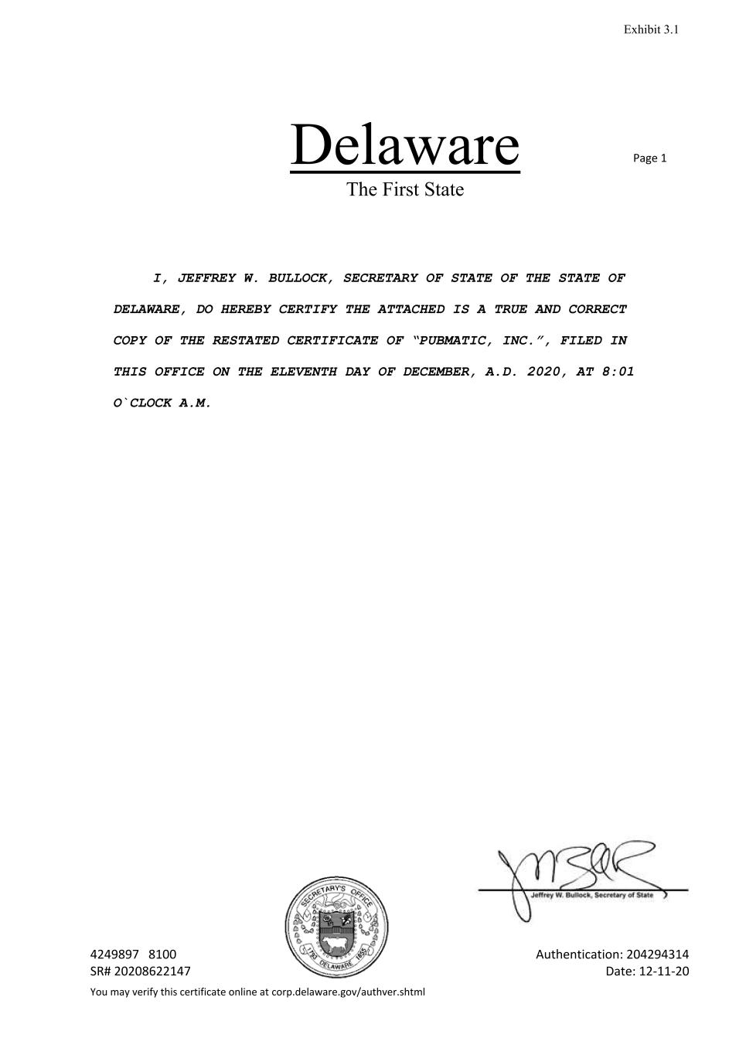

Delaware The First State Page 1 4249897 8100 Authentication: 204294314 SR# 20208622147 Date: 12-11-20 You may verify this certificate online at corp.delaware.gov/authver.shtml I, JEFFREY W. BULLOCK, SECRETARY OF STATE OF THE STATE OF DELAWARE, DO HEREBY CERTIFY THE ATTACHED IS A TRUE AND CORRECT COPY OF THE RESTATED CERTIFICATE OF “PUBMATIC, INC.”, FILED IN THIS OFFICE ON THE ELEVENTH DAY OF DECEMBER, A.D. 2020, AT 8:01 O`CLOCK A.M. Exhibit 3.1


State of Delaware Secretary of State Division of Corporations Delivered 08:01 AM 12/11/2020 FILED 08:01 AM 12/11/2020 SR 20208622147 - FileNumber 4249897 PUBMA TIC, INC. RESTATED CERTIFICATE OF INCORPORATION PubMatic, Inc., a Delaware corporation, hereby certifies as follows: 1. The name of this corporation is PubMatic, Inc. The date of the filing of its original Certificate of Incorporation with the Secretary of State was November 13, 2006 under the name Komli, Inc. 2. The Restated Certificate of Incorporation of this corporation attached hereto as Exhibit A, which is incorporated herein by this reference, and which restates, integrates and further amends the provisions of the Certificate of Incorporation of this corporation, as previously amended and/or restated, has been duly adopted by this corporation's Board of Directors and by the stockholders in accordance with Sections 242 and 245 of the General Corporation Law of the State of Delaware, with the approval of this corporation's stockholders having been given by written consent without a meeting in accordance with Section 228 of the General Corporation Law of the State of Delaware. IN WITNESS WHEREOF, this corporation has caused this Restated Certificate of Incorporation to be signed by its duly authorized officer and the foregoing facts stated herein are true and correct. Dated: December 11, 2020 PubMatic, Inc. By: Isl Rajeev K. Goel Name: Rajeev K. Goel Title: Chief Executive Officer

EXHIBIT A PUBMATIC, INC. RESTATED CERTIFICATE OF INCORPORATION ARTICLE I: NAME The name of this corporation is PubMatic, Inc. (the "Corporation"). ARTICLE II: AGENT FOR SERVICE OF PROCESS The address of the registered office of the Corporation in the State of Delaware is 1209 Orange Street, Wilmington, New Castle County, DE 19801. The name of the registered agent at such address is National Registered Agents, Inc. ARTICLE III: PURPOSE The purpose of the Corporation is to engage in any lawful act or activity for which corporations may be organized under the General Corporation Law of the State of Delaware (the "General Corporation Law'} ARTICLE IV: AUTHORIZED STOCK 1. Total Authorized. 1.1. The total number of shares of all classes of stock that the Corporation has authority to issue is 2,010,000,000 shares, consisting of three classes: 1,000,000,000 shares of Class A Common Stock, $0.0001 par value per share ("Class A Common Stock"), 1,000,000,000 shares of Class B Common Stock, $0.0001 par value per share ("Class B Common Stock" and together with the Class A Common Stock, the "Common Stock''), and 10,000,000 shares of Preferred Stock, $0.0001 par value per share (the "Preferred Stock"). 1.2. The number of authorized shares of Class A Common Stock or Class B Common Stock may be increased or decreased (but not below the number of shares thereof then outstanding) by the affirmative vote of the holders of capital stock representing a majority of the voting power of all the then-outstanding shares of capital stock of the Corporation entitled to vote thereon, irrespective of the provisions of Section 242(b )(2) of the General Corporation Law, and no vote of the holders of the Class A Common Stock or Class B Common Stock voting separately as a class shall be required therefor. 2. Pref erred Stock. 2.1. The Corporation's Board of Directors ("Board of Directors") is authorized, subject to any limitations prescribed by the law of the State of Delaware, by resolution or resolutions adopted from time to time, to provide for the issuance of shares of Preferred Stock in one or more series, and, by filing a certificate of designation pursuant to the

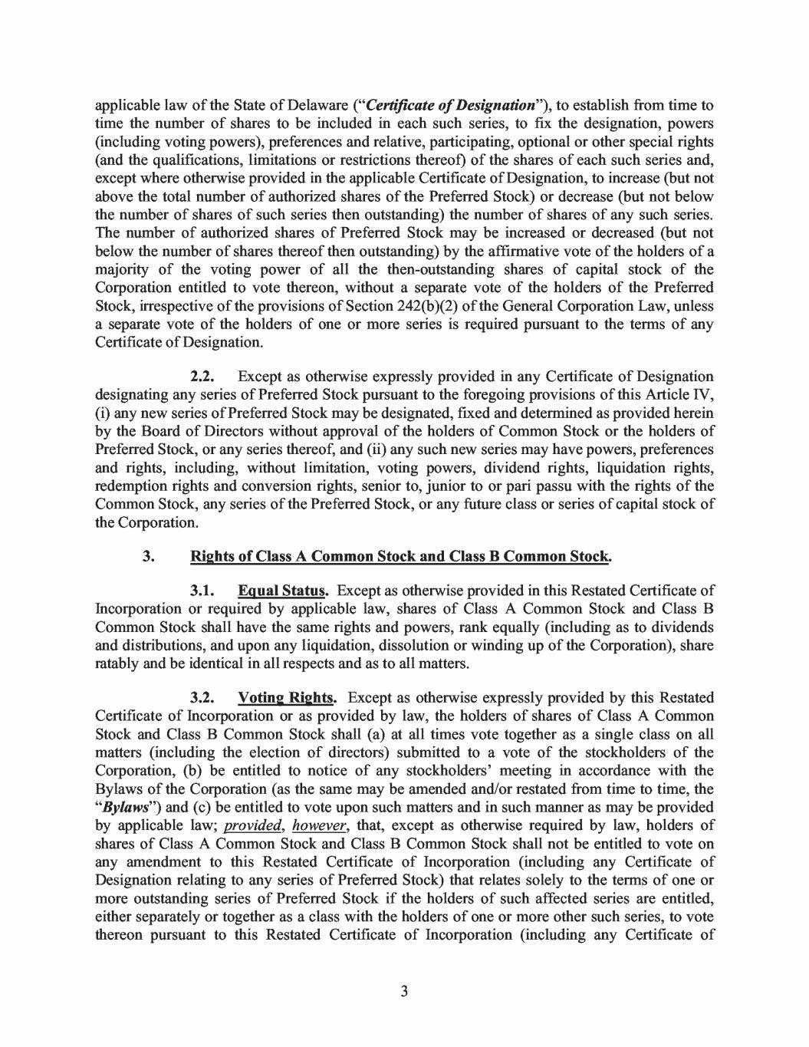
applicable law of the State of Delaware ("Certificate of Designation"), to establish from time to time the number of shares to be included in each such series, to fix the designation, powers (including voting powers), preferences and relative, participating, optional or other special rights (and the qualifications, limitations or restrictions thereof) of the shares of each such series and, except where otherwise provided in the applicable Certificate of Designation, to increase (but not above the total number of authorized shares of the Preferred Stock) or decrease (but not below the number of shares of such series then outstanding) the number of shares of any such series. The number of authorized shares of Preferred Stock may be increased or decreased (but not below the number of shares thereof then outstanding) by the affirmative vote of the holders of a majority of the voting power of all the then-outstanding shares of capital stock of the Corporation entitled to vote thereon, without a separate vote of the holders of the Preferred Stock, irrespective of the provisions of Section 242(b)(2) of the General Corporation Law, unless a separate vote of the holders of one or more series is required pursuant to the terms of any Certificate of Designation. 2.2. Except as otherwise expressly provided in any Certificate of Designation designating any series of Preferred Stock pursuant to the foregoing provisions of this Article IV, (i) any new series of Preferred Stock may be designated, fixed and determined as provided herein by the Board of Directors without approval of the holders of Common Stock or the holders of Preferred Stock, or any series thereof, and (ii) any such new series may have powers, preferences and rights, including, without limitation, voting powers, dividend rights, liquidation rights, redemption rights and conversion rights, senior to, junior to or pari passu with the rights of the Common Stock, any series of the Preferred Stock, or any future class or series of capital stock of the Corporation. 3. Rights of Class A Common Stock and Class B Common Stock. 3.1. Equal Status. Except as otherwise provided in this Restated Certificate of Incorporation or required by applicable law, shares of Class A Common Stock and Class B Common Stock shall have the same rights and powers, rank equally (including as to dividends and distributions, and upon any liquidation, dissolution or winding up of the Corporation), share ratably and be identical in all respects and as to all matters. 3.2. Voting Rights. Except as otherwise expressly provided by this Restated Certificate of Incorporation or as provided by law, the holders of shares of Class A Common Stock and Class B Common Stock shall (a) at all times vote together as a single class on all matters (including the election of directors) submitted to a vote of the stockholders of the Corporation, (b) be entitled to notice of any stockholders' meeting in accordance with the Bylaws of the Corporation (as the same may be amended and/or restated from time to time, the "Bylaws") and ( c) be entitled to vote upon such matters and in such manner as may be provided by applicable law; provided, however, that, except as otherwise required by law, holders of shares of Class A Common Stock and Class B Common Stock shall not be entitled to vote on any amendment to this Restated Certificate of Incorporation (including any Certificate of Designation relating to any series of Preferred Stock) that relates solely to the terms of one or more outstanding series of Preferred Stock if the holders of such affected series are entitled, either separately or together as a class with the holders of one or more other such series, to vote thereon pursuant to this Restated Certificate of Incorporation (including any Certificate of 3

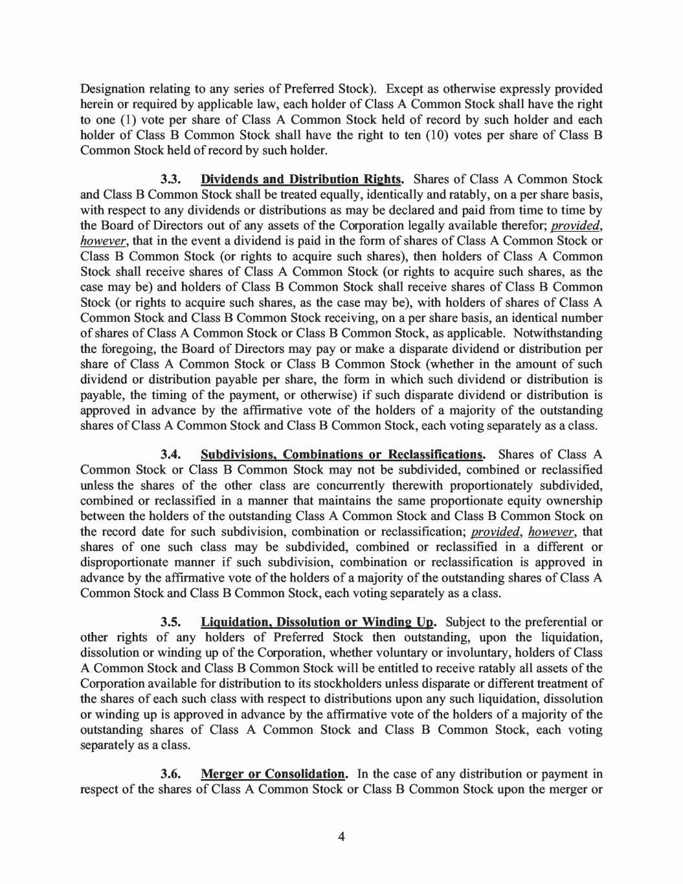
Designation relating to any series of Preferred Stock). Except as otherwise expressly provided herein or required by applicable law, each holder of Class A Common Stock shall have the right to one (1) vote per share of Class A Common Stock held of record by such holder and each holder of Class B Common Stock shall have the right to ten (10) votes per share of Class B Common Stock held of record by such holder. 3.3. Dividends and Distribution Rights. Shares of Class A Common Stock and Class B Common Stock shall be treated equally, identically and ratably, on a per share basis, with respect to any dividends or distributions as may be declared and paid from time to time by the Board of Directors out of any assets of the Corporation legally available therefor; provided, however, that in the event a dividend is paid in the form of shares of Class A Common Stock or Class B Common Stock (or rights to acquire such shares), then holders of Class A Common Stock shall receive shares of Class A Common Stock ( or rights to acquire such shares, as the case may be) and holders of Class B Common Stock shall receive shares of Class B Common Stock ( or rights to acquire such shares, as the case may be), with holders of shares of Class A Common Stock and Class B Common Stock receiving, on a per share basis, an identical number of shares of Class A Common Stock or Class B Common Stock, as applicable. Notwithstanding the foregoing, the Board of Directors may pay or make a disparate dividend or distribution per share of Class A Common Stock or Class B Common Stock (whether in the amount of such dividend or distribution payable per share, the form in which such dividend or distribution is payable, the timing of the payment, or otherwise) if such disparate dividend or distribution is approved in advance by the affrrmative vote of the holders of a majority of the outstanding shares of Class A Common Stock and Class B Common Stock, each voting separately as a class. 3.4. Subdivisions, Combinations or Reclassifications. Shares of Class A Common Stock or Class B Common Stock may not be subdivided, combined or reclassified unless the shares of the other class are concurrently therewith proportionately subdivided, combined or reclassified in a manner that maintains the same proportionate equity ownership between the holders of the outstanding Class A Common Stock and Class B Common Stock on the record date for such subdivision, combination or reclassification; provided, however, that shares of one such class may be subdivided, combined or reclassified in a different or disproportionate manner if such subdivision, combination or reclassification is approved in advance by the affrrmative vote of the holders of a majority of the outstanding shares of Class A Common Stock and Class B Common Stock, each voting separately as a class. 3.5. Liquidation, Dissolution or Winding Up. Subject to the preferential or other rights of any holders of Preferred Stock then outstanding, upon the liquidation, dissolution or winding up of the Corporation, whether voluntary or involuntary, holders of Class A Common Stock and Class B Common Stock will be entitled to receive ratably all assets of the Corporation available for distribution to its stockholders unless disparate or different treatment of the shares of each such class with respect to distributions upon any such liquidation, dissolution or winding up is approved in advance by the affirmative vote of the holders of a majority of the outstanding shares of Class A Common Stock and Class B Common Stock, each voting separately as a class. 3.6. Merger or Consolidation. In the case of any distribution or payment in respect of the shares of Class A Common Stock or Class B Common Stock upon the merger or 4

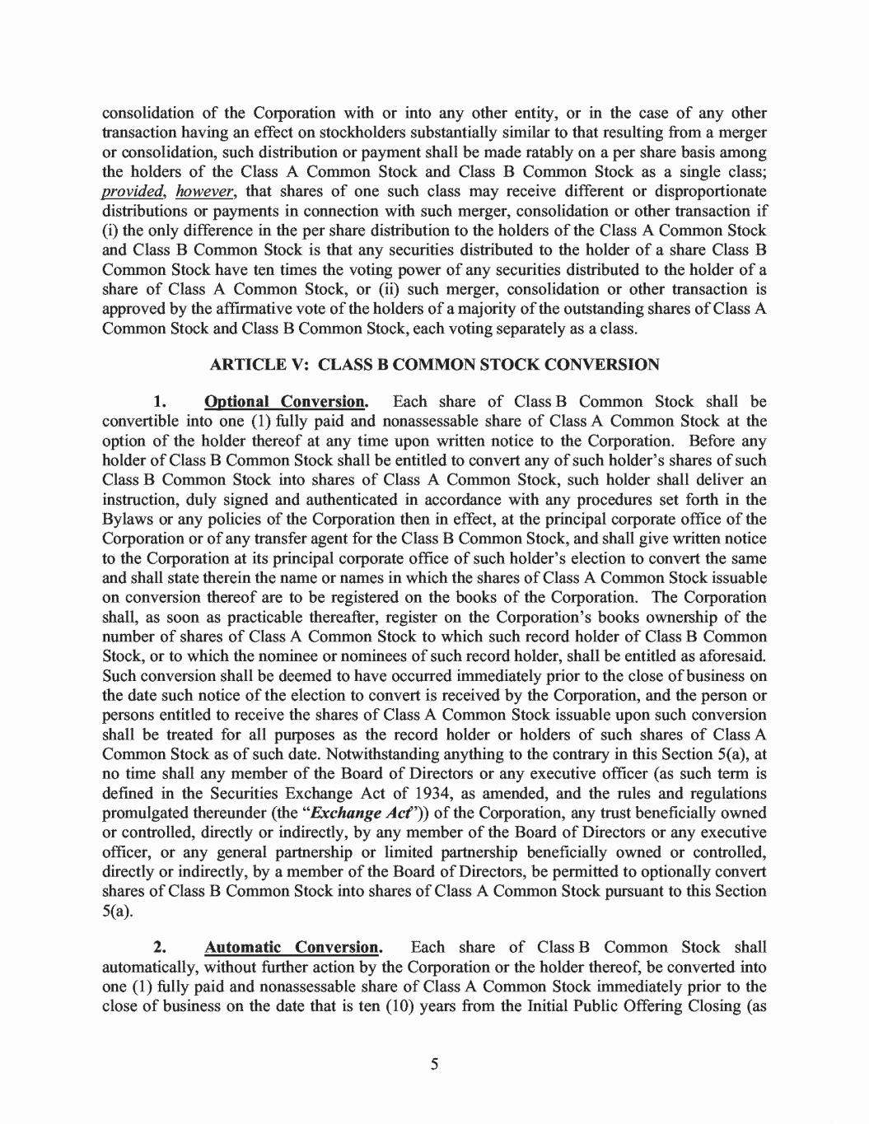
consolidation of the Corporation with or into any other entity, or in the case of any other transaction having an effect on stockholders substantially similar to that resulting from a merger or consolidation, such distribution or payment shall be made ratably on a per share basis among the holders of the Class A Common Stock and Class B Common Stock as a single class; provided, however, that shares of one such class may receive different or disproportionate distributions or payments in connection with such merger, consolidation or other transaction if (i) the only difference in the per share distribution to the holders of the Class A Common Stock and Class B Common Stock is that any securities distributed to the holder of a share Class B Common Stock have ten times the voting power of any securities distributed to the holder of a share of Class A Common Stock, or (ii) such merger, consolidation or other transaction is approved by the affrrmative vote of the holders of a majority of the outstanding shares of Class A Common Stock and Class B Common Stock, each voting separately as a class. ARTICLE V: CLASS B COMMON STOCK CONVERSION 1. Optional Conversion. Each share of Class B Common Stock shall be convertible into one (1) fully paid and nonassessable share of Class A Common Stock at the option of the holder thereof at any time upon written notice to the Corporation. Before any holder of Class B Common Stock shall be entitled to convert any of such holder's shares of such Class B Common Stock into shares of Class A Common Stock, such holder shall deliver an instruction, duly signed and authenticated in accordance with any procedures set forth in the Bylaws or any policies of the Corporation then in effect, at the principal corporate office of the Corporation or of any transfer agent for the Class B Common Stock, and shall give written notice to the Corporation at its principal corporate office of such holder's election to convert the same and shall state therein the name or names in which the shares of Class A Common Stock issuable on conversion thereof are to be registered on the books of the Corporation. The Corporation shall, as soon as practicable thereafter, register on the Corporation's books ownership of the number of shares of Class A Common Stock to which such record holder of Class B Common Stock, or to which the nominee or nominees of such record holder, shall be entitled as aforesaid. Such conversion shall be deemed to have occurred immediately prior to the close of business on the date such notice of the election to convert is received by the Corporation, and the person or persons entitled to receive the shares of Class A Common Stock issuable upon such conversion shall be treated for all purposes as the record holder or holders of such shares of Class A Common Stock as of such date. Notwithstanding anything to the contrary in this Section S(a), at no time shall any member of the Board of Directors or any executive officer ( as such term is defined in the Securities Exchange Act of 1934, as amended, and the rules and regulations promulgated thereunder (the "Exchange Act')) of the Corporation, any trust beneficially owned or controlled, directly or indirectly, by any member of the Board of Directors or any executive officer, or any general partnership or limited partnership beneficially owned or controlled, directly or indirectly, by a member of the Board of Directors, be permitted to optionally convert shares of Class B Common Stock into shares of Class A Common Stock pursuant to this Section S(a). 2. Automatic Conversion. Each share of Class B Common Stock shall automatically, without further action by the Corporation or the holder thereof, be converted into one (1) fully paid and nonassessable share of Class A Common Stock immediately prior to the close of business on the date that is ten (10) years from the Initial Public Offering Closing (as 5

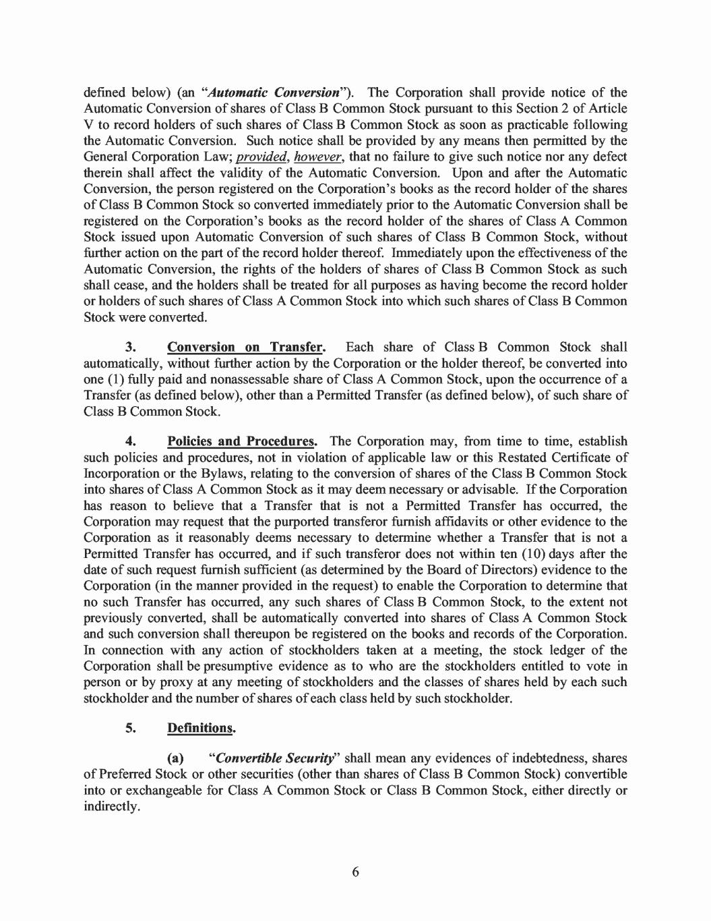
defined below) (an "Automatic Conversion"). The Corporation shall provide notice of the Automatic Conversion of shares of Class B Common Stock pursuant to this Section 2 of Article V to record holders of such shares of Class B Common Stock as soon as practicable following the Automatic Conversion. Such notice shall be provided by any means then permitted by the General Corporation Law; provided, however, that no failure to give such notice nor any defect therein shall affect the validity of the Automatic Conversion. Upon and after the Automatic Conversion, the person registered on the Corporation's books as the record holder of the shares of Class B Common Stock so converted immediately prior to the Automatic Conversion shall be registered on the Corporation's books as the record holder of the shares of Class A Common Stock issued upon Automatic Conversion of such shares of Class B Common Stock, without further action on the part of the record holder thereof. Immediately upon the effectiveness of the Automatic Conversion, the rights of the holders of shares of Class B Common Stock as such shall cease, and the holders shall be treated for all purposes as having become the record holder or holders of such shares of Class A Common Stock into which such shares of Class B Common Stock were converted. 3. Conversion on Transfer. Each share of Class B Common Stock shall automatically, without further action by the Corporation or the holder thereof, be converted into one (1) fully paid and nonassessable share of Class A Common Stock, upon the occurrence of a Transfer (as defined below), other than a Permitted Transfer (as defined below), of such share of Class B Common Stock. 4. Policies and Procedures. The Corporation may, from time to time, establish such policies and procedures, not in violation of applicable law or this Restated Certificate of Incorporation or the Bylaws, relating to the conversion of shares of the Class B Common Stock into shares of Class A Common Stock as it may deem necessary or advisable. If the Corporation has reason to believe that a Transfer that is not a Permitted Transfer has occurred, the Corporation may request that the purported transferor furnish affidavits or other evidence to the Corporation as it reasonably deems necessary to determine whether a Transfer that is not a Permitted Transfer has occurred, and if such transferor does not within ten (10) days after the date of such request furnish sufficient ( as determined by the Board of Directors) evidence to the Corporation (in the manner provided in the request) to enable the Corporation to determine that no such Transfer has occurred, any such shares of Class B Common Stock, to the extent not previously converted, shall be automatically converted into shares of Class A Common Stock and such conversion shall thereupon be registered on the books and records of the Corporation. In connection with any action of stockholders taken at a meeting, the stock ledger of the Corporation shall be presumptive evidence as to who are the stockholders entitled to vote in person or by proxy at any meeting of stockholders and the classes of shares held by each such stockholder and the number of shares of each class held by such stockholder. 5. Definitions. (a) "Convertible Security'' shall mean any evidences of indebtedness, shares of Preferred Stock or other securities (other than shares of Class B Common Stock) convertible into or exchangeable for Class A Common Stock or Class B Common Stock, either directly or indirectly. 6

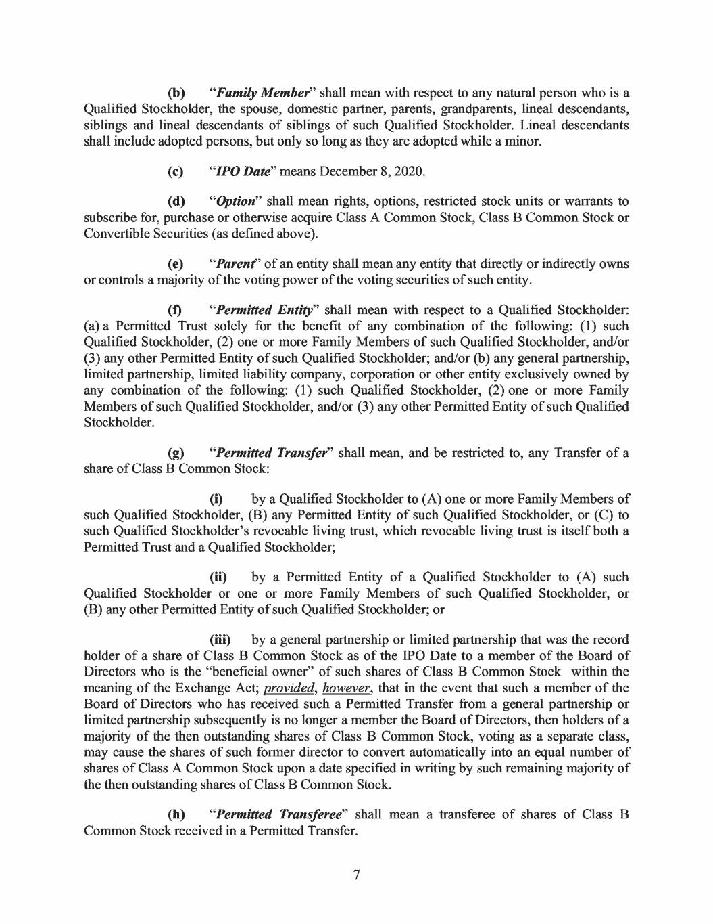
(b) "Family Member' shall mean with respect to any natural person who is a Qualified Stockholder, the spouse, domestic partner, parents, grandparents, lineal descendants, siblings and lineal descendants of siblings of such Qualified Stockholder. Lineal descendants shall include adopted persons, but only so long as they are adopted while a minor. (c) "/PO Date" means December 8, 2020. (d) "Option" shall mean rights, options, restricted stock units or warrants to subscribe for, purchase or otherwise acquire Class A Common Stock, Class B Common Stock or Convertible Securities (as defined above). ( e) "Parent' of an entity shall mean any entity that directly or indirectly owns or controls a majority of the voting power of the voting securities of such entity. (f) "Permitted Entity" shall mean with respect to a Qualified Stockholder: (a) a Permitted Trust solely for the benefit of any combination of the following: (1) such Qualified Stockholder, (2) one or more Family Members of such Qualified Stockholder, and/or (3) any other Permitted Entity of such Qualified Stockholder; and/or (b) any general partnership, limited partnership, limited liability company, corporation or other entity exclusively owned by any combination of the following: (1) such Qualified Stockholder, (2) one or more Family Members of such Qualified Stockholder, and/or (3) any other Permitted Entity of such Qualified Stockholder. (g) "Permitted Transfer" shall mean, and be restricted to, any Transfer of a share of Class B Common Stock: (i) by a Qualified Stockholder to (A) one or more Family Members of such Qualified Stockholder, (B) any Permitted Entity of such Qualified Stockholder, or (C) to such Qualified Stockholder's revocable living trust, which revocable living trust is itself both a Permitted Trust and a Qualified Stockholder; (ii) by a Permitted Entity of a Qualified Stockholder to (A) such Qualified Stockholder or one or more Family Members of such Qualified Stockholder, or (B) any other Permitted Entity of such Qualified Stockholder; or (iii) by a general partnership or limited partnership that was the record holder of a share of Class B Common Stock as of the IPO Date to a member of the Board of Directors who is the "beneficial owner'' of such shares of Class B Common Stock within the meaning of the Exchange Act; provided, however, that in the event that such a member of the Board of Directors who has received such a Permitted Transfer from a general partnership or limited partnership subsequently is no longer a member the Board of Directors, then holders of a majority of the then outstanding shares of Class B Common Stock, voting as a separate class, may cause the shares of such former director to convert automatically into an equal number of shares of Class A Common Stock upon a date specified in writing by such remaining majority of the then outstanding shares of Class B Common Stock. (h) "Permitted Transferee" shall mean a transferee of shares of Class B Common Stock received in a Permitted Transfer. 7

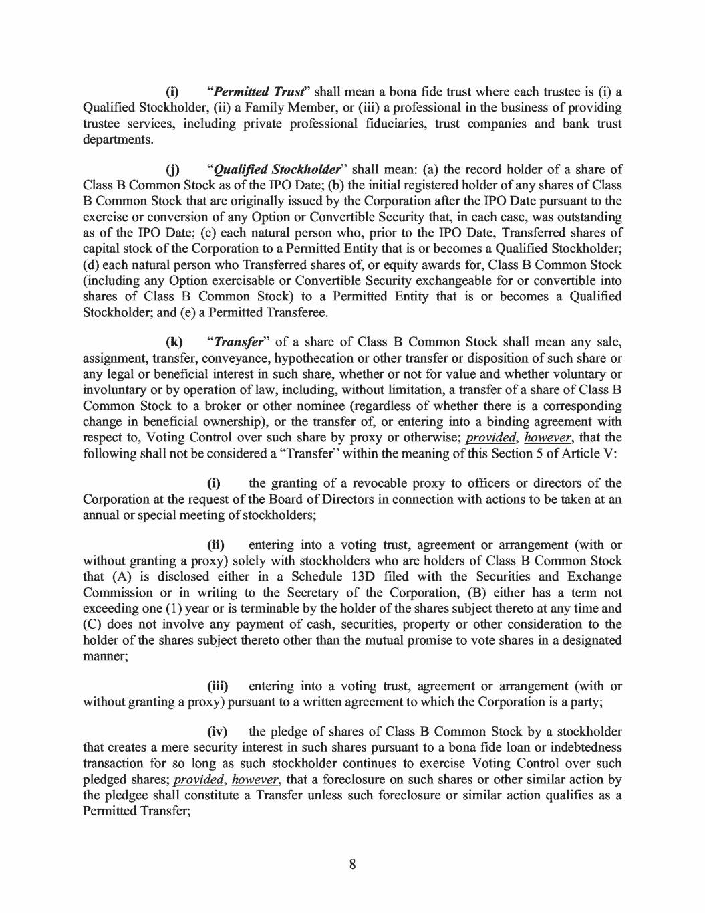
(i) "Permitted Trust' shall mean a bona fide trust where each trustee is (i) a Qualified Stockholder, (ii) a Family Member, or (iii) a professional in the business of providing trustee services, including private professional fiduciaries, trust companies and bank trust departments. (i) "Qualified Stockholder" shall mean: (a) the record holder of a share of Class B Common Stock as of the IPO Date; (b) the initial registered holder of any shares of Class B Common Stock that are originally issued by the Corporation after the IPO Date pursuant to the exercise or conversion of any Option or Convertible Security that, in each case, was outstanding as of the IPO Date; ( c) each natural person who, prior to the IPO Date, Transferred shares of capital stock of the Corporation to a Permitted Entity that is or becomes a Qualified Stockholder; ( d) each natural person who Transferred shares of, or equity awards for, Class B Common Stock (including any Option exercisable or Convertible Security exchangeable for or convertible into shares of Class B Common Stock) to a Permitted Entity that is or becomes a Qualified Stockholder; and ( e) a Permitted Transferee. (k) "Transfer" of a share of Class B Common Stock shall mean any sale, assignment, transfer, conveyance, hypothecation or other transfer or disposition of such share or any legal or beneficial interest in such share, whether or not for value and whether voluntary or involuntary or by operation of law, including, without limitation, a transfer of a share of Class B Common Stock to a broker or other nominee (regardless of whether there is a corresponding change in beneficial ownership), or the transfer of, or entering into a binding agreement with respect to, Voting Control over such share by proxy or otherwise~ provided, however, that the following shall not be considered a "Transfer'' within the meaning of this Section 5 of Article V: (i) the granting of a revocable proxy to officers or directors of the Corporation at the request of the Board of Directors in connection with actions to be taken at an annual or special meeting of stockholders; (ii) entering into a voting trust, agreement or arrangement (with or without granting a proxy) solely with stockholders who are holders of Class B Common Stock that (A) is disclosed either in a Schedule 13D filed with the Securities and Exchange Commission or in writing to the Secretary of the Corporation, (B) either has a term not exceeding one (1) year or is terminable by the holder of the shares subject thereto at any time and (C) does not involve any payment of cash, securities, property or other consideration to the holder of the shares subject thereto other than the mutual promise to vote shares in a designated manner; (iii) entering into a voting trust, agreement or arrangement (with or without granting a proxy) pursuant to a written agreement to which the Corporation is a party; (iv) the pledge of shares of Class B Common Stock by a stockholder that creates a mere security interest in such shares pursuant to a bona fide loan or indebtedness transaction for so long as such stockholder continues to exercise Voting Control over such pledged shares; provided, however, that a foreclosure on such shares or other similar action by the pledgee shall constitute a Transfer unless such foreclosure or similar action qualifies as a Permitted Transfer; 8

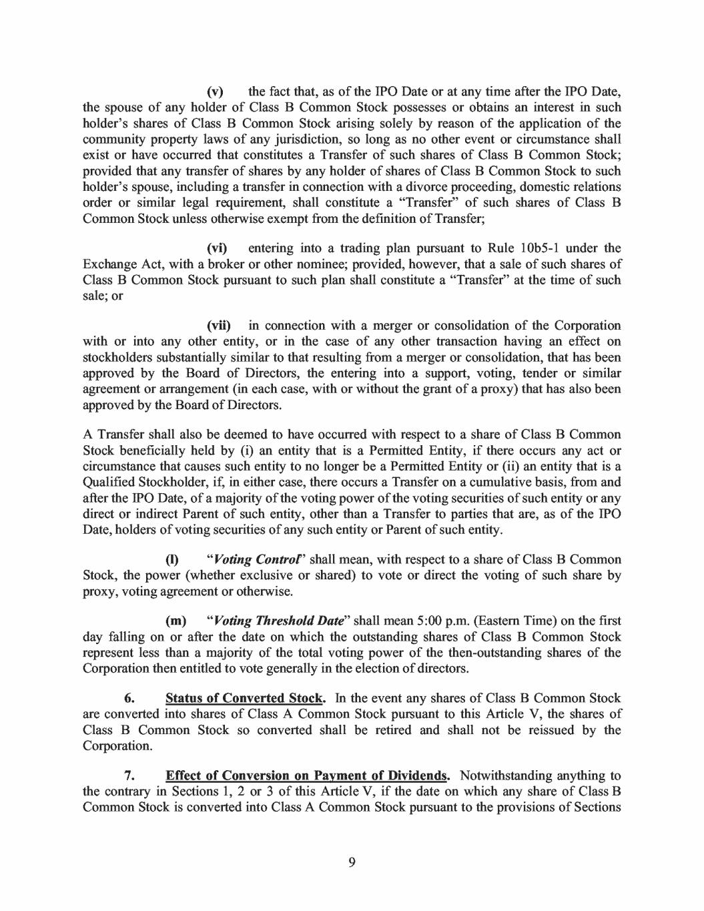
(v) the fact that, as of the IPO Date or at any time after the IPO Date, the spouse of any holder of Class B Common Stock possesses or obtains an interest in such holder's shares of Class B Common Stock arising solely by reason of the application of the community property laws of any jurisdiction, so long as no other event or circumstance shall exist or have occurred that constitutes a Transfer of such shares of Class B Common Stock; provided that any transfer of shares by any holder of shares of Class B Common Stock to such holder's spouse, including a transfer in connection with a divorce proceeding, domestic relations order or similar legal requirement, shall constitute a "Transfer'' of such shares of Class B Common Stock unless otherwise exempt from the definition of Transfer; (vi) entering into a trading plan pursuant to Rule 1 0b5-1 under the Exchange Act, with a broker or other nominee; provided, however, that a sale of such shares of Class B Common Stock pursuant to such plan shall constitute a "Transfer" at the time of such sale; or (vii) in connection with a merger or consolidation of the Corporation with or into any other entity, or in the case of any other transaction having an effect on stockholders substantially similar to that resulting from a merger or consolidation, that has been approved by the Board of Directors, the entering into a support, voting, tender or similar agreement or arrangement (in each case, with or without the grant of a proxy) that has also been approved by the Board of Directors. A Transfer shall also be deemed to have occurred with respect to a share of Class B Common Stock beneficially held by (i) an entity that is a Permitted Entity, if there occurs any act or circumstance that causes such entity to no longer be a Permitted Entity or (ii) an entity that is a Qualified Stockholder, if, in either case, there occurs a Transfer on a cumulative basis, from and after the 1PO Date, of a majority of the voting power of the voting securities of such entity or any direct or indirect Parent of such entity, other than a Transfer to parties that are, as of the IPO Date, holders of voting securities of any such entity or Parent of such entity. (1) "Voting Control' shall mean, with respect to a share of Class B Common Stock, the power (whether exclusive or shared) to vote or direct the voting of such share by proxy, voting agreement or otherwise. (m) "Voting Threshold Date" shall mean 5:00 p.m. (Eastern Time) on the first day falling on or after the date on which the outstanding shares of Class B Common Stock represent less than a majority of the total voting power of the then-outstanding shares of the Corporation then entitled to vote generally in the election of directors. 6. Status of Converted Stock. In the event any shares of Class B Common Stock are converted into shares of Class A Common Stock pursuant to this Article V, the shares of Class B Common Stock so converted shall be retired and shall not be reissued by the Corporation. 7. Effect of Conversion on Payment of Dividends. Notwithstanding anything to the contrary in Sections 1, 2 or 3 of this Article V, if the date on which any share of Class B Common Stock is converted into Class A Common Stock pursuant to the provisions of Sections 9

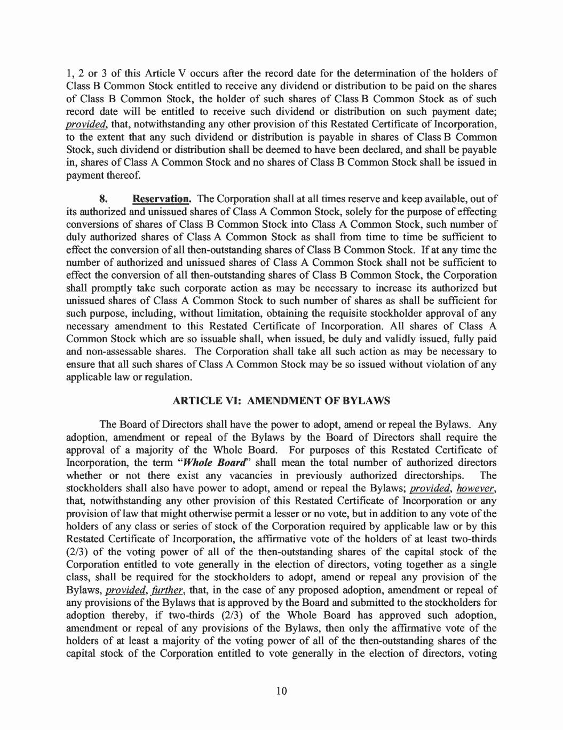
1, 2 or 3 of this Article V occurs after the record date for the determination of the holders of Class B Common Stock entitled to receive any dividend or distribution to be paid on the shares of Class B Common Stock, the holder of such shares of Class B Common Stock as of such record date will be entitled to receive such dividend or distribution on such payment date; provided, that, notwithstanding any other provision of this Restated Certificate of Incorporation, to the extent that any such dividend or distribution is payable in shares of Class B Common Stock, such dividend or distribution shall be deemed to have been declared, and shall be payable in, shares of Class A Common Stock and no shares of Class B Common Stock shall be issued in payment thereof. 8. Reservation. The Corporation shall at all times reserve and keep available, out of its authorized and unissued shares of Class A Common Stock, solely for the purpose of effecting conversions of shares of Class B Common Stock into Class A Common Stock, such number of duly authorized shares of Class A Common Stock as shall from time to time be sufficient to effect the conversion of all then-outstanding shares of Class B Common Stock. If at any time the number of authorized and unissued shares of Class A Common Stock shall not be sufficient to effect the conversion of all then-outstanding shares of Class B Common Stock, the Corporation shall promptly take such corporate action as may be necessary to increase its authorized but unissued shares of Class A Common Stock to such number of shares as shall be sufficient for such purpose, including, without limitation, obtaining the requisite stockholder approval of any necessary amendment to this Restated Certificate of Incorporation. All shares of Class A Common Stock which are so issuable shall, when issued, be duly and validly issued, fully paid and non-assessable shares. The Corporation shall take all such action as may be necessary to ensure that all such shares of Class A Common Stock may be so issued without violation of any applicable law or regulation. ARTICLE VI: AMENDMENT OF BYLAWS The Board of Directors shall have the power to adopt, amend or repeal the Bylaws. Any adoption, amendment or repeal of the Bylaws by the Board of Directors shall require the approval of a majority of the Whole Board. For purposes of this Restated Certificate of Incorporation, the term "Whole Board'' shall mean the total number of authorized directors whether or not there exist any vacancies in previously authorized directorships. The stockholders shall also have power to adopt, amend or repeal the Bylaws; provided, however, that, notwithstanding any other provision of this Restated Certificate of Incorporation or any provision of law that might otherwise permit a lesser or no vote, but in addition to any vote of the holders of any class or series of stock of the Corporation required by applicable law or by this Restated Certificate of Incorporation, the affrrmative vote of the holders of at least two-thirds (2/3) of the voting power of all of the then-outstanding shares of the capital stock of the Corporation entitled to vote generally in the election of directors, voting together as a single class, shall be required for the stockholders to adopt, amend or repeal any provision of the Bylaws, provided, further, that, in the case of any proposed adoption, amendment or repeal of any provisions of the Bylaws that is approved by the Board and submitted to the stockholders for adoption thereby, if two-thirds (2/3) of the Whole Board has approved such adoption, amendment or repeal of any provisions of the Bylaws, then only the affrrmative vote of the holders of at least a majority of the voting power of all of the then-outstanding shares of the capital stock of the Corporation entitled to vote generally in the election of directors, voting 10

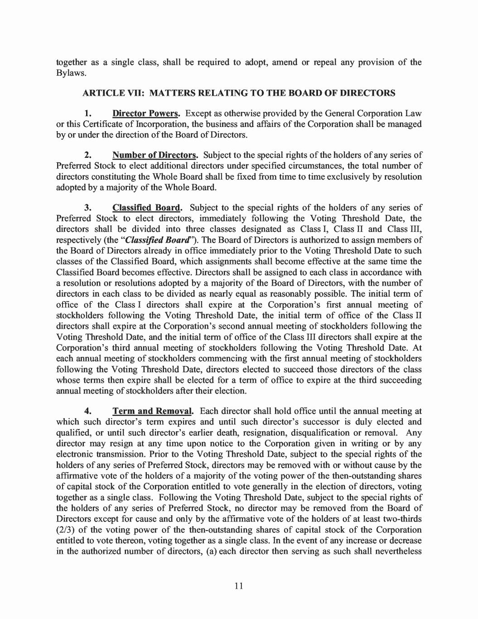
together as a single class, shall be required to adopt, amend or repeal any provision of the Bylaws. ARTICLE VII: MATTERS RELATING TO THE BOARD OF DIRECTORS 1. Director Powers. Except as otherwise provided by the General Corporation Law or this Certificate of Incorporation, the business and affairs of the Corporation shall be managed by or under the direction of the Board of Directors. 2. Number of Directors. Subject to the special rights of the holders of any series of Preferred Stock to elect additional directors under specified circumstances, the total number of directors constituting the Whole Board shall be fixed from time to time exclusively by resolution adopted by a majority of the Whole Board. 3. Classified Board. Subject to the special rights of the holders of any series of Preferred Stock to elect directors, immediately following the Voting Threshold Date, the directors shall be divided into three classes designated as Class I, Class II and Class III, respectively (the "Classified Board''). The Board of Directors is authorized to assign members of the Board of Directors already in office immediately prior to the Voting Threshold Date to such classes of the Classified Board, which assignments shall become effective at the same time the Classified Board becomes effective. Directors shall be assigned to each class in accordance with a resolution or resolutions adopted by a majority of the Board of Directors, with the number of directors in each class to be divided as nearly equal as reasonably possible. The initial term of office of the Class I directors shall expire at the Corporation's first annual meeting of stockholders following the Voting Threshold Date, the initial term of office of the Class II directors shall expire at the Corporation's second annual meeting of stockholders following the Voting Threshold Date, and the initial term of office of the Class III directors shall expire at the Corporation's third annual meeting of stockholders following the Voting Threshold Date. At each annual meeting of stockholders commencing with the first annual meeting of stockholders following the Voting Threshold Date, directors elected to succeed those directors of the class whose terms then expire shall be elected for a term of office to expire at the third succeeding annual meeting of stockholders after their election. 4. Term and Removal. Each director shall hold office until the annual meeting at which such director's term expires and until such director's successor is duly elected and qualified, or until such director's earlier death, resignation, disqualification or removal. Any director may resign at any time upon notice to the Corporation given in writing or by any electronic transmission. Prior to the Voting Threshold Date, subject to the special rights of the holders of any series of Preferred Stock, directors may be removed with or without cause by the affirmative vote of the holders of a majority of the voting power of the then-outstanding shares of capital stock of the Corporation entitled to vote generally in the election of directors, voting together as a single class. Following the Voting Threshold Date, subject to the special rights of the holders of any series of Preferred Stock, no director may be removed from the Board of Directors except for cause and only by the affirmative vote of the holders of at least two-thirds (2/3) of the voting power of the then-outstanding shares of capital stock of the Corporation entitled to vote thereon, voting together as a single class. In the event of any increase or decrease in the authorized number of directors, (a) each director then serving as such shall nevertheless 11

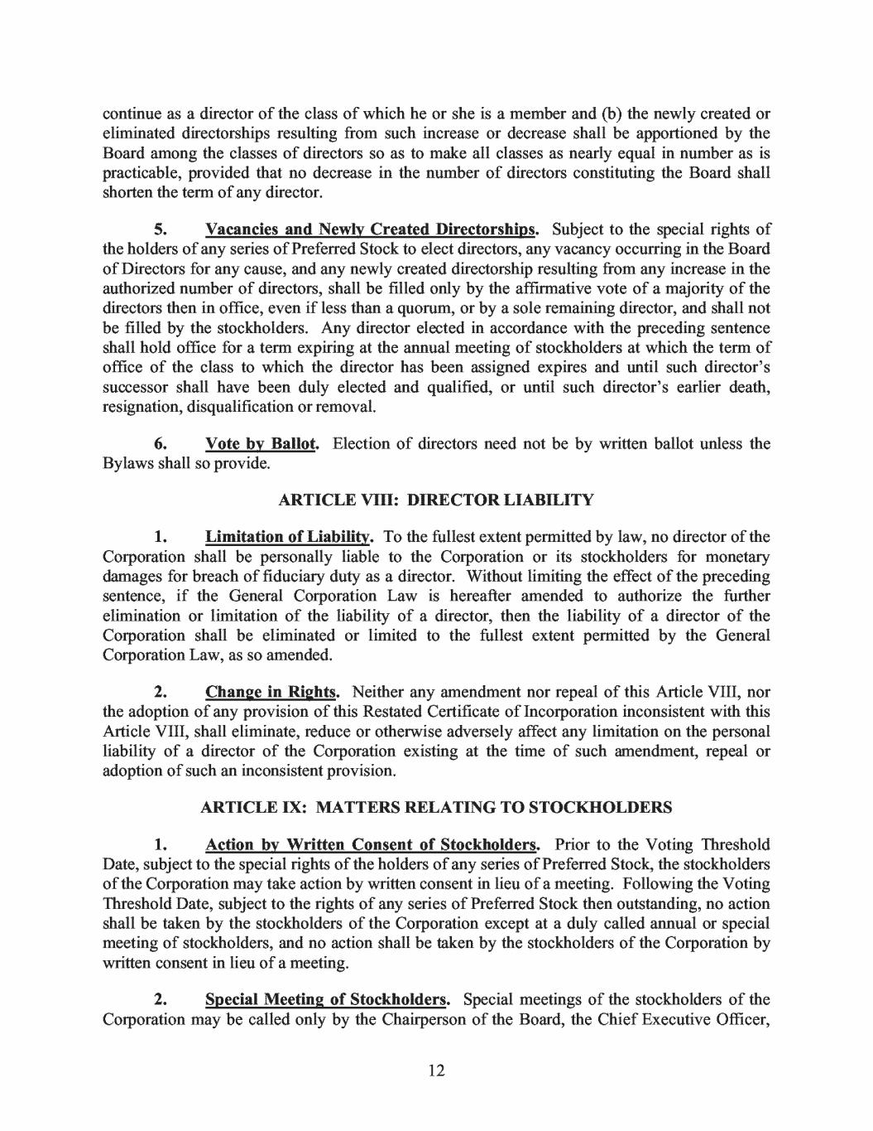
continue as a director of the class of which he or she is a member and (b) the newly created or eliminated directorships resulting from such increase or decrease shall be apportioned by the Board among the classes of directors so as to make all classes as nearly equal in number as is practicable, provided that no decrease in the number of directors constituting the Board shall shorten the term of any director. 5. Vacancies and Newly Created Directorships. Subject to the special rights of the holders of any series of Preferred Stock to elect directors, any vacancy occurring in the Board of Directors for any cause, and any newly created directorship resulting from any increase in the authorized number of directors, shall be filled only by the affirmative vote of a majority of the directors then in office, even if less than a quorum, or by a sole remaining director, and shall not be filled by the stockholders. Any director elected in accordance with the preceding sentence shall hold office for a term expiring at the annual meeting of stockholders at which the term of office of the class to which the director has been assigned expires and until such director's successor shall have been duly elected and qualified, or until such director's earlier death, resignation, disqualification or removal. 6. Vote by Ballot. Election of directors need not be by written ballot unless the Bylaws shall so provide. ARTICLE VIII: DIRECTOR LIABILITY 1. Limitation of Liability. To the fullest extent permitted by law, no director of the Corporation shall be personally liable to the Corporation or its stockholders for monetary damages for breach of fiduciary duty as a director. Without limiting the effect of the preceding sentence, if the General Corporation Law is hereafter amended to authorize the further elimination or limitation of the liability of a director, then the liability of a director of the Corporation shall be eliminated or limited to the fullest extent permitted by the General Corporation Law, as so amended. 2. Change in Rights. Neither any amendment nor repeal of this Article VIII, nor the adoption of any provision of this Restated Certificate of Incorporation inconsistent with this Article VIII, shall eliminate, reduce or otherwise adversely affect any limitation on the personal liability of a director of the Corporation existing at the time of such amendment, repeal or adoption of such an inconsistent provision. ARTICLE IX: MATTERS RELATING TO STOCKHOLDERS 1. Action by Written Consent of Stockholders. Prior to the Voting Threshold Date, subject to the special rights of the holders of any series of Preferred Stock, the stockholders of the Corporation may take action by written consent in lieu of a meeting. Following the Voting Threshold Date, subject to the rights of any series of Preferred Stock then outstanding, no action shall be taken by the stockholders of the Corporation except at a duly called annual or special meeting of stockholders, and no action shall be taken by the stockholders of the Corporation by written consent in lieu of a meeting. 2. Special Meeting of Stockholders. Special meetings of the stockholders of the Corporation may be called only by the Chairperson of the Board, the Chief Executive Officer, 12

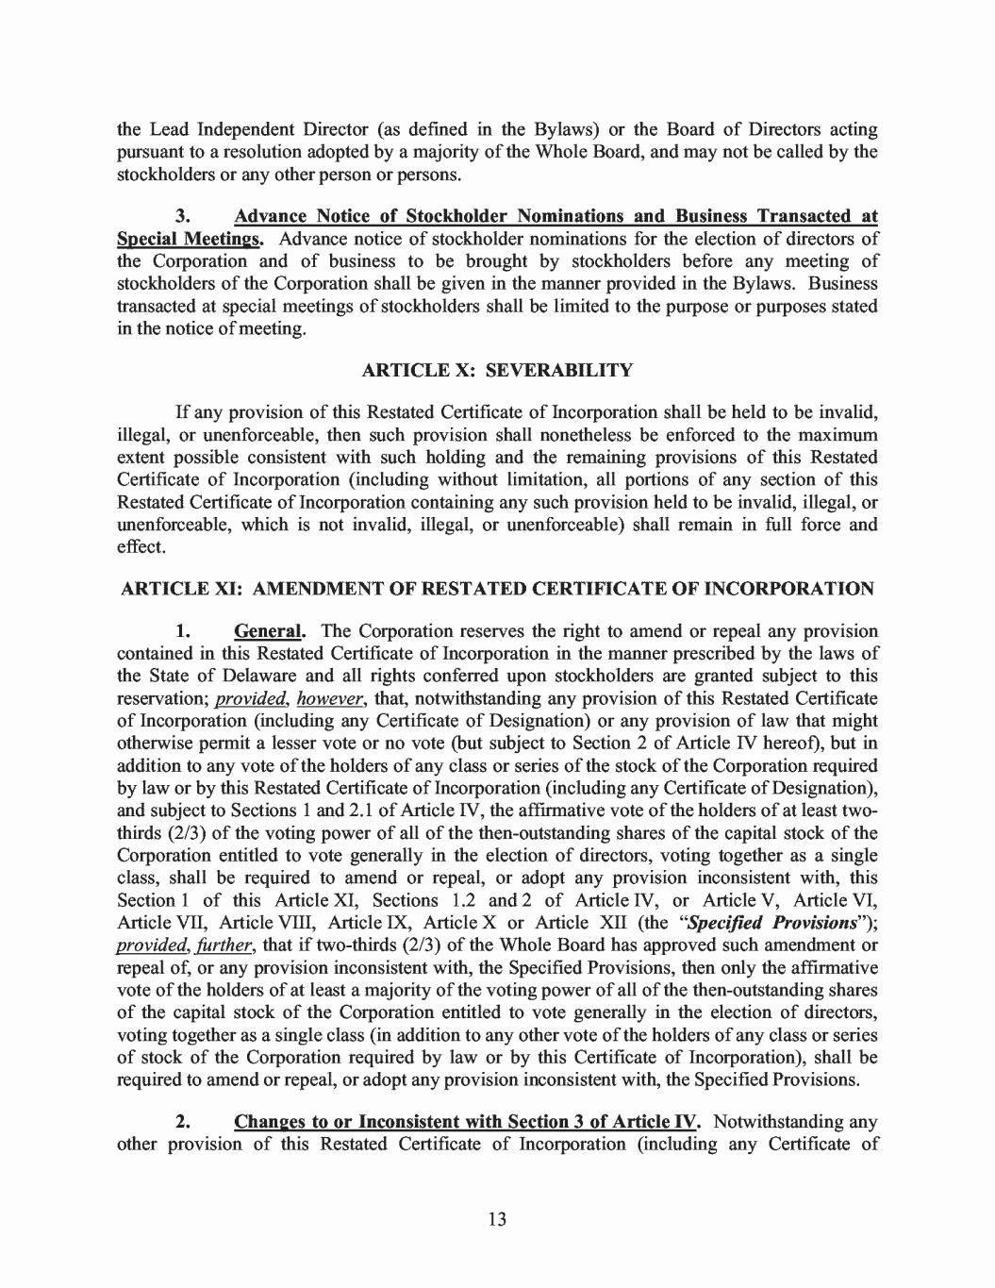
the Lead Independent Director ( as defined in the Bylaws) or the Board of Directors acting pursuant to a resolution adopted by a majority of the Whole Board, and may not be called by the stockholders or any other person or persons. 3. Advance Notice of Stockholder Nominations and Business Transacted at Special Meetings. Advance notice of stockholder nominations for the election of directors of the Corporation and of business to be brought by stockholders before any meeting of stockholders of the Corporation shall be given in the manner provided in the Bylaws. Business transacted at special meetings of stockholders shall be limited to the purpose or purposes stated in the notice of meeting. ARTICLE X: SEVERABILITY If any provision of this Restated Certificate of Incorporation shall be held to be invalid, illegal, or unenforceable, then such provision shall nonetheless be enforced to the maximum extent possible consistent with such holding and the remaining provisions of this Restated Certificate of Incorporation (including without limitation, all portions of any section of this Restated Certificate of Incorporation containing any such provision held to be invalid, illegal, or unenforceable, which is not invalid, illegal, or unenforceable) shall remain in full force and effect. ARTICLE XI: AMENDMENT OF RESTATED CERTIFICATE OF INCORPORATION 1. General. The Corporation reserves the right to amend or repeal any provision contained in this Restated Certificate of Incorporation in the manner prescribed by the laws of the State of Delaware and all rights conferred upon stockholders are granted subject to this reservation; provided, however, that, notwithstanding any provision of this Restated Certificate of Incorporation (including any Certificate of Designation) or any provision of law that might otherwise permit a lesser vote or no vote (but subject to Section 2 of Article IV hereof), but in addition to any vote of the holders of any class or series of the stock of the Corporation required by law or by this Restated Certificate oflncorporation (including any Certificate of Designation), and subject to Sections 1 and 2.1 of Article IV, the affrrmative vote of the holders of at least two- thirds (2/3) of the voting power of all of the then-outstanding shares of the capital stock of the Corporation entitled to vote generally in the election of directors, voting together as a single class, shall be required to amend or repeal, or adopt any provision inconsistent with, this Section 1 of this Article XI, Sections 1.2 and 2 of Article IV, or Article V, Article VI, Article VII, Article VIII, Article IX, Article X or Article XII (the "Specified Provisions"); provided, further, that if two-thirds (2/3) of the Whole Board has approved such amendment or repeal of, or any provision inconsistent with, the Specified Provisions, then only the affirmative vote of the holders of at least a majority of the voting power of all of the then-outstanding shares of the capital stock of the Corporation entitled to vote generally in the election of directors, voting together as a single class (in addition to any other vote of the holders of any class or series of stock of the Corporation required by law or by this Certificate of Incorporation), shall be required to amend or repeal, or adopt any provision inconsistent with, the Specified Provisions. 2. Changes to or Inconsistent with Section 3 of Article IV. Notwithstanding any other provision of this Restated Certificate of Incorporation (including any Certificate of 13

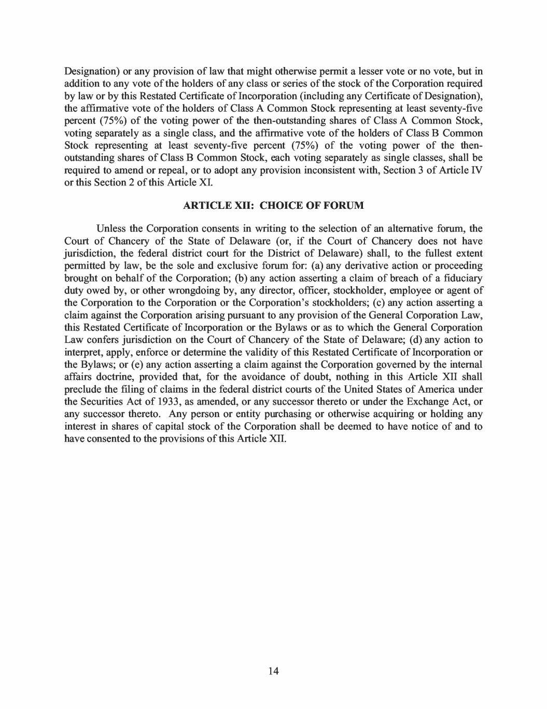
Designation) or any provision of law that might otherwise permit a lesser vote or no vote, but in addition to any vote of the holders of any class or series of the stock of the Corporation required by law or by this Restated Certificate oflncorporation (including any Certificate of Designation), the affirmative vote of the holders of Class A Common Stock representing at least seventy-five percent (75%) of the voting power of the then-outstanding shares of Class A Common Stock, voting separately as a single class, and the affirmative vote of the holders of Class B Common Stock representing at least seventy-five percent (75%) of the voting power of the then- outstanding shares of Class B Common Stock, each voting separately as single classes, shall be required to amend or repeal, or to adopt any provision inconsistent with, Section 3 of Article N or this Section 2 of this Article XI. ARTICLE XII: CHOICE OF FORUM Unless the Corporation consents in writing to the selection of an alternative forum, the Court of Chancery of the State of Delaware ( or, if the Court of Chancery does not have jurisdiction, the federal district court for the District of Delaware) shall, to the fullest extent permitted by law, be the sole and exclusive forum for: (a) any derivative action or proceeding brought on behalf of the Corporation; (b) any action asserting a claim of breach of a fiduciary duty owed by, or other wrongdoing by, any director, officer, stockholder, employee or agent of the Corporation to the Corporation or the Corporation's stockholders; (c) any action asserting a claim against the Corporation arising pursuant to any provision of the General Corporation Law, this Restated Certificate of Incorporation or the Bylaws or as to which the General Corporation Law confers jurisdiction on the Court of Chancery of the State of Delaware; ( d) any action to interpret, apply, enforce or determine the validity of this Restated Certificate of Incorporation or the Bylaws; or ( e) any action asserting a claim against the Corporation governed by the internal affairs doctrine, provided that, for the avoidance of doubt, nothing in this Article XII shall preclude the filing of claims in the federal district courts of the United States of America under the Securities Act of 1933, as amended, or any successor thereto or under the Exchange Act, or any successor thereto. Any person or entity purchasing or otherwise acquiring or holding any interest in shares of capital stock of the Corporation shall be deemed to have notice of and to have consented to the provisions of this Article XII. 14

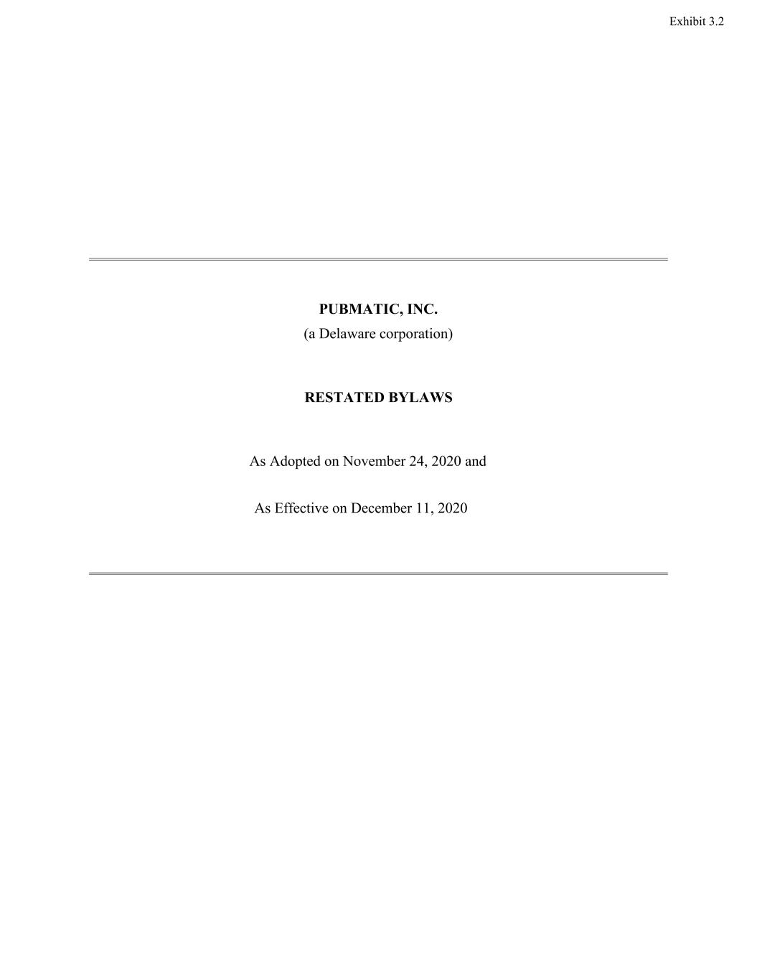
PUBMATIC, INC. (a Delaware corporation) RESTATED BYLAWS As Adopted on November 24, 2020 and As Effective on December 11, 2020 Exhibit 3.2

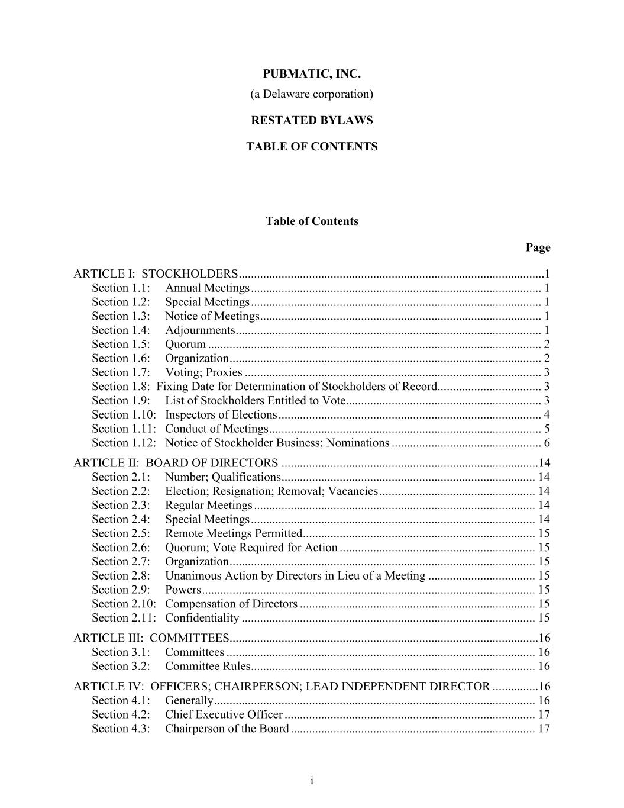
i PUBMATIC, INC. (a Delaware corporation) RESTATED BYLAWS TABLE OF CONTENTS Table of Contents Page ARTICLE I: STOCKHOLDERS ....................................................................................................1 Section 1.1: Annual Meetings ............................................................................................... 1 Section 1.2: Special Meetings ............................................................................................... 1 Section 1.3: Notice of Meetings ............................................................................................ 1 Section 1.4: Adjournments .................................................................................................... 1 Section 1.5: Quorum ............................................................................................................. 2 Section 1.6: Organization ...................................................................................................... 2 Section 1.7: Voting; Proxies ................................................................................................. 3 Section 1.8: Fixing Date for Determination of Stockholders of Record.................................. 3 Section 1.9: List of Stockholders Entitled to Vote................................................................ 3 Section 1.10: Inspectors of Elections ...................................................................................... 4 Section 1.11: Conduct of Meetings ......................................................................................... 5 Section 1.12: Notice of Stockholder Business; Nominations ................................................. 6 ARTICLE II: BOARD OF DIRECTORS ....................................................................................14 Section 2.1: Number; Qualifications ................................................................................... 14 Section 2.2: Election; Resignation; Removal; Vacancies ................................................... 14 Section 2.3: Regular Meetings ............................................................................................ 14 Section 2.4: Special Meetings ............................................................................................. 14 Section 2.5: Remote Meetings Permitted ............................................................................ 15 Section 2.6: Quorum; Vote Required for Action ................................................................ 15 Section 2.7: Organization .................................................................................................... 15 Section 2.8: Unanimous Action by Directors in Lieu of a Meeting ................................... 15 Section 2.9: Powers ............................................................................................................. 15 Section 2.10: Compensation of Directors ............................................................................. 15 Section 2.11: Confidentiality ................................................................................................ 15 ARTICLE III: COMMITTEES.....................................................................................................16 Section 3.1: Committees ..................................................................................................... 16 Section 3.2: Committee Rules ............................................................................................. 16 ARTICLE IV: OFFICERS; CHAIRPERSON; LEAD INDEPENDENT DIRECTOR ...............16 Section 4.1: Generally ......................................................................................................... 16 Section 4.2: Chief Executive Officer .................................................................................. 17 Section 4.3: Chairperson of the Board ................................................................................ 17

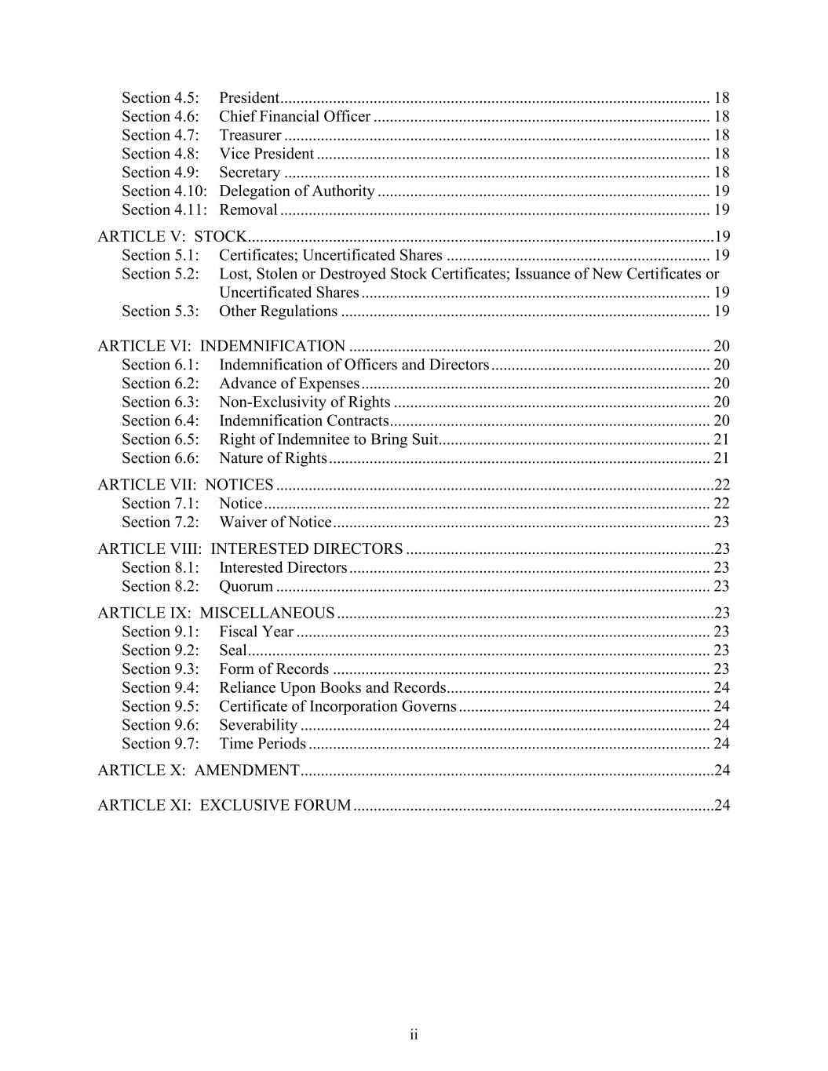
ii Section 4.5: President .......................................................................................................... 18 Section 4.6: Chief Financial Officer ................................................................................... 18 Section 4.7: Treasurer ......................................................................................................... 18 Section 4.8: Vice President ................................................................................................. 18 Section 4.9: Secretary ......................................................................................................... 18 Section 4.10: Delegation of Authority .................................................................................. 19 Section 4.11: Removal .......................................................................................................... 19 ARTICLE V: STOCK...................................................................................................................19 Section 5.1: Certificates; Uncertificated Shares ................................................................. 19 Section 5.2: Lost, Stolen or Destroyed Stock Certificates; Issuance of New Certificates or Uncertificated Shares ...................................................................................... 19 Section 5.3: Other Regulations ........................................................................................... 19 ARTICLE VI: INDEMNIFICATION ......................................................................................... 20 Section 6.1: Indemnification of Officers and Directors ...................................................... 20 Section 6.2: Advance of Expenses ...................................................................................... 20 Section 6.3: Non-Exclusivity of Rights .............................................................................. 20 Section 6.4: Indemnification Contracts ............................................................................... 20 Section 6.5: Right of Indemnitee to Bring Suit ................................................................... 21 Section 6.6: Nature of Rights .............................................................................................. 21 ARTICLE VII: NOTICES ............................................................................................................22 Section 7.1: Notice .............................................................................................................. 22 Section 7.2: Waiver of Notice ............................................................................................. 23 ARTICLE VIII: INTERESTED DIRECTORS ............................................................................23 Section 8.1: Interested Directors ......................................................................................... 23 Section 8.2: Quorum ........................................................................................................... 23 ARTICLE IX: MISCELLANEOUS .............................................................................................23 Section 9.1: Fiscal Year ...................................................................................................... 23 Section 9.2: Seal .................................................................................................................. 23 Section 9.3: Form of Records ............................................................................................. 23 Section 9.4: Reliance Upon Books and Records................................................................. 24 Section 9.5: Certificate of Incorporation Governs .............................................................. 24 Section 9.6: Severability ..................................................................................................... 24 Section 9.7: Time Periods ................................................................................................... 24 ARTICLE X: AMENDMENT ......................................................................................................24 ARTICLE XI: EXCLUSIVE FORUM .........................................................................................24

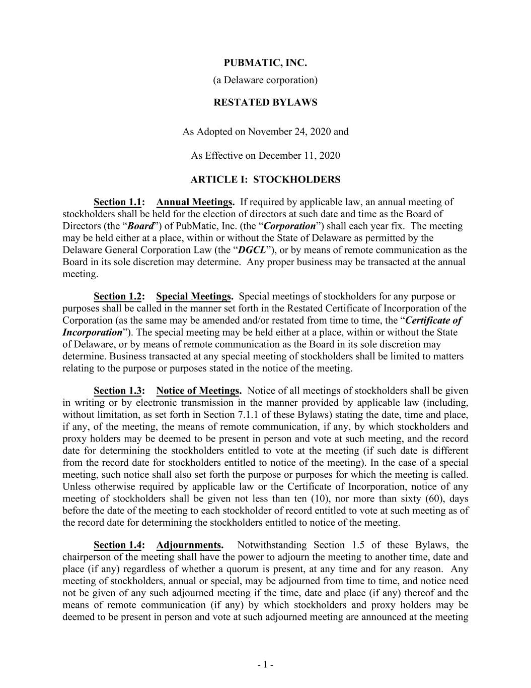
- 1 - PUBMATIC, INC. (a Delaware corporation) RESTATED BYLAWS As Adopted on November 24, 2020 and As Effective on December 11, 2020 ARTICLE I: STOCKHOLDERS Section 1.1: Annual Meetings. If required by applicable law, an annual meeting of stockholders shall be held for the election of directors at such date and time as the Board of Directors (the “Board”) of PubMatic, Inc. (the “Corporation”) shall each year fix. The meeting may be held either at a place, within or without the State of Delaware as permitted by the Delaware General Corporation Law (the “DGCL”), or by means of remote communication as the Board in its sole discretion may determine. Any proper business may be transacted at the annual meeting. Section 1.2: Special Meetings. Special meetings of stockholders for any purpose or purposes shall be called in the manner set forth in the Restated Certificate of Incorporation of the Corporation (as the same may be amended and/or restated from time to time, the “Certificate of Incorporation”). The special meeting may be held either at a place, within or without the State of Delaware, or by means of remote communication as the Board in its sole discretion may determine. Business transacted at any special meeting of stockholders shall be limited to matters relating to the purpose or purposes stated in the notice of the meeting. Section 1.3: Notice of Meetings. Notice of all meetings of stockholders shall be given in writing or by electronic transmission in the manner provided by applicable law (including, without limitation, as set forth in Section 7.1.1 of these Bylaws) stating the date, time and place, if any, of the meeting, the means of remote communication, if any, by which stockholders and proxy holders may be deemed to be present in person and vote at such meeting, and the record date for determining the stockholders entitled to vote at the meeting (if such date is different from the record date for stockholders entitled to notice of the meeting). In the case of a special meeting, such notice shall also set forth the purpose or purposes for which the meeting is called. Unless otherwise required by applicable law or the Certificate of Incorporation, notice of any meeting of stockholders shall be given not less than ten (10), nor more than sixty (60), days before the date of the meeting to each stockholder of record entitled to vote at such meeting as of the record date for determining the stockholders entitled to notice of the meeting. Section 1.4: Adjournments. Notwithstanding Section 1.5 of these Bylaws, the chairperson of the meeting shall have the power to adjourn the meeting to another time, date and place (if any) regardless of whether a quorum is present, at any time and for any reason. Any meeting of stockholders, annual or special, may be adjourned from time to time, and notice need not be given of any such adjourned meeting if the time, date and place (if any) thereof and the means of remote communication (if any) by which stockholders and proxy holders may be deemed to be present in person and vote at such adjourned meeting are announced at the meeting

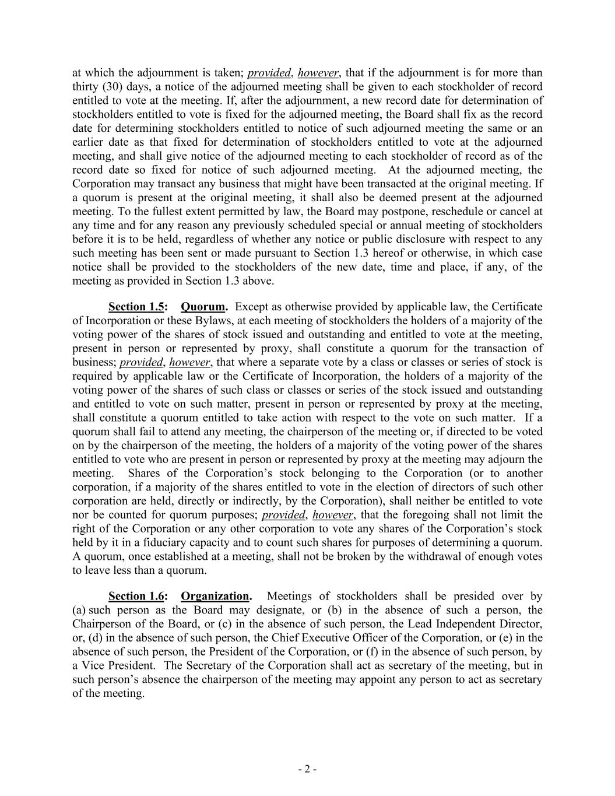
- 2 - at which the adjournment is taken; provided, however, that if the adjournment is for more than thirty (30) days, a notice of the adjourned meeting shall be given to each stockholder of record entitled to vote at the meeting. If, after the adjournment, a new record date for determination of stockholders entitled to vote is fixed for the adjourned meeting, the Board shall fix as the record date for determining stockholders entitled to notice of such adjourned meeting the same or an earlier date as that fixed for determination of stockholders entitled to vote at the adjourned meeting, and shall give notice of the adjourned meeting to each stockholder of record as of the record date so fixed for notice of such adjourned meeting. At the adjourned meeting, the Corporation may transact any business that might have been transacted at the original meeting. If a quorum is present at the original meeting, it shall also be deemed present at the adjourned meeting. To the fullest extent permitted by law, the Board may postpone, reschedule or cancel at any time and for any reason any previously scheduled special or annual meeting of stockholders before it is to be held, regardless of whether any notice or public disclosure with respect to any such meeting has been sent or made pursuant to Section 1.3 hereof or otherwise, in which case notice shall be provided to the stockholders of the new date, time and place, if any, of the meeting as provided in Section 1.3 above. Section 1.5: Quorum. Except as otherwise provided by applicable law, the Certificate of Incorporation or these Bylaws, at each meeting of stockholders the holders of a majority of the voting power of the shares of stock issued and outstanding and entitled to vote at the meeting, present in person or represented by proxy, shall constitute a quorum for the transaction of business; provided, however, that where a separate vote by a class or classes or series of stock is required by applicable law or the Certificate of Incorporation, the holders of a majority of the voting power of the shares of such class or classes or series of the stock issued and outstanding and entitled to vote on such matter, present in person or represented by proxy at the meeting, shall constitute a quorum entitled to take action with respect to the vote on such matter. If a quorum shall fail to attend any meeting, the chairperson of the meeting or, if directed to be voted on by the chairperson of the meeting, the holders of a majority of the voting power of the shares entitled to vote who are present in person or represented by proxy at the meeting may adjourn the meeting. Shares of the Corporation’s stock belonging to the Corporation (or to another corporation, if a majority of the shares entitled to vote in the election of directors of such other corporation are held, directly or indirectly, by the Corporation), shall neither be entitled to vote nor be counted for quorum purposes; provided, however, that the foregoing shall not limit the right of the Corporation or any other corporation to vote any shares of the Corporation’s stock held by it in a fiduciary capacity and to count such shares for purposes of determining a quorum. A quorum, once established at a meeting, shall not be broken by the withdrawal of enough votes to leave less than a quorum. Section 1.6: Organization. Meetings of stockholders shall be presided over by (a) such person as the Board may designate, or (b) in the absence of such a person, the Chairperson of the Board, or (c) in the absence of such person, the Lead Independent Director, or, (d) in the absence of such person, the Chief Executive Officer of the Corporation, or (e) in the absence of such person, the President of the Corporation, or (f) in the absence of such person, by a Vice President. The Secretary of the Corporation shall act as secretary of the meeting, but in such person’s absence the chairperson of the meeting may appoint any person to act as secretary of the meeting.

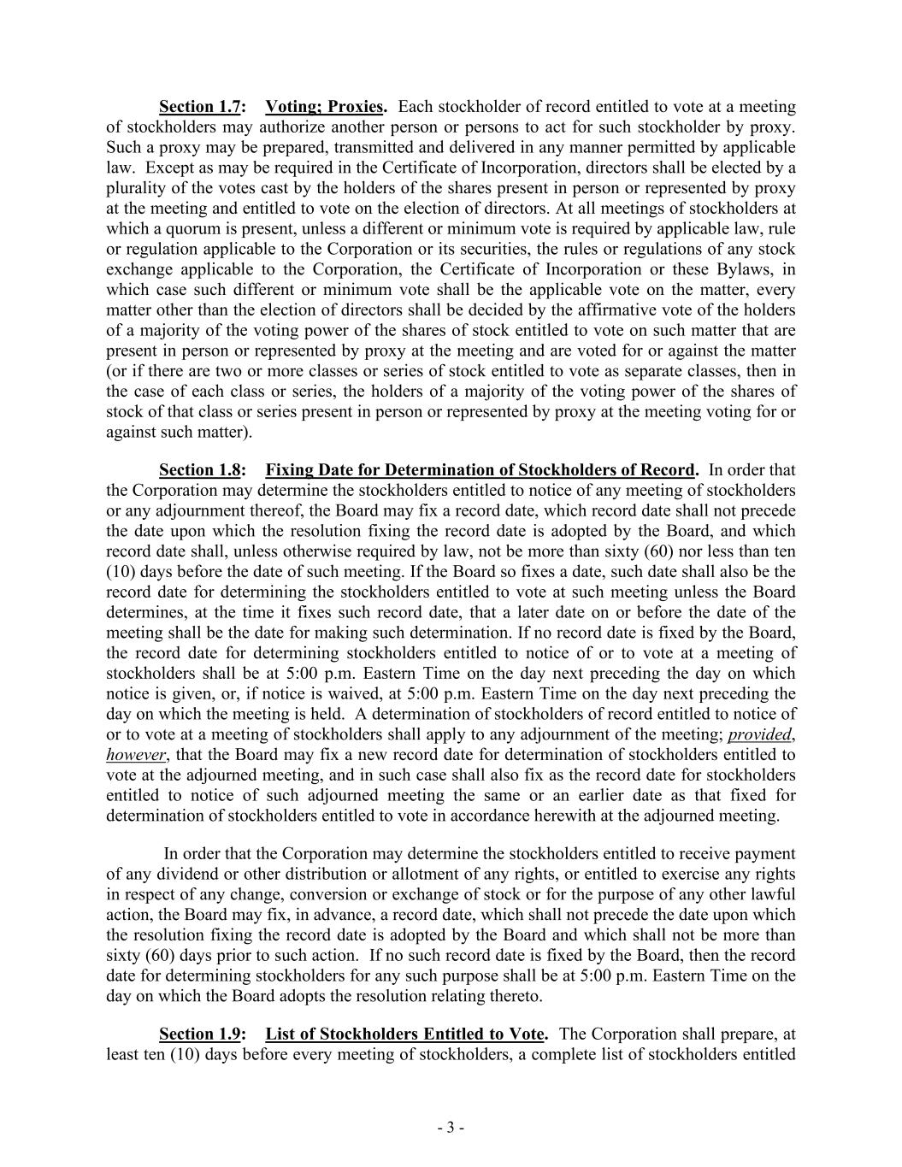
- 3 - Section 1.7: Voting; Proxies. Each stockholder of record entitled to vote at a meeting of stockholders may authorize another person or persons to act for such stockholder by proxy. Such a proxy may be prepared, transmitted and delivered in any manner permitted by applicable law. Except as may be required in the Certificate of Incorporation, directors shall be elected by a plurality of the votes cast by the holders of the shares present in person or represented by proxy at the meeting and entitled to vote on the election of directors. At all meetings of stockholders at which a quorum is present, unless a different or minimum vote is required by applicable law, rule or regulation applicable to the Corporation or its securities, the rules or regulations of any stock exchange applicable to the Corporation, the Certificate of Incorporation or these Bylaws, in which case such different or minimum vote shall be the applicable vote on the matter, every matter other than the election of directors shall be decided by the affirmative vote of the holders of a majority of the voting power of the shares of stock entitled to vote on such matter that are present in person or represented by proxy at the meeting and are voted for or against the matter (or if there are two or more classes or series of stock entitled to vote as separate classes, then in the case of each class or series, the holders of a majority of the voting power of the shares of stock of that class or series present in person or represented by proxy at the meeting voting for or against such matter). Section 1.8: Fixing Date for Determination of Stockholders of Record. In order that the Corporation may determine the stockholders entitled to notice of any meeting of stockholders or any adjournment thereof, the Board may fix a record date, which record date shall not precede the date upon which the resolution fixing the record date is adopted by the Board, and which record date shall, unless otherwise required by law, not be more than sixty (60) nor less than ten (10) days before the date of such meeting. If the Board so fixes a date, such date shall also be the record date for determining the stockholders entitled to vote at such meeting unless the Board determines, at the time it fixes such record date, that a later date on or before the date of the meeting shall be the date for making such determination. If no record date is fixed by the Board, the record date for determining stockholders entitled to notice of or to vote at a meeting of stockholders shall be at 5:00 p.m. Eastern Time on the day next preceding the day on which notice is given, or, if notice is waived, at 5:00 p.m. Eastern Time on the day next preceding the day on which the meeting is held. A determination of stockholders of record entitled to notice of or to vote at a meeting of stockholders shall apply to any adjournment of the meeting; provided, however, that the Board may fix a new record date for determination of stockholders entitled to vote at the adjourned meeting, and in such case shall also fix as the record date for stockholders entitled to notice of such adjourned meeting the same or an earlier date as that fixed for determination of stockholders entitled to vote in accordance herewith at the adjourned meeting. In order that the Corporation may determine the stockholders entitled to receive payment of any dividend or other distribution or allotment of any rights, or entitled to exercise any rights in respect of any change, conversion or exchange of stock or for the purpose of any other lawful action, the Board may fix, in advance, a record date, which shall not precede the date upon which the resolution fixing the record date is adopted by the Board and which shall not be more than sixty (60) days prior to such action. If no such record date is fixed by the Board, then the record date for determining stockholders for any such purpose shall be at 5:00 p.m. Eastern Time on the day on which the Board adopts the resolution relating thereto. Section 1.9: List of Stockholders Entitled to Vote. The Corporation shall prepare, at least ten (10) days before every meeting of stockholders, a complete list of stockholders entitled

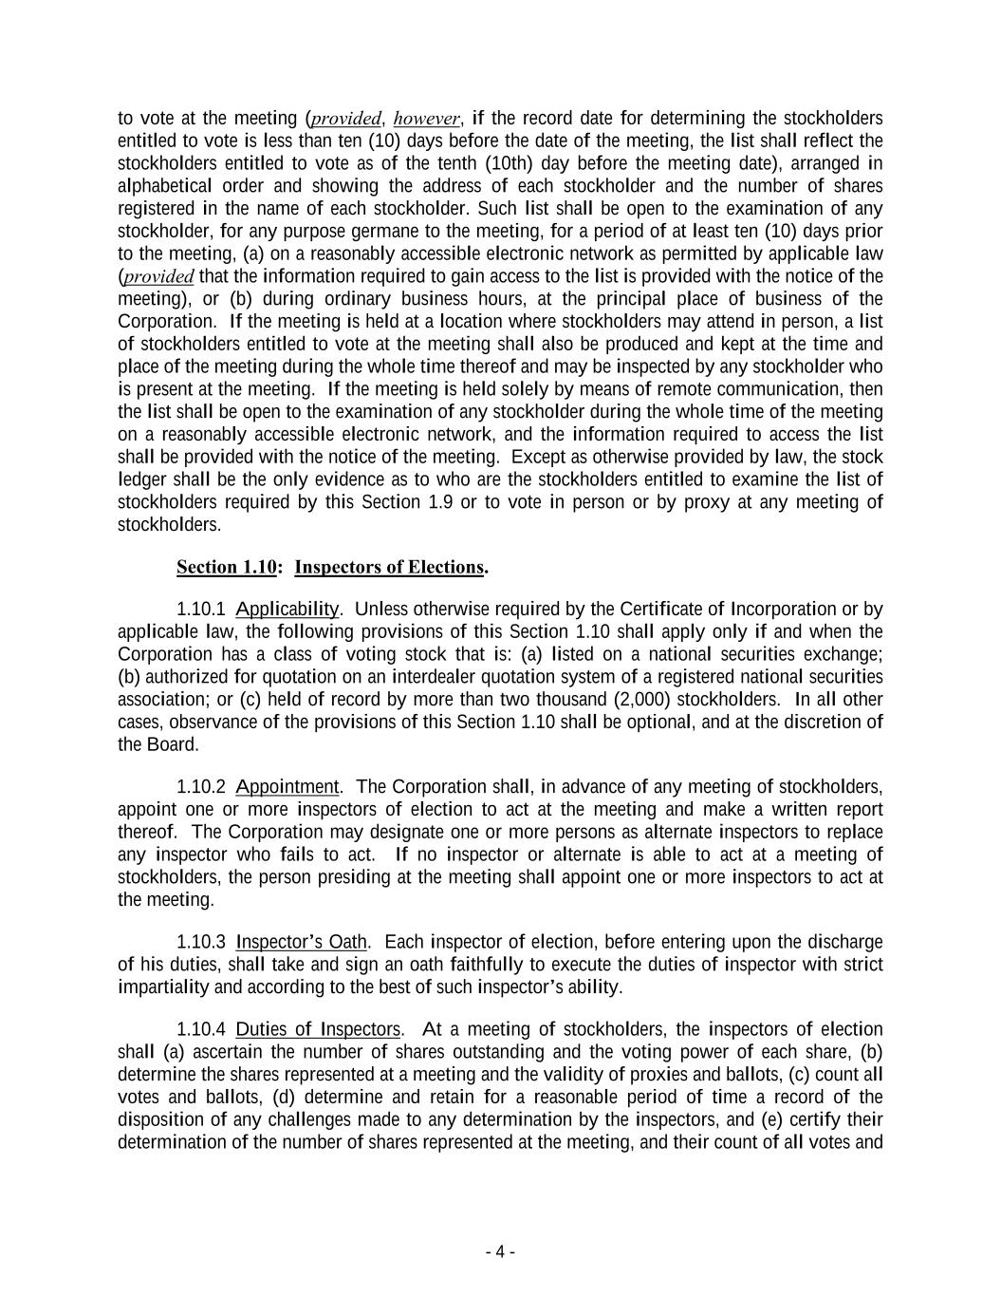
- 4 - to vote at the meeting (provided, however, if the record date for determining the stockholders entitled to vote is less than ten (10) days before the date of the meeting, the list shall reflect the stockholders entitled to vote as of the tenth (10th) day before the meeting date), arranged in alphabetical order and showing the address of each stockholder and the number of shares registered in the name of each stockholder. Such list shall be open to the examination of any stockholder, for any purpose germane to the meeting, for a period of at least ten (10) days prior to the meeting, (a) on a reasonably accessible electronic network as permitted by applicable law (provided that the information required to gain access to the list is provided with the notice of the meeting), or (b) during ordinary business hours, at the principal place of business of the Corporation. If the meeting is held at a location where stockholders may attend in person, a list of stockholders entitled to vote at the meeting shall also be produced and kept at the time and place of the meeting during the whole time thereof and may be inspected by any stockholder who is present at the meeting. If the meeting is held solely by means of remote communication, then the list shall be open to the examination of any stockholder during the whole time of the meeting on a reasonably accessible electronic network, and the information required to access the list shall be provided with the notice of the meeting. Except as otherwise provided by law, the stock ledger shall be the only evidence as to who are the stockholders entitled to examine the list of stockholders required by this Section 1.9 or to vote in person or by proxy at any meeting of stockholders. Section 1.10: Inspectors of Elections. 1.10.1 Applicability. Unless otherwise required by the Certificate of Incorporation or by applicable law, the following provisions of this Section 1.10 shall apply only if and when the Corporation has a class of voting stock that is: (a) listed on a national securities exchange; (b) authorized for quotation on an interdealer quotation system of a registered national securities association; or (c) held of record by more than two thousand (2,000) stockholders. In all other cases, observance of the provisions of this Section 1.10 shall be optional, and at the discretion of the Board. 1.10.2 Appointment. The Corporation shall, in advance of any meeting of stockholders, appoint one or more inspectors of election to act at the meeting and make a written report thereof. The Corporation may designate one or more persons as alternate inspectors to replace any inspector who fails to act. If no inspector or alternate is able to act at a meeting of stockholders, the person presiding at the meeting shall appoint one or more inspectors to act at the meeting. 1.10.3 Inspector’s Oath. Each inspector of election, before entering upon the discharge of his duties, shall take and sign an oath faithfully to execute the duties of inspector with strict impartiality and according to the best of such inspector’s ability. 1.10.4 Duties of Inspectors. At a meeting of stockholders, the inspectors of election shall (a) ascertain the number of shares outstanding and the voting power of each share, (b) determine the shares represented at a meeting and the validity of proxies and ballots, (c) count all votes and ballots, (d) determine and retain for a reasonable period of time a record of the disposition of any challenges made to any determination by the inspectors, and (e) certify their determination of the number of shares represented at the meeting, and their count of all votes and

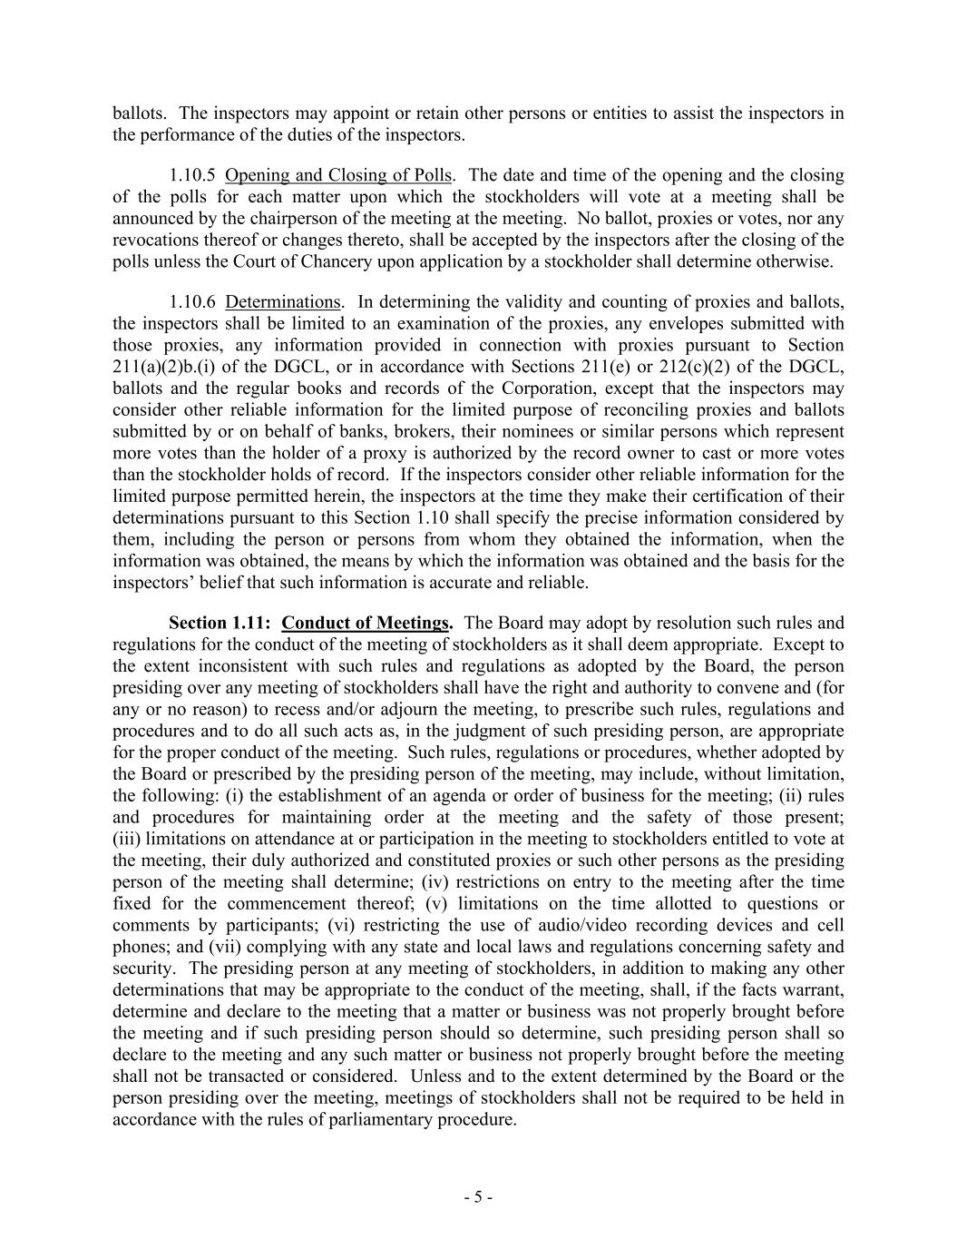
- 5 - ballots. The inspectors may appoint or retain other persons or entities to assist the inspectors in the performance of the duties of the inspectors. 1.10.5 Opening and Closing of Polls. The date and time of the opening and the closing of the polls for each matter upon which the stockholders will vote at a meeting shall be announced by the chairperson of the meeting at the meeting. No ballot, proxies or votes, nor any revocations thereof or changes thereto, shall be accepted by the inspectors after the closing of the polls unless the Court of Chancery upon application by a stockholder shall determine otherwise. 1.10.6 Determinations. In determining the validity and counting of proxies and ballots, the inspectors shall be limited to an examination of the proxies, any envelopes submitted with those proxies, any information provided in connection with proxies pursuant to Section 211(a)(2)b.(i) of the DGCL, or in accordance with Sections 211(e) or 212(c)(2) of the DGCL, ballots and the regular books and records of the Corporation, except that the inspectors may consider other reliable information for the limited purpose of reconciling proxies and ballots submitted by or on behalf of banks, brokers, their nominees or similar persons which represent more votes than the holder of a proxy is authorized by the record owner to cast or more votes than the stockholder holds of record. If the inspectors consider other reliable information for the limited purpose permitted herein, the inspectors at the time they make their certification of their determinations pursuant to this Section 1.10 shall specify the precise information considered by them, including the person or persons from whom they obtained the information, when the information was obtained, the means by which the information was obtained and the basis for the inspectors’ belief that such information is accurate and reliable. Section 1.11: Conduct of Meetings. The Board may adopt by resolution such rules and regulations for the conduct of the meeting of stockholders as it shall deem appropriate. Except to the extent inconsistent with such rules and regulations as adopted by the Board, the person presiding over any meeting of stockholders shall have the right and authority to convene and (for any or no reason) to recess and/or adjourn the meeting, to prescribe such rules, regulations and procedures and to do all such acts as, in the judgment of such presiding person, are appropriate for the proper conduct of the meeting. Such rules, regulations or procedures, whether adopted by the Board or prescribed by the presiding person of the meeting, may include, without limitation, the following: (i) the establishment of an agenda or order of business for the meeting; (ii) rules and procedures for maintaining order at the meeting and the safety of those present; (iii) limitations on attendance at or participation in the meeting to stockholders entitled to vote at the meeting, their duly authorized and constituted proxies or such other persons as the presiding person of the meeting shall determine; (iv) restrictions on entry to the meeting after the time fixed for the commencement thereof; (v) limitations on the time allotted to questions or comments by participants; (vi) restricting the use of audio/video recording devices and cell phones; and (vii) complying with any state and local laws and regulations concerning safety and security. The presiding person at any meeting of stockholders, in addition to making any other determinations that may be appropriate to the conduct of the meeting, shall, if the facts warrant, determine and declare to the meeting that a matter or business was not properly brought before the meeting and if such presiding person should so determine, such presiding person shall so declare to the meeting and any such matter or business not properly brought before the meeting shall not be transacted or considered. Unless and to the extent determined by the Board or the person presiding over the meeting, meetings of stockholders shall not be required to be held in accordance with the rules of parliamentary procedure.

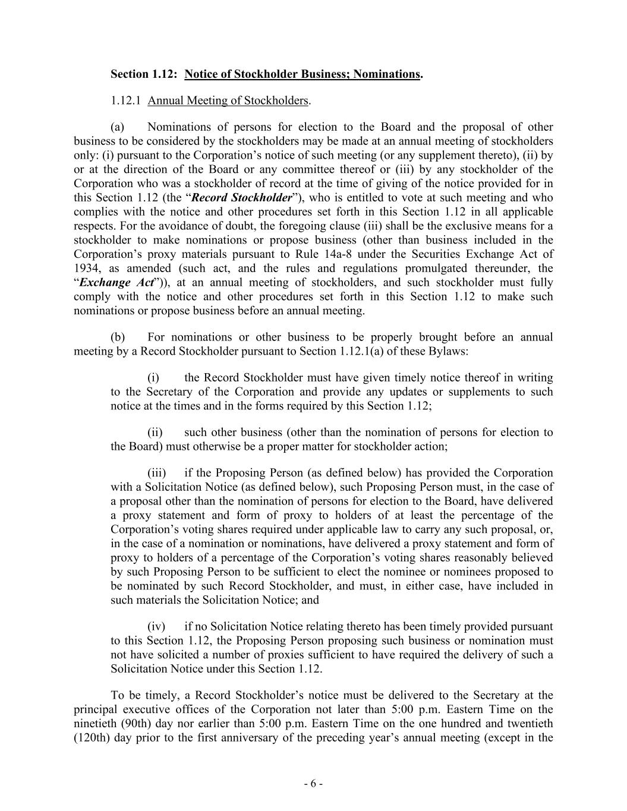
- 6 - Section 1.12: Notice of Stockholder Business; Nominations. 1.12.1 Annual Meeting of Stockholders. (a) Nominations of persons for election to the Board and the proposal of other business to be considered by the stockholders may be made at an annual meeting of stockholders only: (i) pursuant to the Corporation’s notice of such meeting (or any supplement thereto), (ii) by or at the direction of the Board or any committee thereof or (iii) by any stockholder of the Corporation who was a stockholder of record at the time of giving of the notice provided for in this Section 1.12 (the “Record Stockholder”), who is entitled to vote at such meeting and who complies with the notice and other procedures set forth in this Section 1.12 in all applicable respects. For the avoidance of doubt, the foregoing clause (iii) shall be the exclusive means for a stockholder to make nominations or propose business (other than business included in the Corporation’s proxy materials pursuant to Rule 14a-8 under the Securities Exchange Act of 1934, as amended (such act, and the rules and regulations promulgated thereunder, the “Exchange Act”)), at an annual meeting of stockholders, and such stockholder must fully comply with the notice and other procedures set forth in this Section 1.12 to make such nominations or propose business before an annual meeting. (b) For nominations or other business to be properly brought before an annual meeting by a Record Stockholder pursuant to Section 1.12.1(a) of these Bylaws: (i) the Record Stockholder must have given timely notice thereof in writing to the Secretary of the Corporation and provide any updates or supplements to such notice at the times and in the forms required by this Section 1.12; (ii) such other business (other than the nomination of persons for election to the Board) must otherwise be a proper matter for stockholder action; (iii) if the Proposing Person (as defined below) has provided the Corporation with a Solicitation Notice (as defined below), such Proposing Person must, in the case of a proposal other than the nomination of persons for election to the Board, have delivered a proxy statement and form of proxy to holders of at least the percentage of the Corporation’s voting shares required under applicable law to carry any such proposal, or, in the case of a nomination or nominations, have delivered a proxy statement and form of proxy to holders of a percentage of the Corporation’s voting shares reasonably believed by such Proposing Person to be sufficient to elect the nominee or nominees proposed to be nominated by such Record Stockholder, and must, in either case, have included in such materials the Solicitation Notice; and (iv) if no Solicitation Notice relating thereto has been timely provided pursuant to this Section 1.12, the Proposing Person proposing such business or nomination must not have solicited a number of proxies sufficient to have required the delivery of such a Solicitation Notice under this Section 1.12. To be timely, a Record Stockholder’s notice must be delivered to the Secretary at the principal executive offices of the Corporation not later than 5:00 p.m. Eastern Time on the ninetieth (90th) day nor earlier than 5:00 p.m. Eastern Time on the one hundred and twentieth (120th) day prior to the first anniversary of the preceding year’s annual meeting (except in the

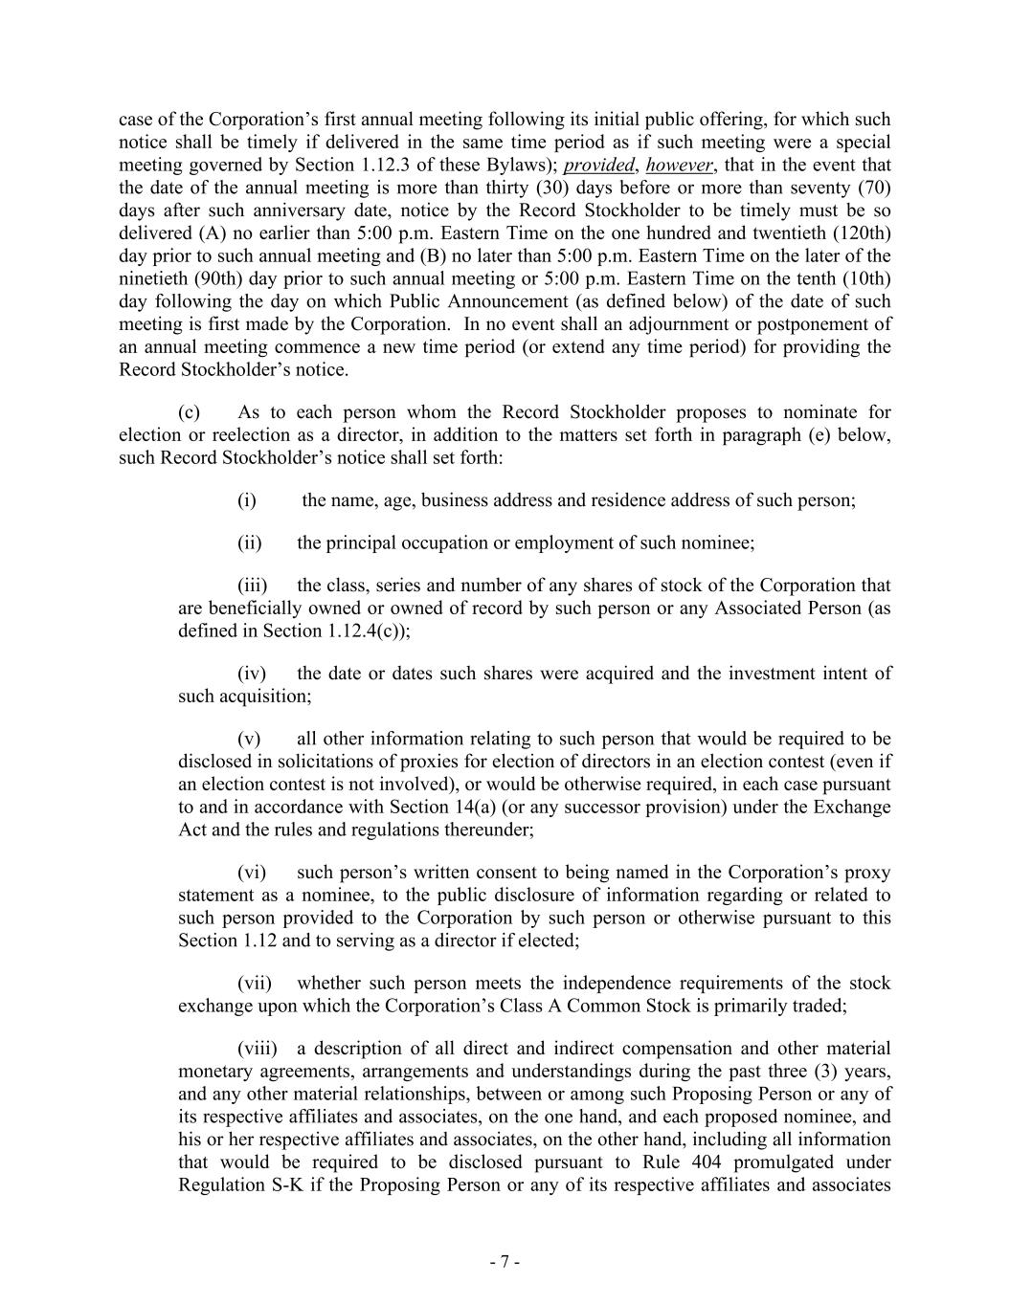
- 7 - case of the Corporation’s first annual meeting following its initial public offering, for which such notice shall be timely if delivered in the same time period as if such meeting were a special meeting governed by Section 1.12.3 of these Bylaws); provided, however, that in the event that the date of the annual meeting is more than thirty (30) days before or more than seventy (70) days after such anniversary date, notice by the Record Stockholder to be timely must be so delivered (A) no earlier than 5:00 p.m. Eastern Time on the one hundred and twentieth (120th) day prior to such annual meeting and (B) no later than 5:00 p.m. Eastern Time on the later of the ninetieth (90th) day prior to such annual meeting or 5:00 p.m. Eastern Time on the tenth (10th) day following the day on which Public Announcement (as defined below) of the date of such meeting is first made by the Corporation. In no event shall an adjournment or postponement of an annual meeting commence a new time period (or extend any time period) for providing the Record Stockholder’s notice. (c) As to each person whom the Record Stockholder proposes to nominate for election or reelection as a director, in addition to the matters set forth in paragraph (e) below, such Record Stockholder’s notice shall set forth: (i) the name, age, business address and residence address of such person; (ii) the principal occupation or employment of such nominee; (iii) the class, series and number of any shares of stock of the Corporation that are beneficially owned or owned of record by such person or any Associated Person (as defined in Section 1.12.4(c)); (iv) the date or dates such shares were acquired and the investment intent of such acquisition; (v) all other information relating to such person that would be required to be disclosed in solicitations of proxies for election of directors in an election contest (even if an election contest is not involved), or would be otherwise required, in each case pursuant to and in accordance with Section 14(a) (or any successor provision) under the Exchange Act and the rules and regulations thereunder; (vi) such person’s written consent to being named in the Corporation’s proxy statement as a nominee, to the public disclosure of information regarding or related to such person provided to the Corporation by such person or otherwise pursuant to this Section 1.12 and to serving as a director if elected; (vii) whether such person meets the independence requirements of the stock exchange upon which the Corporation’s Class A Common Stock is primarily traded; (viii) a description of all direct and indirect compensation and other material monetary agreements, arrangements and understandings during the past three (3) years, and any other material relationships, between or among such Proposing Person or any of its respective affiliates and associates, on the one hand, and each proposed nominee, and his or her respective affiliates and associates, on the other hand, including all information that would be required to be disclosed pursuant to Rule 404 promulgated under Regulation S-K if the Proposing Person or any of its respective affiliates and associates

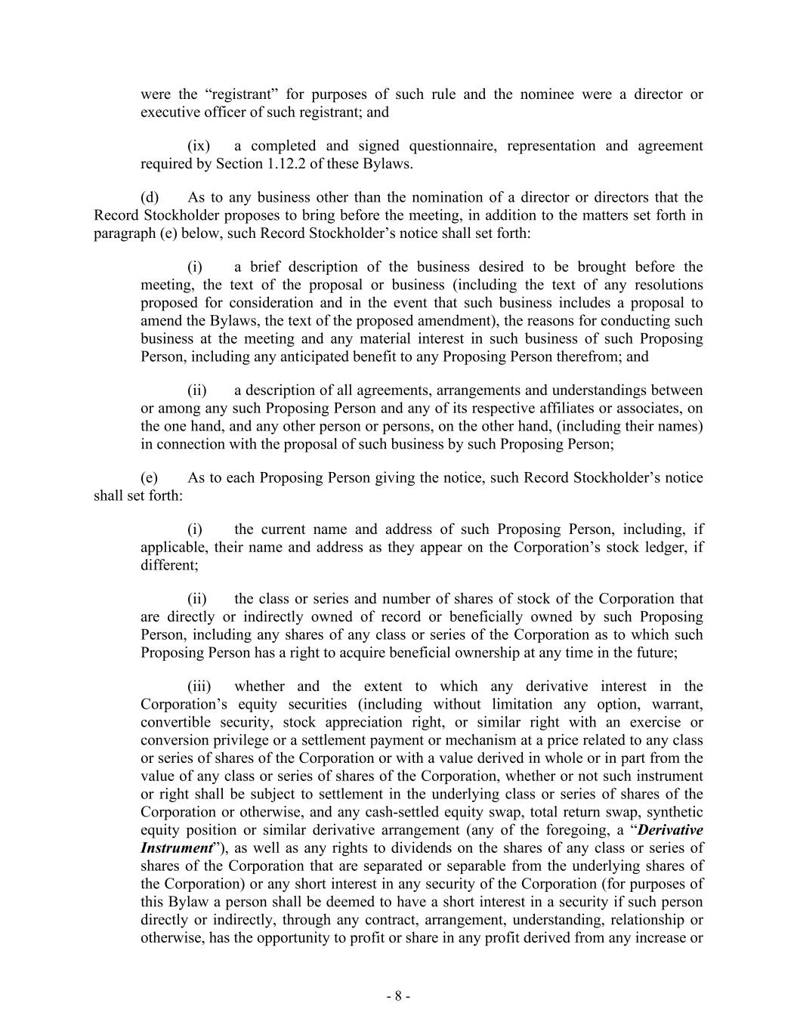
- 8 - were the “registrant” for purposes of such rule and the nominee were a director or executive officer of such registrant; and (ix) a completed and signed questionnaire, representation and agreement required by Section 1.12.2 of these Bylaws. (d) As to any business other than the nomination of a director or directors that the Record Stockholder proposes to bring before the meeting, in addition to the matters set forth in paragraph (e) below, such Record Stockholder’s notice shall set forth: (i) a brief description of the business desired to be brought before the meeting, the text of the proposal or business (including the text of any resolutions proposed for consideration and in the event that such business includes a proposal to amend the Bylaws, the text of the proposed amendment), the reasons for conducting such business at the meeting and any material interest in such business of such Proposing Person, including any anticipated benefit to any Proposing Person therefrom; and (ii) a description of all agreements, arrangements and understandings between or among any such Proposing Person and any of its respective affiliates or associates, on the one hand, and any other person or persons, on the other hand, (including their names) in connection with the proposal of such business by such Proposing Person; (e) As to each Proposing Person giving the notice, such Record Stockholder’s notice shall set forth: (i) the current name and address of such Proposing Person, including, if applicable, their name and address as they appear on the Corporation’s stock ledger, if different; (ii) the class or series and number of shares of stock of the Corporation that are directly or indirectly owned of record or beneficially owned by such Proposing Person, including any shares of any class or series of the Corporation as to which such Proposing Person has a right to acquire beneficial ownership at any time in the future; (iii) whether and the extent to which any derivative interest in the Corporation’s equity securities (including without limitation any option, warrant, convertible security, stock appreciation right, or similar right with an exercise or conversion privilege or a settlement payment or mechanism at a price related to any class or series of shares of the Corporation or with a value derived in whole or in part from the value of any class or series of shares of the Corporation, whether or not such instrument or right shall be subject to settlement in the underlying class or series of shares of the Corporation or otherwise, and any cash-settled equity swap, total return swap, synthetic equity position or similar derivative arrangement (any of the foregoing, a “Derivative Instrument”), as well as any rights to dividends on the shares of any class or series of shares of the Corporation that are separated or separable from the underlying shares of the Corporation) or any short interest in any security of the Corporation (for purposes of this Bylaw a person shall be deemed to have a short interest in a security if such person directly or indirectly, through any contract, arrangement, understanding, relationship or otherwise, has the opportunity to profit or share in any profit derived from any increase or

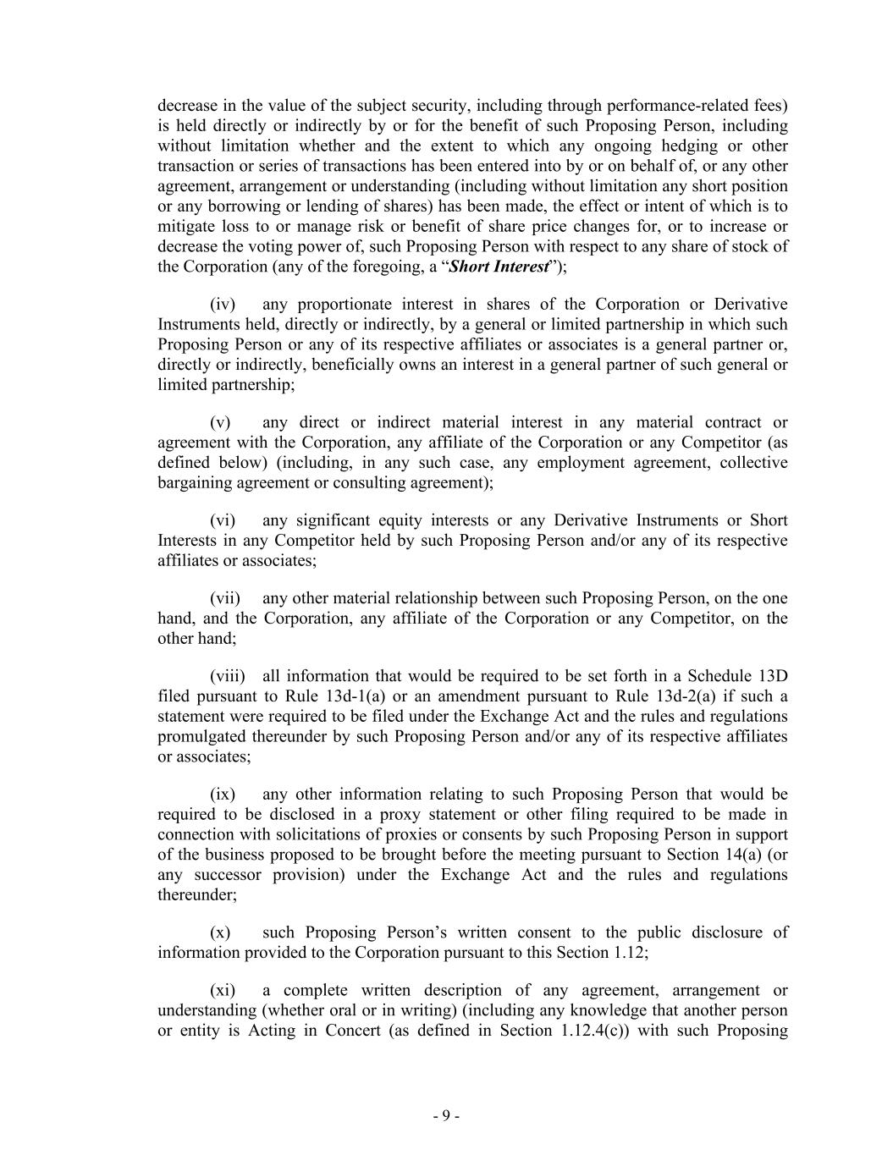
- 9 - decrease in the value of the subject security, including through performance-related fees) is held directly or indirectly by or for the benefit of such Proposing Person, including without limitation whether and the extent to which any ongoing hedging or other transaction or series of transactions has been entered into by or on behalf of, or any other agreement, arrangement or understanding (including without limitation any short position or any borrowing or lending of shares) has been made, the effect or intent of which is to mitigate loss to or manage risk or benefit of share price changes for, or to increase or decrease the voting power of, such Proposing Person with respect to any share of stock of the Corporation (any of the foregoing, a “Short Interest”); (iv) any proportionate interest in shares of the Corporation or Derivative Instruments held, directly or indirectly, by a general or limited partnership in which such Proposing Person or any of its respective affiliates or associates is a general partner or, directly or indirectly, beneficially owns an interest in a general partner of such general or limited partnership; (v) any direct or indirect material interest in any material contract or agreement with the Corporation, any affiliate of the Corporation or any Competitor (as defined below) (including, in any such case, any employment agreement, collective bargaining agreement or consulting agreement); (vi) any significant equity interests or any Derivative Instruments or Short Interests in any Competitor held by such Proposing Person and/or any of its respective affiliates or associates; (vii) any other material relationship between such Proposing Person, on the one hand, and the Corporation, any affiliate of the Corporation or any Competitor, on the other hand; (viii) all information that would be required to be set forth in a Schedule 13D filed pursuant to Rule 13d-1(a) or an amendment pursuant to Rule 13d-2(a) if such a statement were required to be filed under the Exchange Act and the rules and regulations promulgated thereunder by such Proposing Person and/or any of its respective affiliates or associates; (ix) any other information relating to such Proposing Person that would be required to be disclosed in a proxy statement or other filing required to be made in connection with solicitations of proxies or consents by such Proposing Person in support of the business proposed to be brought before the meeting pursuant to Section 14(a) (or any successor provision) under the Exchange Act and the rules and regulations thereunder; (x) such Proposing Person’s written consent to the public disclosure of information provided to the Corporation pursuant to this Section 1.12; (xi) a complete written description of any agreement, arrangement or understanding (whether oral or in writing) (including any knowledge that another person or entity is Acting in Concert (as defined in Section 1.12.4(c)) with such Proposing

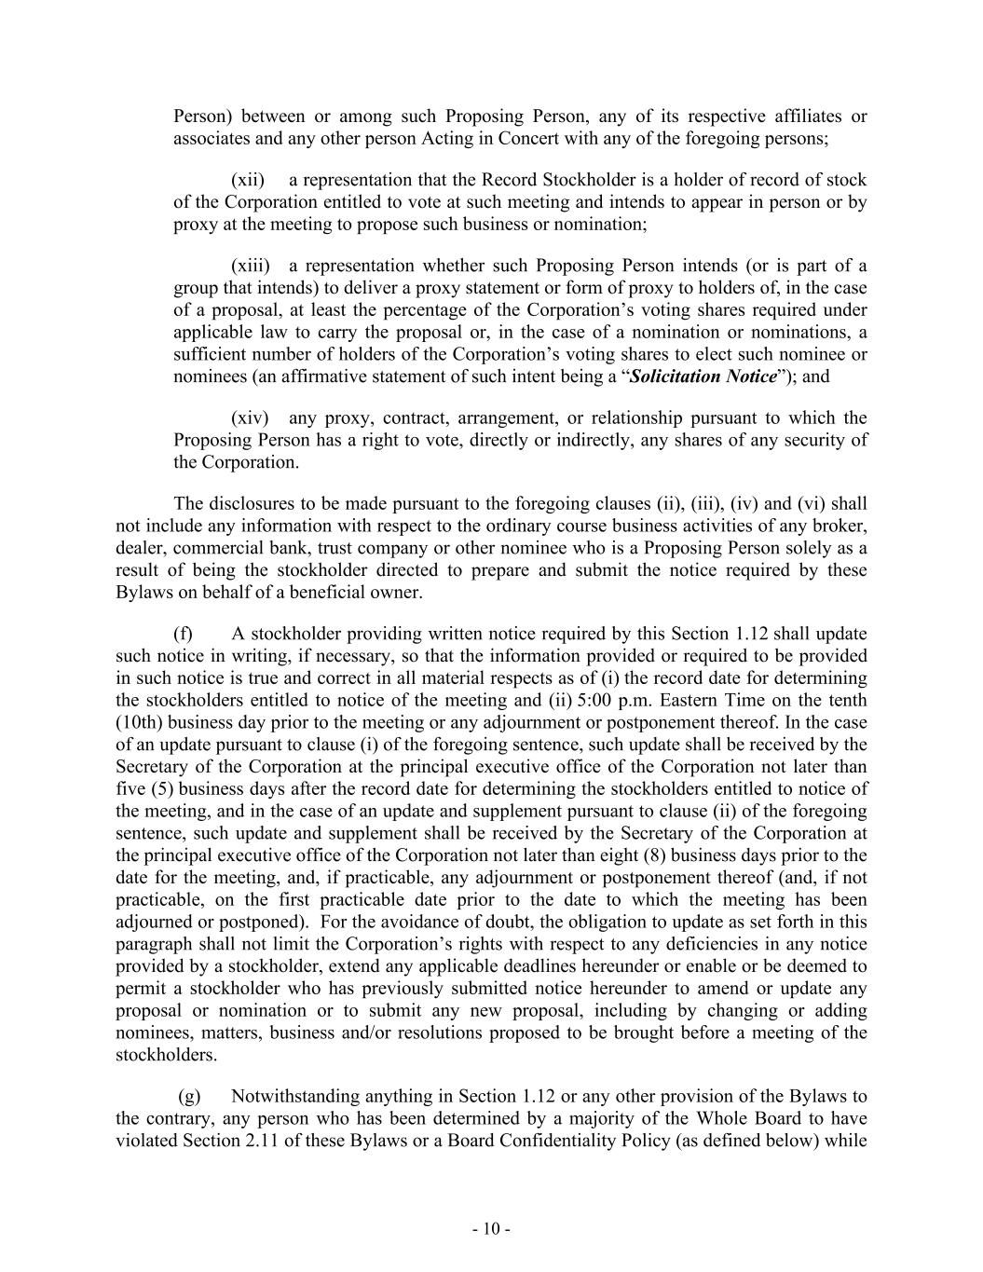
- 10 - Person) between or among such Proposing Person, any of its respective affiliates or associates and any other person Acting in Concert with any of the foregoing persons; (xii) a representation that the Record Stockholder is a holder of record of stock of the Corporation entitled to vote at such meeting and intends to appear in person or by proxy at the meeting to propose such business or nomination; (xiii) a representation whether such Proposing Person intends (or is part of a group that intends) to deliver a proxy statement or form of proxy to holders of, in the case of a proposal, at least the percentage of the Corporation’s voting shares required under applicable law to carry the proposal or, in the case of a nomination or nominations, a sufficient number of holders of the Corporation’s voting shares to elect such nominee or nominees (an affirmative statement of such intent being a “Solicitation Notice”); and (xiv) any proxy, contract, arrangement, or relationship pursuant to which the Proposing Person has a right to vote, directly or indirectly, any shares of any security of the Corporation. The disclosures to be made pursuant to the foregoing clauses (ii), (iii), (iv) and (vi) shall not include any information with respect to the ordinary course business activities of any broker, dealer, commercial bank, trust company or other nominee who is a Proposing Person solely as a result of being the stockholder directed to prepare and submit the notice required by these Bylaws on behalf of a beneficial owner. (f) A stockholder providing written notice required by this Section 1.12 shall update such notice in writing, if necessary, so that the information provided or required to be provided in such notice is true and correct in all material respects as of (i) the record date for determining the stockholders entitled to notice of the meeting and (ii) 5:00 p.m. Eastern Time on the tenth (10th) business day prior to the meeting or any adjournment or postponement thereof. In the case of an update pursuant to clause (i) of the foregoing sentence, such update shall be received by the Secretary of the Corporation at the principal executive office of the Corporation not later than five (5) business days after the record date for determining the stockholders entitled to notice of the meeting, and in the case of an update and supplement pursuant to clause (ii) of the foregoing sentence, such update and supplement shall be received by the Secretary of the Corporation at the principal executive office of the Corporation not later than eight (8) business days prior to the date for the meeting, and, if practicable, any adjournment or postponement thereof (and, if not practicable, on the first practicable date prior to the date to which the meeting has been adjourned or postponed). For the avoidance of doubt, the obligation to update as set forth in this paragraph shall not limit the Corporation’s rights with respect to any deficiencies in any notice provided by a stockholder, extend any applicable deadlines hereunder or enable or be deemed to permit a stockholder who has previously submitted notice hereunder to amend or update any proposal or nomination or to submit any new proposal, including by changing or adding nominees, matters, business and/or resolutions proposed to be brought before a meeting of the stockholders. (g) Notwithstanding anything in Section 1.12 or any other provision of the Bylaws to the contrary, any person who has been determined by a majority of the Whole Board to have violated Section 2.11 of these Bylaws or a Board Confidentiality Policy (as defined below) while

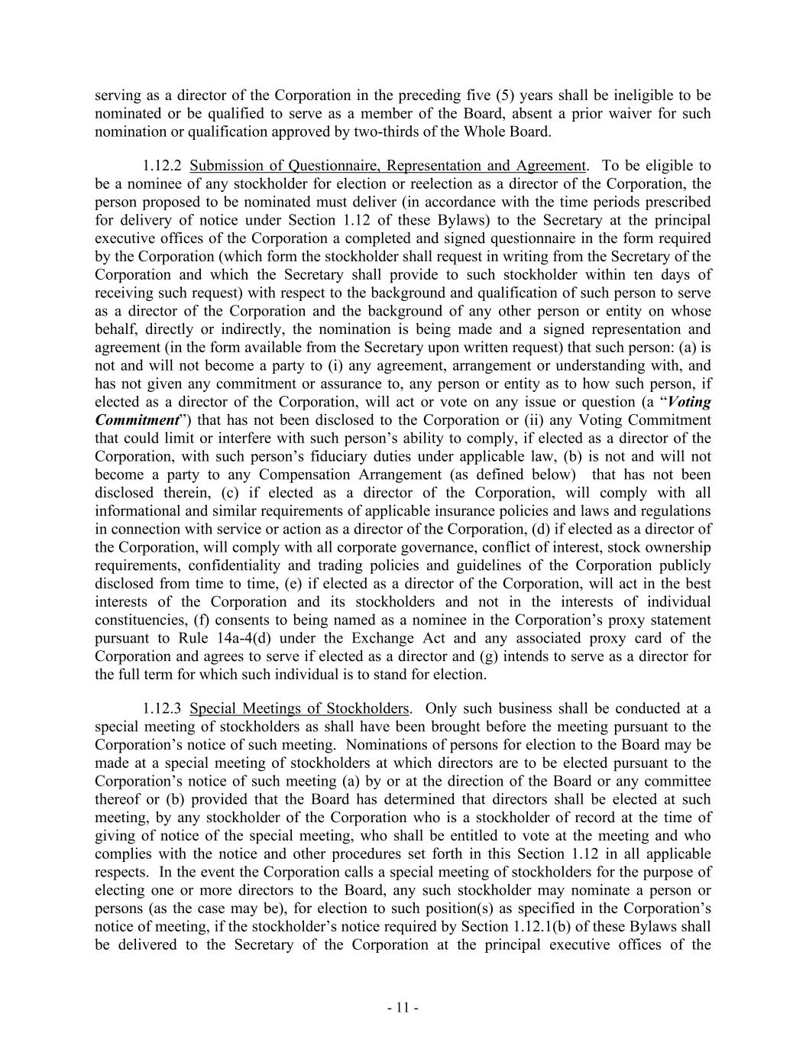
- 11 - serving as a director of the Corporation in the preceding five (5) years shall be ineligible to be nominated or be qualified to serve as a member of the Board, absent a prior waiver for such nomination or qualification approved by two-thirds of the Whole Board. 1.12.2 Submission of Questionnaire, Representation and Agreement. To be eligible to be a nominee of any stockholder for election or reelection as a director of the Corporation, the person proposed to be nominated must deliver (in accordance with the time periods prescribed for delivery of notice under Section 1.12 of these Bylaws) to the Secretary at the principal executive offices of the Corporation a completed and signed questionnaire in the form required by the Corporation (which form the stockholder shall request in writing from the Secretary of the Corporation and which the Secretary shall provide to such stockholder within ten days of receiving such request) with respect to the background and qualification of such person to serve as a director of the Corporation and the background of any other person or entity on whose behalf, directly or indirectly, the nomination is being made and a signed representation and agreement (in the form available from the Secretary upon written request) that such person: (a) is not and will not become a party to (i) any agreement, arrangement or understanding with, and has not given any commitment or assurance to, any person or entity as to how such person, if elected as a director of the Corporation, will act or vote on any issue or question (a “Voting Commitment”) that has not been disclosed to the Corporation or (ii) any Voting Commitment that could limit or interfere with such person’s ability to comply, if elected as a director of the Corporation, with such person’s fiduciary duties under applicable law, (b) is not and will not become a party to any Compensation Arrangement (as defined below) that has not been disclosed therein, (c) if elected as a director of the Corporation, will comply with all informational and similar requirements of applicable insurance policies and laws and regulations in connection with service or action as a director of the Corporation, (d) if elected as a director of the Corporation, will comply with all corporate governance, conflict of interest, stock ownership requirements, confidentiality and trading policies and guidelines of the Corporation publicly disclosed from time to time, (e) if elected as a director of the Corporation, will act in the best interests of the Corporation and its stockholders and not in the interests of individual constituencies, (f) consents to being named as a nominee in the Corporation’s proxy statement pursuant to Rule 14a-4(d) under the Exchange Act and any associated proxy card of the Corporation and agrees to serve if elected as a director and (g) intends to serve as a director for the full term for which such individual is to stand for election. 1.12.3 Special Meetings of Stockholders. Only such business shall be conducted at a special meeting of stockholders as shall have been brought before the meeting pursuant to the Corporation’s notice of such meeting. Nominations of persons for election to the Board may be made at a special meeting of stockholders at which directors are to be elected pursuant to the Corporation’s notice of such meeting (a) by or at the direction of the Board or any committee thereof or (b) provided that the Board has determined that directors shall be elected at such meeting, by any stockholder of the Corporation who is a stockholder of record at the time of giving of notice of the special meeting, who shall be entitled to vote at the meeting and who complies with the notice and other procedures set forth in this Section 1.12 in all applicable respects. In the event the Corporation calls a special meeting of stockholders for the purpose of electing one or more directors to the Board, any such stockholder may nominate a person or persons (as the case may be), for election to such position(s) as specified in the Corporation’s notice of meeting, if the stockholder’s notice required by Section 1.12.1(b) of these Bylaws shall be delivered to the Secretary of the Corporation at the principal executive offices of the

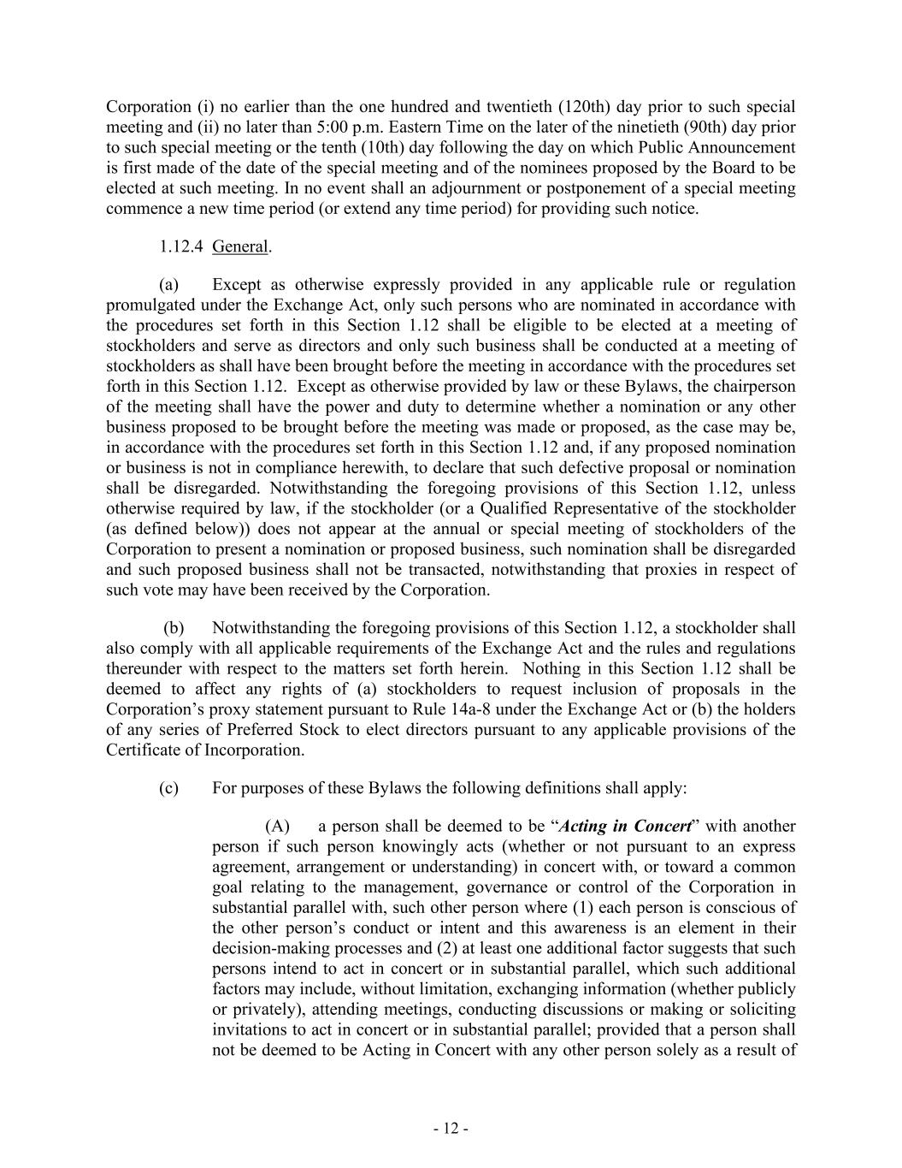
- 12 - Corporation (i) no earlier than the one hundred and twentieth (120th) day prior to such special meeting and (ii) no later than 5:00 p.m. Eastern Time on the later of the ninetieth (90th) day prior to such special meeting or the tenth (10th) day following the day on which Public Announcement is first made of the date of the special meeting and of the nominees proposed by the Board to be elected at such meeting. In no event shall an adjournment or postponement of a special meeting commence a new time period (or extend any time period) for providing such notice. 1.12.4 General. (a) Except as otherwise expressly provided in any applicable rule or regulation promulgated under the Exchange Act, only such persons who are nominated in accordance with the procedures set forth in this Section 1.12 shall be eligible to be elected at a meeting of stockholders and serve as directors and only such business shall be conducted at a meeting of stockholders as shall have been brought before the meeting in accordance with the procedures set forth in this Section 1.12. Except as otherwise provided by law or these Bylaws, the chairperson of the meeting shall have the power and duty to determine whether a nomination or any other business proposed to be brought before the meeting was made or proposed, as the case may be, in accordance with the procedures set forth in this Section 1.12 and, if any proposed nomination or business is not in compliance herewith, to declare that such defective proposal or nomination shall be disregarded. Notwithstanding the foregoing provisions of this Section 1.12, unless otherwise required by law, if the stockholder (or a Qualified Representative of the stockholder (as defined below)) does not appear at the annual or special meeting of stockholders of the Corporation to present a nomination or proposed business, such nomination shall be disregarded and such proposed business shall not be transacted, notwithstanding that proxies in respect of such vote may have been received by the Corporation. (b) Notwithstanding the foregoing provisions of this Section 1.12, a stockholder shall also comply with all applicable requirements of the Exchange Act and the rules and regulations thereunder with respect to the matters set forth herein. Nothing in this Section 1.12 shall be deemed to affect any rights of (a) stockholders to request inclusion of proposals in the Corporation’s proxy statement pursuant to Rule 14a-8 under the Exchange Act or (b) the holders of any series of Preferred Stock to elect directors pursuant to any applicable provisions of the Certificate of Incorporation. (c) For purposes of these Bylaws the following definitions shall apply: (A) a person shall be deemed to be “Acting in Concert” with another person if such person knowingly acts (whether or not pursuant to an express agreement, arrangement or understanding) in concert with, or toward a common goal relating to the management, governance or control of the Corporation in substantial parallel with, such other person where (1) each person is conscious of the other person’s conduct or intent and this awareness is an element in their decision-making processes and (2) at least one additional factor suggests that such persons intend to act in concert or in substantial parallel, which such additional factors may include, without limitation, exchanging information (whether publicly or privately), attending meetings, conducting discussions or making or soliciting invitations to act in concert or in substantial parallel; provided that a person shall not be deemed to be Acting in Concert with any other person solely as a result of

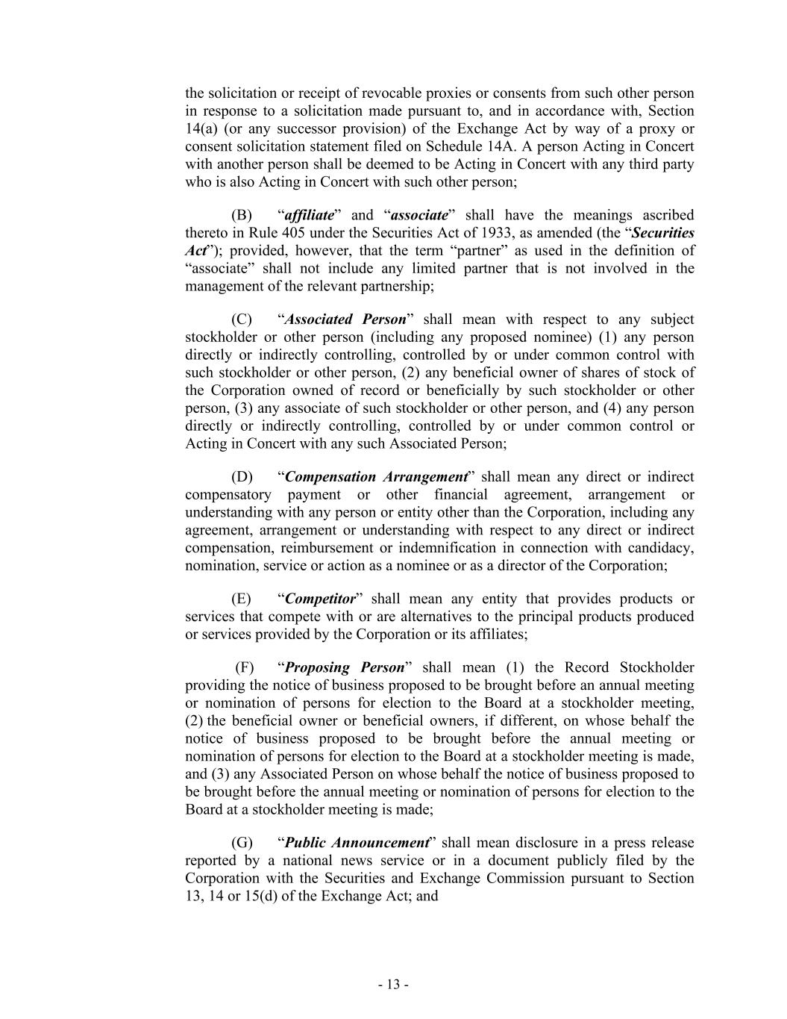
- 13 - the solicitation or receipt of revocable proxies or consents from such other person in response to a solicitation made pursuant to, and in accordance with, Section 14(a) (or any successor provision) of the Exchange Act by way of a proxy or consent solicitation statement filed on Schedule 14A. A person Acting in Concert with another person shall be deemed to be Acting in Concert with any third party who is also Acting in Concert with such other person; (B) “affiliate” and “associate” shall have the meanings ascribed thereto in Rule 405 under the Securities Act of 1933, as amended (the “Securities Act”); provided, however, that the term “partner” as used in the definition of “associate” shall not include any limited partner that is not involved in the management of the relevant partnership; (C) “Associated Person” shall mean with respect to any subject stockholder or other person (including any proposed nominee) (1) any person directly or indirectly controlling, controlled by or under common control with such stockholder or other person, (2) any beneficial owner of shares of stock of the Corporation owned of record or beneficially by such stockholder or other person, (3) any associate of such stockholder or other person, and (4) any person directly or indirectly controlling, controlled by or under common control or Acting in Concert with any such Associated Person; (D) “Compensation Arrangement” shall mean any direct or indirect compensatory payment or other financial agreement, arrangement or understanding with any person or entity other than the Corporation, including any agreement, arrangement or understanding with respect to any direct or indirect compensation, reimbursement or indemnification in connection with candidacy, nomination, service or action as a nominee or as a director of the Corporation; (E) “Competitor” shall mean any entity that provides products or services that compete with or are alternatives to the principal products produced or services provided by the Corporation or its affiliates; (F) “Proposing Person” shall mean (1) the Record Stockholder providing the notice of business proposed to be brought before an annual meeting or nomination of persons for election to the Board at a stockholder meeting, (2) the beneficial owner or beneficial owners, if different, on whose behalf the notice of business proposed to be brought before the annual meeting or nomination of persons for election to the Board at a stockholder meeting is made, and (3) any Associated Person on whose behalf the notice of business proposed to be brought before the annual meeting or nomination of persons for election to the Board at a stockholder meeting is made; (G) “Public Announcement” shall mean disclosure in a press release reported by a national news service or in a document publicly filed by the Corporation with the Securities and Exchange Commission pursuant to Section 13, 14 or 15(d) of the Exchange Act; and

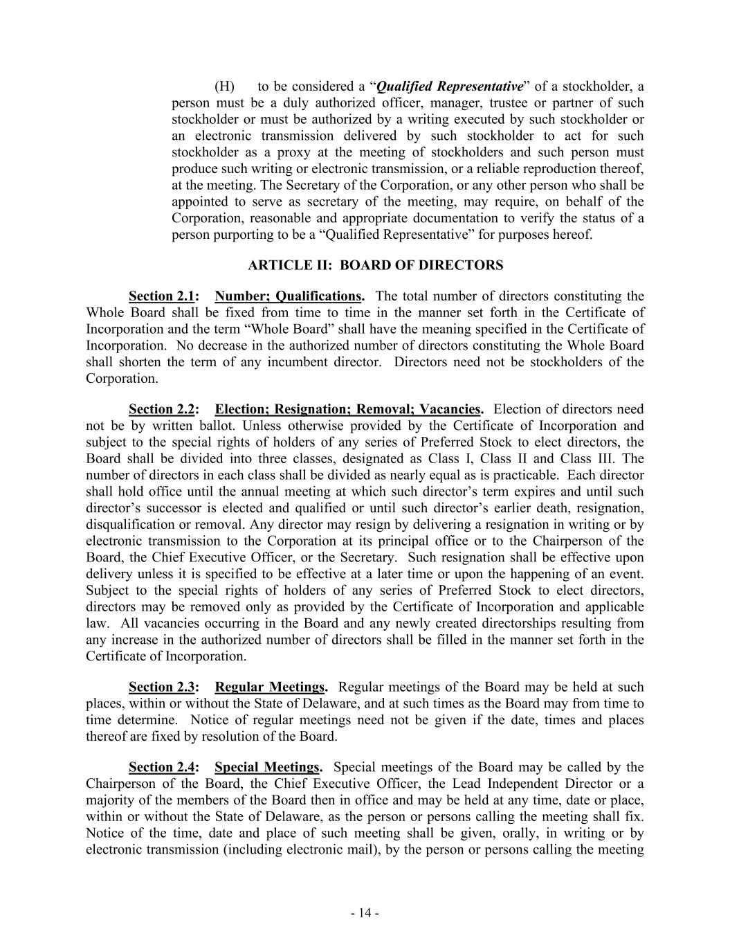
- 14 - (H) to be considered a “Qualified Representative” of a stockholder, a person must be a duly authorized officer, manager, trustee or partner of such stockholder or must be authorized by a writing executed by such stockholder or an electronic transmission delivered by such stockholder to act for such stockholder as a proxy at the meeting of stockholders and such person must produce such writing or electronic transmission, or a reliable reproduction thereof, at the meeting. The Secretary of the Corporation, or any other person who shall be appointed to serve as secretary of the meeting, may require, on behalf of the Corporation, reasonable and appropriate documentation to verify the status of a person purporting to be a “Qualified Representative” for purposes hereof. ARTICLE II: BOARD OF DIRECTORS Section 2.1: Number; Qualifications. The total number of directors constituting the Whole Board shall be fixed from time to time in the manner set forth in the Certificate of Incorporation and the term “Whole Board” shall have the meaning specified in the Certificate of Incorporation. No decrease in the authorized number of directors constituting the Whole Board shall shorten the term of any incumbent director. Directors need not be stockholders of the Corporation. Section 2.2: Election; Resignation; Removal; Vacancies. Election of directors need not be by written ballot. Unless otherwise provided by the Certificate of Incorporation and subject to the special rights of holders of any series of Preferred Stock to elect directors, the Board shall be divided into three classes, designated as Class I, Class II and Class III. The number of directors in each class shall be divided as nearly equal as is practicable. Each director shall hold office until the annual meeting at which such director’s term expires and until such director’s successor is elected and qualified or until such director’s earlier death, resignation, disqualification or removal. Any director may resign by delivering a resignation in writing or by electronic transmission to the Corporation at its principal office or to the Chairperson of the Board, the Chief Executive Officer, or the Secretary. Such resignation shall be effective upon delivery unless it is specified to be effective at a later time or upon the happening of an event. Subject to the special rights of holders of any series of Preferred Stock to elect directors, directors may be removed only as provided by the Certificate of Incorporation and applicable law. All vacancies occurring in the Board and any newly created directorships resulting from any increase in the authorized number of directors shall be filled in the manner set forth in the Certificate of Incorporation. Section 2.3: Regular Meetings. Regular meetings of the Board may be held at such places, within or without the State of Delaware, and at such times as the Board may from time to time determine. Notice of regular meetings need not be given if the date, times and places thereof are fixed by resolution of the Board. Section 2.4: Special Meetings. Special meetings of the Board may be called by the Chairperson of the Board, the Chief Executive Officer, the Lead Independent Director or a majority of the members of the Board then in office and may be held at any time, date or place, within or without the State of Delaware, as the person or persons calling the meeting shall fix. Notice of the time, date and place of such meeting shall be given, orally, in writing or by electronic transmission (including electronic mail), by the person or persons calling the meeting

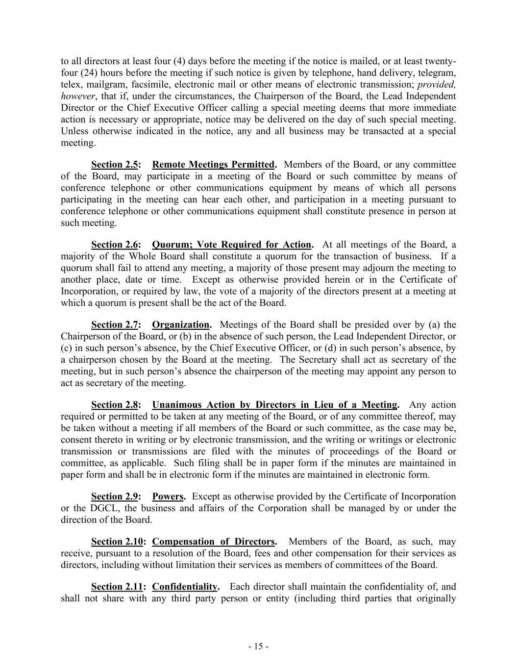
- 15 - to all directors at least four (4) days before the meeting if the notice is mailed, or at least twenty- four (24) hours before the meeting if such notice is given by telephone, hand delivery, telegram, telex, mailgram, facsimile, electronic mail or other means of electronic transmission; provided, however, that if, under the circumstances, the Chairperson of the Board, the Lead Independent Director or the Chief Executive Officer calling a special meeting deems that more immediate action is necessary or appropriate, notice may be delivered on the day of such special meeting. Unless otherwise indicated in the notice, any and all business may be transacted at a special meeting. Section 2.5: Remote Meetings Permitted. Members of the Board, or any committee of the Board, may participate in a meeting of the Board or such committee by means of conference telephone or other communications equipment by means of which all persons participating in the meeting can hear each other, and participation in a meeting pursuant to conference telephone or other communications equipment shall constitute presence in person at such meeting. Section 2.6: Quorum; Vote Required for Action. At all meetings of the Board, a majority of the Whole Board shall constitute a quorum for the transaction of business. If a quorum shall fail to attend any meeting, a majority of those present may adjourn the meeting to another place, date or time. Except as otherwise provided herein or in the Certificate of Incorporation, or required by law, the vote of a majority of the directors present at a meeting at which a quorum is present shall be the act of the Board. Section 2.7: Organization. Meetings of the Board shall be presided over by (a) the Chairperson of the Board, or (b) in the absence of such person, the Lead Independent Director, or (c) in such person’s absence, by the Chief Executive Officer, or (d) in such person’s absence, by a chairperson chosen by the Board at the meeting. The Secretary shall act as secretary of the meeting, but in such person’s absence the chairperson of the meeting may appoint any person to act as secretary of the meeting. Section 2.8: Unanimous Action by Directors in Lieu of a Meeting. Any action required or permitted to be taken at any meeting of the Board, or of any committee thereof, may be taken without a meeting if all members of the Board or such committee, as the case may be, consent thereto in writing or by electronic transmission, and the writing or writings or electronic transmission or transmissions are filed with the minutes of proceedings of the Board or committee, as applicable. Such filing shall be in paper form if the minutes are maintained in paper form and shall be in electronic form if the minutes are maintained in electronic form. Section 2.9: Powers. Except as otherwise provided by the Certificate of Incorporation or the DGCL, the business and affairs of the Corporation shall be managed by or under the direction of the Board. Section 2.10: Compensation of Directors. Members of the Board, as such, may receive, pursuant to a resolution of the Board, fees and other compensation for their services as directors, including without limitation their services as members of committees of the Board. Section 2.11: Confidentiality. Each director shall maintain the confidentiality of, and shall not share with any third party person or entity (including third parties that originally

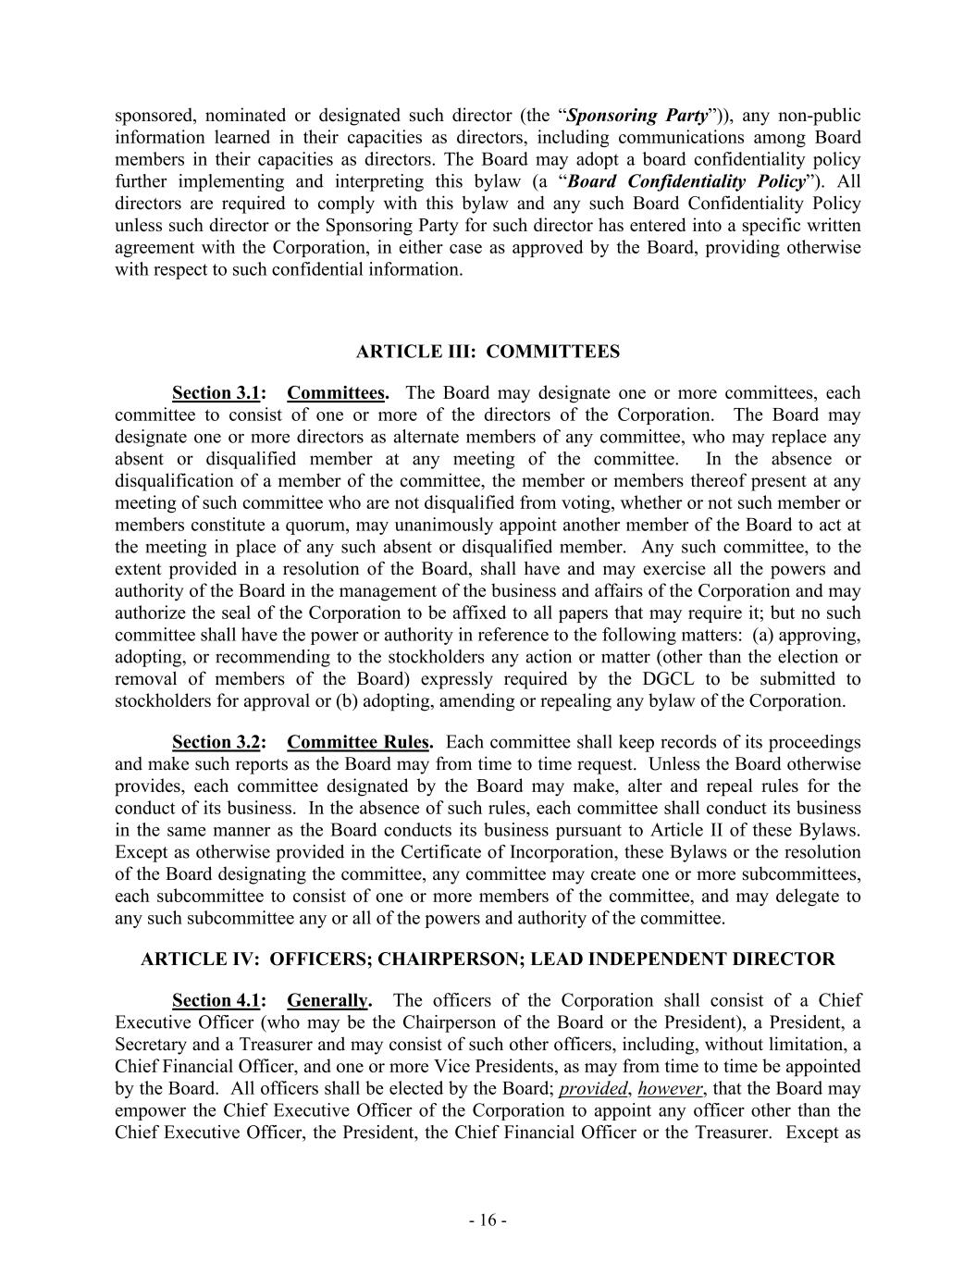
- 16 - sponsored, nominated or designated such director (the “Sponsoring Party”)), any non-public information learned in their capacities as directors, including communications among Board members in their capacities as directors. The Board may adopt a board confidentiality policy further implementing and interpreting this bylaw (a “Board Confidentiality Policy”). All directors are required to comply with this bylaw and any such Board Confidentiality Policy unless such director or the Sponsoring Party for such director has entered into a specific written agreement with the Corporation, in either case as approved by the Board, providing otherwise with respect to such confidential information. ARTICLE III: COMMITTEES Section 3.1: Committees. The Board may designate one or more committees, each committee to consist of one or more of the directors of the Corporation. The Board may designate one or more directors as alternate members of any committee, who may replace any absent or disqualified member at any meeting of the committee. In the absence or disqualification of a member of the committee, the member or members thereof present at any meeting of such committee who are not disqualified from voting, whether or not such member or members constitute a quorum, may unanimously appoint another member of the Board to act at the meeting in place of any such absent or disqualified member. Any such committee, to the extent provided in a resolution of the Board, shall have and may exercise all the powers and authority of the Board in the management of the business and affairs of the Corporation and may authorize the seal of the Corporation to be affixed to all papers that may require it; but no such committee shall have the power or authority in reference to the following matters: (a) approving, adopting, or recommending to the stockholders any action or matter (other than the election or removal of members of the Board) expressly required by the DGCL to be submitted to stockholders for approval or (b) adopting, amending or repealing any bylaw of the Corporation. Section 3.2: Committee Rules. Each committee shall keep records of its proceedings and make such reports as the Board may from time to time request. Unless the Board otherwise provides, each committee designated by the Board may make, alter and repeal rules for the conduct of its business. In the absence of such rules, each committee shall conduct its business in the same manner as the Board conducts its business pursuant to Article II of these Bylaws. Except as otherwise provided in the Certificate of Incorporation, these Bylaws or the resolution of the Board designating the committee, any committee may create one or more subcommittees, each subcommittee to consist of one or more members of the committee, and may delegate to any such subcommittee any or all of the powers and authority of the committee. ARTICLE IV: OFFICERS; CHAIRPERSON; LEAD INDEPENDENT DIRECTOR Section 4.1: Generally. The officers of the Corporation shall consist of a Chief Executive Officer (who may be the Chairperson of the Board or the President), a President, a Secretary and a Treasurer and may consist of such other officers, including, without limitation, a Chief Financial Officer, and one or more Vice Presidents, as may from time to time be appointed by the Board. All officers shall be elected by the Board; provided, however, that the Board may empower the Chief Executive Officer of the Corporation to appoint any officer other than the Chief Executive Officer, the President, the Chief Financial Officer or the Treasurer. Except as

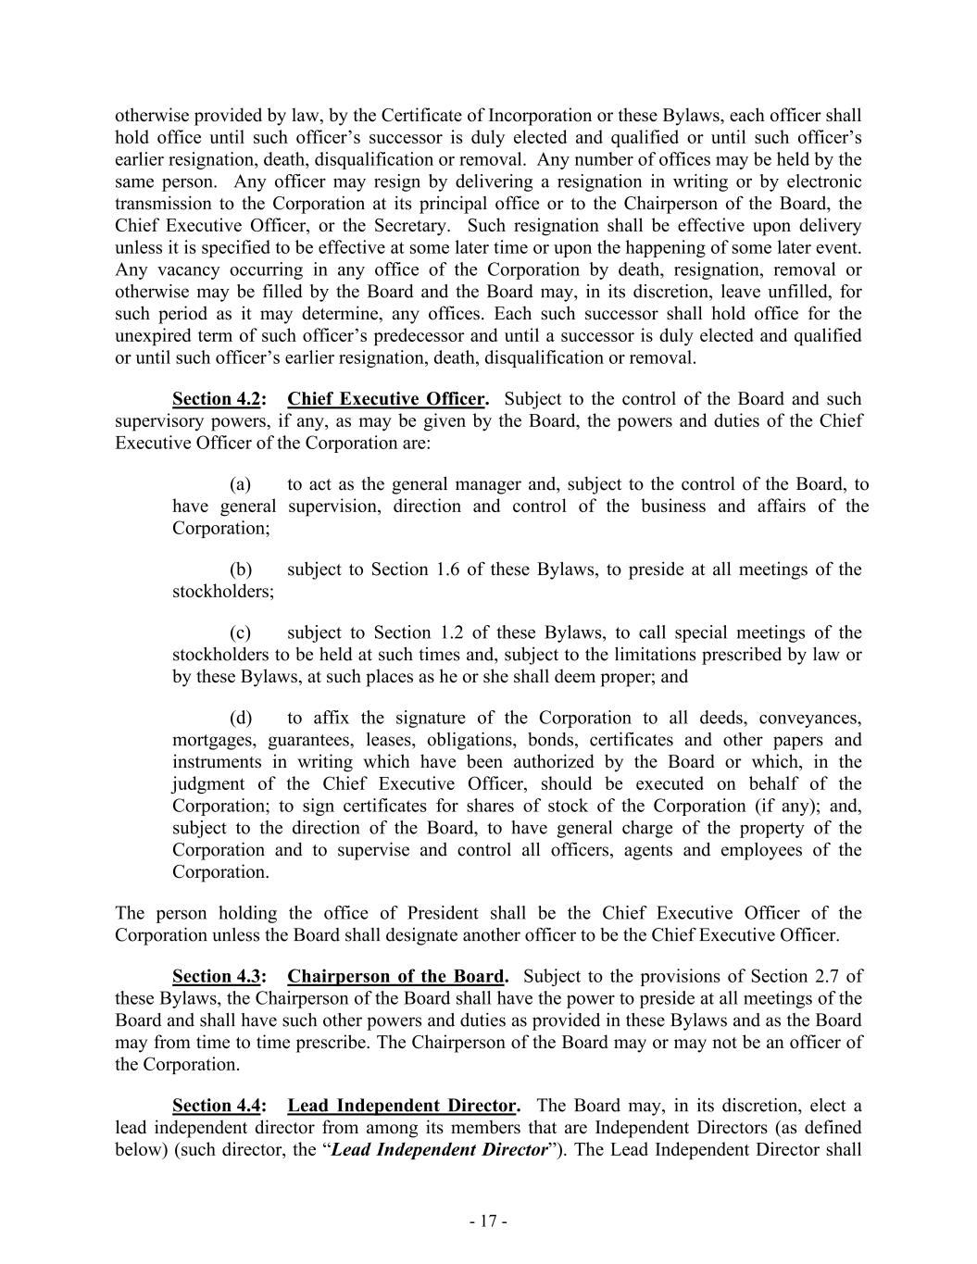
- 17 - otherwise provided by law, by the Certificate of Incorporation or these Bylaws, each officer shall hold office until such officer’s successor is duly elected and qualified or until such officer’s earlier resignation, death, disqualification or removal. Any number of offices may be held by the same person. Any officer may resign by delivering a resignation in writing or by electronic transmission to the Corporation at its principal office or to the Chairperson of the Board, the Chief Executive Officer, or the Secretary. Such resignation shall be effective upon delivery unless it is specified to be effective at some later time or upon the happening of some later event. Any vacancy occurring in any office of the Corporation by death, resignation, removal or otherwise may be filled by the Board and the Board may, in its discretion, leave unfilled, for such period as it may determine, any offices. Each such successor shall hold office for the unexpired term of such officer’s predecessor and until a successor is duly elected and qualified or until such officer’s earlier resignation, death, disqualification or removal. Section 4.2: Chief Executive Officer. Subject to the control of the Board and such supervisory powers, if any, as may be given by the Board, the powers and duties of the Chief Executive Officer of the Corporation are: (a) to act as the general manager and, subject to the control of the Board, to have general supervision, direction and control of the business and affairs of the Corporation; (b) subject to Section 1.6 of these Bylaws, to preside at all meetings of the stockholders; (c) subject to Section 1.2 of these Bylaws, to call special meetings of the stockholders to be held at such times and, subject to the limitations prescribed by law or by these Bylaws, at such places as he or she shall deem proper; and (d) to affix the signature of the Corporation to all deeds, conveyances, mortgages, guarantees, leases, obligations, bonds, certificates and other papers and instruments in writing which have been authorized by the Board or which, in the judgment of the Chief Executive Officer, should be executed on behalf of the Corporation; to sign certificates for shares of stock of the Corporation (if any); and, subject to the direction of the Board, to have general charge of the property of the Corporation and to supervise and control all officers, agents and employees of the Corporation. The person holding the office of President shall be the Chief Executive Officer of the Corporation unless the Board shall designate another officer to be the Chief Executive Officer. Section 4.3: Chairperson of the Board. Subject to the provisions of Section 2.7 of these Bylaws, the Chairperson of the Board shall have the power to preside at all meetings of the Board and shall have such other powers and duties as provided in these Bylaws and as the Board may from time to time prescribe. The Chairperson of the Board may or may not be an officer of the Corporation. Section 4.4: Lead Independent Director. The Board may, in its discretion, elect a lead independent director from among its members that are Independent Directors (as defined below) (such director, the “Lead Independent Director”). The Lead Independent Director shall

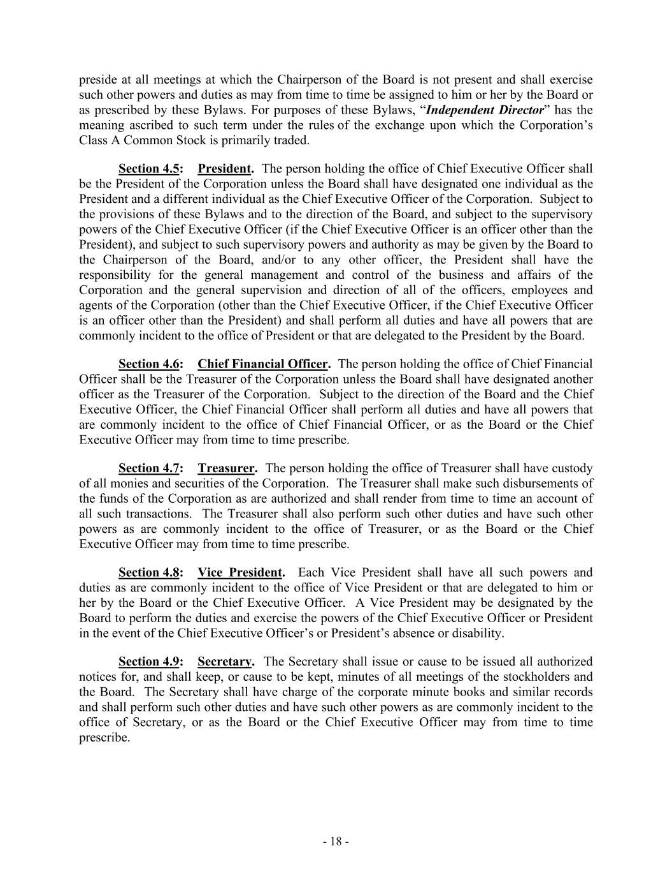
- 18 - preside at all meetings at which the Chairperson of the Board is not present and shall exercise such other powers and duties as may from time to time be assigned to him or her by the Board or as prescribed by these Bylaws. For purposes of these Bylaws, “Independent Director” has the meaning ascribed to such term under the rules of the exchange upon which the Corporation’s Class A Common Stock is primarily traded. Section 4.5: President. The person holding the office of Chief Executive Officer shall be the President of the Corporation unless the Board shall have designated one individual as the President and a different individual as the Chief Executive Officer of the Corporation. Subject to the provisions of these Bylaws and to the direction of the Board, and subject to the supervisory powers of the Chief Executive Officer (if the Chief Executive Officer is an officer other than the President), and subject to such supervisory powers and authority as may be given by the Board to the Chairperson of the Board, and/or to any other officer, the President shall have the responsibility for the general management and control of the business and affairs of the Corporation and the general supervision and direction of all of the officers, employees and agents of the Corporation (other than the Chief Executive Officer, if the Chief Executive Officer is an officer other than the President) and shall perform all duties and have all powers that are commonly incident to the office of President or that are delegated to the President by the Board. Section 4.6: Chief Financial Officer. The person holding the office of Chief Financial Officer shall be the Treasurer of the Corporation unless the Board shall have designated another officer as the Treasurer of the Corporation. Subject to the direction of the Board and the Chief Executive Officer, the Chief Financial Officer shall perform all duties and have all powers that are commonly incident to the office of Chief Financial Officer, or as the Board or the Chief Executive Officer may from time to time prescribe. Section 4.7: Treasurer. The person holding the office of Treasurer shall have custody of all monies and securities of the Corporation. The Treasurer shall make such disbursements of the funds of the Corporation as are authorized and shall render from time to time an account of all such transactions. The Treasurer shall also perform such other duties and have such other powers as are commonly incident to the office of Treasurer, or as the Board or the Chief Executive Officer may from time to time prescribe. Section 4.8: Vice President. Each Vice President shall have all such powers and duties as are commonly incident to the office of Vice President or that are delegated to him or her by the Board or the Chief Executive Officer. A Vice President may be designated by the Board to perform the duties and exercise the powers of the Chief Executive Officer or President in the event of the Chief Executive Officer’s or President’s absence or disability. Section 4.9: Secretary. The Secretary shall issue or cause to be issued all authorized notices for, and shall keep, or cause to be kept, minutes of all meetings of the stockholders and the Board. The Secretary shall have charge of the corporate minute books and similar records and shall perform such other duties and have such other powers as are commonly incident to the office of Secretary, or as the Board or the Chief Executive Officer may from time to time prescribe.

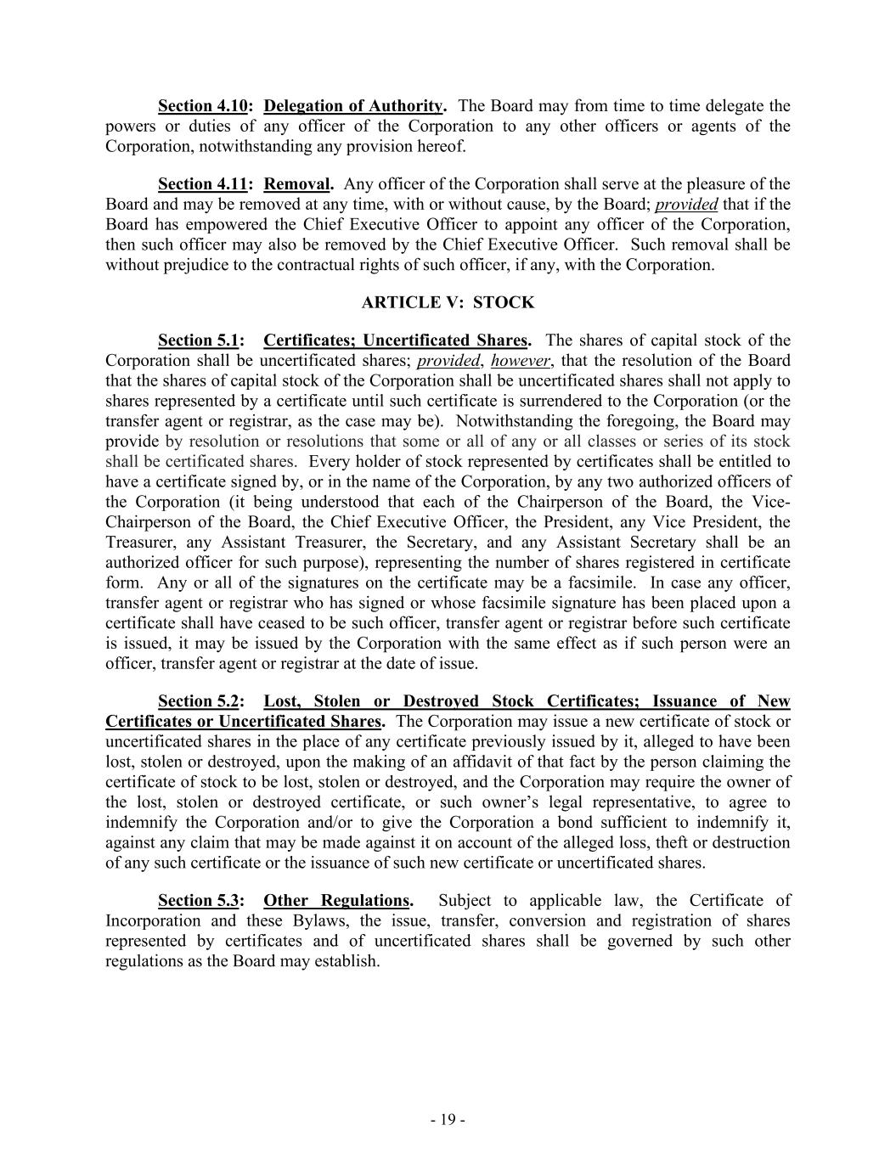
- 19 - Section 4.10: Delegation of Authority. The Board may from time to time delegate the powers or duties of any officer of the Corporation to any other officers or agents of the Corporation, notwithstanding any provision hereof. Section 4.11: Removal. Any officer of the Corporation shall serve at the pleasure of the Board and may be removed at any time, with or without cause, by the Board; provided that if the Board has empowered the Chief Executive Officer to appoint any officer of the Corporation, then such officer may also be removed by the Chief Executive Officer. Such removal shall be without prejudice to the contractual rights of such officer, if any, with the Corporation. ARTICLE V: STOCK Section 5.1: Certificates; Uncertificated Shares. The shares of capital stock of the Corporation shall be uncertificated shares; provided, however, that the resolution of the Board that the shares of capital stock of the Corporation shall be uncertificated shares shall not apply to shares represented by a certificate until such certificate is surrendered to the Corporation (or the transfer agent or registrar, as the case may be). Notwithstanding the foregoing, the Board may provide by resolution or resolutions that some or all of any or all classes or series of its stock shall be certificated shares. Every holder of stock represented by certificates shall be entitled to have a certificate signed by, or in the name of the Corporation, by any two authorized officers of the Corporation (it being understood that each of the Chairperson of the Board, the Vice- Chairperson of the Board, the Chief Executive Officer, the President, any Vice President, the Treasurer, any Assistant Treasurer, the Secretary, and any Assistant Secretary shall be an authorized officer for such purpose), representing the number of shares registered in certificate form. Any or all of the signatures on the certificate may be a facsimile. In case any officer, transfer agent or registrar who has signed or whose facsimile signature has been placed upon a certificate shall have ceased to be such officer, transfer agent or registrar before such certificate is issued, it may be issued by the Corporation with the same effect as if such person were an officer, transfer agent or registrar at the date of issue. Section 5.2: Lost, Stolen or Destroyed Stock Certificates; Issuance of New Certificates or Uncertificated Shares. The Corporation may issue a new certificate of stock or uncertificated shares in the place of any certificate previously issued by it, alleged to have been lost, stolen or destroyed, upon the making of an affidavit of that fact by the person claiming the certificate of stock to be lost, stolen or destroyed, and the Corporation may require the owner of the lost, stolen or destroyed certificate, or such owner’s legal representative, to agree to indemnify the Corporation and/or to give the Corporation a bond sufficient to indemnify it, against any claim that may be made against it on account of the alleged loss, theft or destruction of any such certificate or the issuance of such new certificate or uncertificated shares. Section 5.3: Other Regulations. Subject to applicable law, the Certificate of Incorporation and these Bylaws, the issue, transfer, conversion and registration of shares represented by certificates and of uncertificated shares shall be governed by such other regulations as the Board may establish.

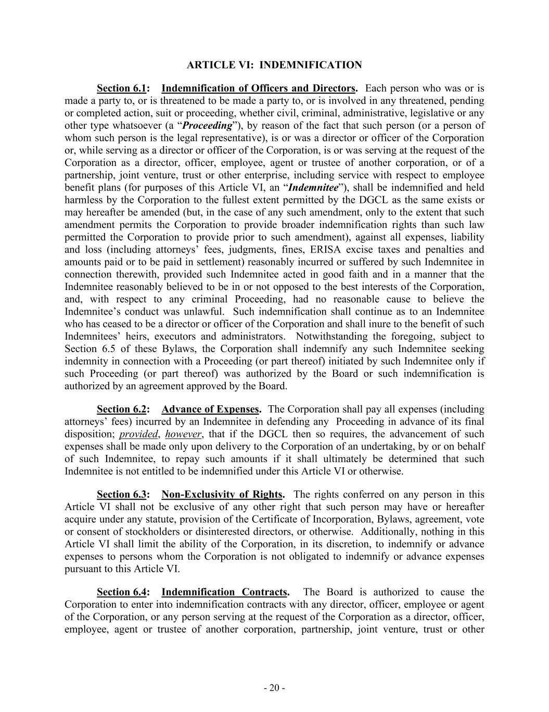
- 20 - ARTICLE VI: INDEMNIFICATION Section 6.1: Indemnification of Officers and Directors. Each person who was or is made a party to, or is threatened to be made a party to, or is involved in any threatened, pending or completed action, suit or proceeding, whether civil, criminal, administrative, legislative or any other type whatsoever (a “Proceeding”), by reason of the fact that such person (or a person of whom such person is the legal representative), is or was a director or officer of the Corporation or, while serving as a director or officer of the Corporation, is or was serving at the request of the Corporation as a director, officer, employee, agent or trustee of another corporation, or of a partnership, joint venture, trust or other enterprise, including service with respect to employee benefit plans (for purposes of this Article VI, an “Indemnitee”), shall be indemnified and held harmless by the Corporation to the fullest extent permitted by the DGCL as the same exists or may hereafter be amended (but, in the case of any such amendment, only to the extent that such amendment permits the Corporation to provide broader indemnification rights than such law permitted the Corporation to provide prior to such amendment), against all expenses, liability and loss (including attorneys’ fees, judgments, fines, ERISA excise taxes and penalties and amounts paid or to be paid in settlement) reasonably incurred or suffered by such Indemnitee in connection therewith, provided such Indemnitee acted in good faith and in a manner that the Indemnitee reasonably believed to be in or not opposed to the best interests of the Corporation, and, with respect to any criminal Proceeding, had no reasonable cause to believe the Indemnitee’s conduct was unlawful. Such indemnification shall continue as to an Indemnitee who has ceased to be a director or officer of the Corporation and shall inure to the benefit of such Indemnitees’ heirs, executors and administrators. Notwithstanding the foregoing, subject to Section 6.5 of these Bylaws, the Corporation shall indemnify any such Indemnitee seeking indemnity in connection with a Proceeding (or part thereof) initiated by such Indemnitee only if such Proceeding (or part thereof) was authorized by the Board or such indemnification is authorized by an agreement approved by the Board. Section 6.2: Advance of Expenses. The Corporation shall pay all expenses (including attorneys’ fees) incurred by an Indemnitee in defending any Proceeding in advance of its final disposition; provided, however, that if the DGCL then so requires, the advancement of such expenses shall be made only upon delivery to the Corporation of an undertaking, by or on behalf of such Indemnitee, to repay such amounts if it shall ultimately be determined that such Indemnitee is not entitled to be indemnified under this Article VI or otherwise. Section 6.3: Non-Exclusivity of Rights. The rights conferred on any person in this Article VI shall not be exclusive of any other right that such person may have or hereafter acquire under any statute, provision of the Certificate of Incorporation, Bylaws, agreement, vote or consent of stockholders or disinterested directors, or otherwise. Additionally, nothing in this Article VI shall limit the ability of the Corporation, in its discretion, to indemnify or advance expenses to persons whom the Corporation is not obligated to indemnify or advance expenses pursuant to this Article VI. Section 6.4: Indemnification Contracts. The Board is authorized to cause the Corporation to enter into indemnification contracts with any director, officer, employee or agent of the Corporation, or any person serving at the request of the Corporation as a director, officer, employee, agent or trustee of another corporation, partnership, joint venture, trust or other

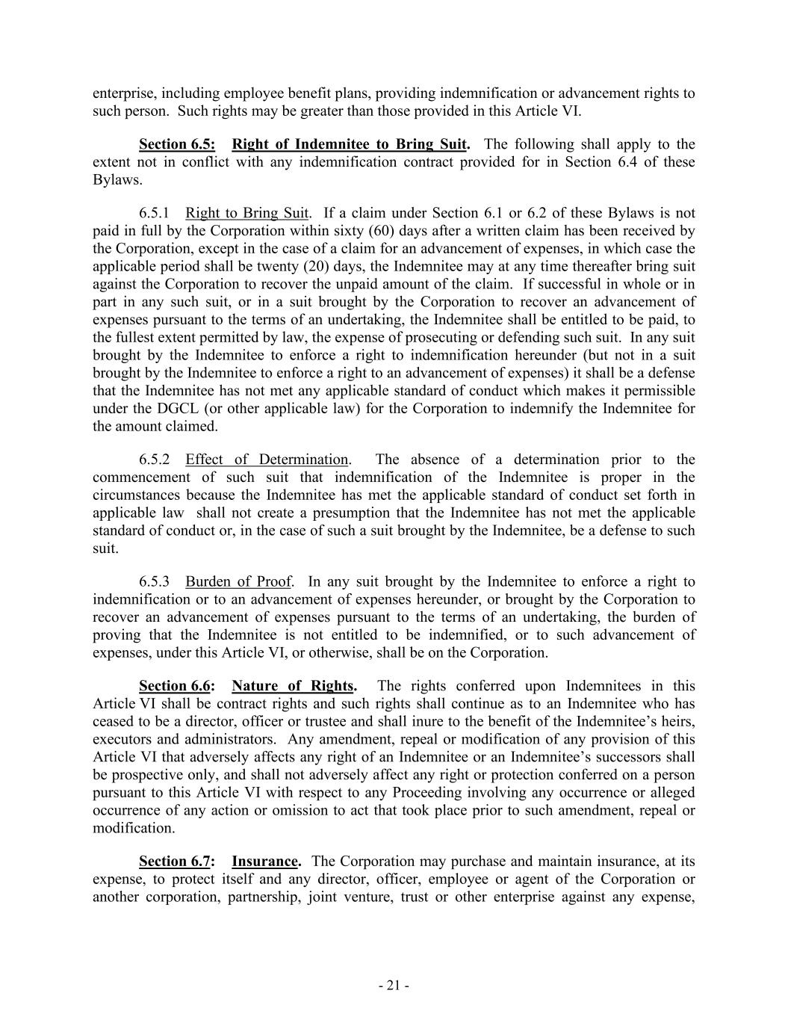
- 21 - enterprise, including employee benefit plans, providing indemnification or advancement rights to such person. Such rights may be greater than those provided in this Article VI. Section 6.5: Right of Indemnitee to Bring Suit. The following shall apply to the extent not in conflict with any indemnification contract provided for in Section 6.4 of these Bylaws. 6.5.1 Right to Bring Suit. If a claim under Section 6.1 or 6.2 of these Bylaws is not paid in full by the Corporation within sixty (60) days after a written claim has been received by the Corporation, except in the case of a claim for an advancement of expenses, in which case the applicable period shall be twenty (20) days, the Indemnitee may at any time thereafter bring suit against the Corporation to recover the unpaid amount of the claim. If successful in whole or in part in any such suit, or in a suit brought by the Corporation to recover an advancement of expenses pursuant to the terms of an undertaking, the Indemnitee shall be entitled to be paid, to the fullest extent permitted by law, the expense of prosecuting or defending such suit. In any suit brought by the Indemnitee to enforce a right to indemnification hereunder (but not in a suit brought by the Indemnitee to enforce a right to an advancement of expenses) it shall be a defense that the Indemnitee has not met any applicable standard of conduct which makes it permissible under the DGCL (or other applicable law) for the Corporation to indemnify the Indemnitee for the amount claimed. 6.5.2 Effect of Determination. The absence of a determination prior to the commencement of such suit that indemnification of the Indemnitee is proper in the circumstances because the Indemnitee has met the applicable standard of conduct set forth in applicable law shall not create a presumption that the Indemnitee has not met the applicable standard of conduct or, in the case of such a suit brought by the Indemnitee, be a defense to such suit. 6.5.3 Burden of Proof. In any suit brought by the Indemnitee to enforce a right to indemnification or to an advancement of expenses hereunder, or brought by the Corporation to recover an advancement of expenses pursuant to the terms of an undertaking, the burden of proving that the Indemnitee is not entitled to be indemnified, or to such advancement of expenses, under this Article VI, or otherwise, shall be on the Corporation. Section 6.6: Nature of Rights. The rights conferred upon Indemnitees in this Article VI shall be contract rights and such rights shall continue as to an Indemnitee who has ceased to be a director, officer or trustee and shall inure to the benefit of the Indemnitee’s heirs, executors and administrators. Any amendment, repeal or modification of any provision of this Article VI that adversely affects any right of an Indemnitee or an Indemnitee’s successors shall be prospective only, and shall not adversely affect any right or protection conferred on a person pursuant to this Article VI with respect to any Proceeding involving any occurrence or alleged occurrence of any action or omission to act that took place prior to such amendment, repeal or modification. Section 6.7: Insurance. The Corporation may purchase and maintain insurance, at its expense, to protect itself and any director, officer, employee or agent of the Corporation or another corporation, partnership, joint venture, trust or other enterprise against any expense,

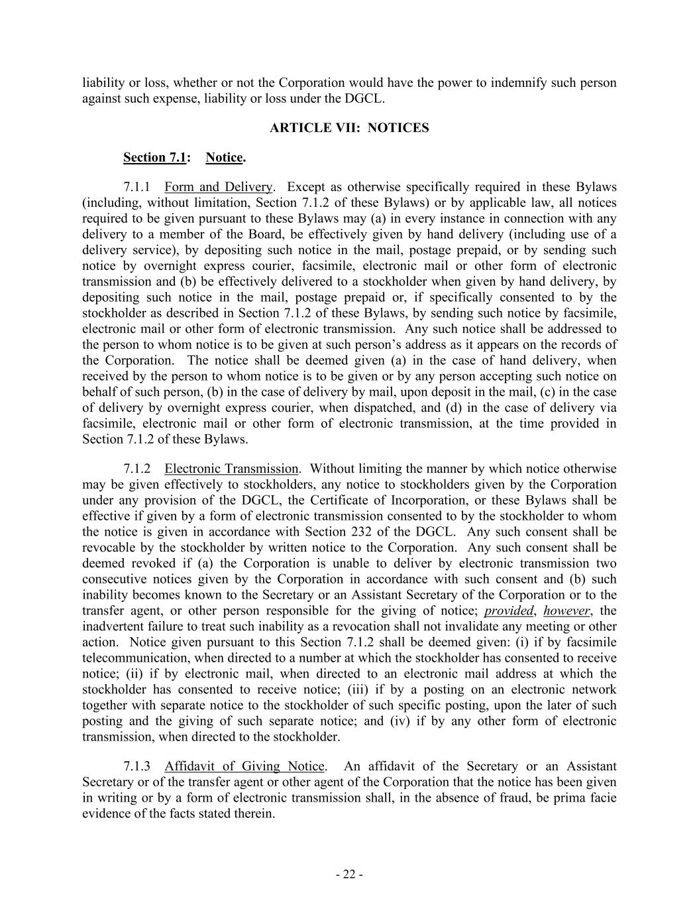
- 22 - liability or loss, whether or not the Corporation would have the power to indemnify such person against such expense, liability or loss under the DGCL. ARTICLE VII: NOTICES Section 7.1: Notice. 7.1.1 Form and Delivery. Except as otherwise specifically required in these Bylaws (including, without limitation, Section 7.1.2 of these Bylaws) or by applicable law, all notices required to be given pursuant to these Bylaws may (a) in every instance in connection with any delivery to a member of the Board, be effectively given by hand delivery (including use of a delivery service), by depositing such notice in the mail, postage prepaid, or by sending such notice by overnight express courier, facsimile, electronic mail or other form of electronic transmission and (b) be effectively delivered to a stockholder when given by hand delivery, by depositing such notice in the mail, postage prepaid or, if specifically consented to by the stockholder as described in Section 7.1.2 of these Bylaws, by sending such notice by facsimile, electronic mail or other form of electronic transmission. Any such notice shall be addressed to the person to whom notice is to be given at such person’s address as it appears on the records of the Corporation. The notice shall be deemed given (a) in the case of hand delivery, when received by the person to whom notice is to be given or by any person accepting such notice on behalf of such person, (b) in the case of delivery by mail, upon deposit in the mail, (c) in the case of delivery by overnight express courier, when dispatched, and (d) in the case of delivery via facsimile, electronic mail or other form of electronic transmission, at the time provided in Section 7.1.2 of these Bylaws. 7.1.2 Electronic Transmission. Without limiting the manner by which notice otherwise may be given effectively to stockholders, any notice to stockholders given by the Corporation under any provision of the DGCL, the Certificate of Incorporation, or these Bylaws shall be effective if given by a form of electronic transmission consented to by the stockholder to whom the notice is given in accordance with Section 232 of the DGCL. Any such consent shall be revocable by the stockholder by written notice to the Corporation. Any such consent shall be deemed revoked if (a) the Corporation is unable to deliver by electronic transmission two consecutive notices given by the Corporation in accordance with such consent and (b) such inability becomes known to the Secretary or an Assistant Secretary of the Corporation or to the transfer agent, or other person responsible for the giving of notice; provided, however, the inadvertent failure to treat such inability as a revocation shall not invalidate any meeting or other action. Notice given pursuant to this Section 7.1.2 shall be deemed given: (i) if by facsimile telecommunication, when directed to a number at which the stockholder has consented to receive notice; (ii) if by electronic mail, when directed to an electronic mail address at which the stockholder has consented to receive notice; (iii) if by a posting on an electronic network together with separate notice to the stockholder of such specific posting, upon the later of such posting and the giving of such separate notice; and (iv) if by any other form of electronic transmission, when directed to the stockholder. 7.1.3 Affidavit of Giving Notice. An affidavit of the Secretary or an Assistant Secretary or of the transfer agent or other agent of the Corporation that the notice has been given in writing or by a form of electronic transmission shall, in the absence of fraud, be prima facie evidence of the facts stated therein.

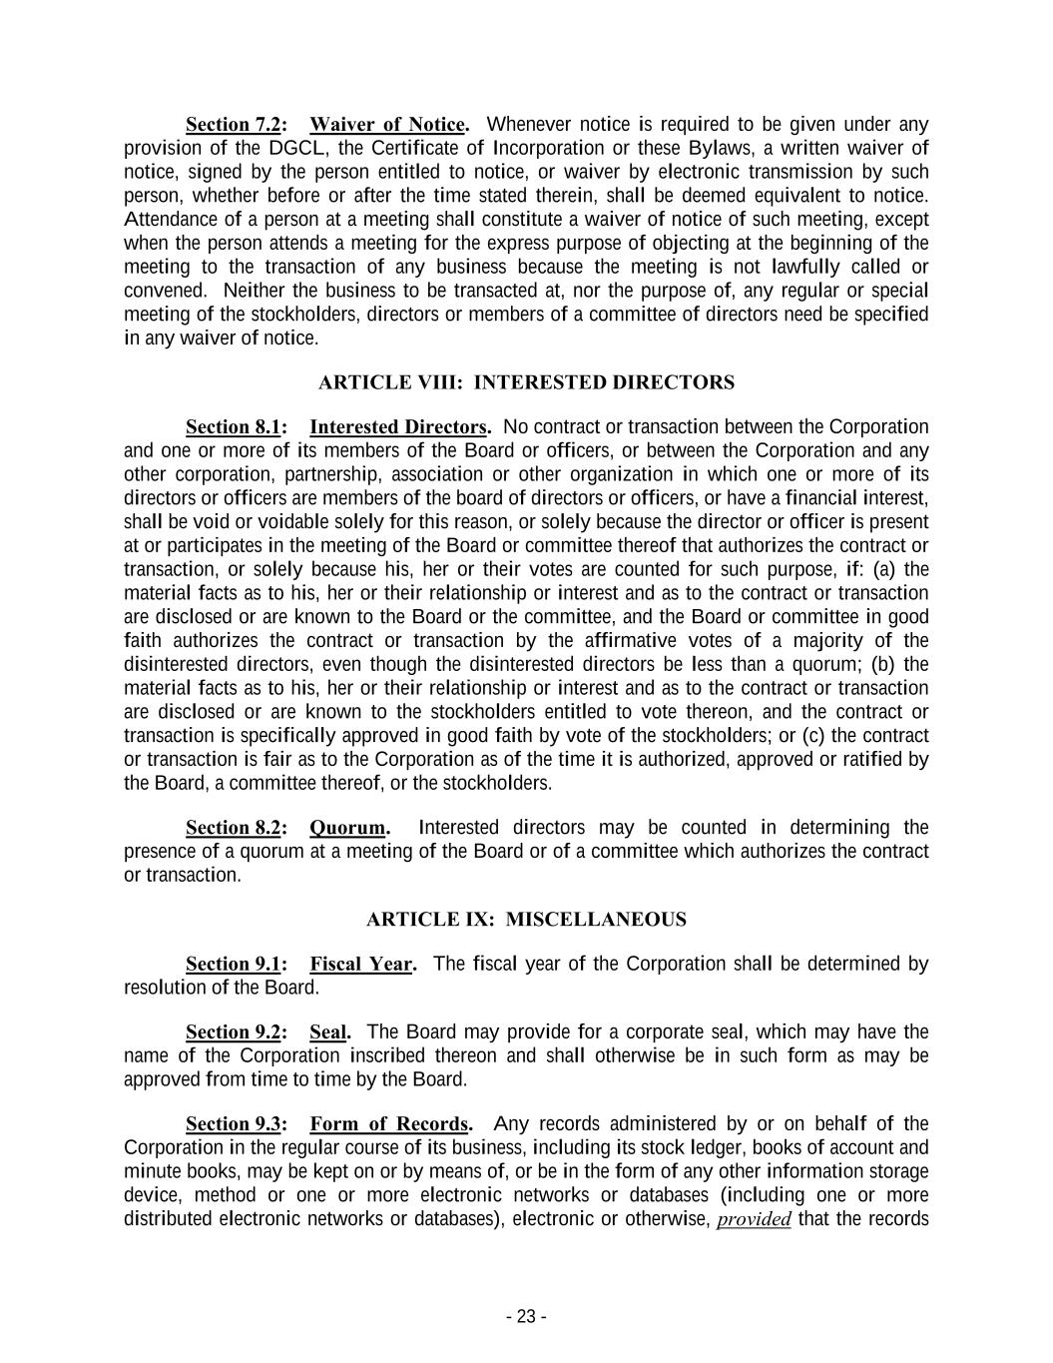
- 23 - Section 7.2: Waiver of Notice. Whenever notice is required to be given under any provision of the DGCL, the Certificate of Incorporation or these Bylaws, a written waiver of notice, signed by the person entitled to notice, or waiver by electronic transmission by such person, whether before or after the time stated therein, shall be deemed equivalent to notice. Attendance of a person at a meeting shall constitute a waiver of notice of such meeting, except when the person attends a meeting for the express purpose of objecting at the beginning of the meeting to the transaction of any business because the meeting is not lawfully called or convened. Neither the business to be transacted at, nor the purpose of, any regular or special meeting of the stockholders, directors or members of a committee of directors need be specified in any waiver of notice. ARTICLE VIII: INTERESTED DIRECTORS Section 8.1: Interested Directors. No contract or transaction between the Corporation and one or more of its members of the Board or officers, or between the Corporation and any other corporation, partnership, association or other organization in which one or more of its directors or officers are members of the board of directors or officers, or have a financial interest, shall be void or voidable solely for this reason, or solely because the director or officer is present at or participates in the meeting of the Board or committee thereof that authorizes the contract or transaction, or solely because his, her or their votes are counted for such purpose, if: (a) the material facts as to his, her or their relationship or interest and as to the contract or transaction are disclosed or are known to the Board or the committee, and the Board or committee in good faith authorizes the contract or transaction by the affirmative votes of a majority of the disinterested directors, even though the disinterested directors be less than a quorum; (b) the material facts as to his, her or their relationship or interest and as to the contract or transaction are disclosed or are known to the stockholders entitled to vote thereon, and the contract or transaction is specifically approved in good faith by vote of the stockholders; or (c) the contract or transaction is fair as to the Corporation as of the time it is authorized, approved or ratified by the Board, a committee thereof, or the stockholders. Section 8.2: Quorum. Interested directors may be counted in determining the presence of a quorum at a meeting of the Board or of a committee which authorizes the contract or transaction. ARTICLE IX: MISCELLANEOUS Section 9.1: Fiscal Year. The fiscal year of the Corporation shall be determined by resolution of the Board. Section 9.2: Seal. The Board may provide for a corporate seal, which may have the name of the Corporation inscribed thereon and shall otherwise be in such form as may be approved from time to time by the Board. Section 9.3: Form of Records. Any records administered by or on behalf of the Corporation in the regular course of its business, including its stock ledger, books of account and minute books, may be kept on or by means of, or be in the form of any other information storage device, method or one or more electronic networks or databases (including one or more distributed electronic networks or databases), electronic or otherwise, provided that the records

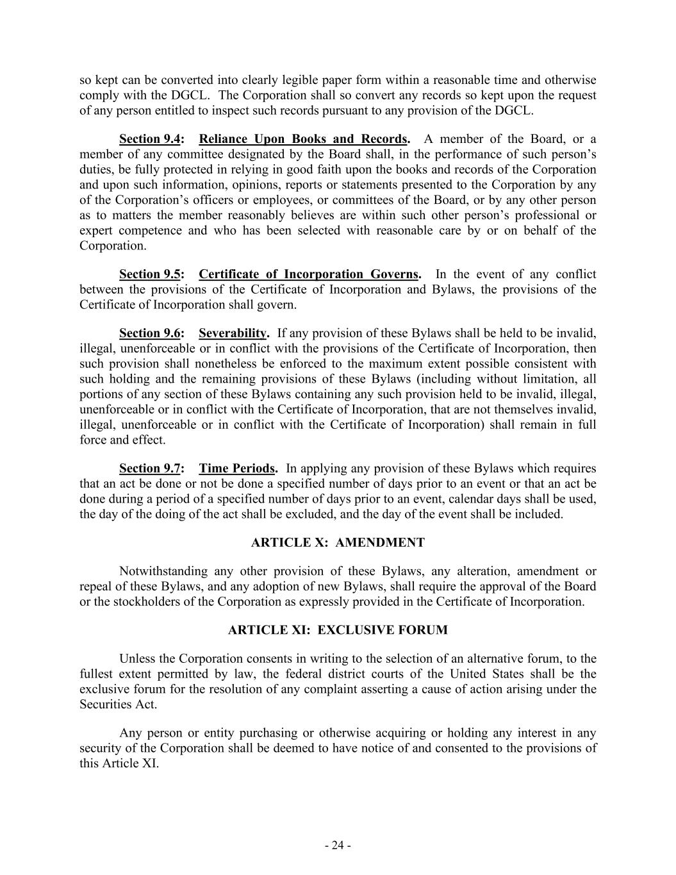
- 24 - so kept can be converted into clearly legible paper form within a reasonable time and otherwise comply with the DGCL. The Corporation shall so convert any records so kept upon the request of any person entitled to inspect such records pursuant to any provision of the DGCL. Section 9.4: Reliance Upon Books and Records. A member of the Board, or a member of any committee designated by the Board shall, in the performance of such person’s duties, be fully protected in relying in good faith upon the books and records of the Corporation and upon such information, opinions, reports or statements presented to the Corporation by any of the Corporation’s officers or employees, or committees of the Board, or by any other person as to matters the member reasonably believes are within such other person’s professional or expert competence and who has been selected with reasonable care by or on behalf of the Corporation. Section 9.5: Certificate of Incorporation Governs. In the event of any conflict between the provisions of the Certificate of Incorporation and Bylaws, the provisions of the Certificate of Incorporation shall govern. Section 9.6: Severability. If any provision of these Bylaws shall be held to be invalid, illegal, unenforceable or in conflict with the provisions of the Certificate of Incorporation, then such provision shall nonetheless be enforced to the maximum extent possible consistent with such holding and the remaining provisions of these Bylaws (including without limitation, all portions of any section of these Bylaws containing any such provision held to be invalid, illegal, unenforceable or in conflict with the Certificate of Incorporation, that are not themselves invalid, illegal, unenforceable or in conflict with the Certificate of Incorporation) shall remain in full force and effect. Section 9.7: Time Periods. In applying any provision of these Bylaws which requires that an act be done or not be done a specified number of days prior to an event or that an act be done during a period of a specified number of days prior to an event, calendar days shall be used, the day of the doing of the act shall be excluded, and the day of the event shall be included. ARTICLE X: AMENDMENT Notwithstanding any other provision of these Bylaws, any alteration, amendment or repeal of these Bylaws, and any adoption of new Bylaws, shall require the approval of the Board or the stockholders of the Corporation as expressly provided in the Certificate of Incorporation. ARTICLE XI: EXCLUSIVE FORUM Unless the Corporation consents in writing to the selection of an alternative forum, to the fullest extent permitted by law, the federal district courts of the United States shall be the exclusive forum for the resolution of any complaint asserting a cause of action arising under the Securities Act. Any person or entity purchasing or otherwise acquiring or holding any interest in any security of the Corporation shall be deemed to have notice of and consented to the provisions of this Article XI.

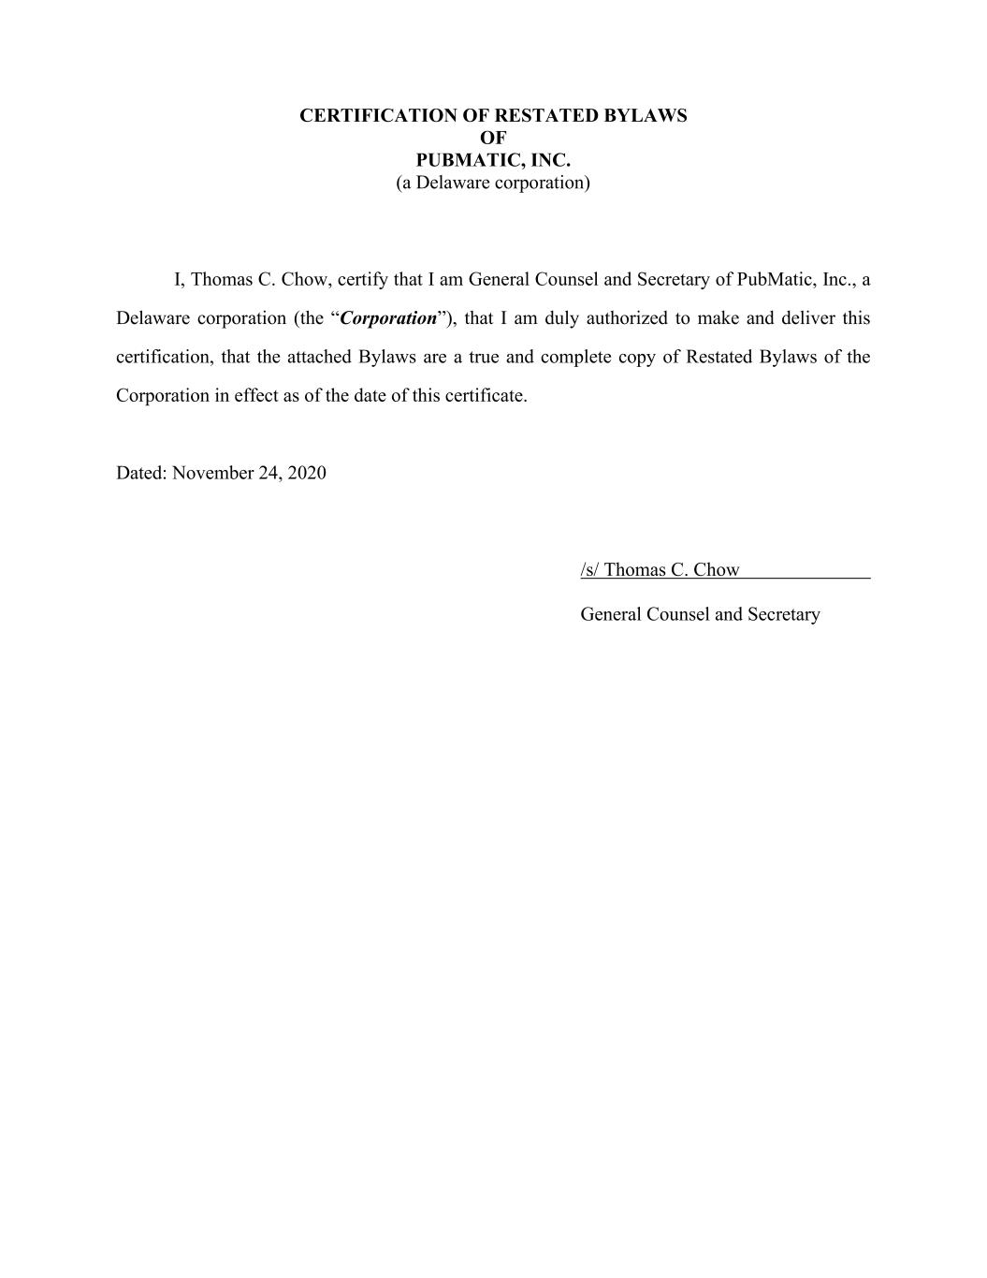
CERTIFICATION OF RESTATED BYLAWS OF PUBMATIC, INC. (a Delaware corporation) I, Thomas C. Chow, certify that I am General Counsel and Secretary of PubMatic, Inc., a Delaware corporation (the “Corporation”), that I am duly authorized to make and deliver this certification, that the attached Bylaws are a true and complete copy of Restated Bylaws of the Corporation in effect as of the date of this certificate. Dated: November 24, 2020 /s/ Thomas C. Chow General Counsel and Secretary

Exhibit 4.3

DESCRIPTION OF THE COMPANY’S SECURITIES
REGISTERED PURSUANT TO SECTION 12 OF THE
SECURITIES EXCHANGE ACT OF 1934, AS AMENDED

As of December 31, 2020, PubMatic, Inc. (the “Company,” “we,” “us,” and “our”) had one class of securities registered under Section 12 of the Securities Exchange Act of 1934, as amended (the “Exchange Act”): our Class A common stock.

DESCRIPTION OF CAPITAL STOCK

The following description of our capital stock is a summary and does not purport to be complete. It is subject to and qualified in its entirety by reference to our Restated Certificate of Incorporation (the “Certificate of Incorporation”) and our Restated Bylaws (the “Bylaws”), each of which are incorporated by reference as an exhibit to the Annual Report on Form 10-K of which this Exhibit 4.1 is a part. We encourage you to read our Certificate of Incorporation, our Bylaws and the applicable provisions of the Delaware General Corporation Law (the “DGCL”), for additional information.

Authorized Capital Stock

Our authorized capital stock consists of 1,000,000,000 shares of Class A common stock, $0.0001 par value per share, 1,000,000,000 shares of Class B common stock, $0.0001 par value per share, and 10,000,000 shares of undesignated preferred stock, $0.0001 par value per share.

Our board of directors has the authority, without further action by the stockholders, to issue the authorized but unissued shares of common stock and preferred stock. These additional shares may be used for a variety of corporate finance transactions, acquisitions and employee benefit plans. The existence of authorized but unissued shares of preferred stock enables our board of directors to render more difficult or to discourage an attempt to obtain control of us by means of a merger, tender offer, proxy contest or otherwise.

Economic Rights

Except as otherwise expressly provided in our Certificate of Incorporation or required by applicable law, shares of Class A common stock and Class B common stock have the same rights and privileges and rank equally, share ratably and are identical in all respects as to all matters, including, without limitation, those described below.

Dividends. Any dividend or distributions paid or payable to the holders of shares of Class A common stock and Class B common stock will be paid equally, identically and ratably, on a per share basis, unless different treatment of the shares of each such class is approved by the affirmative vote of the holders of a majority of the outstanding shares of Class A common stock and Class B common stock, each voting separately as a class; provided, however, that if a dividend or distribution is paid in the form of Class A common stock or Class B common stock (or rights to acquire shares of Class A common stock or Class B common stock), then the holders of the Class A common stock will receive Class A common stock (or rights to acquire shares of Class A common stock) and holders of Class B common stock will receive Class B common stock (or rights to acquire shares of Class B common stock).

Subdivisions and Combinations. If we subdivide or combine in any manner outstanding shares of Class A common stock or Class B common stock, then the outstanding shares of all common stock will be subdivided or combined in the same proportion and manner, unless different treatment of the shares of each such class is approved by the affirmative vote of the holders of a majority of the outstanding shares of Class A common stock and Class B common stock, each voting separately as a class.

Right to Receive Liquidation Distributions. Subject to the preferential or other rights of any holders of preferred stock then outstanding, upon our liquidation, dissolution or winding up, holders of Class A common stock and Class B common stock will be entitled to receive ratably all of our assets available for distribution to our stockholders unless treatment of the shares of each such class is approved by the affirmative vote of the holders of a majority of the outstanding shares of Class A common stock and Class B common stock, each voting separately as a class.

Change of Control Transaction. In connection with any distribution or payment in respect of our capital stock upon the merger or consolidation of PubMatic with or into any other entity, the holders of Class A common stock and Class B common stock will be treated equally and identically with respect to shares of Class A common stock or Class B common stock owned by them, unless different treatment of the shares of each class is approved by the affirmative vote of the holders of a majority of the outstanding shares of Class A common stock and Class B common stock, each voting separately as a class.

Voting Rights

Holders of our Class A common stock are entitled to one vote for each share of Class A common stock held on all matters submitted to a vote of stockholders and holders of our Class B common stock are entitled to ten votes for each share of Class B common stock held on all matters submitted to a vote of stockholders. Holders of shares of our Class A common stock and Class B common stock vote together as a single class on all matters (including the election of directors) submitted to a vote of stockholders, unless otherwise required by Delaware law or our Certificate of Incorporation. Delaware law could require either holders of our Class A common stock or Class B common stock to vote separately as a single class in the following circumstances: (1) if we were to seek to amend our Certificate of Incorporation to increase or decrease the par value of a class of our capital stock, then that class would be required to vote separately to approve the proposed amendment; and (2) if we were to seek to amend our Certificate of Incorporation on in a manner that alters or changes the powers, preferences, or special rights of a class of our capital stock in a manner that affected its holders adversely, then that class would be required to vote separately to approve the proposed amendment.

We have not provided for cumulative voting for the election of directors in our Certificate of Incorporation. Accordingly, holders of a majority of the shares of our common stock will be able to elect all of our directors then standing for election.

No Preemptive or Similar Rights

Our common stock is not entitled to preemptive rights, and is not subject to redemption or sinking fund provisions.

Conversion

Each outstanding share of Class B common stock is convertible at any time at the option of the holder into one share of Class A common stock. In addition, each share of Class B common stock will convert automatically into one share of Class A common stock upon any transfer, whether or not for value, except for certain permitted transfers described in our Certificate of Incorporation, including transfers to family members, trusts solely for the benefit of the stockholder or their family members, and partnerships, corporations, and other entities exclusively owned by the stockholder or their family members. However, our executive officers, board of directors, and their respective affiliates may only convert through a transfer triggering automatic conversion described above, and not an optional conversion. Once converted or transferred and converted into Class A common stock, the Class B common stock will not be reissued.

All the outstanding shares of Class B common stock will convert automatically into shares of Class A common stock on December 11, 2030. Following such conversion, each share of Class A common stock will have

one vote per share and the rights of the holders of all outstanding common stock will be identical. Once converted into Class A common stock, the Class B common stock may not be reissued.

Choice of Forum

Our Certificate of Incorporation provides that, to the fullest extent permitted by law, the Court of Chancery of the State of Delaware will be the exclusive forum for (i) any derivative action or proceeding brought on our behalf; (ii) any action asserting a breach of fiduciary duty; (iii) any action asserting a claim against us arising pursuant to the DGCL, our Certificate of Incorporation or our Bylaws; (iv) or any action asserting a claim against us that is governed by the internal affairs doctrine. Our Bylaws provide that the federal district courts of the United States of America are, to the fullest extent permitted by law, the exclusive forum for resolving any complaint asserting a cause of action arising under the Securities Act of 1933, as amended (the “Securities Act”), which we refer to as a Federal Forum Provision. Our decision to adopt a Federal Forum Provision followed a decision by the Supreme Court of the State of Delaware holding that such provisions are facially valid under Delaware law. While there can be no assurance that federal courts or state courts will follow the holding of the Delaware Supreme Court or determine that the Federal Forum Provision should be enforced in a particular case, application of the Federal Forum Provision means that suits brought by our stockholders to enforce any duty or liability created by the Securities Act must be brought in federal court and cannot be brought in state court. While neither the exclusive forum provision nor the Federal Forum Provision applies to suits brought to enforce any duty or liability created by the Exchange Act, Section 27 of the Exchange Act creates exclusive federal jurisdiction over all claims brought to enforce any duty or liability created by the Exchange Act or the rules and regulations thereunder. Accordingly, actions by our stockholders to enforce any duty or liability created by the Exchange Act or the rules and regulations thereunder also must be brought in federal court. Our stockholders will not be deemed to have waived our compliance with the federal securities laws and the regulations promulgated thereunder. Any person or entity purchasing or otherwise acquiring or holding any interest in any of our securities shall be deemed to have notice of and consented to our exclusive forum provisions, including the Federal Forum Provision. These provisions may limit a stockholder’s ability to bring a claim in a judicial forum of their choosing for disputes with us or our directors, officers or other employees, which may discourage lawsuits against us and our directors, officers, and other employees.

Preferred Stock
Under the terms of our Certificate of Incorporation, our board of directors is authorized, subject to limitations prescribed by the DGCL, to issue preferred stock in one or more series, to establish from time to time the number of shares to be included in each series and to fix the designation, powers, preferences, and rights of the shares of each series and any of its qualifications, limitations or restrictions, in each case without further vote or action by our stockholders. Our board of directors may increase or decrease the number of shares of any series of preferred stock, but not below the number of shares of that series then outstanding, without any further vote or action by our stockholders. Our board of directors may authorize the issuance of preferred stock with voting or conversion rights that could adversely affect the voting power or other rights of the holders of our common stock. The issuance of preferred stock, while providing flexibility in connection with possible acquisitions and other corporate purposes, could, among other things, have the effect of delaying, deferring, or preventing a change in control of our company and might adversely affect the voting and other rights of the holders of our common stock.

Anti-Takeover Provisions

The provisions of the DGCL, our Certificate of Incorporation, and our Bylaws, could have the effect of delaying, deferring or discouraging another person from acquiring control of our company. These provisions, which are summarized below, are expected to discourage certain types of coercive takeover practices and inadequate takeover bids and encourage persons seeking to acquire control of our company to first negotiate with our board of directors. We believe that the benefits of increased protection of our potential ability to negotiate with an unfriendly or unsolicited acquirer outweigh the disadvantages of discouraging a proposal to acquire us because negotiation of these proposals could result in an improvement of their terms.

Section 203 of the Delaware General Corporation Law

We are subject to, and have not opted out of, the provisions of Section 203 of the DGCL regulating corporate takeovers. In general, Section 203 prohibits a publicly held Delaware corporation from engaging in a “business combination” with an “interested stockholder” for a three-year period following the time that this stockholder becomes an interested stockholder, unless the business combination is approved in a prescribed manner. Under Section 203, a business combination between a corporation and an interested stockholder is prohibited unless it satisfies one of the following conditions:

(1)before the stockholder became interested, the board of directors of the corporation approved either the business combination or the transaction which resulted in the stockholder becoming an interested stockholder;

(2)upon consummation of the transaction which resulted in the stockholder becoming an interested stockholder, the interested stockholder owned at least 85% of the voting stock of the corporation outstanding at the time the transaction commenced, excluding for purposes of determining the voting stock outstanding (but not the outstanding voting stock owned by the interested stockholder), shares owned (i) by persons who are directors and also officers, and (ii) employee stock plans in which employee participants do not have the right to determine confidentially whether shares held subject to the plan will be tendered in a tender or exchange offer; or

(3)at or after the time the stockholder became interested, the business combination was approved by the board of directors and authorized at an annual or special meeting of the stockholders by the affirmative vote of at least two-thirds of the outstanding voting stock which is not owned by the interested stockholder.

In general, Section 203 defines a “business combination” to include the following:

(1)any merger or consolidation involving the corporation and the interested stockholder;

(2)any sale, transfer, lease, pledge or other disposition of 10% or more of the assets of the corporation involving the interested stockholder;

(3)subject to exceptions, any transaction that results in the issuance of transfer by the corporation of any stock of the corporation to the interested stockholder;

(4)any transaction involving the corporation that has the effect of increasing the proportionate share of the stock of any class or series of the corporation beneficially owned by the interested stockholder; or

(5)the receipt by the interested stockholder of the benefit of any loans, advances, guarantees, pledges or other financial benefits provided by or through the corporation.

In general, Section 203 defines an “interested stockholder” as any entity or person beneficially owning 15% or more of the outstanding voting stock of the corporation and any entity or person affiliated with or controlling or controlled by the entity or person.

Dual Class Common Stock

As described above, our Certificate of Incorporation provides for a dual class common stock structure pursuant to which holders of our Class B common stock (which include our founders, pre-IPO investors, executives,

and employees) will have the ability to control the outcome of matters requiring stockholder approval, even if they own significantly less than a majority of the shares of our outstanding Class A and Class B common stock, including the election of directors and significant corporate transactions, such as a merger or other sale of our company or its assets.

Board Vacancies

Our Certificate of Incorporation and Bylaws authorize generally only our board of directors to fill vacant directorships resulting from any cause or created by the expansion of our board of directors. In addition, the number of directors constituting our board of directors may be set only by resolution adopted by a majority vote of our entire board of directors. These provisions prevent a stockholder from increasing the size of our board of directors and gaining control of our board of directors by filling the resulting vacancies with its own nominees.

Classified Board

Initially, our board of directors will not be classified. However, our Certificate of Incorporation and Bylaws provide that our board of directors will be classified into three classes of directors at such time as the outstanding shares of our Class B common stock represent less than a majority of the combined voting power of our common stock. Directors may be removed from office with or without cause so long as our board of directors is not classified, and after our board of directors is classified, directors may be removed from office only for cause. The existence of a classified board of directors could delay a successful tender offeror from obtaining majority control of our board of directors, and the prospect of that delay might deter a potential offeror.

Stockholder Action

Initially, stockholders may take action by written consent. However, our Certificate of Incorporation provide that stockholders may no longer take action by written consent at such time as the outstanding shares of our Class B common stock represent less than a majority of the combined voting power of our common stock. At such time, our stockholders may only take action at annual or special meetings of our stockholders. Stockholders will not be permitted to cumulate their votes for the election of directors. Our Bylaws further provide that special meetings of our stockholders may be called only by a majority of our entire board of directors. Additionally, our Bylaws limit the business that may be conducted at an annual meeting of stockholders to those matters properly brought before the meeting.

Holding Requirements for Stockholder Proposals and Director Nominations

Our Bylaws require continuous, beneficial ownership of 1% of our common stock for one year for stockholders seeking to bring business before our annual meeting of stockholders or to nominate candidates for election as directors at our annual meeting of stockholders. These provisions may delay or preclude our stockholders from bringing matters before our annual meeting of stockholders and from making nominations for directors at our annual meeting of stockholders.

Advance Notice Requirements for Stockholder Proposals and Director Nominations

Our Bylaws provide advance notice procedures for stockholders seeking to bring business before our annual meeting of stockholders or to nominate candidates for election as directors at our annual meeting of stockholders. Our Bylaws also specify certain requirements regarding the form and content of a stockholder’s notice. These provisions may preclude our stockholders from bringing matters before our annual meeting of stockholders or from making nominations for directors at our annual meeting of stockholders.

Amendment to Certificate of Incorporation and Bylaws

Certain amendments to Certificate of Incorporation will require approval by the holders of at least two-thirds of our outstanding common stock. An amendment to our Bylaws requires the approval of a majority of our entire board of directors or approval by the holders of at least two-thirds of our outstanding common stock.

Transfer Agent and Registrar

The transfer agent and registrar for our common stock is Computershare Trust Company, N.A. The address for the transfer agent and registrar is 480 Washington Blvd Jersey City, NJ 07310, and its telephone number is (800) 962-4284.

Exchange Listing

Our Class A common stock is listed on the NASDAQ Global Market under the symbol “PUBM.”

Exhibit 10.4



2020 Executive Bonus Plan

Overview

This 2020 Executive Bonus Plan (“Plan”) specifies the terms and conditions under which eligible executive employees of PubMatic, Inc. and/or its subsidiaries (“Company” or “PubMatic”) may receive bonuses from the Company and how the Plan will be administered. This Plan states how bonuses are calculated, but it does not change your target bonus. Please read this entire document carefully, as important aspects of the Plan and your potential bonus are detailed in this document.

This Plan is for the plan year January 1, 2020 through December 31, 2020 (the “Plan Period”). The Company reserves the right to modify, extend, withdraw or terminate this Plan, prospectively, at any time.

Purpose of Plan

The purpose of the Plan is to reward executive employees for achieving defined objectives and financial targets, to help the Company achieve its overall goals, and to retain high-performing employees.

Plan Objectives

The primary objective of the Plan is to promote business success by:

•Creating a uniform plan for executives that is consistent with the market.
•Incenting executives to focus on Company targets and Individual Action Plans.
•Providing an opportunity to receive a bonus beyond current bonus targets, should the Company exceed performance targets.

Participants and Eligibility

An executive employee of the Company is eligible to participate in the Plan if the following eligibility criteria are met:

•You are one of the following executives of the Company: Chief Executive Officer; Chief Growth Officer; Chief Financial Officer; President, Engineering; Chief Technology Officer; Chief Commercial Officer; General Counsel; SVP, Product Management; SVP, Corporate Development & GM of Mobile; VP, Human Resources; Chief Marketing Officer, or any other position as determined by the Board of Directors of the Company or a designated committee thereto (the “Board”).
•The executive employee is not an eligible participant under any other bonus plan generally available to employees of PubMatic for the Plan Period; and
•The employee is employed in Good Standing by PubMatic in a regular, full-time position through the Bonus Payment Date, subject to applicable law.

Executive employees who are eligible to participate in the Plan are referred to herein as “Participants.” Each Participant must sign, date, and return a copy of this Plan to the Company before the Participant is eligible to receive any payments or benefits under the Plan, subject to applicable law.

Definitions

1H: The first half of a calendar year, meaning January 1 through June 30.

2H: The second half of a calendar year, meaning July 1 through December 31.

Adjusted Pre-Tax Net Income: Company’s earnings before income taxes and excluding stock-based compensation costs.

Bonus Payment Date: The date occurring after the close of the annual review process as approved by the Board, which date shall be the next scheduled payroll on or after March 15, 2020.

Bonus Pool: The total aggregate target bonus amount of all eligible Participants under this Plan as of the end of each half year. For an eligible Participant who works for less than entire half year, such Participant’s target bonus amount will be prorated based on the number of days worked during the Plan Period divided by the number of days in the half year.

Good Standing: This means that you have neither received any written warnings for misconduct, nor been placed on a performance improvement plan during the Plan Period.

Revenue (GAAP): The actual revenue recognized by the Company, as defined by generally accepted accounting principles (GAAP).

Bonus Target Amount

Please refer to your offer letter, promotion letter, employment contract, or similar documentation (“Employment Agreement”) for your bonus target, or contact Human Resources.

Criteria

A bonus may be paid to a Participant based on factors such as Company performance and continued employment with the Company in Good Standing through the Bonus Payment Date.

Plan Components and Weightings

The Plan consists of:

Financial Metric Component. The financial metric component of a Participant’s bonus will be weighted in the aggregate at 100%, and annual attainment will be measured based on the half-year Company performance targets and weightings specified in in Exhibit A.

Performance Based Adjustments to the Bonus Pool. The Adjusted Pre-Tax Net Income metric will be used to determine the half year adjustment to the Bonus Pool based on the targets specified in Exhibit B. Any adjustments to the Bonus Pool amount will be distributed on a prorated basis to all eligible Participants based on their respective bonus target amounts. This adjustment will occur after the calculation of the preliminary bonus amount detailed in the “Bonus Calculation” section below.

For example, if the Bonus Pool is $600k for 1H and a Participant has a $60,000 target bonus, the Participant’s preliminary bonus amount will be subject to 10.0% of any adjustment, positive or negative, to the Bonus Pool.

For each component of the Plan, a 50% weighting will apply to 1H 2020 and a 50% weighting will apply to 2H 2020.

Minimum Achievement

In order for any bonus payout to be earned for the year, the Financial Metric Component in the aggregate for the year must equal or exceed 80% of the target specified in Exhibit A hereto, prior to applying any multipliers.

Multipliers
Multipliers will be applied to achievement on financial metrics based on Company performance for each half-year.
The resulting percentage achievement, as applicable, will factor into the Participant’s bonus payout for the year per the table below.

Multipliers are calculated using the square method: multiplying the achievement against itself to come up with the final achievement. For example, an achievement of 110% would yield an achievement used for end of year calculation of 121% (110% x 110%= 121%).

Multiplier Table Example
Achievement in Aggregate |  |  | Multiplier |  |  | Final Achievement Result
80% |  |  | 80% |  |  | 64.0%
94% |  |  | 94% |  |  | 88.4%
95% |  |  | 95% |  |  | 90.3%
100% |  |  | 100% |  |  | 100.0%
110% |  |  | 110% |  |  | 121.0%
134% |  |  | 134% |  |  | 179.6%
185% |  |  | 185% |  |  | 342.3%

Bonus Calculation
The bonus calculation for each year is a two-step process. Bonus calculations are prorated for days worked in the Plan Period, subject to applicable law.
Steps
1.The financial metrics are calculated. If the weighted average is over the minimum achievement of 80% specified above, multipliers will be applied to the financial metric, which will be used to calculate the preliminary bonus amount.
2.For every $1 above the Adjusted Pre-Tax Net Income target specified in Exhibit B hereto, 7 cents will be added to the Bonus Pool. For every $1 below the Adjusted Pre-Tax Net Income Target, 7 cents will be removed from the Bonus Pool for 1H (this amount will be revised as part of the 2H planning process). Any adjustments to the Bonus Pool will be applied on a prorated basis to the preliminary bonus amount and a final bonus amount will be calculated.
Bonus calculation for each Participant, including any Bonus Pool adjustment, for each half is capped at 250% of the Participant’s target bonus. Bonus payouts are then prorated based on the number of days worked during the Plan Period divided by the number of days in Plan Period.

Bonus Calculation Example
Total Bonus Pool |  |  | $600,000
Participant’s Pro Rata Share of Bonus Pool |  |  | 10.00%
Participant’s Target Bonus for Plan Period |  |  | $60,000
Participant’s Target Bonus for 1H (1/2 of annual) |  |  | $30,000
Participant’s Target Bonus for 2H (2/2 of annual) |  |  | $30,000
1H Metrics |  |  |  |  |  |  |  |  |  |  |  | Weight |  |  |  |  |  | Achievement |  |  |  |  |  | Notes
 |  |  |  |  |  | 1H Revenue (GAAP)  1H Revenue (GAAP) w/ multiplier |  |  |  |  |  | 100% |  |  |  |  |  | 110.0%  121.0% |  |  |  |  |  | (110% x 110%)
 |  |  |  |  |  | 1H Preliminary Bonus Payment Amount |  |  |  |  |  | $36,300 |  |  |  |  |  |  |  |  |  |  |  | $30,000 x 121%
 |  |  |  |  |  | 1H Bonus Pool
 |  |  |  |  |  | 1H Adjusted Pre-Tax Net Income Target |  |  |  |  |  | $20,000,000
 |  |  |  |  |  | 1H Adjusted Pre-Tax Net Income Actual |  |  |  |  |  | $25,000,000
 |  |  |  |  |  | Amount Above or Below Target (delta) |  |  |  |  |  | +$5,000,000
 |  |  |  |  |  | 1H Bonus Pool Adjustment ($0.07 per $) |  |  |  |  |  | +$350,000
 |  |  |  |  |  | Participant’s Share (10% of Bonus Pool) |  |  |  |  |  | +$35,000
 |  |  |  |  |  | 1H Total Payout |  |  |  |  |  | $71,300 |  |  |  |  |  | 1H Preliminary Bonus Payment Amount + 1H Participant’s Share of Pool
 |  |  |  |  |  | 2H Metrics |  |  |  |  |  | Weight |  |  |  |  |  | Achievement |  |  |  |  |  | Notes
 |  |  |  |  |  | 2H Revenue (GAAP)  2H Revenue (GAAP) w/ multiplier |  |  |  |  |  | 100% |  |  |  |  |  | 90.0%  81.0% |  |  |  |  |  | 90% x 90%
 |  |  |  |  |  | 2H Preliminary Bonus Payment Amount |  |  |  |  |  | $24,300 |  |  |  |  |  |  |  |  |  |  |  | $30,000 x 81%
 |  |  |  |  |  | 2H Bonus Pool
 |  |  |  |  |  | 2H Adjusted Pre-Tax Net Income Target |  |  |  |  |  | $20,000,000
 |  |  |  |  |  | 2H Adjusted Pre-Tax Net Income Actual |  |  |  |  |  | $17,000,000
 |  |  |  |  |  | Amount Above or Below Target (delta) |  |  |  |  |  | -$3,000,000
 |  |  |  |  |  | 2H Bonus Pool Adjustment ($0.05 per $) |  |  |  |  |  | -$150,000 |  |  |  |  |  |  |  |  |  |  |  | $0.05 used for illustration
 |  |  |  |  |  | Participant’s Share (10% of Bonus Pool) |  |  |  |  |  | -$15,000
 |  |  |  |  |  | 2H Total Payout |  |  |  |  |  | $9,300 |  |  |  |  |  | 2H Preliminary Bonus Payment Amount + 2H Participant’s Share of Pool
Annual Total Payout (1H + 2H) |  |  | $80,600

Company-Approved Leaves of Absence

If a Participant goes on a Company-approved leave of absence in excess of thirty (30) days, the Company may revise the Participant’s targets on a pro-rated basis from thirty (30) days following the last day of work prior to leave and the first day of work upon return from leave. Bonuses for a Plan Period during which a Participant is on a Company-approved leave of absence will be prorated and will not accrue after thirty (30) days while the Participant is on leave, subject to applicable law.

Standards of Conduct

Any violation of the Company’s policies, including PubMatic’s code of conduct, may result in a negative penalty on eligibility to accrue and/or receive bonuses under this Plan, and may subject the Participant to disciplinary action, up to and including termination of employment.

Participants Who Become Ineligible or Who Are Terminated

If a Participant becomes ineligible to participate in the Plan because the Participant is transferred into a Company position that is not eligible to participate in this Plan, the Participant’s targets under this Plan will be pro-rated according to the last day of work under this Plan immediately prior to the transfer.

If a Participant becomes ineligible to participate in the Plan because the Participant’s employment with the Company terminates for any reason or the Participant is under notice of employment termination (whether given or received) prior to the applicable Bonus Payment Date (i.e., by voluntary resignation, involuntary termination, or death or otherwise), the Participant’s eligibility to earn any future bonus under this Plan shall cease on the Participant’s final day of employment, except to the extent prohibited by applicable law. To be clear, for a Participant to earn any bonus under this Plan, the Participant must be employed on the Bonus Payment Date, except as prohibited by law.

Overpayment of Bonuses

By signing the Plan, the Participant agrees to promptly repay the Company for any bonus overpayment made to the Participant (e.g., due to miscalculation, payroll errors), and agrees to authorize the Company to make deductions from the Participant’s earned wages and/or future bonus payments under the Plan, to recover any overpayments. In the event the Participant and the Company cannot agree on repayment terms, the Company reserves all its legal rights, including its right to initiate legal action to recover the overpayment and/or to deduct the overpayment from the Participant’s earned wages (including the Participant’s final paycheck) in accordance with applicable laws.

Company’s Rights

The Company reserves the right to accept and reject customers and proposed agreements with customers, to set and modify prices and discounts, and to otherwise make all decisions with respect to the Company’s business. No bonuses will be earned for any contracts not approved by, or otherwise rejected by, the Company for any reason.

Plan Administration

This Plan is authorized and administered by the Board, who has sole authority to interpret the Plan and to make or nullify any provision or procedure, as deemed necessary, for proper administration of the Plan. Unless otherwise prohibited by law, any determination by the Board regarding the Plan or any of its provisions or procedures shall be final and binding as to all affected Participants.

Plan Changes or Discontinuance

Except as limited by applicable law, the Company reserves the right to modify, discontinue, or otherwise change the Plan or any of its provisions at any time for any reason, including, without limitation, the right to modify or change a Participant’s weightings, targets/metrics, achievement criteria (including thresholds or caps for specific target achievement) or bonus payments to account, among other things, for Company financial performance, change in market conditions, client circumstances that are outside of Participant control, non-recurring charges, makegoods or other financial factors, as well as a Participant’s performance or failure to comply with the Company’s policies or procedures. Any such modification, discontinuance or change shall be made in a written document and provided to the affected Participant or Participants.

At-Will Employment

If Participant is an at-will employee, nothing in this Plan alters or modifies the at-will nature of a Participant’s employment with the Company, and the Participant and the Company have the right to terminate the at-will employment relationship at any time, with or without notice or cause, except as limited by applicable laws or the Participant’s Employment Agreement.

Governing Law

This Plan and all agreements hereunder shall be governed by and construed in accordance with the laws of the State of California, without giving effect to that body of laws pertaining to conflict of laws.

Signature

By signing below, you acknowledge that you have carefully read this document and understand its terms. Additionally, you agree that this document contains the entire agreement between you and the Company regarding your participation in a Company bonus plan for the Plan Period, and supersedes any and all other bonus plans or agreements or arrangements you have or may have had with the Company, including any such Company bonus plan covering the Company’s immediately prior fiscal year. To be clear, if you do not sign and return this Plan to the Company, you shall not be eligible to continue to receive bonus payments with regard to the Plan Period under the terms of any such prior bonus plans to which you have been subject.

If you are signing this document by electronic signature such as Adobe Sign: (i) you agree, and it is your intent, to sign this document and affirmation by electronic signature such as Adobe Sign and by electronically submitting this document to the Company; (ii) you understand that your signing and submitting this record/document in this fashion is the legal equivalent of having placed your handwritten signature on the submitted record/document and this affirmation; and (iii) you understand and agree that by electronically signing and submitting this record/document in this fashion, you are affirming to the truth of the information contained therein.

Participant:

By: ___________________________________________________________

Name: _________________________

Date: ____________________________________________

PubMatic:

_______________________________
Rajeev Goel, Co-Founder & CEO

Exhibit A-- 2020 Company Performance Metric Targets

Metric |  |  | Weight |  |  | 1H 2020 Target |  |  | 2H 2020 Target
Revenue (GAAP) |  |  | 100% |  |  | $56.864M |  |  | $67.226M

Exhibit B – FY 2020 Adjusted Pre-Tax Net Income Achievement

Metric |  |  | 1H 2020 Target |  |  | 2H 2020 Target
Adjusted Pre-Tax Net Income |  |  | -$1.532M |  |  | $5,104M

Exhibit 21.1
SUBSIDIARIES OF PUBMATIC, INC.

Name: |  |  | Jurisdiction:
PubMatic India Private Limited  6th Floor, Amar Paradigm, Baner Road, near D-mart  Pune, Maharashtra 411045, India |  |  | India

Exhibit 23.1
CONSENT OF INDEPENDENT REGISTERED PUBLIC ACCOUNTING FIRM
We consent to the incorporation by reference in Registration Statement No. 333-251237 on Form S-8 of our report dated March 25, 2021, relating to the financial statements of PubMatic, Inc. and subsidiaries, appearing in this Annual Report on Form 10-K for the year ended December 31, 2020.

/s/ Deloitte & Touche LLP
San Jose, California
March 25, 2021

Exhibit 31.1

CERTIFICATION OF CHIEF EXECUTIVE OFFICER
PURSUANT TO EXCHANGE ACT RULES 13a-14(a) AND 15d-14(a)
AS ADOPTED PURSUANT TO SECTION 302 OF THE SARBANES-OXLEY ACT OF 2002

I, Rajeev K. Goel, certify that:

1.I have reviewed this Annual Report on Form 10-K of PubMatic, Inc.;

2.Based on my knowledge, this report does not contain any untrue statement of a material fact or omit to state a material fact necessary to make the statements made, in light of the circumstances under which such statements were made, not misleading with respect to the period covered by this report;

3.Based on my knowledge, the financial statements, and other financial information included in this report, fairly present in all material respects the financial condition, results of operations and cash flows of the registrant as of, and for, the periods presented in this report;

4.The registrant’s other certifying officer and I are responsible for establishing and maintaining disclosure controls and procedures (as defined in Exchange Act Rules 13a-15(e) and 15d-15(e)) for the registrant and have:

(a)Designed such disclosure controls and procedures, or caused such disclosure controls and procedures to be designed under our supervision, to ensure that material information relating to the registrant, including its consolidated subsidiaries, is made known to us by others within those entities, particularly during the period in which this report is being prepared;

(b)Evaluated the effectiveness of the registrant’s disclosure controls and procedures and presented in this report our conclusions about the effectiveness of the disclosure controls and procedures, as of the end of the period covered by this report based on such evaluation; and

(c)Disclosed in this report any change in the registrant’s internal control over financial reporting that occurred during the registrant’s most recent fiscal quarter (the registrant’s fourth fiscal quarter in the case of an annual report) that has materially affected, or is reasonably likely to materially affect, the registrant’s internal control over financial reporting; and

5.The registrant’s other certifying officer and I have disclosed, based on our most recent evaluation of internal control over financial reporting, to the registrant’s auditors and the audit committee of the registrant’s board of directors (or persons performing the equivalent functions):

(a)All significant deficiencies and material weaknesses in the design or operation of internal control over financial reporting which are reasonably likely to adversely affect the registrant’s ability to record, process, summarize and report financial information; and

(b)Any fraud, whether or not material, that involves management or other employees who have a significant role in the registrant’s internal control over financial reporting.

Dated: March 25, 2021 |  |  | By: /s/ Rajeev K. Goel
 |  |  | Rajeev K. Goel
 |  |  | Chief Executive Officer
 |  |  | (Principal Executive Officer)

Exhibit 31.2

CERTIFICATION OF CHIEF FINANCIAL OFFICER
PURSUANT TO EXCHANGE ACT RULES 13a-14(a) AND 15d-14(a)
AS ADOPTED PURSUANT TO SECTION 302 OF THE SARBANES-OXLEY ACT OF 2002

I, Steven Pantelick, certify that:

1.I have reviewed this Annual Report on Form 10-K of PubMatic, Inc.;

2.Based on my knowledge, this report does not contain any untrue statement of a material fact or omit to state a material fact necessary to make the statements made, in light of the circumstances under which such statements were made, not misleading with respect to the period covered by this report;

3.Based on my knowledge, the financial statements, and other financial information included in this report, fairly present in all material respects the financial condition, results of operations and cash flows of the registrant as of, and for, the periods presented in this report;

4.The registrant’s other certifying officer and I are responsible for establishing and maintaining disclosure controls and procedures (as defined in Exchange Act Rules 13a-15(e) and 15d-15(e)) for the registrant and have:

(a)Designed such disclosure controls and procedures, or caused such disclosure controls and procedures to be designed under our supervision, to ensure that material information relating to the registrant, including its consolidated subsidiaries, is made known to us by others within those entities, particularly during the period in which this report is being prepared;

(b)Evaluated the effectiveness of the registrant’s disclosure controls and procedures and presented in this report our conclusions about the effectiveness of the disclosure controls and procedures, as of the end of the period covered by this report based on such evaluation; and

(c)Disclosed in this report any change in the registrant’s internal control over financial reporting that occurred during the registrant’s most recent fiscal quarter (the registrant’s fourth fiscal quarter in the case of an annual report) that has materially affected, or is reasonably likely to materially affect, the registrant’s internal control over financial reporting; and

5.The registrant’s other certifying officer and I have disclosed, based on our most recent evaluation of internal control over financial reporting, to the registrant’s auditors and the audit committee of the registrant’s board of directors (or persons performing the equivalent functions):

(a)All significant deficiencies and material weaknesses in the design or operation of internal control over financial reporting which are reasonably likely to adversely affect the registrant’s ability to record, process, summarize and report financial information; and

(b)Any fraud, whether or not material, that involves management or other employees who have a significant role in the registrant’s internal control over financial reporting.

Dated: March 25, 2021 |  |  | By: /s/ Steven Pantelick
 |  |  | Steven Pantelick
 |  |  | Chief Financial Officer
 |  |  | (Principal Financial Officer)

Exhibit 32.1

CERTIFICATION OF CHIEF EXECUTIVE OFFICER
PURSUANT TO PURSUANT TO 18 U.S.C. SECTION 1350,
AS ADOPTED PURSUANT TO SECTION 906 OF THE SARBANES-OXLEY ACT OF 2002

I, Rajeev K. Goel, Chief Executive Officer of PubMatic, Inc. (the “Company”), do hereby certify, pursuant to 18 U.S.C. Section 1350, as adopted pursuant to Section 906 of the Sarbanes-Oxley Act of 2002, that to my knowledge:

(1)the Annual Report on Form 10-K of the Company for the fiscal year ended December 31, 2020 (the “Report”) fully complies with the requirements of Section 13(a) or 15(d) of the Securities Exchange Act of 1934; and

(2)the information contained in the Report fairly presents, in all material respects, the financial condition and results of operations of the Company.

Dated: March 25, 2021 |  |  | By: /s/ Rajeev K. Goel
 |  |  | Rajeev K. Goel
 |  |  | Chief Executive Officer
 |  |  | (Principal Executive Officer)
The foregoing certification is not deemed filed with the Securities and Exchange Commission for purposes of Section 18 of the Securities Exchange Act of 1934, as amended (the “Exchange Act”), and is not to be incorporated by reference into any filing of PubMatic, Inc. under the Securities Act of 1933, as amended, or the Exchange Act, whether made before or after the date hereof, regardless of any general incorporation language in such filing.

Exhibit 32.2

CERTIFICATION OF CHIEF FINANCIAL OFFICER
PURSUANT TO PURSUANT TO 18 U.S.C. SECTION 1350,
AS ADOPTED PURSUANT TO SECTION 906 OF THE SARBANES-OXLEY ACT OF 2002

I, Steven Pantelick, Chief Financial Officer of PubMatic, Inc. (the “Company”), do hereby certify, pursuant to 18 U.S.C. Section 1350, as adopted pursuant to Section 906 of the Sarbanes-Oxley Act of 2002, that to my knowledge:

(1)the Annual Report on Form 10-K of the Company for the fiscal year ended December 31, 2020 (the “Report”) fully complies with the requirements of Section 13(a) or 15(d) of the Securities Exchange Act of 1934; and

(2)the information contained in the Report fairly presents, in all material respects, the financial condition and results of operations of the Company.

Dated: March 25, 2021 |  |  | By: /s/ Steven Pantelick
 |  |  | Steven Pantelick
 |  |  | Chief Financial Officer
 |  |  | (Principal Financial Officer)

The foregoing certification is not deemed filed with the Securities and Exchange Commission for purposes of Section 18 of the Securities Exchange Act of 1934, as amended (the “Exchange Act”), and is not to be incorporated by reference into any filing of PubMatic, Inc. under the Securities Act of 1933, as amended, or the Exchange Act, whether made before or after the date hereof, regardless of any general incorporation language in such filing.

